Introduction.

Pro-Go Pty Limited is a private company located at Geelong, Victoria. The company’s main products are high-quality cameras. The company was founded in 2004 and since then, grew rapidly in Australia. The company is renowned for its innovation, producing high-quality cameras. Other important features that sell Pro-Go’s cameras are video files that operate even in dim conditions. The company has been able to gain a significant market share as it patents the different technologies used to produce its products. Although Pro-Go commands a significant market share, the company now experiences strategic threats related to standalone usage of its cameras. As such, the company now needs to develop a strategy for its future sustainability.

Core business value proposition and Target market.

The core business value proposition of Pro-Go Pty Limited is to deliver professional quality images for people on adventures. In other words, the company notably targets people who are adventurous and who would like to capture their adventurous activities. Through its continued innovation, the company has been able to deliver high-quality cameras, allowing people to capture high-quality images (.

Impact of the external environment and strategic threats.

Pro-Go needs to scan its environment to uncover strategic threats and act accordingly. From the PESTLE perspective, it is noteworthy that macro-environmental factors are highly attributable to strategic threats notably economic and technological. For instance, recent technological advances will adversely affect Go-Pro’s strategy, as explained later in the scope of this paper. Economically, the level of competition will also affect the company’s strategy in the long term. Using the porters five forces model, the company must have a competitive advantage over its competitors' thanks to high quality. However, the threat of substitution is a force to reckon with, given that mobile phones have cameras (Lasserre, 2017). This way, it is arguable that customers can easily switch to phones as they have more functionalities compared to Pro-Go’s cameras. The other forces from this model are insignificant as far as Pro-Go’s strategy is concerned.

From the above analysis, the key strategic threats of Pro-Go are discussed:

**Technological disruption and connected devices**: In the realm of recent technological advances, the company must modify its cameras to attract customers and retain the existing ones. Technological advancement has seen the development of mobile phones with smart cameras. This, therefore, poses a stiff competition to Pro-Go cameras. Moving forward, the company needs to incorporate new technologies on its cameras such as 360-degree field view. This feature helps to view beauty and recording (Saadatmand, Dabab & Weber, 2018). Additionally, the feature will allow full coverage of the room. Another important feature to be incorporated is facial recognition. Nowadays, phones have facial recognition capabilities allowing them to identify the owner and delivering real-time location updates. Incorporating such features in these standalone cameras will improve their security, and hence allow the company to compete with mobile phone companies.

The technological advances indeed subject Pro-Go cameras to many threats. In yet another instance, the cameras lack night vision capabilities. As such, many customers cannot even take photos during the night. A feature that allows Pro-Go cameras to take pictures during the night or in dark places is very important, given that phone manufacturers have already started bridging this niche (Varelas & Georgopoulos, 2017). Besides, there is an urgent need for unlimited battery backup with rechargeable batteries with solar cells such that they can be recharged through solar energy. Currently, the company’s batteries are recharged using electricity and hence not economical for some consumers (Schilling & Shankar, 2019). As a result, such customers have shifted to the use of mobile phones. However, the most important aspect in terms of technological advances is light field photography technology that allows recording the desired portion such that focus can be shed. Hence, incorporation of this feature/ technology alongside others can bring rapid changes in sales and will help to retain the existing base of customers.

**Connected devices:** Currently, Pro-Go cameras are connected with Li-ion rechargeable batteries. This way, such rechargeable batteries could catch fire and cause significant harm to customers who use them. Such a feature has been very detrimental to the company as many customers have shunned away from its products (Aguinis, Edwards, & Bradley, 2017). Moving forward, the company must come with another strategy to safeguard customers from such harm. Importantly, checking safety marks of connected devices so that beforehand safety measures can be taken to reduce such risks is paramount. Strategically, the company must now have a safety checker in all stages of implementation. This is important to predict and analyze faults beforehand, and to make necessary changes whenever necessary.

**Competition from the smartphone industry:**  Stiff competition from smartphone companies is another strategic threat to Pro-Go company. Since 2010, there was been an increase in smartphone penetration in Australia. Importantly, smartphone companies have leveraged technology to develop high definition cameras. Examples of smartphone companies setting standards in the camera industry are Oppo, Huawei, Vivo and Samsung. In yet another instance, smartphones are capable of multi-functionality, unlike the Pro-Go cameras that can only take pictures. Figure 2 below shows a shrink in the digital camera market as a result of competition, for years 2009 and 2014.

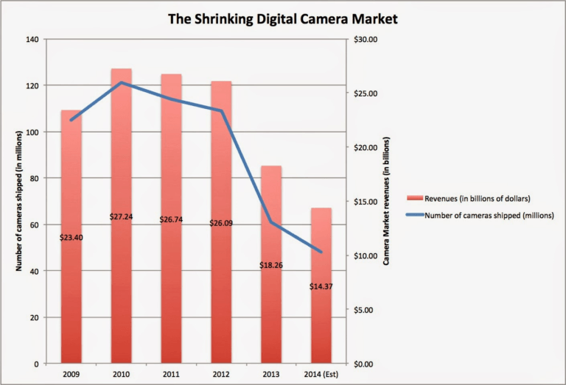

From the above figure, it is shown that the number of cameras shipped between 2009 and 2014 decreased from 110 million to 50 million.

Pro-Go prospects for the future.

From the above discussion, Pro-Go camera faces three key strategic threats namely competition from the smartphone industry, technological disruption and connected devices. Moving into the future, Pro-Go needs to redefine its strategy through the following if it were to remain competitive:

* Develop cameras with additional features such as facial recognition, night vision and 360-degree field.
* Completely do away with Li-ion rechargeable batteries and replace them with solar batteries.

Conclusion and Recommendations.

Summing up, it is evident that Pro-Go Pty Ltd faces significant strategic threats. Specifically, technological disruption and competition from the smartphone industry are strong forces to reckon with. As such, the company needs to change/ modify the product features to incorporate high definition, night vision, facial recognition, among other technologies. It is important to note that to remain competitive, the company must pay close attention to the following recommendations:

* Identifying changes in consumer behaviour. The consumer behaviour is rapidly changing and hence the company must be aware of such shifts. For example, customers now want cameras that can capture real-life experiences.
* The company must collect customer feedback. To provide high-quality devices, feedback from customers must be considered. Once the company has received feedback from the customers, it will be able to tailor its products to meet their needs/ preferences.

References.

Schilling, M. A., & Shankar, R. (2019). *Strategic management of technological innovation*. McGraw-Hill Education.

Varelas, S., & Georgopoulos, N. (2017). Competition as a critical factor of the strategic planning of hotel businesses. *J Hotel Bus Manag*, *6*(167), 17.

Saadatmand, M., Dabab, M., & Weber, C. (2018, August). Dynamics of competition and strategy: A literature review of strategic management models and frameworks. In *2018 Portland international conference on management of engineering and technology (PICMET)* (pp. 1-14). IEEE.

Aguinis, H., Edwards, J. R., & Bradley, K. J. (2017). Improving our understanding of moderation and mediation in strategic management research. *Organizational Research Methods*, *20*(4), 665-685.

Lasserre, P. (2017). *Global strategic management*. Macmillan International Higher Education.