Notes

Notes 1
.Net Coding 3
Datasets 3
Combo/Grid/Dropdown 4
Streams 5
Serialize a class 6
Datasource 11
XML Coding 12
LinQ 14
WPF 18
WCF 21
SQL 29
Count columns: 29
Sum a column: 29
Insert a row: 29
Stored Procedures: 30
Cursor: 31
SQL Profiler 32
Surface Area Configuration 34

.Net Coding
I will place different items here that I feel does not fall into one of the other topics.

I created a library that holds different classes one of those classes’ uses my customized collection class. In the “CompareValues” method which you have to implement I compare values from different fields so I have to know the field’s type.

If TypeOf valueOfX Is Double Then
Dim myDbl As Double
Double.TryParse(ValueToFind.ToString, myDbl)
Dim comp As IComparable = CType(valueOfX, IComparable)
valCompare = comp.CompareTo(myDbl)

So “valCompare” holds 0=Equal, 1=Greater, or -1=Less which you can then decide with the additional help of a constraint variable to determine if you have a match. Note, you could use this same check in validation.

Hook up an event.

AddHandler Me._operation.ProgressChanged, AddressOf _oper_ProgressChanged

Raise an event.

RaiseEvent ProgressChanged(Me, e)

Datasets

The rTALIS app used a big dataset here are a couple of items I had to code.

- Loop through a collection in the dataset

Dim BeniList As DataTable
BeniList = Me.RTALISDataSetRockwell.Tables("BeneficiaryCollections")
For Each beneItem As DataRow In BeniList.Rows
If beneItem("HIC").ToString() = Me.HICTextBox.Text Then
MsgBox("Col " & beneItem("HIC").ToString() & _
" from the selection " & Me.HICTextBox.Text _
)
End If
Next

- Check a field in the dataset for nulls

If Not Me.RTALISDataSetRockwell.BeneficiaryCollections(0).Item("MiddleName").Equals(DBNull.Value) Then
_appBene.MiddleName = Me.RTALISDataSetRockwell.BeneficiaryCollections(0).MiddleName
End If

- To update columns
Me.RTALISDataSetRockwell.Appeals(0).Prov_Name = _appProv.Name

Combo/Grid/Dropdown

- To set an entry in a filled combo box to a value, this works as long as data value is 0,1,2,etc… else set the SelectedValue

StateComboBox.SelectedIndex = StateComboBox.FindString(_appBene.State.ToUpper)

- To get the current value from the selected item in the combo box

_appBene.State = StateComboBox.SelectedValue

- To use a selected row’s column from a grid that has a dataset as it’s datasource
_appProv.City = Me.ProvidersDataGridView.SelectedRows.Item(0).Cells("CityDataGridViewTextBoxColumn").Value

- Asp.net Dropdownlist

If Not IsNothing(Me.drpLiceST.Items.FindByText(myPerson.LiceSt)) Then
Me.drpLiceST.SelectedValue = Me.drpLiceST.Items.FindByText(myPerson.LiceSt).Value
End If

Streams
The following example is for FileStream:

Dim objReader As New FileStream(myImageFil, FileMode.Open, FileAccess.Read)
Dim imageContent() As Byte
ReDim imageContent(objReader.Length)
objReader.Read(imageContent, 0, Convert.ToInt32(objReader.Length))
objReader.Close()
objReader = Nothing

Dim imagedata() As Byte = myResult.ToArray
Dim sw As New FileStream(Me.txtBar.Text & ".pdf", FileMode.Create, FileAccess.Write)
sw.Write(imagedata, 0, imagedata.Length)
sw.Flush()
sw.Close()
sw = Nothing

The following examples are for StreamReader and StreamWriter:

Dim sr As StreamReader = New StreamReader(myISOFil)
Dim SRcouter As StreamReader = New StreamReader(myISOFil)
Dim line As String = ""
'
' let's get a count of the lines in the file
'
Dim myTotal As Integer = 0
Do While SRcouter.Peek <> -1
line = SRcouter.ReadLine()
If Len(line) < 10 Then Exit Do
myTotal = myTotal + 1
Loop
SRcouter.Close()

Do
line = sr.ReadLine()
If Len(line) < 10 Then Exit Do
…
Loop Until line Is Nothing
…
Write

Dim sw As StreamWriter = New StreamWriter(myExpName)

For Each itemSum As AcctSummary In SumCol
Dim tmpAmt As String
tmpAmt = itemSum.Amount.ToString
If itemSum.DebitCredit = "C" Then
tmpAmt = "-" & tmpAmt
End If
' does the amount have a decimal point in it
If tmpAmt.LastIndexOf(".") > 0 Then
Select Case tmpAmt.Length - (tmpAmt.LastIndexOf(".") + 1)
Case 1
tmpAmt = tmpAmt & "0"
Case 2
tmpAmt = tmpAmt
Case Else
tmpAmt = tmpAmt.Remove(tmpAmt.LastIndexOf(".") + 3)
End Select
tmpAmt = tmpAmt.Substring(0, tmpAmt.LastIndexOf(".")) & _
tmpAmt.Substring(tmpAmt.LastIndexOf(".") + 1)
End If
sw.WriteLine(String.Format("{0}{1}{2}" & _
"{3}{4}", _
itemSum.AcctNumber.PadRight(24), _
myFrmDt, _
myToDt, _
tmpAmt.PadLeft(12), "AIT".PadLeft(44)))
Next
sw.Flush()
sw.Close()

Serialize a class

Imports Microsoft.VisualBasic
Imports System.Xml.Serialization
<Serializable()> _
Public Class Demos
<XmlElement(GetType(cateitem))> _
Public category As New ArrayList

<XmlInclude(GetType(cateitem))> _
Public Sub add(ByVal entry As cateitem)
category.Add(entry)
End Sub

End Class

Public Class cateitem
Private _catName As String
<XmlAttribute("categoryName")> _
Public Property CatName() As String
Get
Return _catName
End Get
Set(ByVal value As String)
_catName = value
End Set
End Property
<XmlElement(GetType(demoitem))> _
Public demo As New ArrayList

<XmlInclude(GetType(demoitem))> _
Public Sub add(ByVal entry As demoitem)
demo.Add(entry)
End Sub

End Class

Public Class demoitem
Private _header As String
<XmlAttribute("header")> _
Public Property Header() As String
Get
Return _header
End Get
Set(ByVal value As String)
_header = value
End Set
End Property
Private _page As String
<XmlAttribute("page")> _
Public Property Page() As String
Get
Return _page
End Get
Set(ByVal value As String)
_page = value
End Set
End Property
End Class

Here’s the code that uses the classes

<Conditional("TestDemoSer")> _
Private Sub useDemoSer()

Dim myTxtSer As XmlSerializer = New XmlSerializer(GetType(Demos))
Dim sw As New IO.StringWriter()
Dim myDemos As New Demos()
'
' create the first category entry
'
Dim myCate As New cateitem()
myCate.CatName = "Start Here"
'
' create the first demo entry for the first cate
'
Dim myDemo1 As New demoitem
myDemo1.Header = "Intro"
myDemo1.Page = "..\StartHere\Samplepage.xaml"
myCate.add(myDemo1)
myDemo1 = Nothing
'
' create the second entry for the first cate
'
Dim myDemo2 As New demoitem
myDemo2.Header = "List of Dependency Properties"
myDemo2.Page = "..\StartHere\ListOfDPs.xaml"
myCate.add(myDemo2)
myDemo2 = Nothing
' add the first category entry into the demos document
myDemos.add(myCate)
myCate = Nothing
'
' create the second category entry
'
Dim myCate2 As New cateitem()
myCate2.CatName = "DataSources"
'
' create the first demo entry for the second cate
'
Dim myDemoA As New demoitem
myDemoA.Header = "Element to Element"
myDemoA.Page = "..\DataSources\FontSize.xaml"
myCate2.add(myDemoA)
myDemoA = Nothing
'
' create the second entry for the second cate
'
Dim myDemoB As New demoitem
myDemoB.Header = "Change Notification"
myDemoB.Page = "..\Notification\InventoryMonitor.xaml"
myCate2.add(myDemoB)
myDemoB = Nothing
' add the second category entry into the demos document
myDemos.add(myCate2)
myCate2 = Nothing

myTxtSer.Serialize(sw, myDemos)
lstResults.ClearSelection()
lstResults.Items.Add(sw.ToString())
End Sub

An alternate approach using the “WITH”

<Conditional("TestDemoWith")> _
Private Sub useDemoWith()
Dim myTxtSer As XmlSerializer = New XmlSerializer(GetType(Demos))
Dim sw As New IO.StringWriter()
Dim my1Catdemo As demoitem() = { _
New demoitem With { _
.Header = "Intro", _
.Page = "..\StartHere\Samplepage.xaml"}, _
New demoitem With { _
.Header = "How to start", _
.Page = "..\StartHere\myHowTo.xaml"} _
}
Dim my2Catdemo As demoitem() = { _
New demoitem With { _
.Header = "Element to Element", _
.Page = "..\DataSources\FontSize.xaml"}, _
New demoitem With { _
.Header = "Change Notification", _
.Page = "..\Notification\InventoryMonitor.xaml"} _
}
'
' create the category entries
'
Dim myCats As cateitem() = { _
New cateitem() With { _
.CatName = "Start Here", _
.demo = my1Catdemo.ToList()}, _
New cateitem() With { _
.CatName = "DataSources", _
.demo = my2Catdemo.ToList()} _
}
Dim myDemos As New Demos With {.category = myCats.ToList}
myTxtSer.Serialize(sw, myDemos)
lstResults.ClearSelection()
lstResults.Items.Add(sw.ToString())
End Sub

Repeater
In the following steps I will attempt to document how to use the repeater to sort the data. A couple of definitions: Data access layer (DAL) and Business logic layer (BLL).

First we will start in the DAL. You need a stored procedure that will use the arguments that are stored in the application to return the result set.

ALTER PROCEDURE dbo.GetProductsPagedAndSorted
(
@sortExpression nvarchar(100),
@startRowIndex int,
@maximumRows int
)
AS

-- Make sure a @sortExpression is specified
IF LEN(@sortExpression) = 0
SET @sortExpression = 'ProductID'

-- Issue query
DECLARE @sql nvarchar(4000)
SET @sql = 'SELECT ProductID, ProductName, SupplierID, CategoryID, QuantityPerUnit, UnitPrice, UnitsInStock, UnitsOnOrder, ReorderLevel, Discontinued, CategoryName, SupplierName
FROM (SELECT ProductID, ProductName, p.SupplierID, p.CategoryID, QuantityPerUnit, UnitPrice, UnitsInStock, UnitsOnOrder, ReorderLevel, Discontinued,
c.CategoryName, s.CompanyName AS SupplierName,
ROW_NUMBER() OVER (ORDER BY ' + @sortExpression + ') AS RowRank
FROM Products AS p
INNER JOIN Categories AS c ON
c.CategoryID = p.CategoryID
INNER JOIN Suppliers AS s ON
s.SupplierID = p.SupplierID) AS ProductsWithRowNumbers
WHERE RowRank > ' + CONVERT(nvarchar(10), @startRowIndex) +
' AND RowRank <= (' + CONVERT(nvarchar(10), @startRowIndex) + ' + '
+ CONVERT(nvarchar(10), @maximumRows) + ')'

Next, create an adapter in your project and add the stored procedure to it.

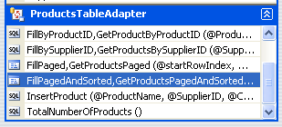

Now we will create the BLL object that is called by the user interface in our case a web page. You need to add a reference to the adaptor in your class.
[System.ComponentModel.DataObjectMethodAttribute(System.ComponentModel.DataObjectMethodType.Select, false)]
public Northwind.ProductsDataTable GetProductsPagedAndSorted(string sortExpression, int startRowIndex, int maximumRows)
{
return Adapter.GetProductsPagedAndSorted(sortExpression, startRowIndex, maximumRows);
}

Then in the user interface complete the loop. In the web page you have

<asp:Repeater ID="Products" runat="server" DataSourceID="ProductsDataSource"
EnableViewState="False">
<ItemTemplate>
<h4><asp:Label ID="ProductNameLabel" runat="server"
Text='<%# Eval("ProductName") %>'></asp:Label></h4>
Category:
<asp:Label ID="CategoryNameLabel" runat="server"
Text='<%# Eval("CategoryName") %>'></asp:Label><br />
Supplier:
<asp:Label ID="SupplierNameLabel" runat="server"
Text='<%# Eval("SupplierName") %>'></asp:Label><br /> <br /> <br />
</ItemTemplate>
</asp:Repeater>
<asp:ObjectDataSource ID="ProductsDataSource" runat="server"
OldValuesParameterFormatString="original_{0}" TypeName="ProductsBLL"
SelectMethod="GetProductsPagedAndSorted"
OnSelecting="ProductsDataSource_Selecting">
<SelectParameters>
<asp:Parameter Name="sortExpression" Type="String" />
<asp:Parameter Name="startRowIndex" Type="Int32" />
<asp:Parameter Name="maximumRows" Type="Int32" />
</SelectParameters>
</asp:ObjectDataSource>

Now you keep the parameters in the page as follows

public partial class PagingSortingDataListRepeater_SortingWithCustomPaging : System.Web.UI.Page
{
protected void ProductsDataSource_Selecting
(object sender, ObjectDataSourceSelectingEventArgs e)
{
e.InputParameters["startRowIndex"] = StartRowIndex;
e.InputParameters["maximumRows"] = MaximumRows;
e.InputParameters["sortExpression"] = SortExpression;
// Disable the paging interface buttons, if needed
FirstPage.Enabled = StartRowIndex != 0;
PrevPage.Enabled = StartRowIndex != 0;

int LastPageStartRowIndex = ((TotalRowCount - 1) / MaximumRows) * MaximumRows;
NextPage.Enabled = StartRowIndex < LastPageStartRowIndex;
LastPage.Enabled = StartRowIndex < LastPageStartRowIndex;
}

protected void FirstPage_Click(object sender, EventArgs e)
{
// Return to StartRowIndex of 0 and rebind data
StartRowIndex = 0;
Products.DataBind();
}

protected void PrevPage_Click(object sender, EventArgs e)
{
// Subtract MaximumRows from StartRowIndex and rebind data
StartRowIndex -= MaximumRows;
Products.DataBind();
}

protected void NextPage_Click(object sender, EventArgs e)
{
// Add MaximumRows to StartRowIndex and rebind data
StartRowIndex += MaximumRows;
Products.DataBind();
}

protected void LastPage_Click(object sender, EventArgs e)
{
// Set StartRowIndex = to last page's starting row index and rebind data
StartRowIndex = ((TotalRowCount - 1) / MaximumRows) * MaximumRows;
Products.DataBind();
}

protected void SortByProductName_Click(object sender, EventArgs e)
{
StartRowIndex = 0;
SortExpression = "ProductName";
Products.DataBind();
}

protected void SortByCategoryName_Click(object sender, EventArgs e)
{
StartRowIndex = 0;
SortExpression = "CategoryName";
Products.DataBind();
}

protected void SortBySupplierName_Click(object sender, EventArgs e)
{
StartRowIndex = 0;
SortExpression = "CompanyName";
Products.DataBind();
}

private int StartRowIndex
{
get
{
object o = ViewState["StartRowIndex"];
if (o == null)
return 0;
else
return (int)o;
}
set
{
ViewState["StartRowIndex"] = value;
}
}

private int MaximumRows
{
get
{
object o = ViewState["MaximumRows"];
if (o == null)
return 5;
else
return (int)o;
}
set
{
ViewState["MaximumRows"] = value;
}
}

private string SortExpression
{
get
{
object o = ViewState["SortExpression"];
if (o == null)
return "ProductName";
else
return o.ToString();
}
set
{
ViewState["SortExpression"] = value;
}
}

private int TotalRowCount
{
get
{
// Return the value from the TotalNumberOfProducts() method
ProductsBLL productsAPI = new ProductsBLL();
return productsAPI.TotalNumberOfProducts();
}
}
}
This is a simple method of sorting and paging a repeater.

Datasource
The following datasource uses a configuration variable “QuoteConnString” and a session variable “PolicyNu” to read the stored procedure.

<asp:SqlDataSource ID="dsPolPerson" runat="server"
ConnectionString="<%$ ConnectionStrings:QuoteConnString %>"
SelectCommand="SP_Claims_GetDriverList" SelectCommandType="StoredProcedure">
<SelectParameters>
<asp:SessionParameter Name="PolicyNumber"
SessionField="PolicyNu" Type="String" />
</SelectParameters>
</asp:SqlDataSource>

XML Coding

Read using a schema

XmlTextReader xtr = new XmlTextReader(fileName);
XmlValidatingReader vreader = new XmlValidatingReader(xtr);
vreader.ValidationType = ValidationType.Auto;
vreader.ValidationEventHandler +=
new ValidationEventHandler(this.ValidationEventHandle);

while (vreader.Read())
{
switch (vreader.NodeType) {
case XmlNodeType.Element :
this.mylocal.StatusText = "\r\n" + vreader.Name + ' ';
if (vreader.HasAttributes)
this.mylocal.StatusText = GetAttList(vreader);
break;
case XmlNodeType.Text:
this.mylocal.StatusText = vreader.Value;
break;
case XmlNodeType.Comment :
this.mylocal.StatusText = vreader.Value;
break;
}
}

xtr.Close();
vreader.Close();

write then read

// Open the XML writer
XmlTextWriter xmlw = new XmlTextWriter(filename, null);
xmlw.Formatting = Formatting.Indented;

xmlw.WriteStartDocument();
xmlw.WriteComment("Array to Base64 XML");

xmlw.WriteStartElement("array");
xmlw.WriteAttributeString("xmlns", "x", null, "dinoe:msdn-mag");
foreach (string s in theArray)
{
xmlw.WriteStartElement("x", "element", null);
xmlw.WriteBase64(Encoding.Unicode.GetBytes(s), 0, s.Length * 2); // Unicode
xmlw.WriteEndElement();
}
xmlw.WriteEndDocument();

// Close the writer
xmlw.Close();

// Read it back!
XmlTextReader reader = new XmlTextReader(filename);
while (reader.Read())
{
if (reader.LocalName == "element")
{

byte[] bytes = new byte[1000];
int n = reader.ReadBase64(bytes, 0, 1000);
string buf = Encoding.Unicode.GetString(bytes);

Console.WriteLine(buf.Substring(0, n));
}
}
reader.Close();

LinQ

Sql

Dim mySer As New DataContext(My.Settings.Northwind)
Dim results As IEnumerable(Of Customers) = _
mySer.ExecuteQuery(Of Customers) _
("SELECT CompanyName," & _
"ContactName " & _
"FROM customers")
Me.lstResult.Items.Clear()
For Each cst As Customers In results
Me.lstResult.Items.Add("Company: " & cst.CompanyName & vbTab & _
"Name: " & cst.ContactName & vbTab & "Total: " & _
cst.Total)
Next

Classes

Dim cust1 As New Customers With {.CompanyName = "Steve' Shop", _
.ContactName = "Steve", .Total = 99}
Dim cust2 As New Customers With {.CompanyName = "Ponytail Girl", _
.ContactName = "Julia", .Total = 87}
Dim cust3 As New Customers With {.CompanyName = "Basenine", _
.ContactName = "Doug", .Total = 76}

Dim arrlst As New ArrayList
arrlst.Add(cust1)
arrlst.Add(cust2)
arrlst.Add(cust3)
Dim query = From cst As Customers In arrlst _
Where cst.Total > 85 _
Select cst

Me.lstResult.Items.Clear()
For Each cst As Customers In query
Me.lstResult.Items.Add(cst.CompanyName _
& " " & cst.ContactName & " " & cst.Total)
Next

XML

Dim xmlDoc = XDocument.Load(txtFileName.Text)
' this query will retrieve the cat name and children so we can go
' through them
Dim query = From category In xmlDoc...<category> _
Select category.Attribute("categoryName").Value, Demos = _
category.Descendants
Me.ListBox1.Items.Clear()
For Each v In query
Me.ListBox1.Items.Add(v.Value & ": ")
For Each d In v.Demos
Me.ListBox1.Items.Add(d.@header & " " & d.@page)
Next
Me.ListBox1.Items.Add("=======================================")
Next

<demos>
<category categoryName="Start Here">
<demo header ="Intro"
page="..\StartHere\Samplepage.xaml"
/>
<demo header ="List of Dependency Properties"
page="..\StartHere\ListOfDPs.xaml"
/>

</category>
<category categoryName="DataSources">
<demo header ="Element to Element"
page="..\DataSources\FontSize.xaml"
/>
<demo header ="Change Notification"
page="..\Notification\InventoryMonitor.xaml"
/>
</category>
<category categoryName="Data Context">
<demo header ="Data Context and Business Objects"
page="..\DataContext\Context1.xaml"
/>
<demo header ="Setting Different Data Context"
page="..\DataContext\Context2.xaml"
/>
</category>
</demos>

Designer

VS2008 comes with a template for creating Linq2SQL classes using a designer. Below is a snap shot of the CheckRequest table in the designer.

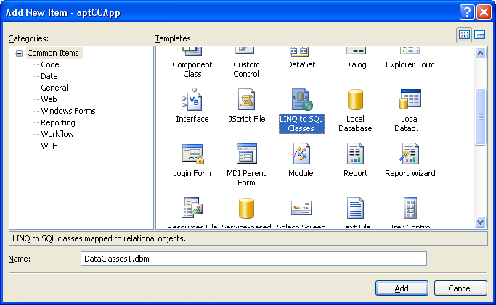

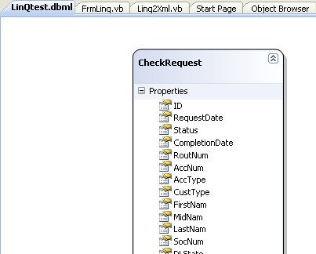

So now I can reference this data context and class in my code. Note the lamda expression.

Dim myCheckdb As New LinQtestDataContext
Me.lstResult.Items.Clear()
Dim myCheck = myCheckdb.CheckRequests.SingleOrDefault(Function(CheckRequest) CheckRequest.ID = 1)

If IsNothing(myCheck) Then
Me.lstResult.Items.Add("Could not find the id")
Else
'Dim myItem As WebCheck = DirectCast(myCheck, WebCheck)
Me.lstResult.Items.Add(myCheck.ID & " " & myCheck.DeFirstNam & " " & myCheck.CustType & " " & myCheck.email)
End If

The following code sets a variable trying to read the db using linq.

Dim mydbObj As New aptACHdataDataContext

Try
Dim myStartId = (From p In mydbObj.PaymentBatchDates _
Select p.ID).Max()

Me.myId = myStartId
Catch ex As Exception
Me.myId = 0
End Try

Try
Dim myStartDt = (From p In mydbObj.PaymentBatchDates _
Where p.BatchType = myType _
Select p.EndDate).Max()
mystart = myStartDt.AddDays(1)
Catch ex As Exception
mystart = Now()
End Try
mydbObj = Nothing

The following code processes ACH transactions.

Dim mydbObj As New aptACHdataDataContext

Try
Dim myACHFinRecs = From p In mydbObj.PaymentActivity_Finances _
Where p.PaymentMethod = "ACH" _
And p.DateStamp >= Me.myStart.SelectedDate.Value _
And p.DateStamp < Me.myEnd.SelectedDate.Value _
Select p
For Each achItem As PaymentActivity_Finance In myACHFinRecs
Dim acctType As String = ""
Select Case UCase(achItem.AccountType)
Case "CHECK"
acctType = "27"
Case "SAVE"
acctType = "37"
End Select
procDtl(achItem.ID, _
achItem.RoutingNumber, _
Cryptography.DecryptTripleDES(achItem.AccountNumber), _
acctType, _
achItem.AccountHolderName, _
achItem.PaymentAmount)
Next
Catch ex As Exception
Me.StatusMsg.Content = ex.Message
Utilities.LoggerMsg(Me.StatusMsg.Content)
End Try
mydbObj = Nothing
NOTE:If you make changes in the database to any items that are used in your project you must Refresh the projects objects. They do not automaticly update!!

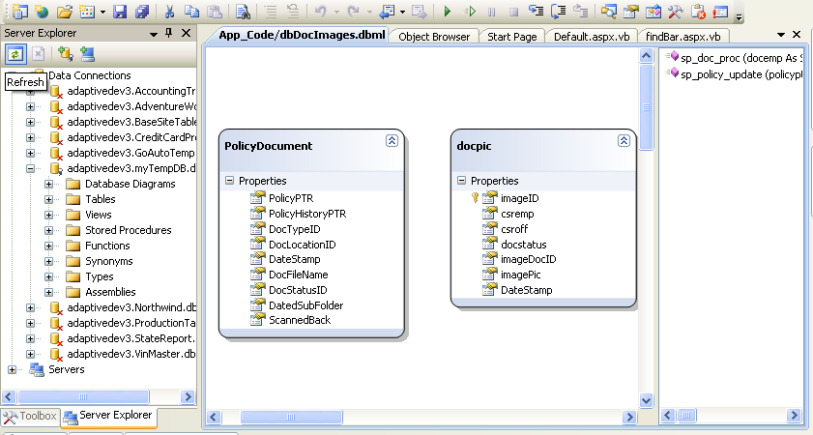

WPF
Windows Presentation Foundation (WPF) is a new model used in the User interface. In WPF you do not use a form you use XAML to paint your screen image. I will place some of my examples here.

The following is an example of the XAML screen.

<Window x:Class="Window1"
xmlns="http://schemas.microsoft.com/winfx/2006/xaml/presentation"
xmlns:x="http://schemas.microsoft.com/winfx/2006/xaml"
Title="ISO File Process" Height="181" Width="470" Icon="/aptISOwpf;component/goauto.ico">
<Grid>
<Menu Height="22" Name="Menu1" VerticalAlignment="Top">
<MenuItem Header="_File">
<MenuItem Header="About" Click="btAbout_Click" />
<Separator />
<MenuItem Header="E_xit" Click="btExit_Click" />
</MenuItem>
</Menu>
<Label Height="28" HorizontalAlignment="Left"
Margin="14,31,0,0" Name="Label1"
VerticalAlignment="Top" Width="60">Filename:</Label>
<TextBox Height="23" Margin="74,31,0,0" Name="txtFileName"
VerticalAlignment="Top" HorizontalAlignment="Left"
Width="302" />
<Button Height="23" HorizontalAlignment="Right"
Margin="0,29.138,29,0" Name="btGetFile"
VerticalAlignment="Top" Width="36">...</Button>
<Button Margin="14,70,0,50" Name="btProcess"
HorizontalAlignment="Left" Width="67"
IsEnabled="False">Process</Button>
<StatusBar Height="31" Name="StatusBar1"
VerticalAlignment="Bottom">
<StatusBarItem Name="StatusMsg" Height="Auto"
Width="350">Enter the ISO file name to start the process</StatusBarItem>
</StatusBar>
</Grid>
</Window>
Now as long as you are not doing anything fancy then you can reference the fields and events as you would in a WinForm project.

Events:

Private Sub btExit_Click(ByVal sender As System.Object, _
ByVal e As System.Windows.RoutedEventArgs)
Application.Current.Shutdown()
End Sub

Private Sub btAbout_Click(ByVal sender As System.Object, _
ByVal e As System.Windows.RoutedEventArgs)
Dim myAbout As New About
myAbout.ShowDialog()
myAbout = Nothing
End Sub

By the way use Application.Current.Shutdown() to stop a WPF application.

Referencing variables:

If filDial.ShowDialog() = True Then
txtFileName.Text = filDial.FileName
Me.btProcess.IsEnabled = True
Me.StatusMsg.Content = "Press the Process button to add the data to the Vin Master db."
Else
Me.StatusMsg.Content = "You must select a file in order to proceed."
Me.btProcess.IsEnabled = False
Exit Sub
End If

The magic comes in when you want to add new features to the user interface. I have just a couple of examples. Using the Page/Window Resources section of the page you define a variety of items that can be used for settings variables and creating styles.

xmlns:local="clr-namespace:WpfPersonList"
…
<Page.Resources>
<local:PerInfo x:Key="pInfo"
FirstName="" LastName="" Address="" City="" State="" Zip=""
></local:PerInfo>
…
<Grid Height="352" Width="350">
<StackPanel Margin="81,4,93,0" Name="StackPanel1" Height="138"
VerticalAlignment="Top">
<TextBox Name="txtFirst"
Text="{Binding Source=
{StaticResource pInfo},
Path=FirstName, Mode=TwoWay,
ValidatesOnDataErrors=True}"
Height="23" Width="120" HorizontalAlignment="Left" />

In this example I created a reference to a class, PerInfo, in my project, WpfPersonList. In the main section of the page I can now use this to talk back and forth to the user interface.

WCF
Windows Communication Foundation (WCF) is a new model used to create communication code over the network. WCF gives us more control over the configuration of the communication channels used. The new library in the framework used for WCF is System.ServiceModel.

Create your interface by adding the System.ServiceModel to your class library, DemoInterfaces. The following service is our example service that will be used further in the topic. This is a basic service with no customization. Using attributes and their properties we can customize the service to further control access etc.

<ServiceContract()> _
Public Interface ICustomer

<OperationContract()> _
Function GetCustomer(ByVal customerID As Integer) As String

<OperationContract()> _
Function GetOrderHistory(ByVal customerID As Integer) As String

End Interface

The “OperationContract” defines the methods in the service. There are additional attributes you can use to further customize each contract. The HTTP verbs GET, POST, PUT, and DELETE can be customized using the following:

- WebGetAttribute if you think of it like the old http GET then you would be correct. We can customize the input, output, and the url that must be used in order to invoke the “GetItems” method below.

[OperationContract]
[WebGet(BodyStyle = WebMessageBodyStyle.Bare,
RequestFormat = WebMessageFormat.Xml,
ResponseFormat = WebMessageFormat.Xml,
UriTemplate = "GetItems")]
Dictionary<string, string> GetItems();

- WebInokeAttribute if you think of it like the old http POST then you would be correct. Below SaveItem gets “key” from the url and the “item” comes from the body of the message.

[OperationContract]
[WebInvoke(BodyStyle = WebMessageBodyStyle.Bare,
RequestFormat = WebMessageFormat.Xml,
ResponseFormat = WebMessageFormat.Xml,
UriTemplate = "SaveItem?id={key}", Method = "POST")]
void SaveItem(string key, string item);

This class, DemoCustomerBZ, implements the interface for the WCF object from above. Add a reference to the interface DemoInterFaces in this class library project.

Public Class CustomerBz
Implements ICustomer

Public Function GetCustomer(ByVal customerID As Integer) As String _
Implements DemoInterfaces.ICustomer.GetCustomer
Dim dsCust As New DataSet
Dim dt As New DataTable()
dt.Columns.Add("CustomerID", GetType(Int32))
dt.Columns.Add("CustomerName", GetType(String))
dt.Columns.Add("CustomerNumber", GetType(String))

dt.Rows.Add(customerID, "Customer " + customerID.ToString(), _
"ID " + customerID.ToString())
dsCust.Tables.Add(dt)
Return dsCust.GetXml()
End Function

Public Function GetOrderHistory(ByVal customerID As Integer) As String _
Implements DemoInterfaces.ICustomer.GetOrderHistory
Dim dsCustOrder As New DataSet
Dim dt As New DataTable()
dt.Columns.Add("CustomerID", GetType(Int32))
dt.Columns.Add("OrderID", GetType(String))
dt.Columns.Add("OrderDate", GetType(DateTime))
dt.Columns.Add("OrderAmount", GetType(Decimal))
dt.Columns.Add("OrderStatus", GetType(String))

dt.Rows.Add(customerID, "1001", New DateTime(2006, 11, 21), _
1100, "Completed")
dt.Rows.Add(customerID, "1523", New DateTime(2007, 1, 3), _
1100, "Pending")
dsCustOrder.Tables.Add(dt)
Return dsCustOrder.GetXml()
End Function
End Class

Build both class libraries for use with other projects. We can now create an IIS 6 web service in which IIS manages the lifetime of the service. Modify the standard service by performing the following steps:

Add the references to both classes that were built from above.

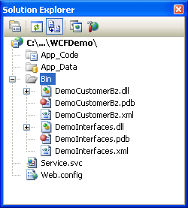

Remove the standard interface class file because the implementation is in the CustomerBZ class for this new service. Modify the service settings in the web.config file with the following:

<service name="DemoCustomerBz.CustomerBz" behaviorConfiguration="ServiceBehavior">
<!-- Service Endpoints -->
<endpoint address="" binding="basicHttpBinding" contract="DemoInterfaces.ICustomer">

We have identified the interface used in this service as CustomerBZ. At this point the subject of binding comes up. Binding is how to expose the service endpoints that handle communication that is defined here in the service. If our client uses the wrong binding there is no successful connection. You can have multiple endpoints set up in this service.

Modify the Service.svc file as follows:

%@ServiceHost Language="VB" Debug="true" Service="DemoCustomerBz.CustomerBz" %

With this reference to the implementation class in the svc file and the endpoint in the configuration file the service is now ready for use. Start the service.

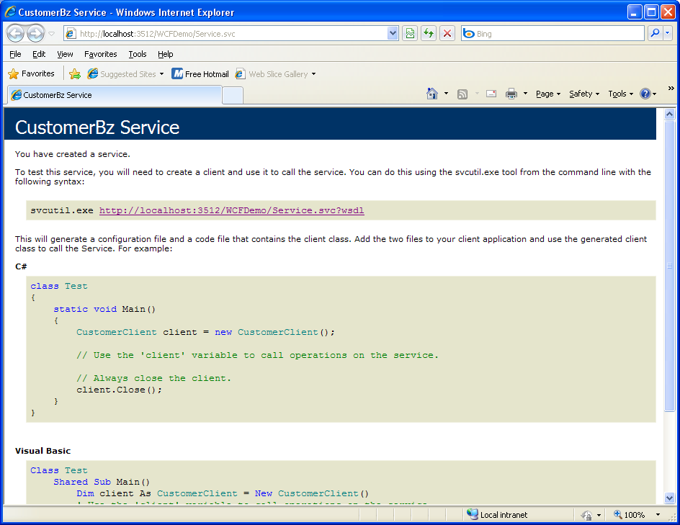

Now create your consumer (a.k.a. client) add a reference to the interface DemoInterfaces library created above. The code follows. Note we are building the reference to the service through code not the “Add Reference” approach. This gives us the ability to customize the communication.

Public Class Form1
Dim customerFactory As ChannelFactory(Of ICustomer)
Dim customerProxy As ICustomer

Private Sub btnRetCust_Click(ByVal sender As System.Object, ByVal e As System.EventArgs) Handles btnRetCust.Click
Me.dgCust.DataSource = Nothing
Try
Me.UpdateStatus("Retrieving the Customer")
Dim CustomerString As String =
customerProxy.GetCustomer(12)
Me.dgCust.DataSource = Me.XML2Ds(CustomerString)
Me.UpdateStatus("Customer retrieved successfully")
Catch ex As Exception
Me.UpdateStatus(ex.Message)
End Try
End Sub

Private Sub btnRetCol_Click(ByVal sender As System.Object, ByVal e As System.EventArgs) Handles btnRetCol.Click
Me.dgCustColl.DataSource = Nothing
Try
Me.UpdateStatus("Retrieving the Customer's orders")
Dim CustomerString As String =
customerProxy.GetOrderHistory(13)
Me.dgCustColl.DataSource = Me.XML2Ds(CustomerString)
Me.UpdateStatus("Orders retrieved successfully")
Catch ex As Exception
Me.UpdateStatus(ex.Message)
End Try
End Sub

Private Function XML2Ds(ByVal XMLData As String) As BindingSource
Dim dsReturn As New DataSet()
Dim sr As New StringReader(XMLData)
dsReturn.ReadXml(sr, XmlReadMode.InferSchema)
dsReturn.AcceptChanges()
Dim dv As New DataView(dsReturn.Tables(0))
Dim bs As New BindingSource
bs.DataSource = dv
Return bs
End Function

Private Sub UpdateStatus(ByVal clabel As String)
Me.lblStatus.Text = clabel
Me.lblStatus.Visible = True
Me.lblStatus.Update()
End Sub

Private Sub Form1_Load(ByVal sender As System.Object, ByVal e As System.EventArgs) Handles MyBase.Load
Try
Me.customerFactory = New ChannelFactory(Of ICustomer)("Customer")
Me.customerProxy = customerFactory.CreateChannel()
Catch ex As Exception
Me.UpdateStatus(ex.Message)
End Try
End Sub

End Class

Then you can add the following endpoint binding to the app.config. Once again if this does not match service’s bindings there is no connection.

<system.serviceModel>
<client>
<endpoint address="http://localhost:3512/WCFDemo/Service.svc"
binding="basicHttpBinding"
contract="DemoInterfaces.ICustomer"
name="Customer" />
</client>
</system.serviceModel>

Run your client and you should see the following:
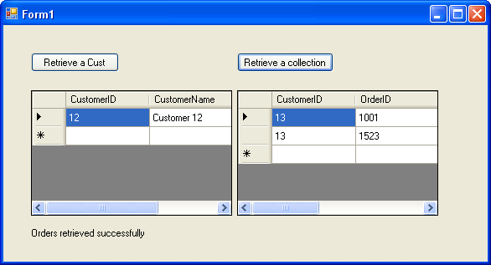

You have successfully communicated with the service.

We can create what is called a “Self-hosting” application that starts up the WCF service. Self-hosting is the simplest way to host services. You write the code necessary to initialize the ServiceHost and manage the service’s lifetime. Console, WinForm, WPF, and windows services are examples of the types of projects that I am talking about.

For this project you have to add references to all three libraries from above. The System.ServiceModel, interface DemoInterfaces, and DemoCustomerBz are the libraries.

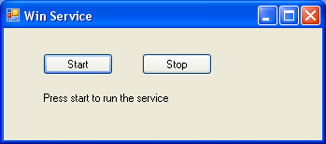

This application has a simple interface to start and stop the service. The code looks like the following:

Private oHost As ServiceHost

Private Sub btnStart_Click(ByVal sender As System.Object, ByVal e As System.EventArgs) Handles btnStart.Click
oHost = New ServiceHost(GetType(CustomerBz))
Me.UpdateStatus("Attempting to start the Service")
Try
oHost.Open()
Me.UpdateStatus("Service Started successfully")
Catch ex As Exception
Me.UpdateStatus(ex.Message)
End Try
End Sub

Private Sub btnStop_Click(ByVal sender As System.Object, ByVal e As System.EventArgs) Handles btnStop.Click
Me.UpdateStatus("Service Stopped")
oHost.Close()
End Sub

Private Sub UpdateStatus(ByVal clabel As String)
Me.lblStatus.Text = clabel
Me.lblStatus.Visible = True
Me.lblStatus.Update()
End Sub

Add the following to your app.config file to define the service’s endpoint.

<system.serviceModel>
<services>
<service name="DemoCustomerBz.CustomerBz">
<endpoint address="net.tcp://localhost:8228/CustomerBz"
binding="netTcpBinding"
contract="DemoInterfaces.ICustomer" />
</service>
</services>
</system.serviceModel>

Start the app and then start up your client from above with the modified app.config settings for it.

<endpoint address="net.tcp://localhost:8228/CustomerBz"
binding="netTcpBinding"
contract="DemoInterfaces.ICustomer"
name="Customer" />

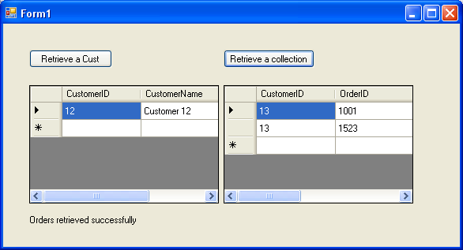

You have successfully communicated with the service.

Table 1: A summary of hosting options and supported features.
Feature | Self-Hosting | IIS Hosting | WAS Hosting
Executable Process/ App Domain | Yes | Yes | Yes
Configuration | App.config | Web.config | Web.config
Activation | Manual at startup | Message-based | Message-based
Idle-Time Management | No | Yes | Yes
Health Monitoring | No | Yes | Yes
Process Recycling | No | Yes | Yes
Management Tools | No | Yes | Yes

SQL

Count columns:

select title, count(title) from HumanResources.Employee
group by title

Sum a column:

select Act.id, TrnDtl.id,
sum(AccTrn.Amount) total
from GL_Account Act
left outer join GL_TranDetail TrnDtl on Act.ID = TrnDtl.AccountPtr
left outer join GL_Company Co on TrnDtl.CompanyPtr = Co.id
left outer join GL_AccountingTrans AccTrn on TrnDtl.id = AccTrn.TranDetailPTR
left outer join CompleteTransaction CompTrn on AccTrn.CompletedTransactionPTR = CompTrn.id
where comptrn.accountingdate > '7/1/2009' and comptrn.accountingdate < '7/31/2009'
group by Act.id, TrnDtl.id
order by Act.id, trndtl.id

Insert a row:

insert into VinLookup_0510
values(1,'7/24/2009 5:08:34 PM','7/24/2009 5:08:34 PM',
1,'JA3AB36F&A','JA3','20JA3AB36F&A','MITS','Galant es',
'Galant','GALANT ES','','SEDAN 4D','4',' ',
'2.4',' ','R','S','P','','','','','17','14','','','','','9','','','7/24/2009 5:08:41 PM','ISO')

insert into vinstyle select distinct style_raw, style from vinlookup order by style_raw

insert into vinmake select distinct
makecd = case make
when 'American Motors' then
'AMC '
else
upper(substring(make, 1, 4))
end, make
from vinlookup
order by makecd

Stored Procedures:

create proc [dbo].[SP_VinLookup]
@myvin as nvarchar(17), @myDate as datetime
as
begin
declare @mynewvin nvarchar(10),
@idfnd int,
@debug int
set @debug = 0
set @idfnd = -1
-- JA3AB36F&6068208 for the ISO file Y060904P.prn
-- mine 5GZCZ534679999999
--set @myvin = '5QZCZ534679999999'
select @idfnd = ID from vinlookup where vin like @myvin and effective_date < @myDate
if @@Rowcount = 0
goto FindGen9
goto Leaving
FindGen9:
if @debug = 1
select @myvin
--
-- We could not find the vin using the full ten characters so I try to find it
-- by using the wildcards _ I can found the vins using the ISO input. Position 9
--
set @mynewvin = substring(@myvin, 1, 8) + '_' + substring(@myvin, 10, 1)
if @debug = 1
print @mynewvin + ' ' + cast(@myDate as nvarchar(8))
select @idfnd = ID from vinlookup where vin like @mynewvin and effective_date < @myDate
if @@Rowcount = 0
goto FindGen4
goto Leaving

…

Leaving:
--
-- by the time we get here we either have the id or a -1
--
if @debug = 1
select @idfnd
return @idfnd
end

Cursor:

-- local variables
declare @kid as int
declare @id as int
set @id = 3402

declare Child scroll cursor for
select distinct ChildShopId
from
edg_tbl_Parentshoprelations
where
parentshopid = @id and
not (childshopid = @id)

open Child
fetch first from Child into @kid
while @@fetch_status = 0
begin
exec edg_sp_GetSubscriberById @kid
fetch next from Child into @kid
end
close Child
deallocate Child

SQL Profiler

You can use the profiler to follow the sql command issued to the server you connect to. To start the process you need to create a “New Trace”.

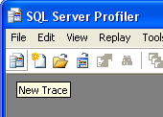 You then select the server you want to run from.

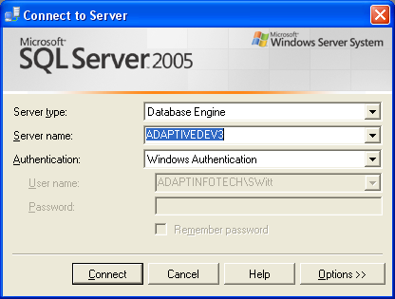

Now you need to set the properties for the trace.

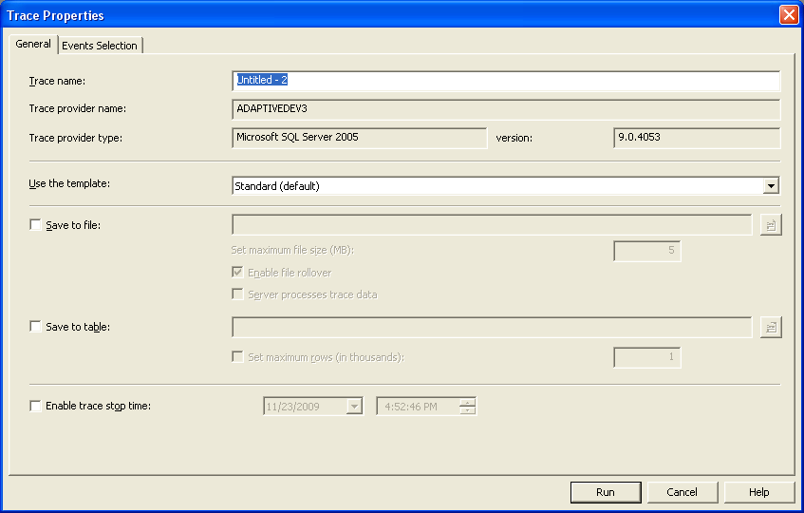

Click the “Events Selection” tab. Set all of the events off, below I use this for a stored procedure and its “StmtCompleted” event. I have checked the “TextData” column.

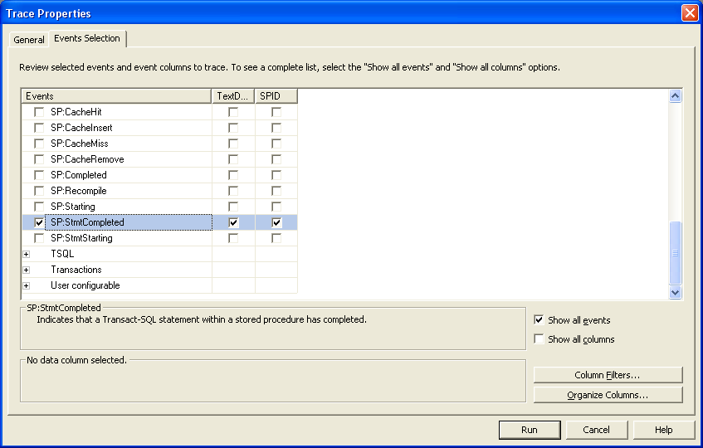

Click “Run”. You now have a log of all of the activity on the server.

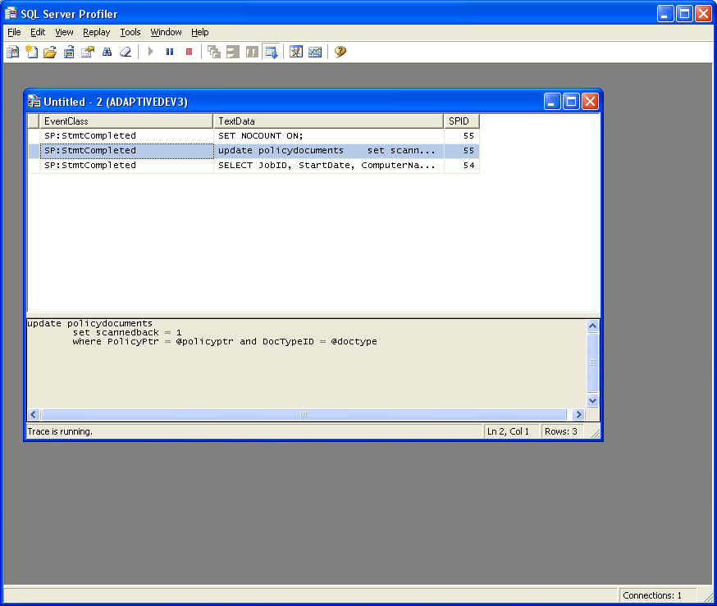

Surface Area Configuration

