MVC RAD

eMemberPay MVC 3
eMemberPay diagram 3
Struts Configuration File 4
eMemberPay modules 6
Input screen 6
subscriberPay 6
subscriberReg 7
subscriberCard 7
subscriberVerify 8
subscriberPay 9

eMemberPay MVC

eMemberPay diagram

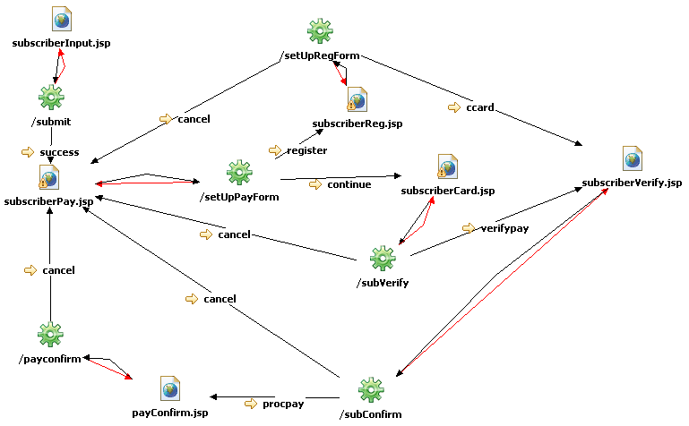

Struts Configuration File

<!-- Form Beans -->
<form-beans>
<form-bean name="SubInputForm"
type="com.bcbst.ememberpayweb.forms.SubInputForm">
</form-bean>
<form-bean name="ReadPayment"
type="com.bcbst.ememberpayweb.forms.SubmitPayment">
</form-bean>
<form-bean name="RegPayment"
type="com.bcbst.ememberpayweb.forms.RegPayment">
</form-bean>
<form-bean name="EnterCardInfo"
type="com.bcbst.ememberpayweb.forms.SubCCInputForm">
</form-bean>
<form-bean name="ApprovePayment"
type="com.bcbst.ememberpayweb.forms.VerifyPayment">
</form-bean>
<form-bean name="ProcessPayment"
type="com.bcbst.ememberpayweb.forms.ProcessPayment">
</form-bean>
</form-beans>

<!-- Action Mappings -->
<action-mappings>
<action name="SubInputForm" path="/submit" scope="session"
type="com.bcbst.ememberpayweb.actions.SubInputAction"
input="/subscriberInput.jsp">
<forward name="success" path="/subscriberPay.jsp">
</forward>
</action>
<action name="ReadPayment" path="/setUpPayForm" scope="session"
type="com.bcbst.ememberpayweb.actions.SetUpPayFormAction"
input="/subscriberPay.jsp">
<forward name="continue" path="/subscriberCard.jsp"></forward>
<forward name="register" path="/subscriberReg.jsp"></forward>
</action>
<action name="RegPayment" path="/setUpRegForm" scope="session"
type="com.bcbst.ememberpayweb.actions.SetUpRegFormAction"
input="/subscriberReg.jsp">
<forward name="ccard" path="/subscriberVerify.jsp"></forward>
<forward name="cancel" path="/subscriberPay.jsp"></forward>
</action>
<action name="EnterCardInfo" path="/subVerify" scope="session"
type="com.bcbst.ememberpayweb.actions.CompCCAction"
input="/subscriberCard.jsp">
<forward name="verifypay" path="/subscriberVerify.jsp"></forward>
<forward name="cancel" path="/subscriberPay.jsp"></forward>
</action>
<action name="ApprovePayment" path="/subConfirm" scope="session"
type="com.bcbst.ememberpayweb.actions.VerificationAction"
input="/subscriberVerify.jsp">
<forward name="procpay" path="/payConfirm.jsp"></forward>
<forward name="cancel" path="/subscriberPay.jsp"></forward>
</action>
<action name="ProcessPayment" path="/payconfirm" scope="session"
type="com.bcbst.ememberpayweb.actions.PayconfirmAction"
input="/payConfirm.jsp">
<forward name="cancel" path="/subscriberPay.jsp"></forward>
</action>
</action-mappings>

<!-- Message Resources -->
<message-resources parameter="com.bcbst.ememberpayweb.resources.ApplicationResources"/>

eMemberPay modules

Input screen
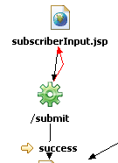

Form
<form-bean name="SubInputForm"
type="com.bcbst.ememberpayweb.forms.SubInputForm">
</form-bean>
Action
<action name="SubInputForm"
path="/submit" scope="session" type="com.bcbst.ememberpayweb.actions.SubInputAction" input="/subscriberInput.jsp">
<forward name="success" path="/subscriberPay.jsp"></forward>
</action>

subscriberPay

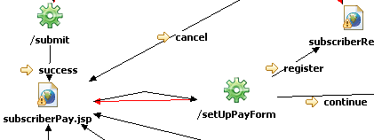

Form
<form-bean name="ReadPayment"
type="com.bcbst.ememberpayweb.forms.SubmitPayment">
</form-bean>
Action
<action name="ReadPayment" path="/setUpPayForm" scope="session"
type="com.bcbst.ememberpayweb.actions.SetUpPayFormAction"
input="/subscriberPay.jsp">
<forward name="continue" path="/subscriberCard.jsp"></forward>
<forward name="register" path="/subscriberReg.jsp"></forward>
</action>

subscriberReg
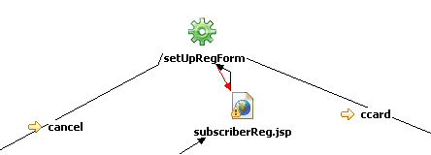

Form
<form-bean name="RegPayment"
type="com.bcbst.ememberpayweb.forms.RegPayment">
</form-bean>
Action
<action name="RegPayment" path="/setUpRegForm" scope="session"
type="com.bcbst.ememberpayweb.actions.SetUpRegFormAction"
input="/subscriberReg.jsp">
<forward name="ccard" path="/subscriberVerify.jsp"></forward>
<forward name="cancel" path="/subscriberPay.jsp"></forward>
</action>

subscriberCard
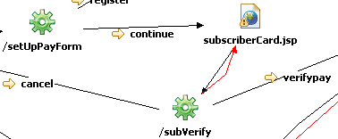

Form
<form-bean name="EnterCardInfo"
type="com.bcbst.ememberpayweb.forms.SubCCInputForm">
</form-bean>

Action
<action name="EnterCardInfo" path="/subVerify" scope="session"
type="com.bcbst.ememberpayweb.actions.CompCCAction"
input="/subscriberCard.jsp">
<forward name="verifypay" path="/subscriberVerify.jsp"></forward>
<forward name="cancel" path="/subscriberPay.jsp"></forward>
</action>

subscriberVerify
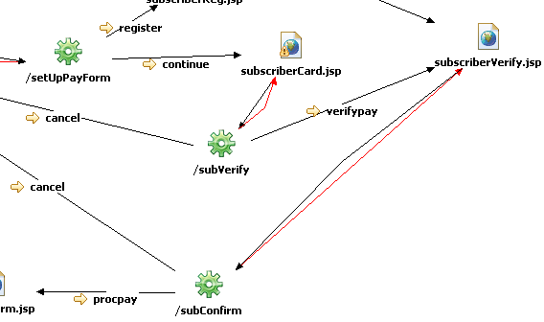

Form
<form-bean name="ApprovePayment"
type="com.bcbst.ememberpayweb.forms.VerifyPayment">
</form-bean>
Action
<action name="ApprovePayment" path="/subConfirm" scope="session"
type="com.bcbst.ememberpayweb.actions.VerificationAction"
input="/subscriberVerify.jsp">
<forward name="procpay" path="/payConfirm.jsp"></forward>
<forward name="cancel" path="/subscriberPay.jsp"></forward>
</action>

subscriberPay
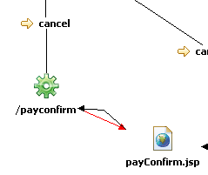

Form
<form-bean name="ProcessPayment"
type="com.bcbst.ememberpayweb.forms.ProcessPayment">
</form-bean>
Action
<action name="ProcessPayment" path="/payconfirm" scope="session"
type="com.bcbst.ememberpayweb.actions.PayconfirmAction"
input="/payConfirm.jsp">
<forward name="cancel" path="/subscriberPay.jsp"></forward>
</action>

