RAD and ClearCase

Overview 3
ClearCase View 3
RAD 6

Overview

This document outlines the steps to establish a RAD workspace environment to develop in. This document assumes you have experience with ClearCase, ClearQuest, RAD, and the CMMI process. It is assumed that a project has been established in ClearQuest and that ClearCase contains the source code to be worked on.

ClearCase View

Create your view and make sure it is pointing to the M: drive.

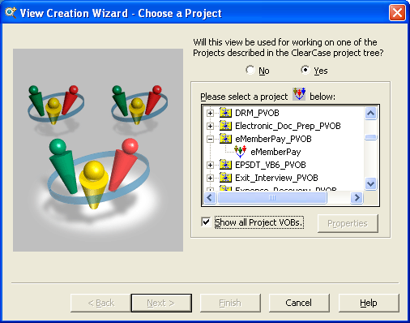

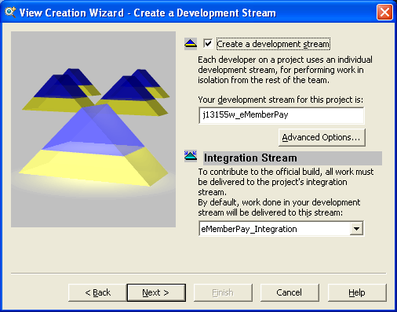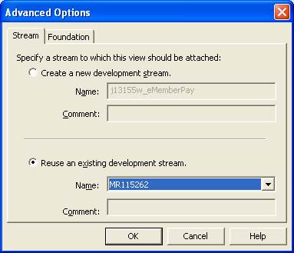
You can now use the explorer and your new view to navigate to your source code and begin your work.

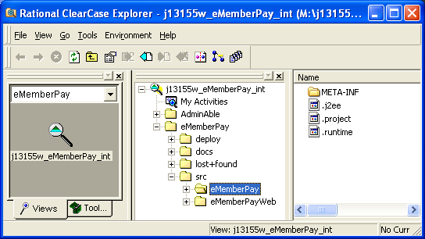

RAD
When you open RAD browse to the M: drive location where your view is pointing and locate the src folder. This will be the top level folder for your workspace.

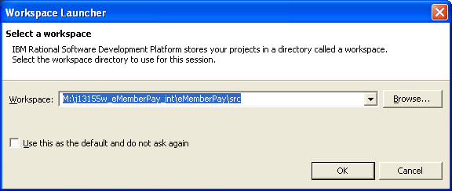

When you point RAD at the src folder it creates the .metadata sub-folder.

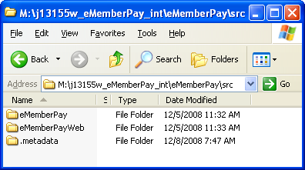
RAD opens a new empty workspace.

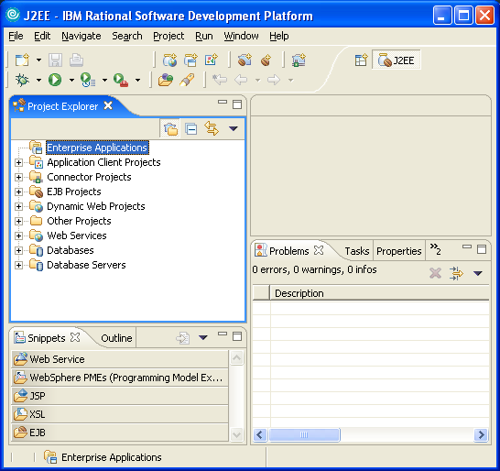

You will build from the .project files in each sub-folder. You import each piece of the workspace using existing project file from each sub-folder.

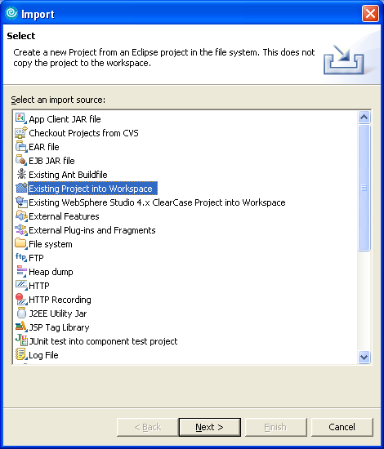

After importing each sub-folder you should be ready to work.

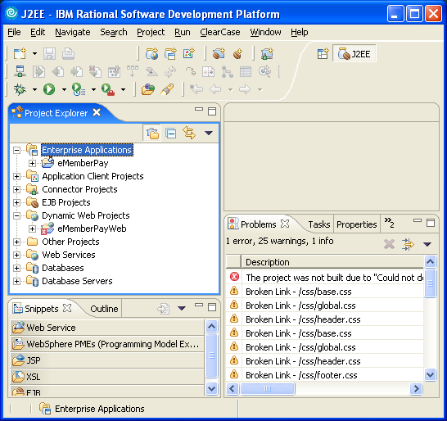

You can use the ClearCase menu item to connect to the VOB and other tools.

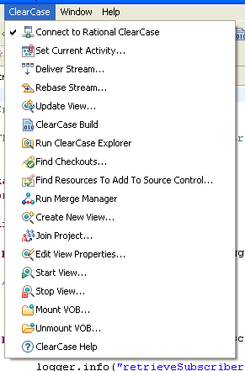

When you are ready to make changes to the code you need to check out each member.

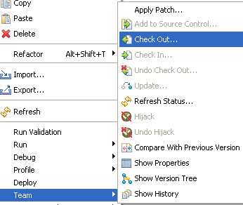

You will be asked which view to check out from.

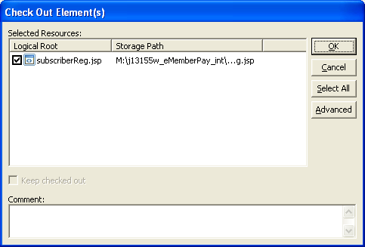

Then you will have to have an activity.

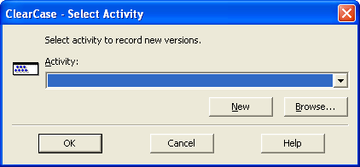

Once you have completed your changes you must check the code in.

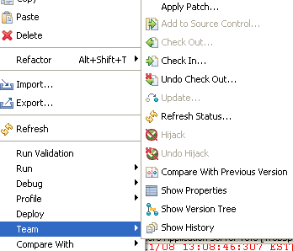

You can add additional comments if you wish.

