Create the database.

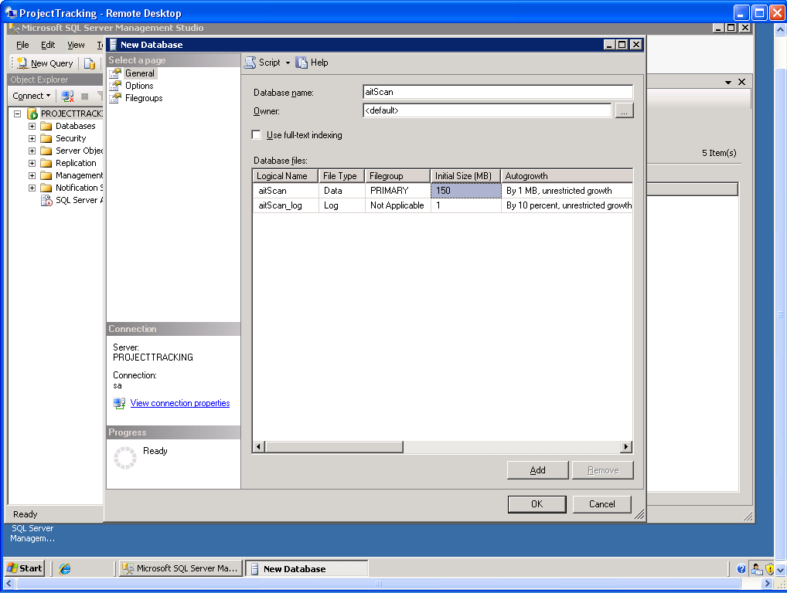

Create the tables for the project

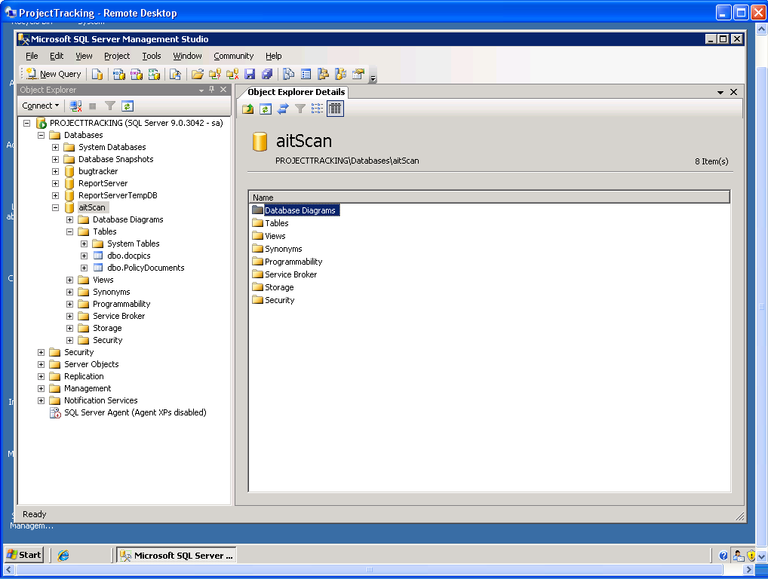

Create the stored procedures.

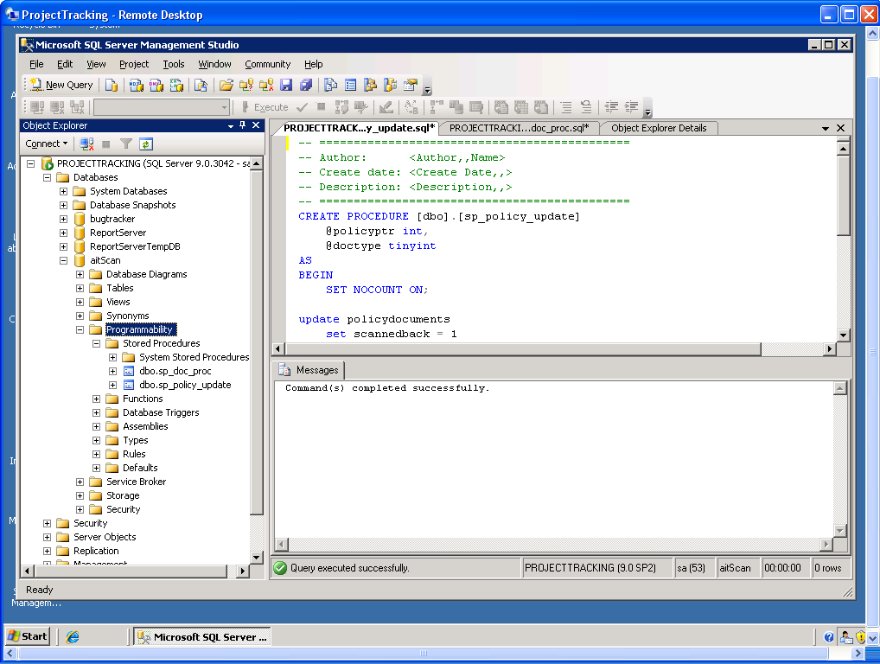

ProjectTracking->aitScan
Setup the project on the server.

I published to the server which setup the initial site.

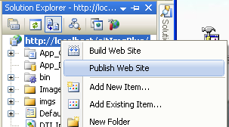

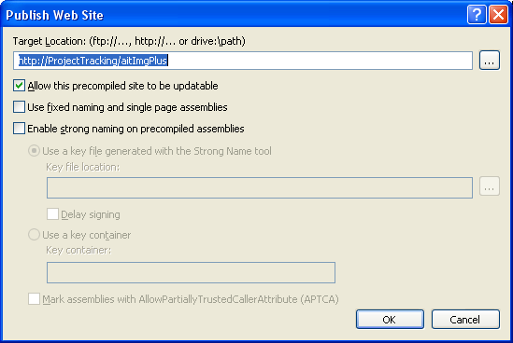

Note: Once copied you need to check the imgs folder and delete any files from the source location. They will have a different owner id that will cause problems.

Set the ASP.NET version to 2.0.50727

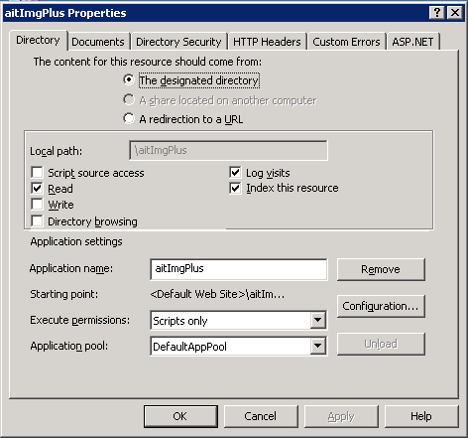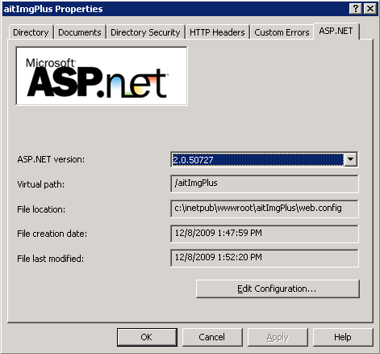

Set the default page

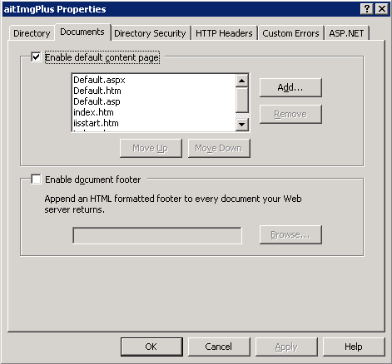

ImageMan needs to know the server that their software will run from in order to generate a license file. This license file from ImageMan is placed in the web site folder.

I added the MIME to the site for ImageMan license file.

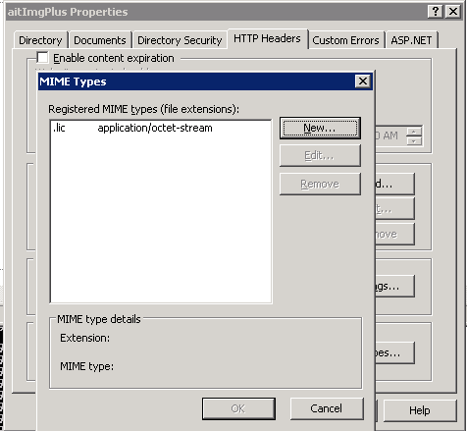
I have made a change in the configuration file for the image folder. I made the folder based on the full path and added a virtual directory inside my aitImgPlus folder.

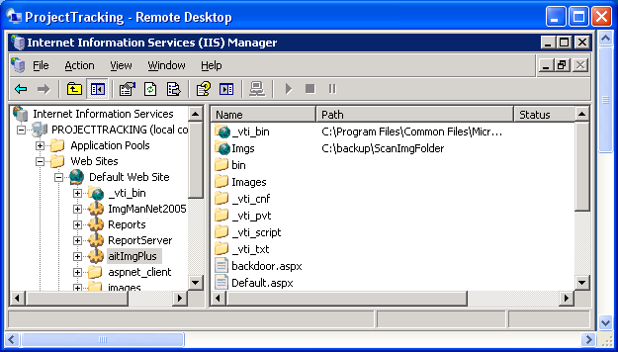

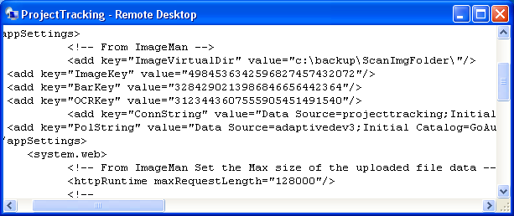

On projecttracking I placed the folder in a different location and added the virtual folder here so the images can be view from the web. While on my machine I left the folder in the same place and did not need the virtual folder.

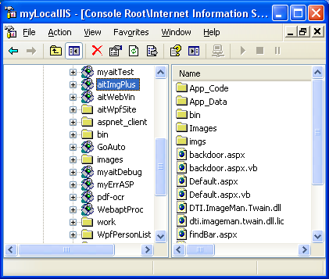

This way when I publish I do not have to re-do the security settings for the image folder.

The permissions for the aspnet user follow:

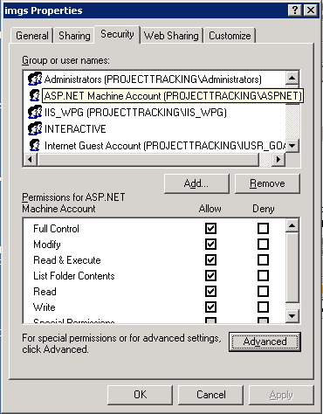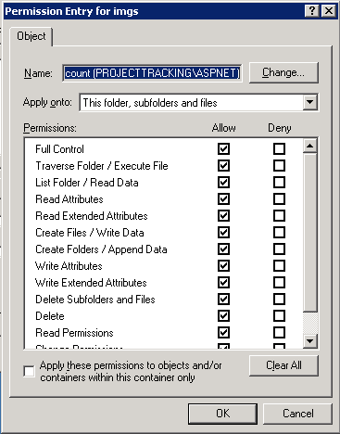

The permissions for the IUSR_GOAUTODOCGEN user follow:

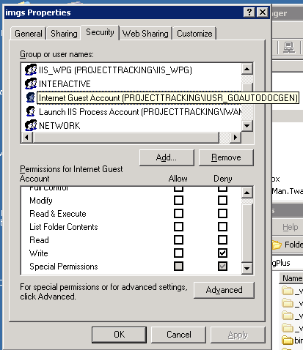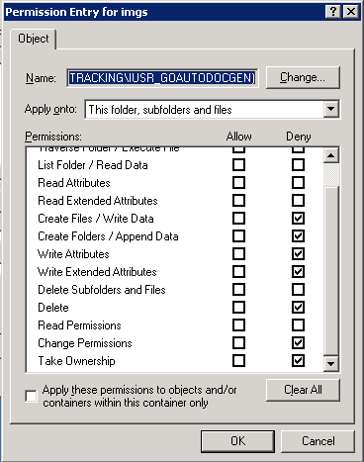

The permissions for the IWAM_GOAUTODOCGEN user follow:

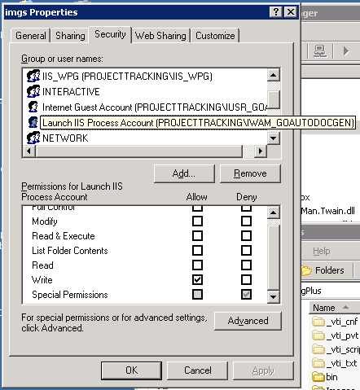

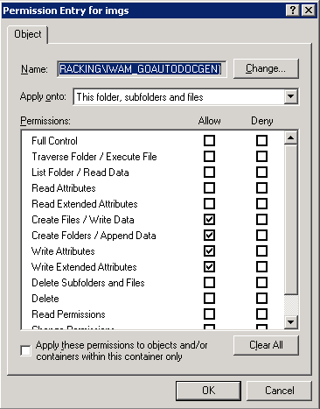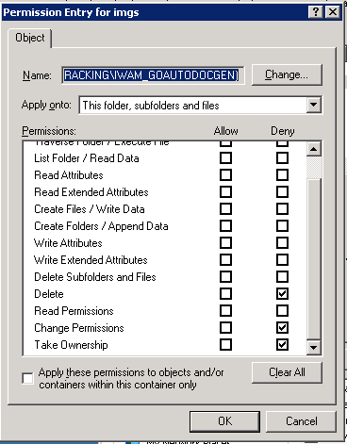
The permissions for the Users user follow:

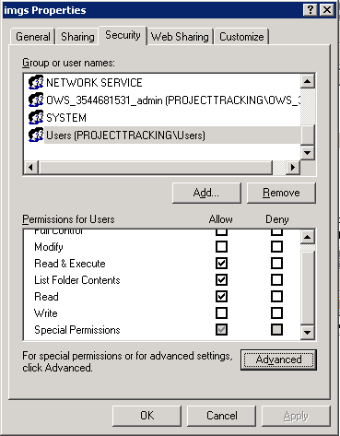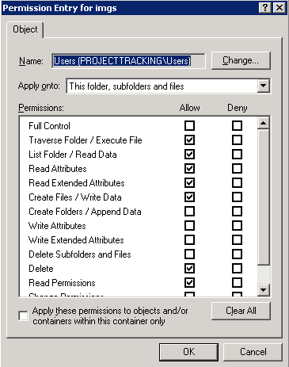

Modify the web.config file updating the database connection string.

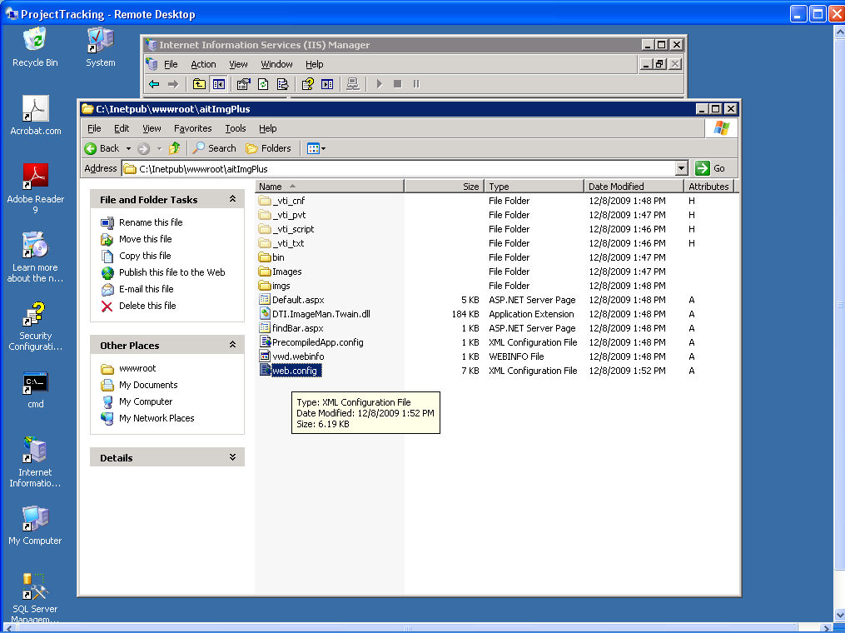

Note: License keys for the GdPicture software are also located in this file.

I contacted ImageMan support they wanted me to use the configuration utility on the client for the site. If there are several versions of the framework then use the most recent one to perform this activity.

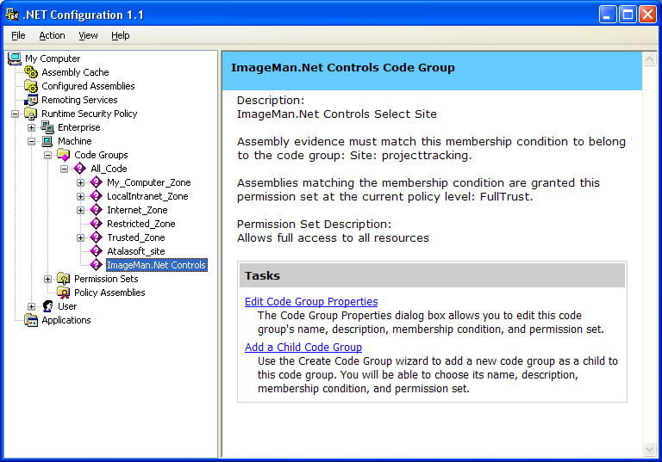

See below

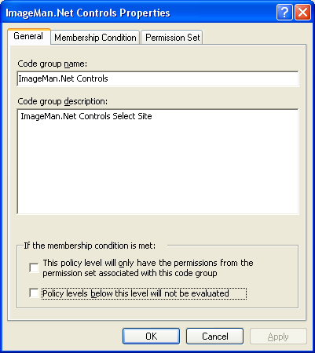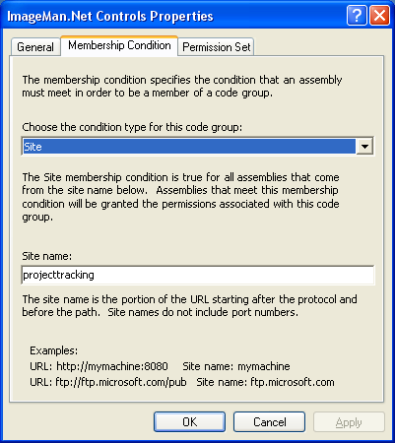

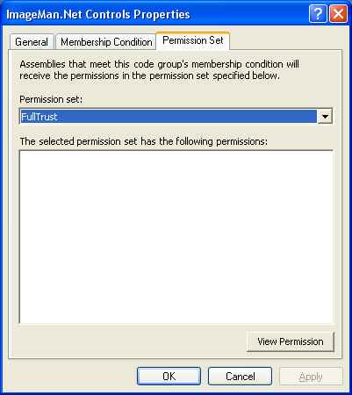

Optionally you can use the following technique to configure the client side. We had to use this on some machines that had multiple versions but not the recent utility. Using the caspol.exe .net Framework utility you can configure the .Net Framework to allow the ImageMan.Net Twain controls to run in a client side Internet Explorer application.

The caspol.exe utility is located in the \windows\Microsoft.Net\Framework\<framework Version> directory. When multiple versions of the .Net Framework are installed on a machine then the most recent version' caspol.exe must be run.

The commandline for caspol is:

caspol.exe -polchgprompt off -addgroup 1 -site localhost FullTrust

Replace “localhost” with the domain/server name that your users will use to access the web application containing the ImageMan.Net Twain controls.

I am able to get to the page from Dev3.

