Linear Discriminatory Analysis

Original Data : Subset of iris dataset (Versicolor, Virginica) classes
Standardised

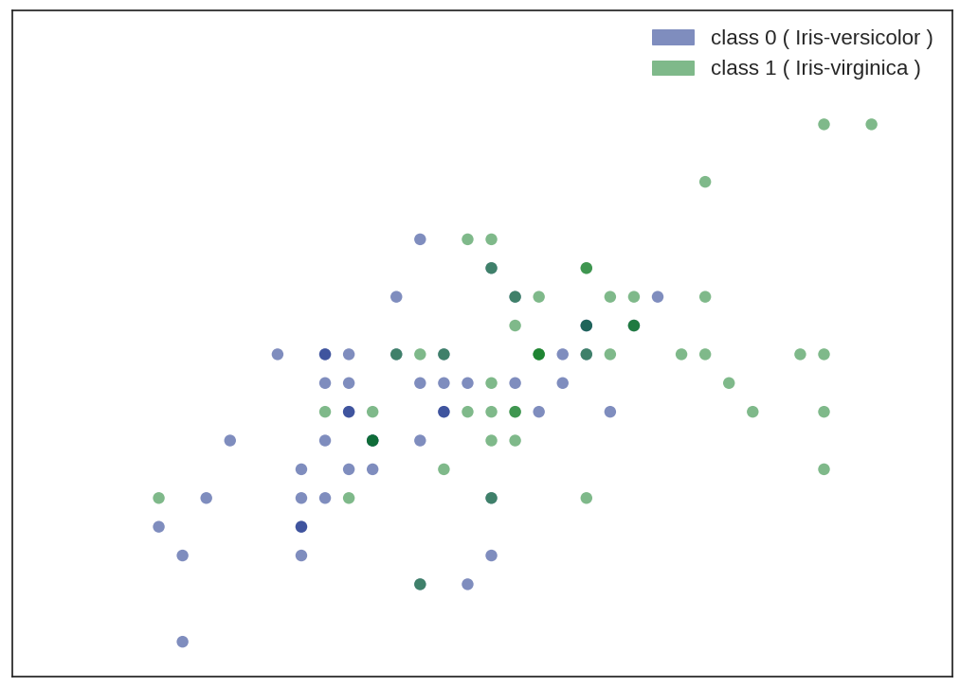
d
After LDA (Dimensionality Reduction):

