Sample type attribute “SEEK sample” in SEEK.

One sample used/registered in 2 different sample types: how to establish a link.

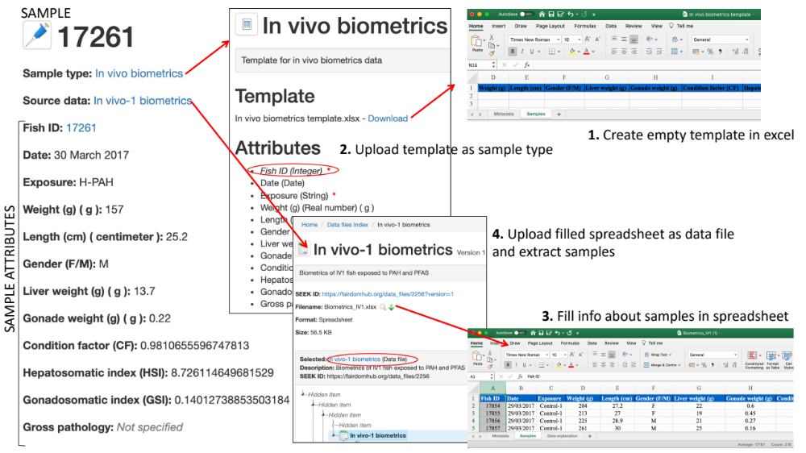

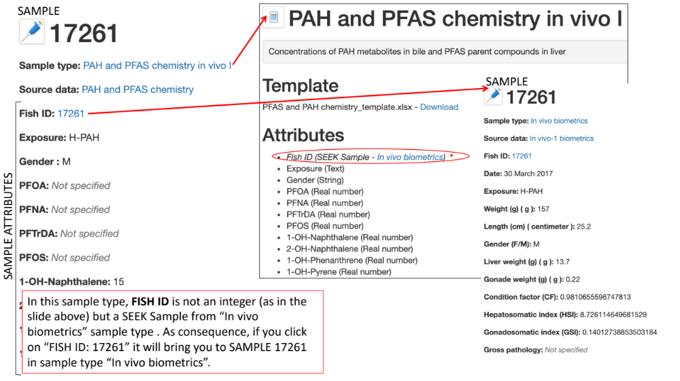

QUESTIONS:
- How does the link between identical FISH IDs present in the two different sample types occurs?
- What happen if you edit FISH ID – SEEK Sample by replacing “In vivo biometrics” with another sample type?

