Data schematic for the Beacon Plants implementation

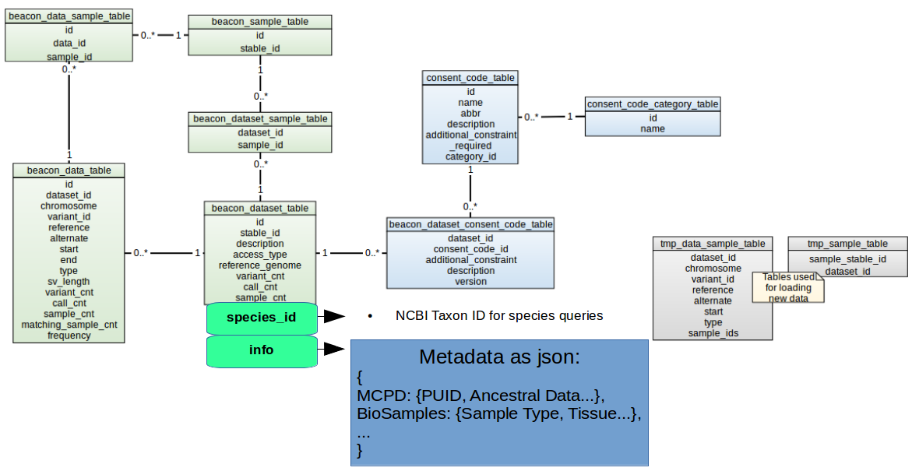
To minimize changes to the pre-existing data schematic employed by the ELIXIR Beacon project, we only made two changes to the schematic, both of them in the Beacon_dataset_table SQL table:

- The new species_id field is a character field designed to take an NCBI taxon id (for example, “9606” to indicate homo sapiens Linnaeus, or “36596” to indicate Prunus armeniaca L.). This allows queries to the beacon database to restrict which datasets they interrogate to only those belonging to a specific taxon id.

- The info field was modified to remove any constraints on it’s length. This allows it to be used as storage for a json string that contains any metadata associated with the dataset, in the form of indivivdual dictionaries for each different metadata standard integrated.

For example, for a plant Beacon containing Apricot data and the NCBI BioSamples metadata associated with each dataset:

species_id : “36596”
info : “{BioSamples : { Tissue : ‘Leaf’, Age : ‘2 months’} }”

