# Basic Introduction of RST

# Quick Start

1. Install RST. RST will start at the end of the installation.

<http://10.221.64.240:8080/RSTDeploy/Default.htm>

1. Download the latest Router 6000 EDI template. See References.
2. Create a project in RST.

RST – File – New

1. Complete the EDI using the examples as a guide. Examples are on the hidden worksheets. Also, you can generate a filled EDI from a configuration file.

RST – File – Import – Convert(Script to EDI)

For more details about Converting function, please see 6.9.6

1. Import the EDI. An EDI importing:

RST – File - Import – Import EDI – Normal EDI

And the EDI batch generating

RST – File - Import – Import EDI – EDI Batch Processing.

For more details about EDI Batch Processing, please see 6.9.7

1. Or create new node in RST

Right click on “Network” in Project panel – Add Network Element

1. Generate the script.

RST – File – Export – Export All

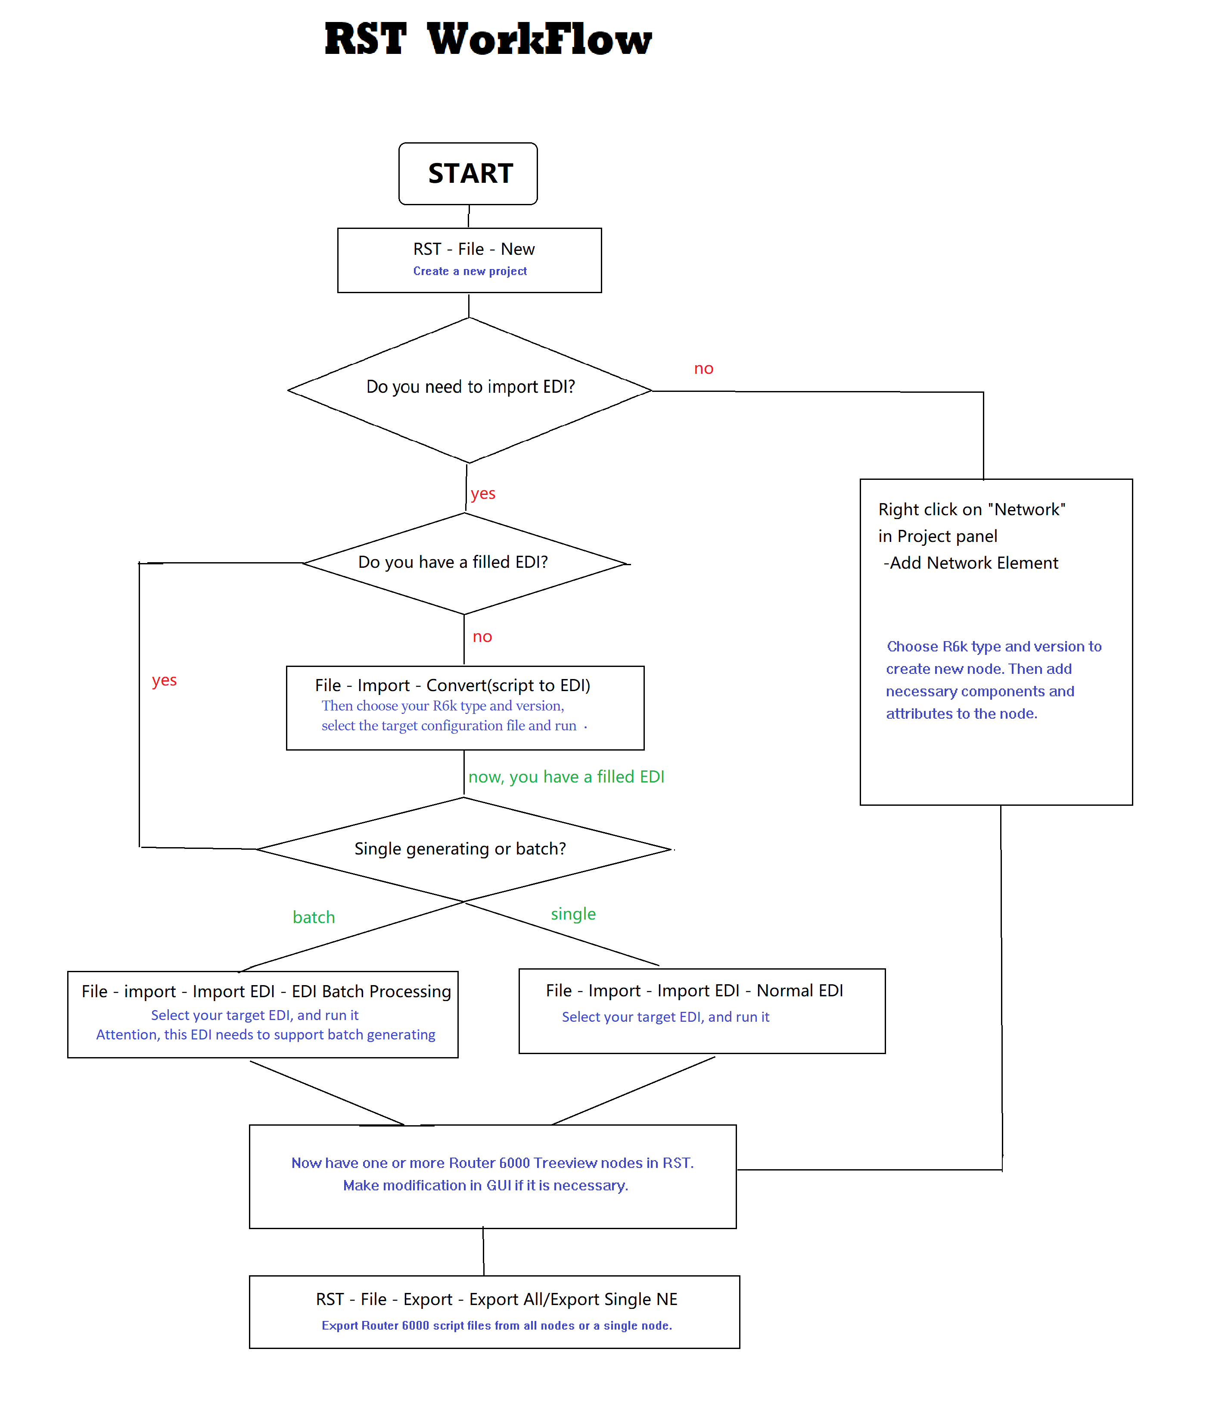

# Steps to create a script file for one new Router 6000

The following steps illustrate how to create a script file for one new Router 6000.

## Overview of steps

* Complete the EDI
* Start RST
* Extract EDI
* Create a new project
* Import the EDI
* Correct errors
* Export the network
* Review the script file

### Details of steps

1. Complete the EDI and review it with the customer. This step is the quality gate. A review is important because it will correct errors at this point, rather than at a more expensive point later in the process.
2. Start the RST program on your PC. To start, Start – All Programs – Ericsson – NRO Tools – RST. See below.

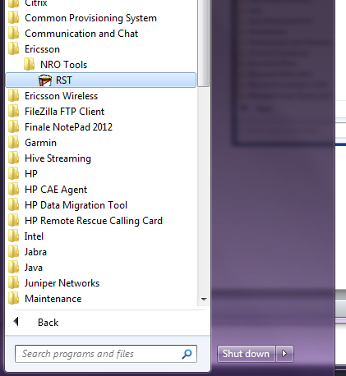

RST will also check if a new version of the program is available. If so, select “OK” to download it. See below.

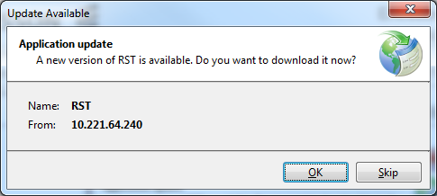

1. On initial install, select the profile directories as seen below. Here are some example values.

Export Dir: C:\Users\<user>\Documents\Router\19Q2\RST\export

Import Dir: C:\Users\<user>\Documents\Router\19Q2\RST\import

Profile Dir: C:\Users\<user>\Documents\Router\19Q2\RST\profile

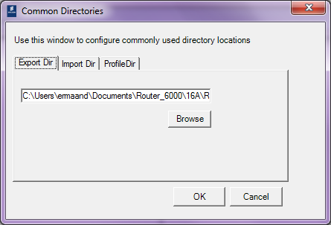

1. Create a new project. RST – File – New. Select a Customer Unit. Project1 is created. A project can consist of several networks. For this example, we will use one project with one network. See below.

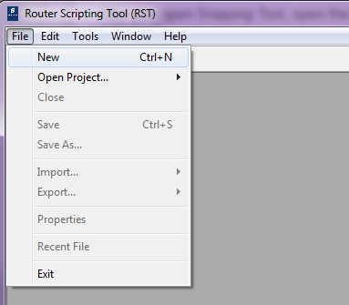

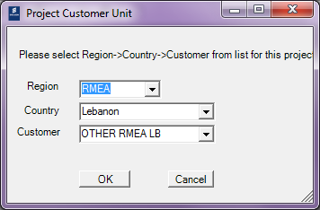

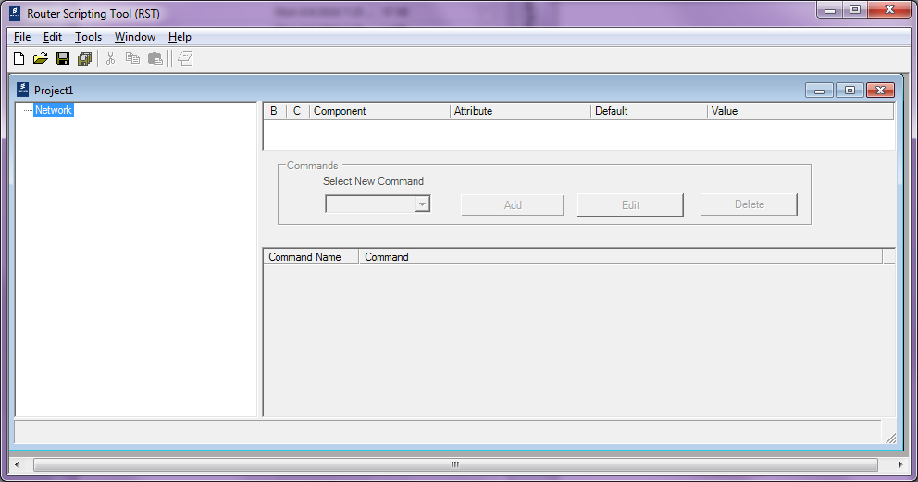

1. If you need a new empty EDI, you can Extract one. To Extract, File – Export – Extract EDI.

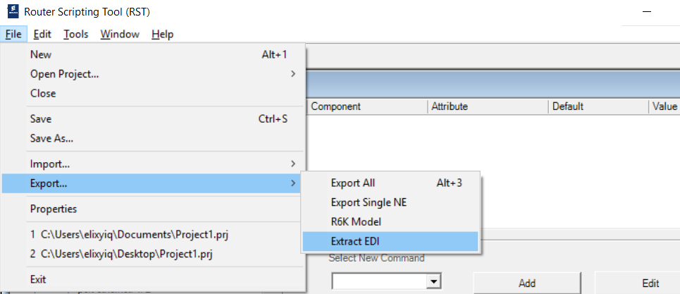

1. Select the version of EDI you want to extract, and assign the location of output. See below.

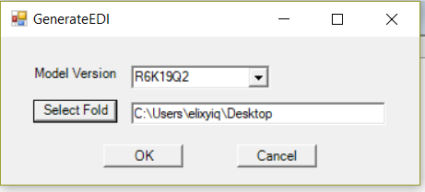

1. Import the EDI. To import, File – Import – Import EDI – Normal EDI. In RST, this creates one network. A network represents one router. See below.

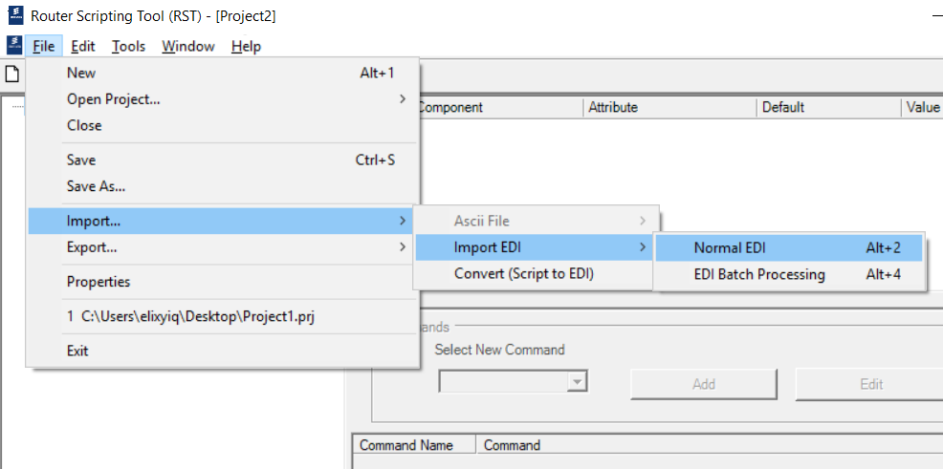

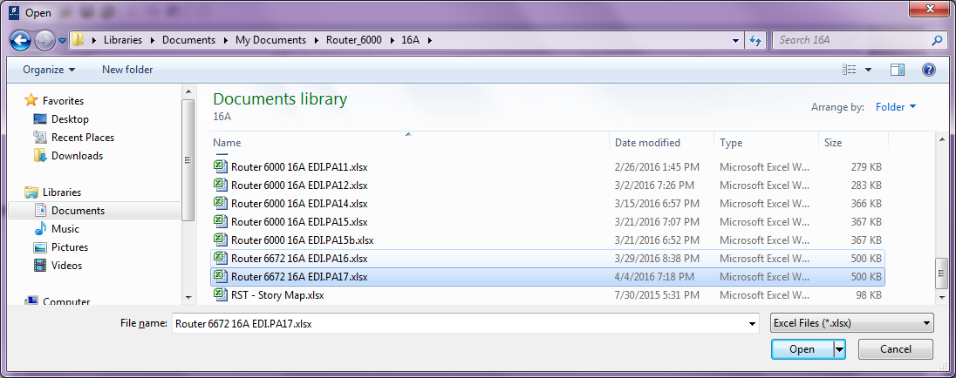

1. The results of the import are shown in the “Error Display Form”. If there are no import errors, select OK. Warnings are different than errors. Warnings should be investigated, but need not stop the process of creating the script file. See below.

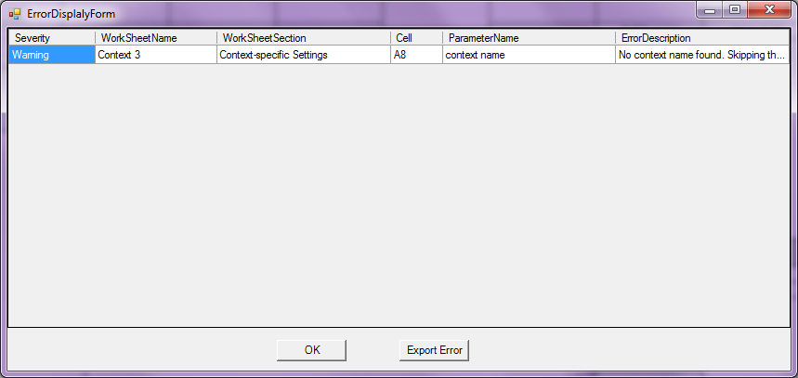

1. If there are Import errors (see below), correct the EDI, close the project, and go back to 4. To close, RST – File – Close. It is more reliable to close the project rather than to re-import the EDI because a re-import only makes additive changes to the network. Deletions are not performed.

You can alternatively create a new project (Project2) without closing the first one (Project1). Just make sure the new project is the active one.

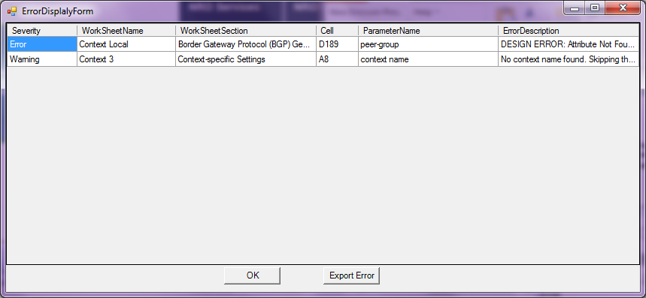

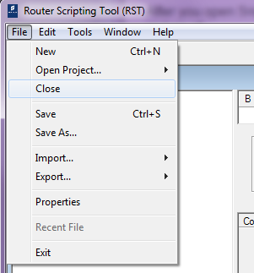

1. Errors can be exported by selecting “Export Error”. They are exported in a CSV format. See below. A CSV file can be opened by Excel. RST lists each error by showing the worksheet, section, and cell that caused the error, so it is easier to find the source of the error.

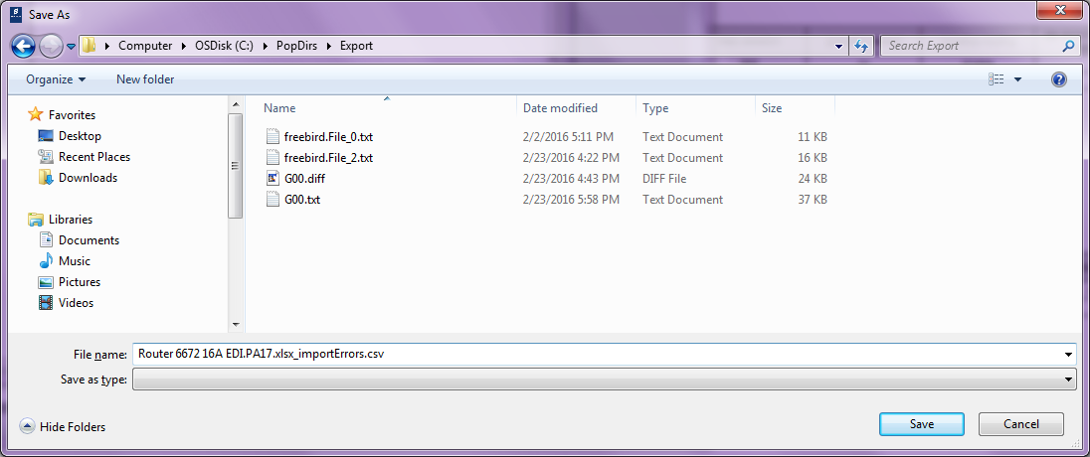

1. Create new node on Treeview. You can create a node directly instead of importing an EDI. Right click on “Network” – Add Network Element

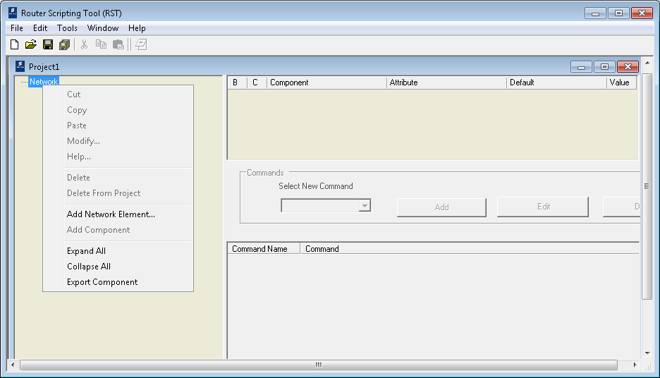

Fill out the name and select device type and model version. Click “OK” to submit. 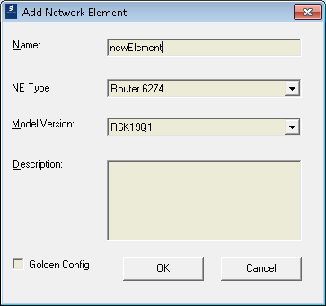

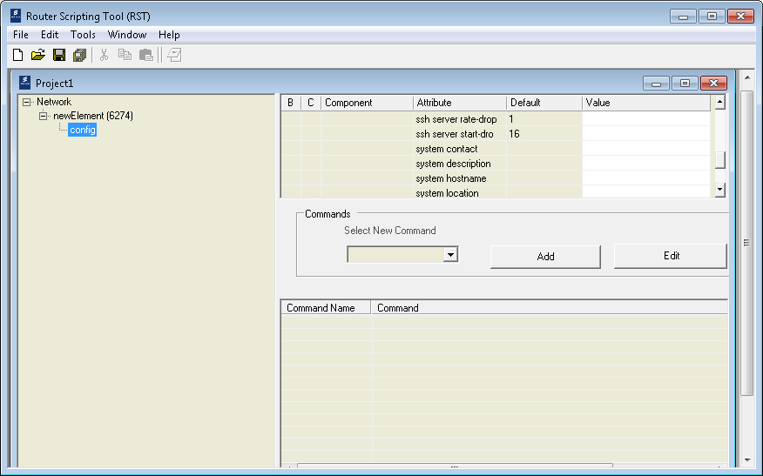

Now , you have created a new node in project.

1. Make custom modifications if necessary by modifying parameters within RST. See below. This is not recommended because then RST and the EDI would no longer be in sync. Instead, it is recommended to correct the EDI, close the project, and go back to step 4

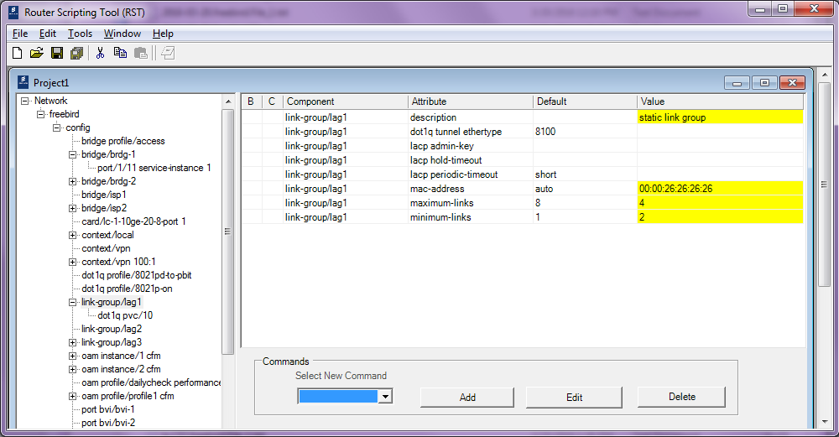

1. Repeat steps 5-9 for all the routers you want in this project. Having one router per project is also fine. The exported script will be the same in either case.
2. Export the network. This creates the script file. To export, File – Export – Export All. If no Export Profiles have been created, a warning window states that the “Default Profile” will be used. See below. The Default Profile exports the script in the same order as the “show configuration” command. This order seems to also work best when running a script file.

Leave field “Output Format” at the default setting of “CLI Manager Format”. That is the only format supported in this release. Select “OK” to export.

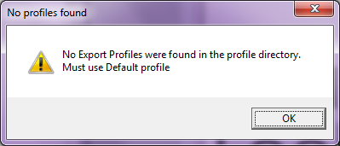

1. Create the script file. In the “Export Config” window, optionally enter an “Export Prefix”. This is a string that is used to name the output script file. See below. The full script file name is <Export Prefix>.<system hostname>.File_1.txt. In my example it will be 2016-04-05.freebird.File_1.txt. One script file will be created for each network (i.e. router).

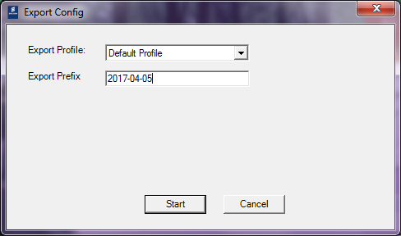

1. Review the script file by comparing it to the EDI.
2. Send the script file to site.
3. If no custom modifications have been made, close the project, and exit RST. Otherwise, the project may be saved to be worked on later. To save, File – Save As – Filename. To exit, File – Exit. See below.

File – Save As:

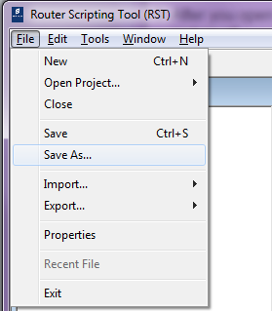

File – Save As – File Name:

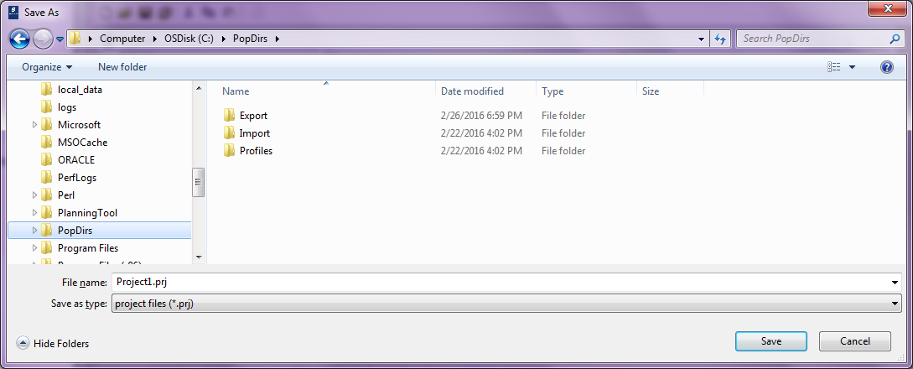

File – Exit:

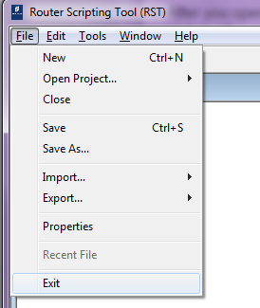

# Additional functions

Introduction of two additional functions: Convert script to EDI and Batch Generating.

## Converting (Script to EDI)

When you don`t have a filled EDI , but only a valid configuration file, using Converting (Script to EDI) to make a filled EDI.

1. To start, RST – File – Import – Convert(Script to EDI). See below.

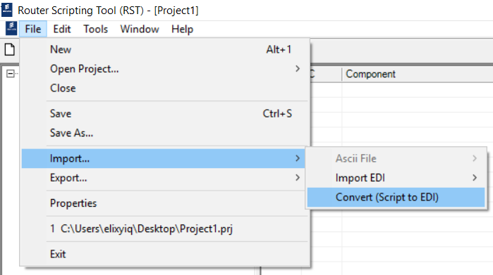

1. Select Model Version, R6K Type and target script file.

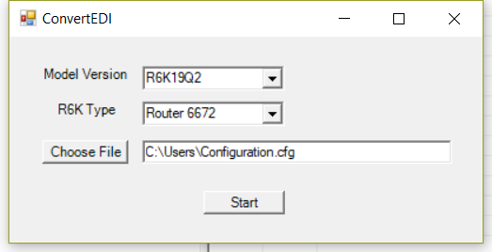

1. Click Start to run. Finally you got an EDI at the same location with the script file you selected. Details see below.

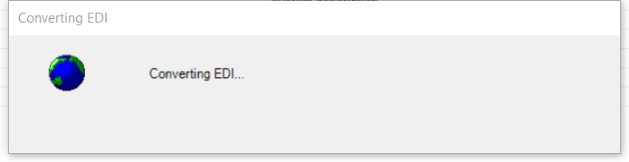

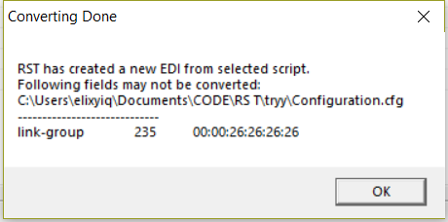

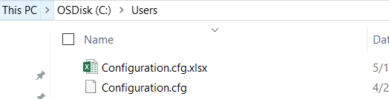

## Batch Processing

Batch Processing can help RST generating multiple scripts with one EDI in one time importing. Before processing, you need to have a filled EDI first. Batching Processing will allow you to mark several fields as batch fields, and remains the rest same.

So for the final output scripts, most parts in the script is same for each output script, but only these marked batch fields are different with each other as you typed in.

Here are the detail steps:

1. Open a filled EDI, select the fields you want to batch processing. For example, we want to make the “testContext” and “testInterface” for this tutorial. And you could select any filed as you wish.

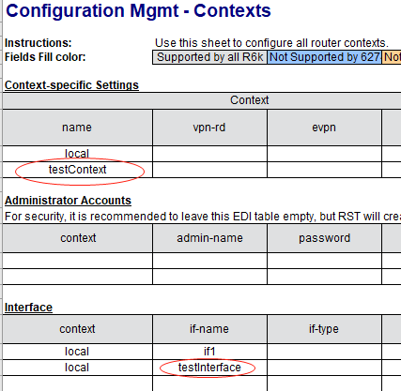

1. Add “***” at start of these cell`s value. The ‘***‘ will be solved as signal of batch processing, So any filed whose value start with *** will become a batch processing beacon.

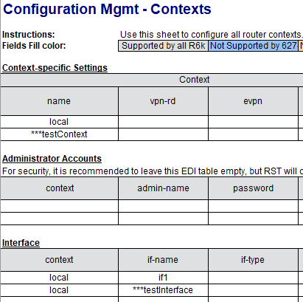

Attention, you can change these beacons name to any value you want, just make sure that all beacons have different name with each other and start with *** .

1. Go to the sheet Batch Generate. Add batch beacons name in Row1 to create the batch processing columns.

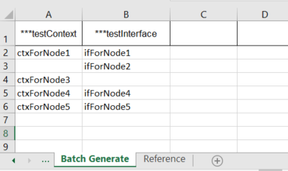

Add values for each column, as shows above. Here are two columns “***testContext” and “testInterface”, from Row2 to Row6 are values for the two columns. In this table, RST will generate 5 scripts finally. The first node has a context name “ctxForNode1” and a interface “ifForNode1”, the sec one doesn`t has the context, and has a interface “ifForNode2”. Users can modify these values based on their needs.

1. After you have a batch generating EDI, open RST and run batch processing.

RST – File – Import – Import EDI – EDI Batch Processing

Select target EDI file. Similar with importing a normal EDI.

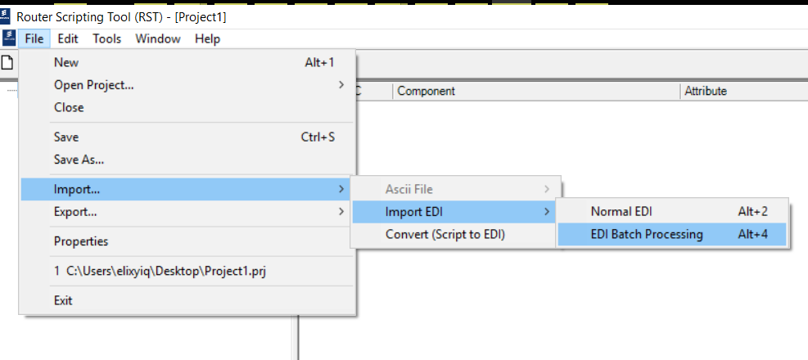

1. Re-modify and verify your batch processing table.

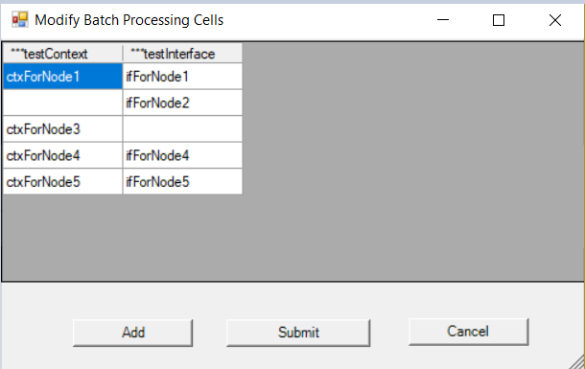

Each row means one node. Users can add, modify or delete (when leaving a whole row empty this node will be ignored) nodes in this page, but this modification won`t make an effect to original EDI.

1. After RST finish running, we have the multiple nodes treeview.

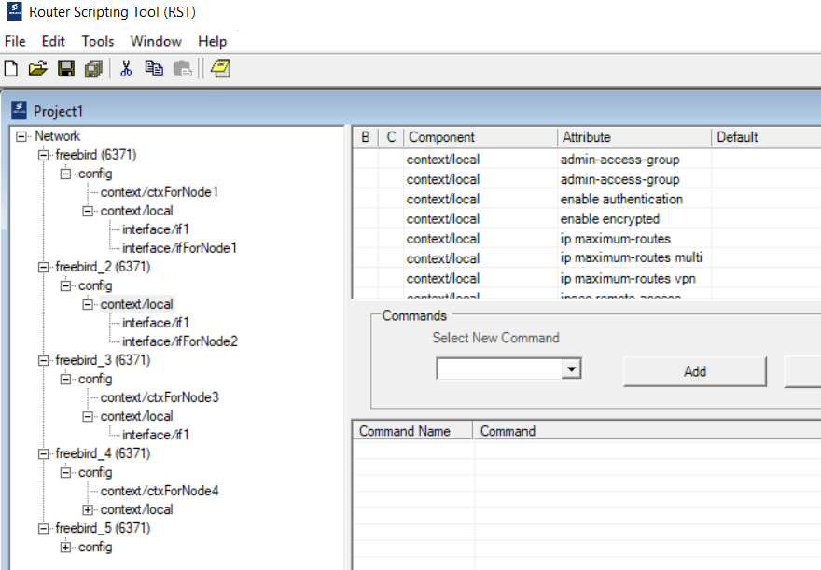

Same as our expectation, we have 5 nodes in total. And the node 1 has 2 contexts(local and ctxForNode1), 2 interfaces(if1 and ifForNode1). Node 2 only has one context(local), but 2 interfaces(if1 and ifForNode2). Node 3 has two contexts, but only 1 interface. Node 4 and 5 are also working well.

1. RST – File – Export – Export All / Export Single NE.