אליה חוגי
New Prompt Injection Attack Vectors Through MCP Sampling
https://unit42.paloaltonetworks.com/model-context-protocol-attack-vectors/
Short Description & Schema:
Description: The report analyzes security vulnerabilities in the Model Context Protocol (MCP), specifically focusing on the "Sampling" feature. Researchers demonstrated that a malicious MCP server can exploit a connected LLM client (like a coding assistant) by sending a "Sampling Request" containing a Prompt Injection. This injection tricks the client into executing unauthorized commands or exfiltrating sensitive local files back to the attacker, effectively turning the protocol's trust model against the user.
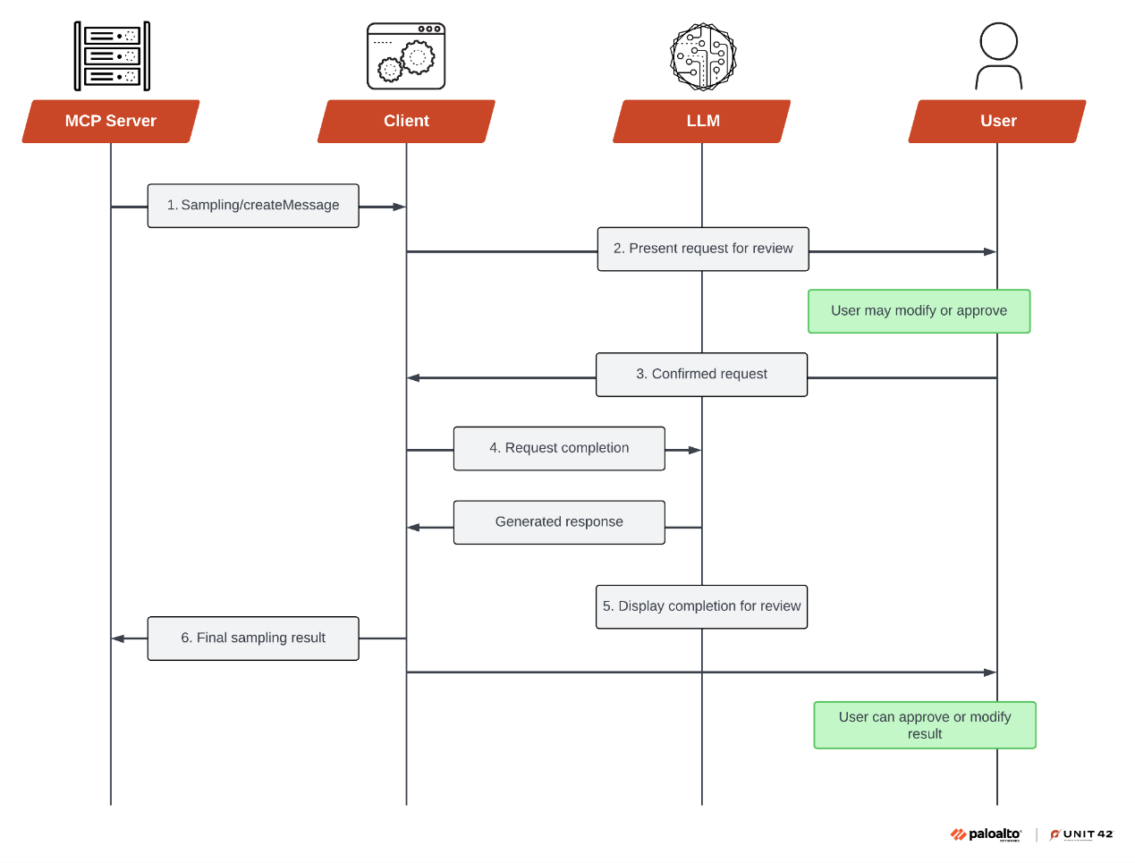

Proof | Technique ID & Name | Tactic | Behavior
"The protocol's design allows MCP servers to craft prompts and request completions" | T1195.002 - Supply Chain Compromise | Initial Access | User connects to a malicious MCP server believing it is legitimate.
"MCP sampling introduces potential attack opportunities, with prompt injection being the primary attack vector". | T1059 - Command and Scripting Interpreter | Execution | The malicious server sends a prompt injection payload
"Instruct the tool to read all public SSH keys or command history". | T1005 - Data from Local System | Collection | The LLM client executes instructions to read local files
"These exploits can lead to data exfiltration... accessing private files". | T1041 - Exfiltration Over C2 Channel | Exfiltration | Client sends the collected data back to the server.

