**SPRINT-5 (YOLO MODEL Architecture) :**

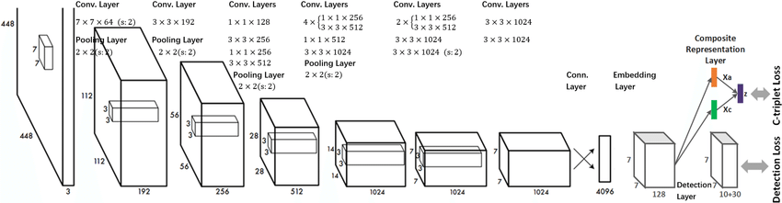

YOLO is an extremely fast real time multi object detection algorithm. YOLO stands for “You Only Look Once”.

The method used to come up with these probabilities is logistic regression. The bounding boxes are weighted by the associated probabilities. For class prediction, independent logistic classifiers are used.

YOLO divides each image into a grid of S x S and each grid predicts N bounding boxes and confidence. The confidence reflects the accuracy of the bounding box and whether the bounding box actually contains an object(regardless of class). YOLO also predicts the classification score for each box for every class in training. You can combine both the classes to calculate the probability of each class being present in a predicted box.

Yolo predicts multiple bounding boxes per grid cell. At training time we only want one bounding box predictor to be responsible for each object. We assign one predictor to be responsible for predicting an object based on which prediction has the highest current IOU with the ground truth. This leads to specialization between the bounding box predictors.

Each predictor gets better at predicting certain sizes, aspect ratio or classes of object, improving overall recall.

The YOLO framework (You Only Look Once) on the other hand, deals with object detection in a different way. It takes the entire image in a single instance and predicts the bounding box coordinates and class probabilities for these boxes. **The biggest advantage of using YOLO is its superb speed**– it’s incredibly fast and can process 45 frames per second. YOLO also understands generalized object representation.

This is one of the best algorithms for object detection and has shown a comparatively similar performance to the R-CNN algorithms.

It is based on regression where object detection and localization and classification the object for the input image will take place in a single go. This type of algorithms is commonly used real-time object detection.