**YOLO OBJECT MODEL DETECTION**

**YOLO OVERVIEW:**

* YOLO is extremely fast. Since we frame detection as a regression problem we don’t need a complex pipeline. We simply run our neural network on a new image at test time to predict detections. Our base network runs at 45 frames per second with no batch processing on a Titan X GPU and a fast version runs at more than 150 fps. This means we can process streaming video in real-time with less than 25 milliseconds of latency.
* Second, YOLO reasons globally about the image when making predictions. Unlike sliding window and region proposal-based techniques, YOLO sees the entire image during training and test time so it implicitly encodes contextual information about classes as well as their appearance. Fast R-CNN, a top detection method, mistakes background patches in an image for objects because it can’t see the larger context. YOLO makes less than half the number of background errors compared to Fast R-CNN.
* Third, YOLO learns generalizable representations of objects. When trained on natural images and tested on artwork, YOLO outperforms top detection methods like DPM and R-CNN by a wide margin. Since YOLO is highly generalizable it is less likely to break down when applied to new domains or unexpected inputs.
* The different YOLO implementations (Darknet, **Darkflow**, etc) are amazing tools that can be used to start detecting common objects in images or videos “out of the box”, to do that detection it is only necessary to download and install the system and already trained weights.
* Note: We have used Darkflow Model.

**YOLO ARCHITECTURE:**

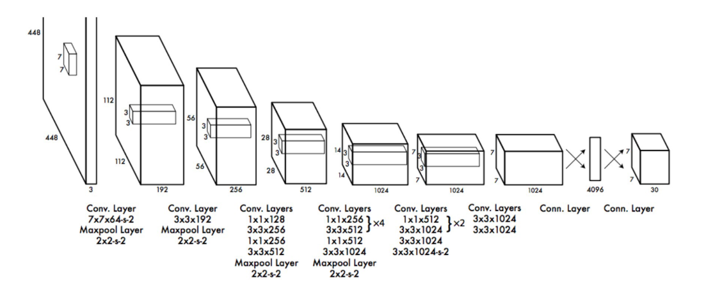

* It has 24 convolutional layers followed by 2 fully connected layers. Instead of the inception modules used by GoogLeNet, we simply use 1 × 1 reduction layers followed by 3 × 3 convolutional layers.
* Fast YOLO uses a neural network with fewer convolutional layers (9 instead of 24) and fewer filters in those layers.
* The YOLO design enables end-to-end training and realtime speeds while maintaining high average precision. Our system divides the input image into an S × S grid. If the center of an object falls into a grid cell, that grid cell is responsible for detecting that object.
* Each grid cell predicts B bounding boxes and confidence scores for those boxes. These confidence scores reflect how confident the model is that the box contains an object and also how accurate it thinks the box is that it predicts.
* We define confidence as Pr(Object) ∗ IOU . If no object exists in that cell, the confidence scores should be zero. Otherwise we want the confidence score to equal the intersection over union (IOU) between the predicted box and the ground truth.
* Each bounding box consists of 5 predictions: x, y, w, h, and confidence. The (x, y) coordinates represent the center of the box relative to the bounds of the grid cell. The width and height are predicted relative to the whole image. Finally the confidence prediction represents the IOU between the predicted box and any ground truth box.
* Each grid cell also predicts C conditional class probabilities, Pr(Classi |Object). These probabilities are conditioned on the grid cell containing an object. We only predict one set of class probabilities per grid cell, regardless of the number of boxes B.
* At test time we multiply the conditional class probabilities and the individual box confidence predictions, which give us class-specific confidence scores for each box. These scores encode both the probability of that class appearing in the box and how well the predicted box fits the objects.