TC3_ForLop

1.- Write a script that takes one of these files and determines the number of rows (pollinators) and columns (plants). Note that columns are separated by spaces and that there is a space at the end of each line. Your script should return.

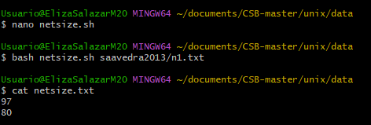

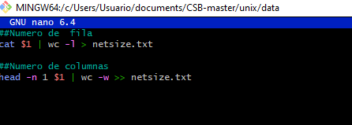

2. [Advanced]

Write a script that prints the numbers of rows and columns for each network:

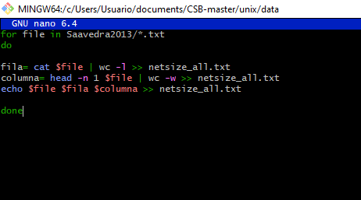

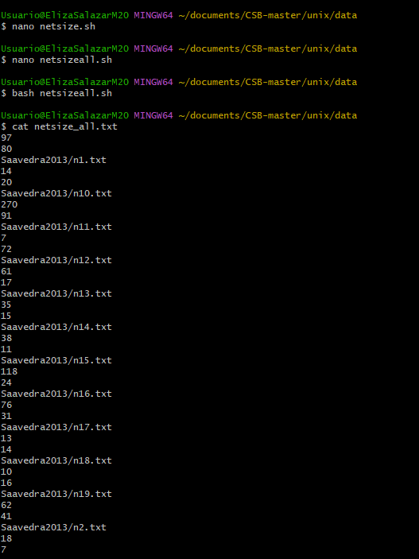

3. Which file has the largest number of rows? Which has the largest

number of columns?

Mas filas n57



Mas columnas n55

