¿Qué es y para qué utilizar el code review?

It is the analysis and review, by members of a software development team, of other member team´s code. It is a step in the software development process that allows identifying possible errors in the programming/implementation, as well as possible improvements to provide the code with more scalability or maintainability.

¿Cuáles son los niveles de acceso y cómo funcionan? (Modificadores)

Modifiers access are keywords that provide accesibility to clases, methods, variables and other members.
Public: It can be accesed from within the class, outside the class, within the package and outside the package.

Private: It can be accesed only from within the class.

Protected: It can be accesed within the package and outside the package only through subclass.

Default: If we don´t specify a keyword to set access level it will be considered as default. The scope of this modifier is only in its package.

Static: It can be accesed from its own class, it´s not necessary to be instantiated.
¿Qué patrones de arquitectura conoces y cómo funcionan?
(Capas, Cliente-Servidor, Maestro-Esclavo, MVC, Etc..)

Layered Architecture:It´s one of the most commonly used pattern where the code is grouped by layers and each layer provides services to the next above layer. In this pattern we have 3 layers, presentation, application and data. Users access the presentation layer , then the application layer runs the business logic. The data layer has a database for the storage and retrieval of data.

Client-Server: This pattern compose 2 parts, a server and one or multiples clients. The server component provides services to multiple client components. This pattern compose of two parts; a server and multiple clients. The server component will provide services to multiple client components. The clients request services from the server and the server provides relevant services to clients. And the server continues to listen for requests from the clients.

Master-Slave: This pattern consists of 2 parts too, master and slaves. The master component distributes the tasks among identical slave components and calculates the final result from the results returned by the slaves.

MVC: This compose 3 parts, Model-View-Controller.
Model: It contains the functionality and basic data of business logic.
View: Shows the information to the final user.
Controller: The controller is the building block between the model and the view. View triggers events, subsequently, the controller acts on it. The action is typically a method call to the model. The response is shown in the view.

Broker:
It consists in a broker wich coordinates requests and responses between client and servers. In this case servers publish their services and features to a broker. Clients request a service from the broker and the broker redirects the client to an correct service.

Peer to peer:
In this pattern, the individual components have the same authority . Components can function both as a client, requesting services from other components, and as a server, providing services to other components. A component can be a server or a client and can change its role dynamically over time.

Blackboard Pattern: It is a pattern commonly used for artificial intelligence. In this pattern we have 3 actors, a blackboard, a collection of knowledge resources and a controller. Blackboard have the relevant information of application. The knowledge resources collect information and update the blackboard. And the controller component reads from the blackboard aund updates the application.

Interpreter: A pattern specific to certain use cases. The interpreter pattern deals with the grammar of programming languages. It offers an interpreter for the language. This pattern uses a hierarchy of expressions and it generates a tree structure for evaluating expresions.

Event-bus pattern: Listeners subscribe to particular channels. Listeners are notified of messages that are published on a channel to which they have previously subscribed.

Pipe-filter pattern: This pattern cab be used to structure systems that produce and process a sequence of data. Each processing step is included within a filter component. The data to be processed is passed through pipelines. These pipelines can be used for buffering or synchronization purposes.
¿Qué patrones de diseño conoces y cómo funcionan?
(Creacionales, Estructurales, Comportamiento)

Creational design patterns: This desig pattern deals about class instantiation and creation. These patterns emphasize the encapsulation of the instantiation logic, hiding the concrete details of each object and allowing us to work with abstractions. We can clasify this pattern in class creation patterns and object creation patterns. Some known creational design patterns are the following:

Abstract Factory: Creates an instance of several families of classes.
Builder: Separates object construction from its representation.
Factory Method: Creates an instance of several derived classes.
Object Pool: Avoid expensive acquisition and release of resources by recycling objects that are no longer in use.
Prototype:A fully initialized instance to be copied or cloned.
Singleton:A class of which only a single instance can exist.

Structural design patterns: This design pattern consist grouping objects and classes to get complex structures and new functionality. Some known structural design patterns are the following:

Facade: A single class that represents an entire subsystem.
Decorator: Add responsibilities to objects dynamically.
Adapter: Match interfaces of different classes.
Bridge: Separates an object’s interface from its implementation.
Composite: A tree structure of simple and composite objects.
Decorator: Add responsibilities to objects dynamically.
Flyweight: A fine-grained instance used for efficient sharing.
Private Class Data: Restricts accessor/mutator Access.
Proxy: An object representing another object.

Behavioral design patterns: This design pattern deals with the accountability of objects and the way they communicate wich other . Some known behavioral design patterns are the following:

Chain of responsibility: A way of passing a request between a chain of objects.
Command: Encapsulate a command request as an object.
Iterator: Sequentially access the elements of a collection.
Mediator: Defines simplified communication between classes.
Memento: Capture and restore an object's internal state.
Observer: A way of notifying change to a number of classes.
State: Alter an object's behavior when its state changes.
Strategy: Encapsulates an algorithm inside a class.
Template method: Defer the exact steps of an algorithm to a subclass.
Visitor: Defines a new operation to a class without change.

¿Qué es SOLID?
SOLID is an acronim to describe the five principles are object-oriented design concepts relevant to software development.

Single responsability: Each class should be responsible for a single part of functionality of the system.

Open/Close: Software components shoul be open for extensión but not for modification.

Liskov Substitution: Objects of a superclass should be replaceble with objects of its subclases without breaking the system.

Interface Segregation: No clients shoul be forced to depend on methods that it does not use.

Dependency inversión:High levels modules should not depend on low-level modules, both should depend on abstractions.

POO:¿Que es una Clase?

A class is a representation of an object properties and behaviors. Basicaly it´s a drawing of an object, how object is going to be represented.
POO:¿Qué es y para que se utiliza la herencia?

Inheritance: Property of an object to acquire all the properties and behaviors of its parent object. In this context it uses a relationship child-parent to achieve inheritance. In order to set this property we should have the keyword extends.
POO:¿Qué es y para que se utilizan las interfaces?

Interface is an abstract class that is used to group related methods with empty bodies but contains abstract methods wich must be implemented by the java objects as rules.
POO:¿Qué es el polimorfismo?

Polymorphism is the ability of an object wich allows it to take multiple forms and can acquire and ability to operate from different perspectives.
¿Qué es y cómo funciona una API web?

Application programming interface for either a web or web browser. Web APIs are exposed through web services that allow client applications to obtain and perform operations on the data that the service exposes.
¿Qué herramientas se pueden utilizar para probar Web APIs?

We need a tool can be able to simulate a request from user and can show us the response of web server. We can use some tools are:

SoapUI
Postman
Apache Jmeter
Apigee
Newman
Rest Assured
Restlet
RoboHydra
Gatling

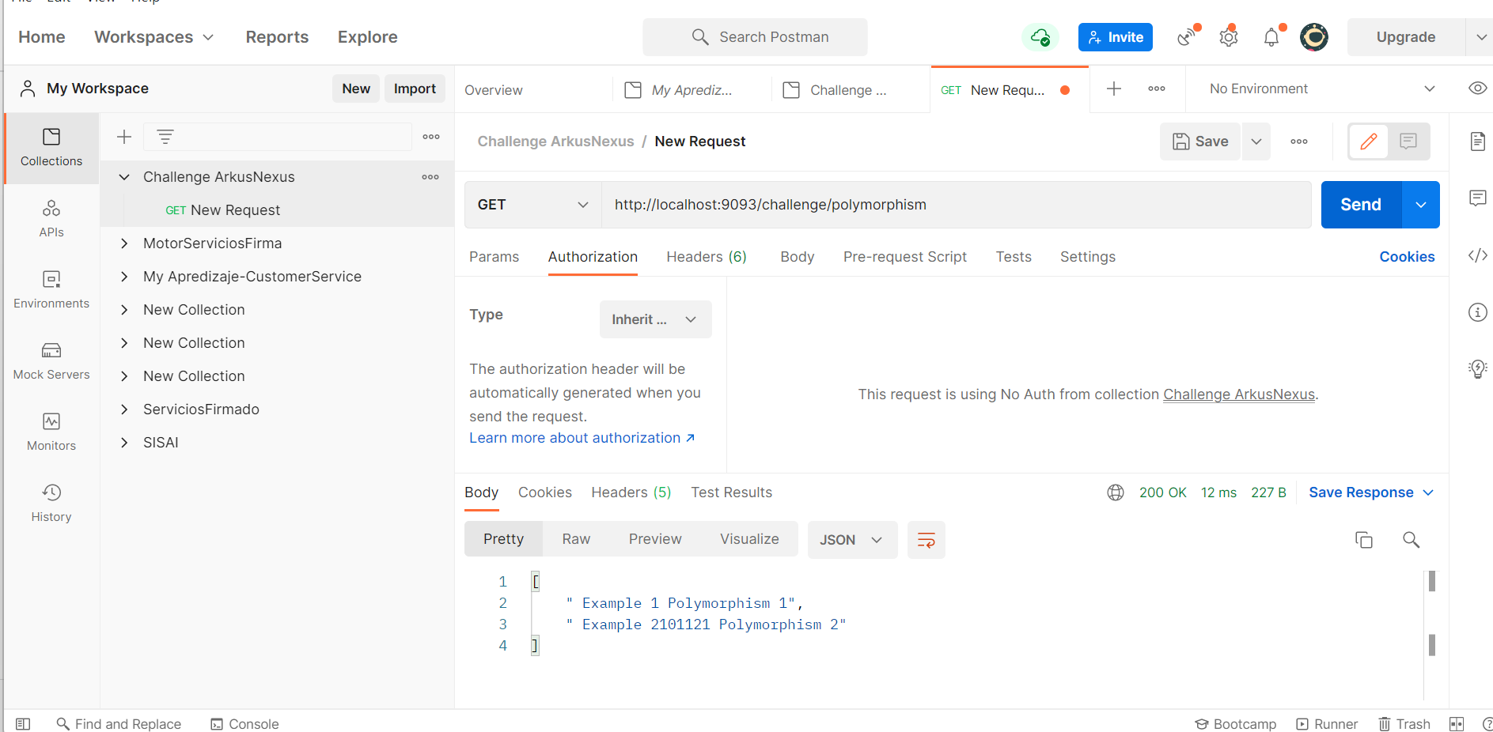
¿Qué herramienta has utilizado para el manejo de errores?

I have used CheckMarx as part of the process DevOps to scan bugs and vulnerabilities in my projects.
Test driven development
It is a technique development software that consists developer first write test case before writing the production to fulfill that test and recfactoring. It means we describe the behavior of our code before we implement it. Some purpouses about this process is to reduce bugs during coding. Implement the exactly functionality for the client and produce modular software , reusable and extensible.

