**Article information**

**Article title:**

**The experimental heating of rye, oat, spelt, wheat and barley between 215 and 300°C: the stable carbon and nitrogen isotope data and the photographic evidence of changes to the morphology of the grains.**

**Authors**

*Elizabeth Stroud*1, Michael Charles1, Amy Bogaard1, Erika Nitsch2, Helena Hamerow1.*

**Affiliations**

*1School of Archaeology, University of Oxford*

*2* Cabbage Moor, Great Shelford, Cambridge, CB22 5NB, UK

**Corresponding author’s email address and Twitter handle**

elizabeth.stroud@arch.ox.ac.uk

**Keywords**

*Stable isotope analysis, Charring offset, Temperature and duration heating experiment, Archaeology, Archaeobotany*

**Abstract**

*The effect that heating has on cereal grain morphology and isotopic values has far reaching consequences for archaeobotanical research and palaeodietary reconstructions. Stable carbon and nitrogen isotopic data and mass loss percentages on, and photographs of, rye, oat, barley, wheat and spelt from a heating experiment are presented and support Stroud et al (accepted). The experiment heated rye, oat, spelt at 215, 230 ,245, 260 and 300°C for 4, 8 and 24 hrs, with each temperature/duration condition consisting of 3 samples of 10 grains per sample. The mass loss of the grains, the %C and %N, and δ13C and δ15N values are presented. Furthermore, photographs of the grains’ external and internal morphology for each temperature/duration combination are provided. The wheat and barley data of samples charred between 215 -260°C/ 4-24 hrs were obtained from the published and unpublished dataset of Nitsch et al (2015) and it is this dataset which the new data builds upon. This article also provides the published and unpublished data and photographs from Nitsch et al (2015), bringing together a dataset of nine crop species. This article provides the raw data from two cereal grain heating experiment, which will enable further research into understanding the impact of heating on both grain isotopic values and grain morphology. It also allows users to construct charred-uncharred isotopic offsets for a combination of species relevant to their research.*

**Specifications table**

|  |  |
| --- | --- |
| **Subject** | Social Sciences - Archaeology |
| **Specific subject area** | Stable carbon and nitrogen isotope analysis  Grain morphology  Charring and heating  Cereals |
| **Type of data** | Tables  Csv files  Images  Graphs  R script |
| **How the data were acquired** | Wheat, rye, oat, barley and spelt were experimentally charred in a Gallenkamp Plus II oven at a range of temperatures and time durations (215-300°C, 4-24hrs). The mass of the samples (batches of 10 grains per sample) were weighed before and after heating to obtain the mass loss percentage. The samples’ stable carbon and nitrogen isotopes were analysed in a Sercon EA-GSL mass spectrometer at the University of Oxford’s Research Laboratory for Archaeology and the History of Art. Microscopy of the experimentally heated grains was conducted using a Leica microscope with Lumenera camera. Additional data was obtained from Nitsch et al (2015) and an unpublished archive located at the University of Oxford. |
| **Data format** | Raw  Analysed |
| **Description of data collection** | Isotopic analysis of the experimentally heated cereal grains was conducted using separate carbon and nitrogen runs due to the limited %N of some species. An inhouse alanine standard was used to drift correct the isotopic data, while a two-point normalisation was conducted on the majority of samples using IAEA-N1 and IAEA-N2 (nitrogen) and IAEA-C6 and IAEA-C7 (carbon). A small portion of rerun samples were normalised using the inhouse SEAL standard and EMA-P2.  Grains of each time/temperature combination were examined under a microscope and photographed. All graphing and statistical analysis were performed using R |
| **Data source location** | Institution: University of Oxford  City/Town/Region: Oxford  Country: United Kingdom  Nitsch et al. (2015) and  Github |
| **Data accessibility** | Repository name: Github  Direct URL to data: https://github.com/elizabethastroud/Charring_paper |
| **Related research article** | Stroud et al. (accepted). Turning up the heat: Assessing the impact of charring regime on the morphology and stable isotopic values of cereal grains. Journal of Archaeological Science |

**Value of the data**

* + The data provided can be used to understand the impact of different combinations of heating temperature and duration on the δ13C and δ15N values of wheat, barley, rye, spelt and oat, as well as mass loss, %C and %N of the grains and changes to grain morphology
  + Understanding the impact of heating on cereal grains’ δ13C and δ15N values is vital for archaeologists using such data for palaeodietary analysis and comparison with modern experiments. Furthermore, understanding the impact of heating on the morphology of different cereal species is of importance in archaeobotanical research, providing an understanding of the impact of heating on identification features, as well as taphonomic consideration such as survivability
  + The presented data allow for the construction of isotopic offsets between the charred and uncharred archaeobotanical material which is important when comparing with uncharred material or when the isotopic values are used for palaeodietary reconstruction
  + Photographs of the heated grains provide a library against which archaeological grains can be compared, allowing for the selection of suitable grains for isotopic analysis, as well as research into the effect heating has on grain morphology
  + The data allows other archaeologists to tailor their understanding of the impact of heating to their specific crop suite and can be used with data from Nitsch et al (2015) to construct sites specific charring offsets.

**Data description**

This publication presents the isotopic data of experimentally charred cereal grains (rye, oat, spelt, wheat and barley), charred at 16 different temperature and duration combinations (215-300°C 4-24hs). Additionally, photographs showing the internal and external morphology of the experimentally charred grains at the different temperature/time combinations are included. These data (Dataset 1 and Dataset 2) can be found [here](https://github.com/elizabethastroud/Charring_paper). These data have been used in Stroud et al. (accepted) to understand grain morphological changes which occur during charring as well as the isotopic differences between the different time and temperature combinations.

Tables 1, 2, 3, 4 provide the analytical conditions of the isotopic measurements of all the newly conducted analyses and can be found [here](https://github.com/elizabethastroud/Charring_paper). Table 5 shows the accuracy, precision and overall uncertainty of the data as per Szpak et al. (2017) as well as the overall uncertainty for the combined Nitsch et al (2015) dataset and new data (as per Kragten 1994), and an overall uncertainty for the new data and selected wheat and barley data from Nitsch et al (2015). Dataset 1 contains the results of the stable carbon and nitrogen isotope analysis of the experimentally charred grains (primary and secondary data), including the raw and calibrated isotopic data as well as the %C and %N of the samples (also graphically represented in Figure 1 and 2 showing only species with 300°C data). The standard uncertainty of each sample as calculated using the Kragten (1994) spreadsheet method is also included. Furthermore, the weights of the samples before and after heating is provided in Table 6 and the mass loss for the new data is graphically represented in Figure 3. Dataset 2 provides internal and external photographs of examples of each species at each heating time and temperature combination. The images contain wheat and barley photos previous taken by Nitsch et al 2015, while the rye, spelt, oat, and wheat (300°C) and barley (300°C) are newly charred material. This publication provides the [link](https://github.com/elizabethastroud/Charring_paper) to the storage location of the raw data csv files and R script required for calculating the precision, accuracy and uncertainty, as well as the regression models used in Stroud et al. (accepted), allowing users to construct their own charring offset for their range of crop taxa. The R script also provides the code used to construct the figures in this publication as well as Stroud et al. (accepted).

Table 5. The accuracy, precision and standard uncertainty of the new isotopic data as per Szpak et al. (2017) as well all data as per Kragten (1994), and just the data used in Stroud et al (accepted).

|  |  |  |  |
| --- | --- | --- | --- |
|  |  | δ13C(VPDB) (‰) | δ15N(AIR)(‰) |
| New data | Accuracy (u(bias)) | 0.16 | 0.517 |
| Precision (u(Rw)) | 0.082 | 0.268 |
| Standard Uncertainty (Uc) | 0.179 | 0.583 |
| New data + All Nitsch et al (2015) data | Kragten (1994) spreadsheet method | 0.073 | 0.298 |
| New data + only barley and wheat Nitsch et al (2015) data (Stroud et al. (accepted) data) | Kragten (1994) spreadsheet method | 0.077 | 0.309 |

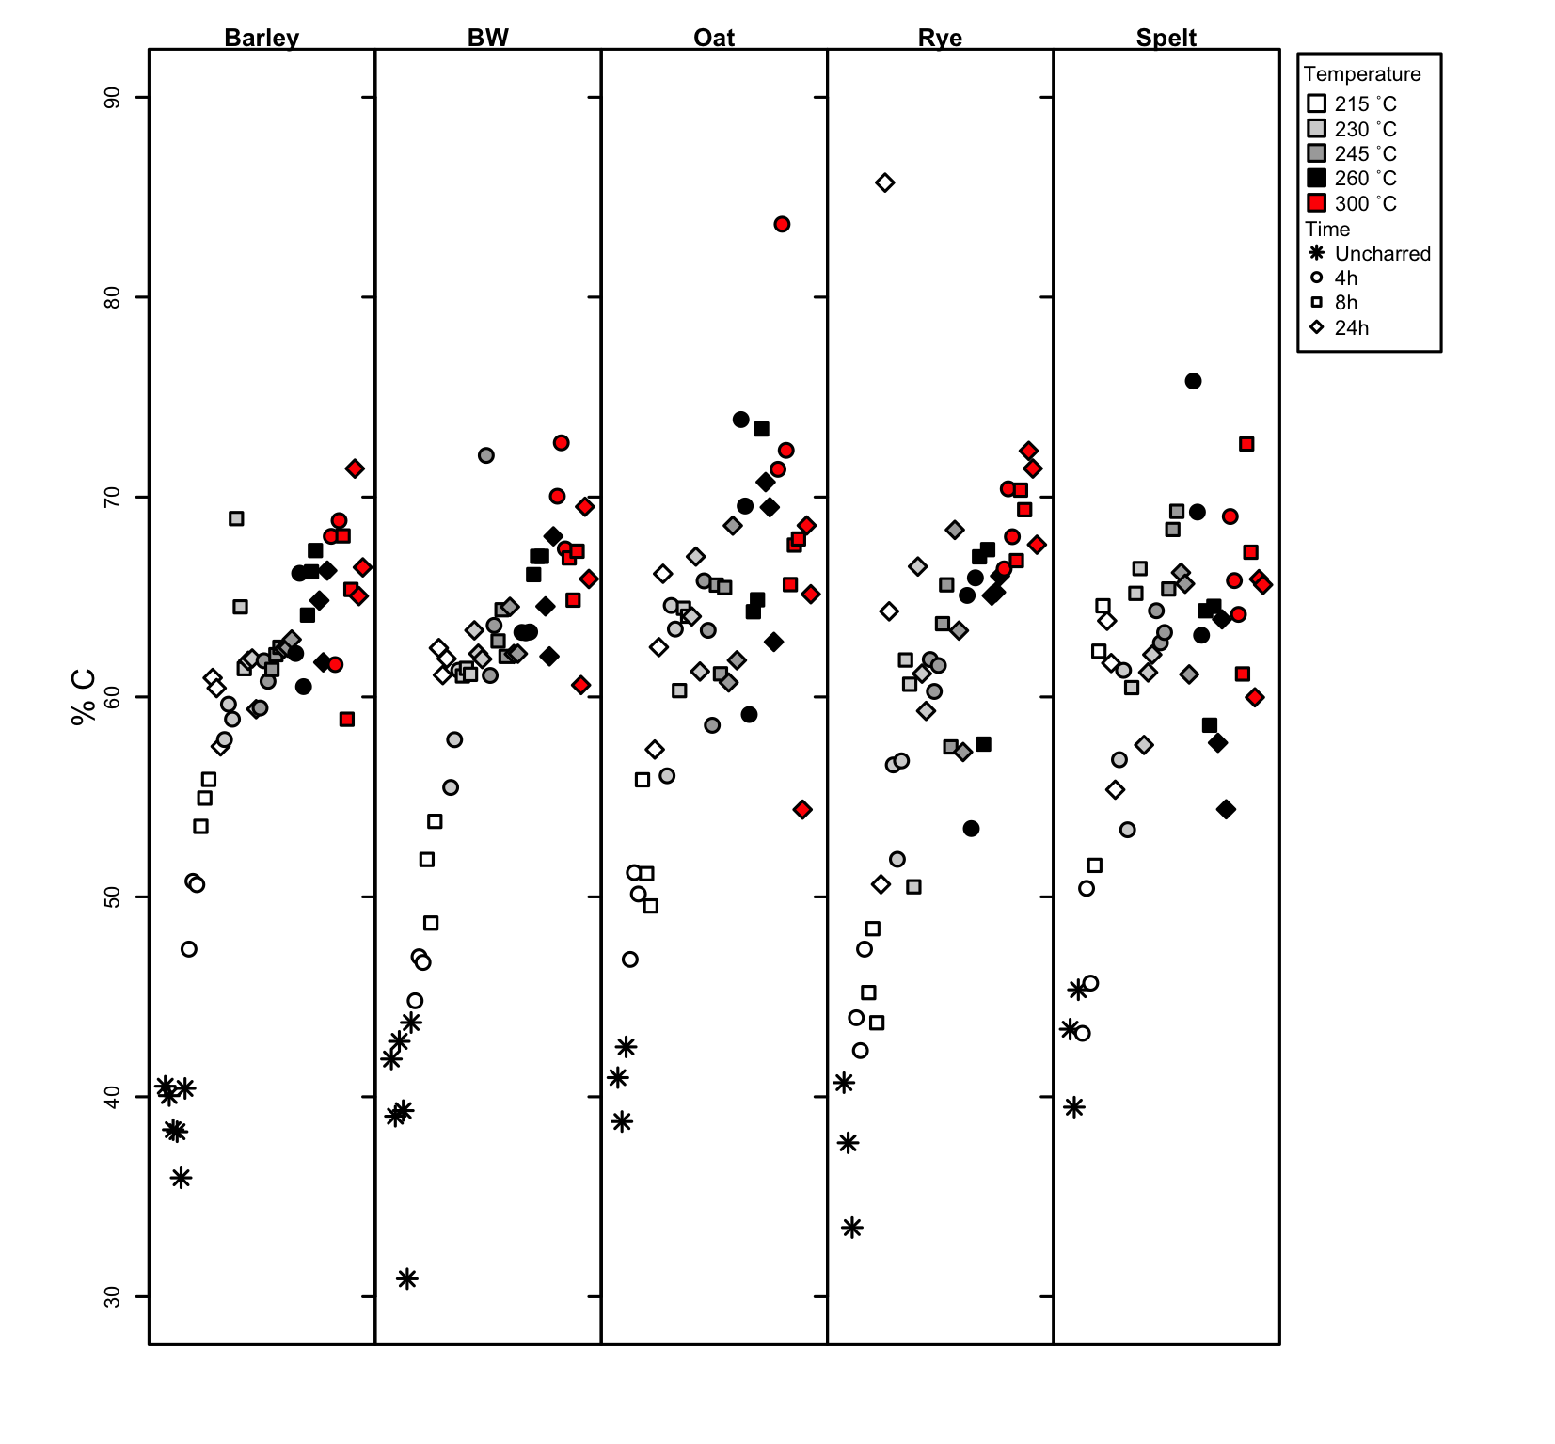

Figure 1. The %C of the five species charred up to 300ºC showing the changes in %C from uncharred through too 300ºC for 24 hrs

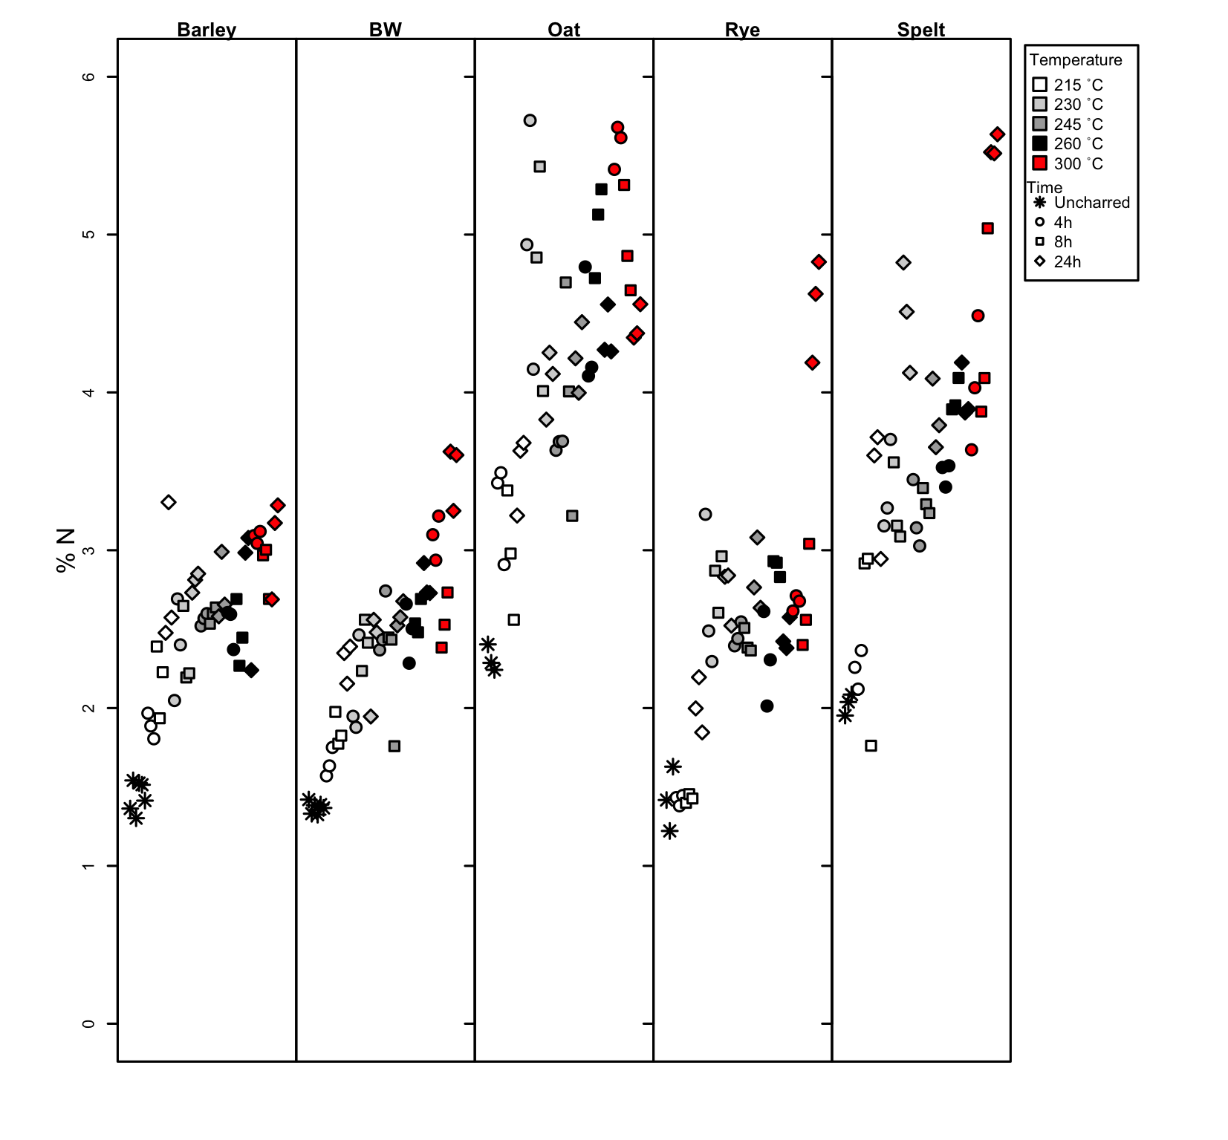

Figure 2. The %N of the five species charred up to 300ºC showing the changes in %N from uncharred through too 300ºC for 24 hrs

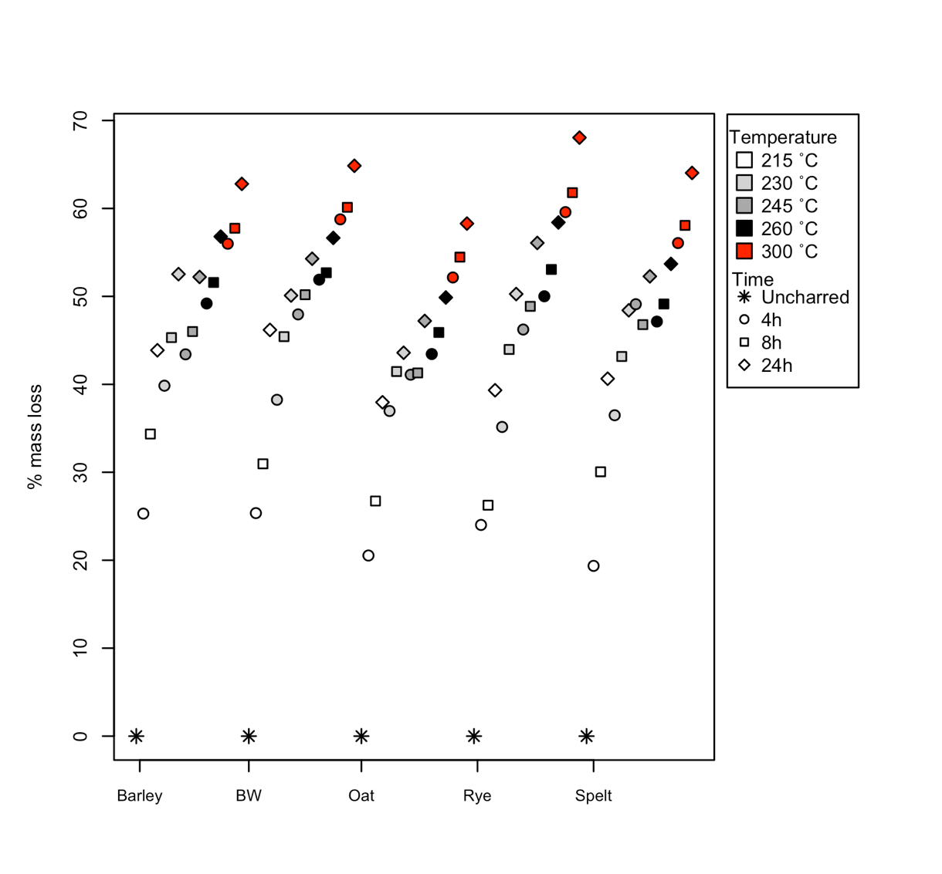

Figure 3. The averaged percentage mass loss of the three replaces of different time and temperature charring combination.

**Experimental design, materials and methods**

The data presented in this paper derive from the new experimental heating of the grains of five cereal species at 16 different time and temperature combinations. The aim was to understand the impact of heating both isotopically and morphologically on wheat, barley, rye, oat and spelt. This would allow for the calculation of a charring offset suitable for archaeobotanical assemblages containing such species, as well as the selection of suitable grains for isotopic analysis (see Stroud et al. (accepted)). The methodology used for the experiment follows that of Nitsch et al. (2015) so as to make it comparable with the Nitsch et al. (2015) isotopic data from their heating experiment on wheat and barley.

Nitsch et al. (2015) published the stable carbon and nitrogen isotopic values of seven different species which had been experimentally charred at 215°C, 230°C, 245°C and 260°C for 4, 8 and 24 hours. The raw data from the Nitsch et al. (2015) experiment was obtained from data stores at the School of Archaeology, University of Oxford and was incorporated within the datasets presented here. The bread wheat and hulled barley data from Nitsch et al (2015) was combined with the new data in Stroud et al. (accepted) The new dataset added an extra temperature to Nitsch et al. (2015) set of 4 temperatures, with the addition of the heating temperature of 300°C. The original raw data from the Nitsch et al. 2015 publication, including all available raw isotopic data for their species was included in Dataset 1.

#### Materials

New data were obtained using rye, oat and spelt grains all grown on organic farms. Whitehall Farm in Peterborough (UK) provided the rye grains, Tamarisk Farm in Dorset (UK) provided the oat grains and the spelt grains came from experimental plot 26 at Sutton Bonnington (UK). The grains used all came from a single field. The experiment used the same hulled barely material used by Nitsch et al. (2015), still located at the School of Archaeology, University of Oxford: a single field in the Sault region of Provence in France (code CHA-11). The bread wheat came from plot 18 of the Bad Lauchstädt long-term static fertilization experiment in Germany, the same location from which the Nitsch et al. 2015 material was derived, however the newly charred material came from the harvest of 2004. This had, however, been grown under the same cultivation conditions as the Nitsch et al. (2015) samples.

Eight hundred grains of rye, oat and spelt each were used, providing enough material to cover the 16 different combinations of temperature and time, including an unheated batch. A total 50 grains were selected for each of the heating combinations so as to provide enough material for both isotopic analysis and photography to assess the morphological changes of the grains. Three replicates of ten grains were used per heating condition, with the remaining 20 grains used for the photography. Each batch’s weight was taken before and after heating to understand mass loss for each heating condition.

A similar method was followed for the new barley and wheat grains, with 200 grains used per species. This allowed a total of 50 grains to be selected for each of the new heating conditions (300°C at 4, 8, and 24hrs) as well as a batch left uncharred so as to compare comparability between the new data and old data.

#### Heating

A Gallenkamp Plus II electric oven at the School of Archaeology, University of Oxford was used for the experimental heating. Spelt, oat and rye were charred at five different temperatures for three different durations: 215°C, 230°C, 245°C, 260°C and 300°C at 4 hours, 8 hours or 24 hours. Furthermore, the new wheat and barley grains were charred for 4 hours, 8 hours or 24 hours at 300°C so as to extend the already existing Nitsch et al. (2015) dataset to 300°C. Following the same protocol as Nitsch et al. (2015) the grains were wrapped in aluminium foil envelopes and buried in sand within beakers. The oven was preheated to the required temperature before the beakers were placed inside. The temperature of the oven was recorded throughout the duration of the heating using four thermocouples connected to a datalogger. Three of the thermocouples were buried inside beakers of sand at three points in the oven to understand the temperatures experienced by the grains, while a fourth thermocouple was placed in the oven to monitor the overall oven temperature outside the sand. Data shows that once the oven reached temperature, variability was less than 3%. Once the allotted heating time was reached the grains were removed from the oven and left to cool in the sand until they reached room temperature.

#### Isotopic analysis

Three replicates of the 16 temperature/duration combinations, a total of 48 samples per species, were isotopically analysed at the University of Oxford’s Research Laboratory for Archaeology and the History of Art. Each replicate contained 10 grains which were homogenised using an agate mortar and pestle into a powder. As the uncharred material was too hard to homogenise by hand, it was homogenised using a Spex 2760 Freezer/Mill. The homogenised powders were weighed into tins for isotopic analysis, with one isotopic sample per replicate. The samples were analysed on a Sercon 20-22 EA-GSL isotope ratio mass spectrometer operating in continuous flow. Due to the variability of the %N of the different species, the samples had their nitrogen and carbon measured in separate runs. The raw and drift corrected isotope ratios were calculated through comparison with an internal alanine standard.

A two-point calibration to convert the raw δ13C values to δ13CVPDB was conducted using two bracketing reference materials: IAEA-C7 and IAEA-C6. A two-point calibration using IAEA- N1 and IAEA-N2 converted the raw δ15N values to δ15NAIR for the majority of samples. A small number of samples which were re-run due to low nitrogen yields, were normalised using the internal standards of SEAL and EMA-P2 (runfile 200827). Data precision, accuracy and overall uncertainly were examined following Szpak et al. (2017). Check standards of Alanine, and EMA-P2 (when not used as a calibration standard) or Leucine were included in each run. Every tenth sample was duplicated and, following Szpak et al (2017), they were used in conjunction with the calibration standards, to understand accuracy and precision (see Tables 1,2,3,4 and 5). Precision, or within laboratory random error was calculated as the root sum-square of the pooled standard deviations of all repeated measurements (check and calibrations standards and duplicates). Accuracy, or systematic measurement error, was calculated as the root-sum-square of the root-mean-square of the difference between the observed mean and the known value of check standards and the root-mean-square of the known standard deviation of the check standards (Szpak et al 2017). The standard uncertainty of a given sample was calculated as the root-sum-square of the precision and accuracy.

The standard uncertainty of each isotope value was also calculated following the Kragten approximation method (Kragten 1994). This allowed measurement uncertainty of the new isotope samples and of the Nitsch et al (2015) data to be compared. The Nitsch et al (2015) dataset used the Kragten method to understand measurement uncertainty and did not contain enough standards/replicates to allow for the Szpak method to be applied. Nitsch et al (2015) did not duplicate any samples and used slightly different calibration standards, with USGS40 used instead of IAEA-N2 (see Nitsch et al 2015 supplementary table 1), as well as IAEA-N1 and IAEA-C7 and IAEA-C6. By calculating the standard uncertainty of the new data using the Kragten method, the overall average uncertainty of all data, new and old, could be calculated (see Table 5).

All graphing and statistical analysis was conducted using R-Studio, with R version 4.1.

#### Sectioning and Photography

The remaining 20 grains from each of the 16 different heating conditions were examined under a Lecia stereo microscope to understand changes to the morphology of the grains. Detailed photos using the Lecia microscope with an attached Lumenera infinity 3-6 UR camera were taken of the external morphology of a grain best representing the average distortion seen within each heating condition. Grains were sectioned in half at right angles to the grain’s ventral groove allowing the internal structure of the grains to be examined under the microscope. The Lumenera infinity software was used to take the photos and add scale bars.

**CRediT author statement**

***Elizabeth Stroud:****Conceptualization, Methodology, Formal analysis, Investigation, Data curation, Visualization, Writing- Original draft preparation, Writing- Reviewing and Editing.* ***Michael Charles****: Methodology, Visualization, Writing- Reviewing and Editing.* ***Amy Bogaard****: Writing- Reviewing and Editing, Supervision.* ***Erika Nitsch:*** *Resources.* ***Helena Hamerow:*** *Funding acquisition*

**Acknowledgments**

*Funding: This work undertaken as part of the FeedSax project which is funded by the European Research Council (ERC) under the European Union’s Horizon 2020 research and innovation programme under grant agreement no.*[*741751*](https://www.sciencedirect.com/science/article/pii/S1879981721000358?via%3Dihub#gs0005)*.*

**Declaration of interests**

*Please* ***tick*** *the appropriate statement below and declare any financial interests/personal relationships which may affect your work in the box below.*

The authors declare that they have no known competing financial interests or personal relationships that could have appeared to influence the work reported in this paper.

The authors declare the following financial interests/personal relationships which may be considered as potential competing interests:

**References**

Kragten, J., 1994. Tutorial review. Calculating standard deviations and confidence intervals with a universally applicable spreadsheet technique. *Analyst*, *119*(10), pp.2161-2165.

Nitsch, E.K., Charles, M. and Bogaard, A., 2015. Calculating a statistically robust δ13C and δ15N offset for charred cereal and pulse seeds. *STAR: Science & Technology of Archaeological Research*, *1*(1), pp.1-8.

Stroud, E., *Charles, M. Bogaard, A., Nitsch, E., and H. Hamerow* (accepted). Turning up the heat: Assessing the impact of charring regime on the morphology and stable isotopic values of cereal grains. Journal of Archaeological Science

Szpak, P., Metcalfe, J.Z. and Macdonald, R.A., 2017. Best practices for calibrating and reporting stable isotope measurements in archaeology. *Journal of Archaeological Science: Reports*, *13*, pp.609-616.