Concrete Compressive Strength: Project 2
Introduction

Concrete is used in construction materials very often, and its strength is a property that determines the quality, durability, etc. The accurate prediction of strength of concrete is crucial for optimizing and reducing cost of production, while ensuring that the materials used are safe. In this project, we explore data-driven approaches to model and predict the strength of concrete using its features. The data, obtained by UCI machine learning repository, has 8 features that are properties of cement such as: cement, blast furnace slag, fly ask, water, superplasticizer, coarse aggregate, fine aggregate, and curing age. The response variable is the cements compressive strength. The goal of this project is to build and compare 4 different regression models to identify which one best predicts strength.

- Polynomial Regression, which captures the nonlinear effects of concrete ingredients -such as cement, water, and superplasticizer content—on compressive strength.
- Spline Regression, which models the relationship between strength and predictors like cement content or curing age in a piecewise flexible manner.
- Regression Tree, a nonparametric model predicting average compressive strength, offering a simpler and interpretable view of different ingredient combinations.
- Random Forest, an ensemble of multiple regression trees that average their predictions to improve accuracy and robustness. It also provides insight into importance of features, highlighting which material properties most strongly impact strength.

The dataset is split into training and testing (70/30 split) subsets. The Mean Squared Error (MSE) on the testing set is used as a performance metric to compare models. Additionally, model tuning is preformed where appropriate using cross-validation, and for the Random Forest, feature importance is examined to interpret which properties most strongly influence strength.

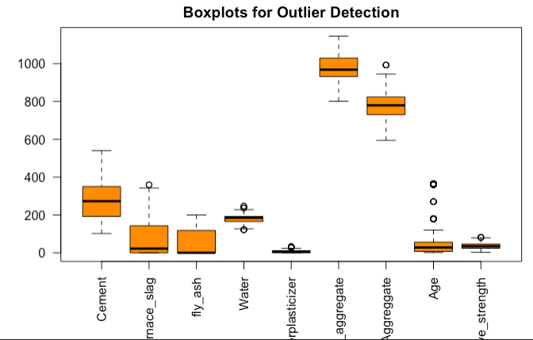
Data Cleaning and Exploratory Analysis

Cleaning:
- Renamed variables for clarity and consistency.
- Confirmed no missing values.
- Confirmed all columns are numeric and continuous.
- Checked for obvious data entry errors or extreme outliers (none required removal).

Exploratory Analysis:
- Pairwise scatterplots and correlation table to inspect linear relationships and multicollinearity, show no evidence of significant multicollinearity.
- Distribution of response variable: Shows to be approximately normally distributed, with slight right skewness.
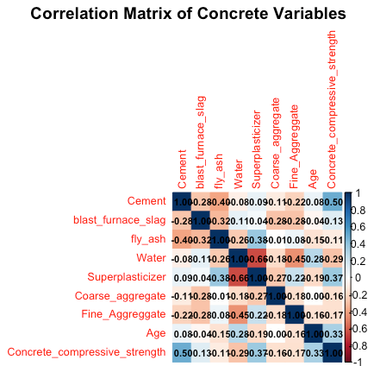
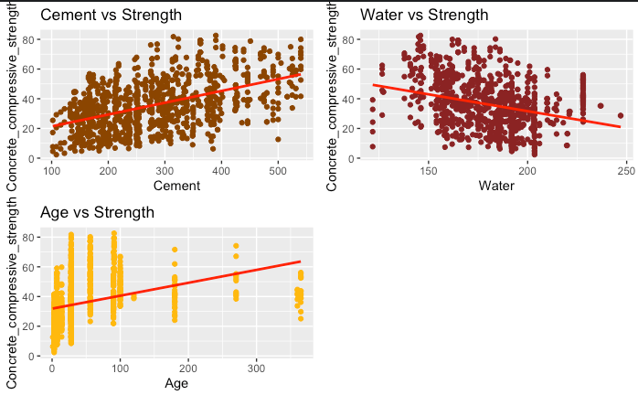
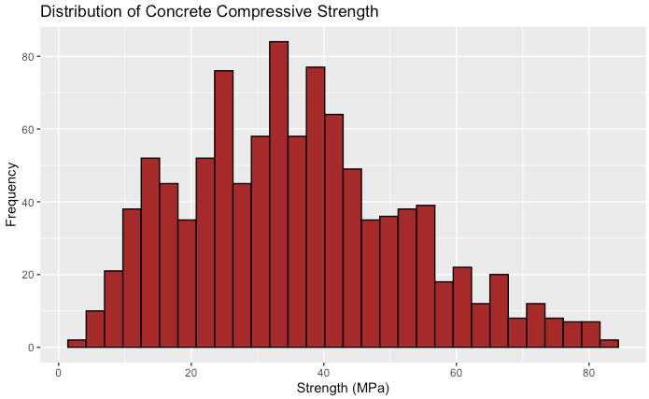
The relationships between variables age, cement, and water, suggests that non-linear regression models would provide more accurate representation of the data. While the linear trend lines capture the superficial direction of the relationships, the scatter of the points and the extremely low r-squared values indicate curvature and diminishing or accelerating effects that a straight line cannot fully describe.

Methodologies and Approaches

All models used the same 70/30 train/test split and seed 598, where models required tuning, we used cross-validation on the training set to select hyperparameters, then evaluated final model in the test set.

- Polynomial Regression Model

Test MSE = 41.1557, Test RMSE = 6.4153, Test MAE = 5.1198, Test R^2 = 0.8649
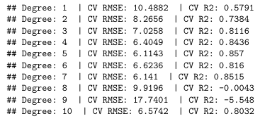

Degree 5: lowest RMSE and highest R^2

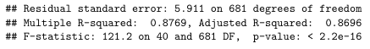

Polynomial regression with degree = 5
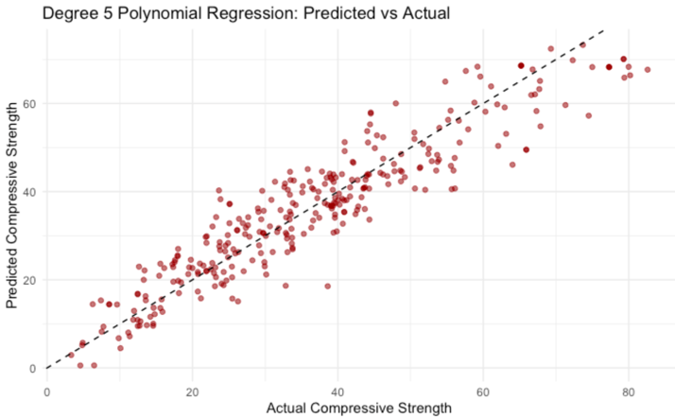
- Models cv results show lowest error at degree 5, because at degree 6 overfitting began to occur.
- achieved a residual standard error = 5.9
- Adjusted r^2 value = 0.8696. This indicates that 87% of the variation in compressive strength is explained by the non-linear combination of features.
- The F-stat = 121.2
- Test RMSE = 6.42
- Test R^2 = 0.865 (generally preforms well)
Overall, polynomial model (degree 5) decently captured the non-linear relationship across different components of concrete.
- Splines Model

Cross-validation across 1-10 degrees of freedom found df = 7 minimized MSE = 34.185.
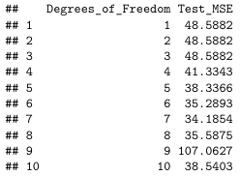

lowest Test MSE

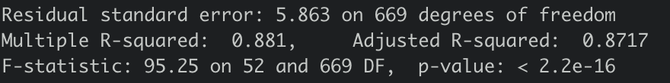

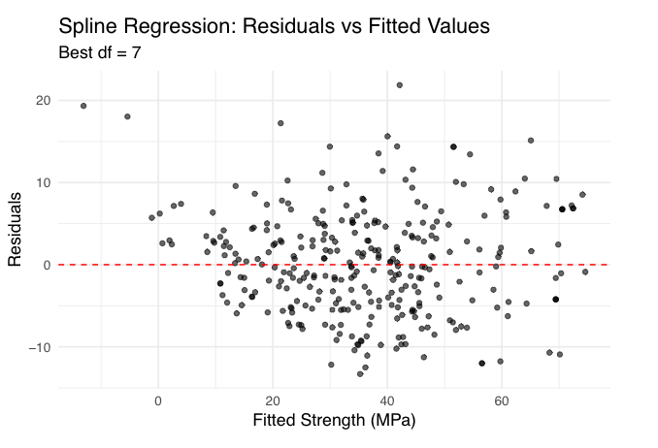
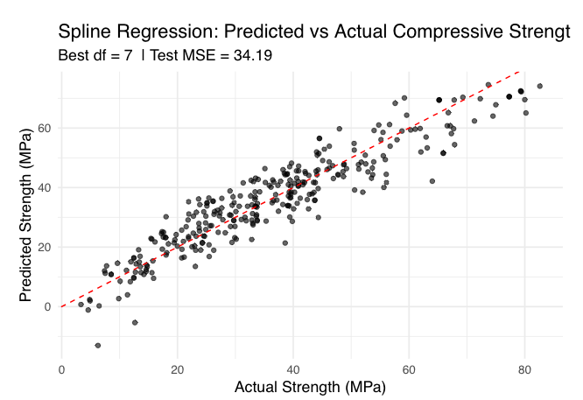
Spline regression with degree 7:
- Achieved residual standard error = 5.86
- Adjusted r^2 = 0.872
- F-stat of 95.25 with p-val < 0.05, significant
- RMSE = 5.85
- R^2 = 0.869 (test data)
- Residual plot shows residuals approximately random distribution.

Spline model provides flexibility and interpretability. Unlike polynomial model, splices adapt to localized non-linear trends, capturing subtle curvature in the relationship among components and strength. Overall, indicating a strong fit and robust explanatory power.

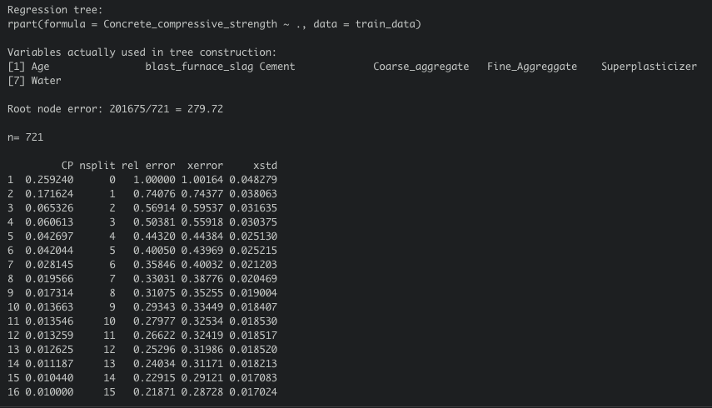
- Regression Tree Model
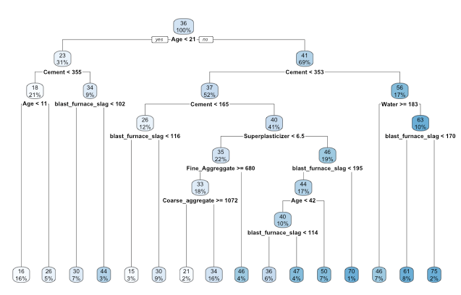

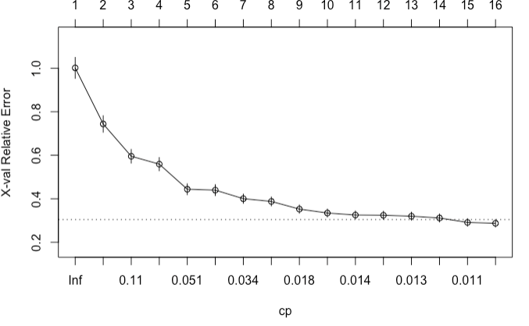

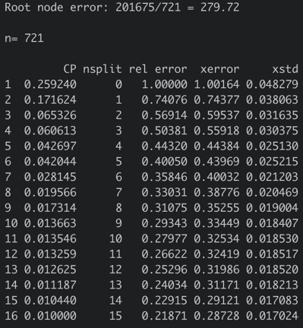
Regression Tree (Prunned) 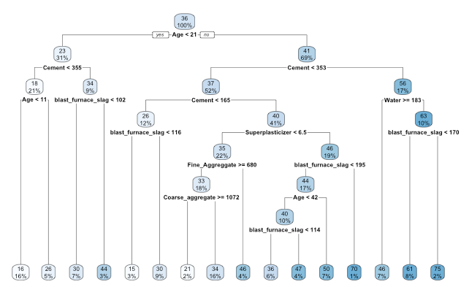
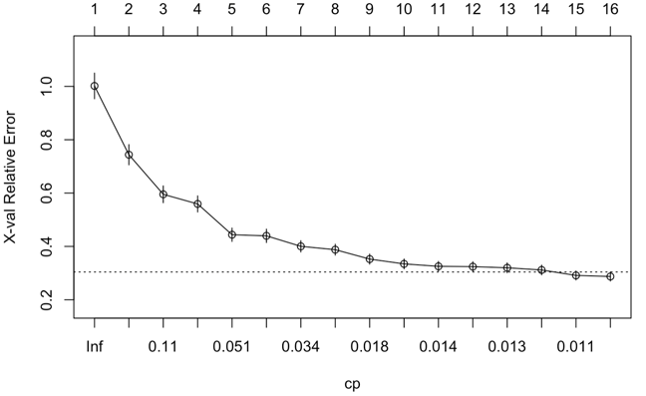
The root split occurs at Age < 21 days, which means there’s a major physical distinction between “early age” and “mature age” in concrete.
- First partition captures strength increases drastically during initial curing period.
- Left branch (“early age” concrete) was divided by cement < 335 kg/m^3 and blast furnace slag < 102, suggesting that low cement and other material content limit early strength development.
- Right branch (“older” concrete) shows splits at cement >= 353 and water >= 183, which reinforces the importance of amount of binder and water-cement ratio in later strength performance.
- Secondary splits revealed superplasticizer < 6.5 and fine aggregate >= 680 improved predicted strength. Nodes involving blast furnace slag < 170 and age < 42 highlight mix-dependent effects where slag influences strength increases differently over time.
Regression tree model predicts concrete strength using hierarchical variable splits. The full tree was pruned at the optimal complexity parameter (cp = 0.011) based on lowest cv-validated relative error (approx. 0.2) as shown in the CP plot. Pruning reduces overfitting while keeping the trees most important branches. These yields:
- Test RMSE = 9.9
- R^2 = 0.646
- Indicating moderate predictive accuracy & relative interpretability.

- Random Forest Model
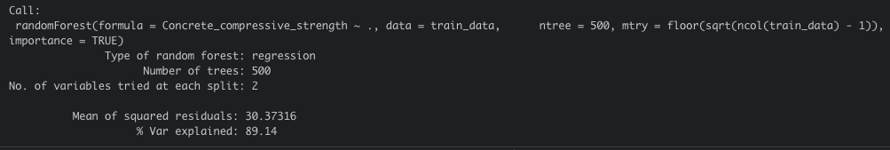
RMSE = 6.169792
R-squared = 0.8624

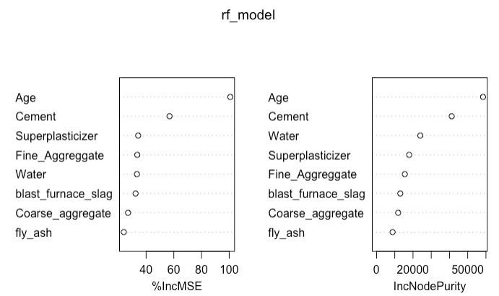
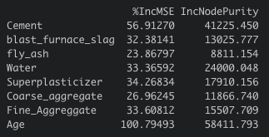

- The Random Forest model was constructed using 500 trees and an optimized mtry value 3.
- The model explains approx. 89.1% of the variance in concrete compressive strength on the train set.
- Test RMSE = 6.17
- R^2 = 0.862 (indicates excellent predictive capability)
Most influential predictors: Age, Cement. According to variable importance analysis, Age and Cement shows the highest increases in node purity and MSE. This makes sense because these two variables consistently alighn with other properties that contribute to the development of concrete strength such as cement directly contributes to binder content and water, while age captures the curing process. Water and Superplasticizer are the secondary important features, highlighting the balance between workability and strength. Blast Furnace Slag and Fine Aggregate exhibit more moderate effects.
Random Forest effectively captures more complex nonlinearities and variable behavior that a single tree cannot capture. Compared to pruned regression tree, this model reduces residual error by average across different tree structures, improving accuracy. The mean of squared residuals = 30.37 reflects minimal bias. Overall, Random Forest model achieved a compromise between interpretability and predictive power.
Results
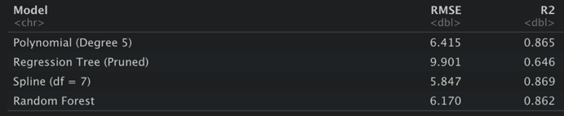

lowest RMSE, highest R^2

Each model’s performance was evaluated using RMSE and R^2 to assess predictive accuracy and model fit.
- The Spline regression with df = 7 achieved the best overall performance with the lowest RMSE = 5.85 and the highest R^2 = 0.869, indicating its smooth piecewise structure modeled the nonlinear relationship quite well between concrete components and its strength.
- The random forest model produced a similarly high r^2 = 0.862 and RMSE = 6.17. Slightly underperforming compared to spline model, it successfully captured complex variable interactions.
- The polynomial regression with degree 5 closely followed with an RMSE = 6.42 and r^2 = 0.865, demonstrating strong predictive capability.
- The regression tree (pruned) has a notably higher RMSE = 9.9 and lower r^2 = 0.646, confirming that single-tree structures are prone to having a higher variance and less stability compared to other models.
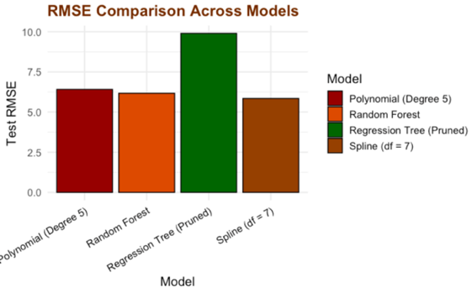
Summary
Overall, both Spline and Random Forest models delivered highly reliable predictions and captured the nonlinearities present in the data well. Spline regression demonstrated superior precision and flexibility, efficiently approximating the smooth, nonlinear effects of the concrete features on compressive strength.
Random Forest model provided comparable accuracy while still providing insight into the importance of features. It identified age and cement as the most contributing features, closely followed by water and superplasticizer. Polynomial regression, on the other hand, effectively captured the curvature and non-linearity of the data but had some sensitivity to degree selection. The regression tree had the best visual representation of the data. In conclusion, this analysis confirms that advanced regression approaches like splines and ensemble methods offer significant improvements in interpretability and reliability for modeling concrete’s compressive strength.

