Module 2 - R Markdown Document 1

Elizabeth M. Juhasz

2025-04-20

# This is a Level 1 Header

## R Markdown

### This is a Level 3 Header

This is an R Markdown document. Markdown is a simple formatting syntax for authoring HTML, PDF, and MS Word documents. For more details on using R Markdown see <http://rmarkdown.rstudio.com>.

This is a link to [Google.](http://google.com)

When we compile our document, we are using the rmarkdown package.

2+2  
mean(c(1,2,3,4,5))

Here is an example of a non-numbered list

* Breakfast
  + food
    - eggs
    - toast
    - bacon
  + drink
    - apple juice
* Lunch
  + taco

Here is an example of a numbered list:

1. Breakfast
   1. food
      1. eggs
      2. toast
      3. bacon
   2. drink
      1. apple juice
2. Lunch
   1. taco

Here is an example of block quote:

This is a block quote. This paragraph has two lines.

1. This is a list inside a block quote.
2. Second item.

Here is an example of nested block quote:

This is a block quote. This paragraph has two lines.

This text is nested

Here is an example of code within a block quote.

2+2  
mean(c(1,2,3,4,5))

When you click the **Knit** button a document will be generated that includes both content as well as the output of any embedded R code chunks within the document. You can embed an R code chunk like this:

summary(cars)

## speed dist   
## Min. : 4.0 Min. : 2.00   
## 1st Qu.:12.0 1st Qu.: 26.00   
## Median :15.0 Median : 36.00   
## Mean :15.4 Mean : 42.98   
## 3rd Qu.:19.0 3rd Qu.: 56.00   
## Max. :25.0 Max. :120.00

## Including Plots

You can also embed plots, for example:

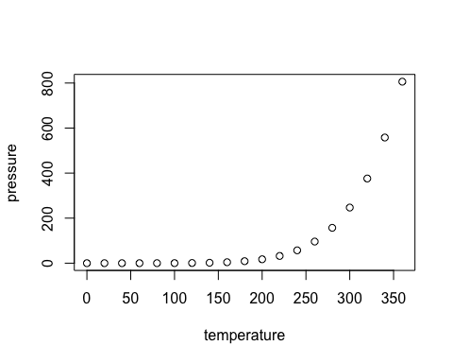

Note that the echo = FALSE parameter was added to the code chunk to prevent printing of the R code that generated the plot.