Homework5_613

Elizabeth Marge

2/26/2021

Stockreturns <- c(-8.36, 1.63, -2.27, -2.93, -2.70,   
 -2.93, -9.14, -2.64, 6.82, -2.35,   
 -3.58, 6.13, 7.00, -15.25, -8.66,  
 -1.03, -9.16, -1.25, -1.22, -10.27,  
 -5.11, -0.80, -1.44, 1.28, -0.65,  
 4.34, 12.22, -7.21, -0.09, 7.34,   
 5.04, -7.24, -2.14, -1.01, -1.41,   
 12.03, -2.53, 4.33, 1.35)  
Stockreturns

## [1] -8.36 1.63 -2.27 -2.93 -2.70 -2.93 -9.14 -2.64 6.82 -2.35  
## [11] -3.58 6.13 7.00 -15.25 -8.66 -1.03 -9.16 -1.25 -1.22 -10.27  
## [21] -5.11 -0.80 -1.44 1.28 -0.65 4.34 12.22 -7.21 -0.09 7.34  
## [31] 5.04 -7.24 -2.14 -1.01 -1.41 12.03 -2.53 4.33 1.35

## 1

mean(Stockreturns)

## [1] -1.124615

## 2

sd(Stockreturns)

## [1] 5.977673

## 3

pnorm(-1.5, mean=-1.124615, sd=5.977673, lower.tail = TRUE)

## [1] 0.4749637

## 4

pnorm(.70, mean=-1.124615, sd=5.977673, lower.tail = FALSE)

## [1] 0.3800923

## 5

summary(Stockreturns)

## Min. 1st Qu. Median Mean 3rd Qu. Max.   
## -15.250 -3.255 -1.410 -1.125 1.490 12.220

## The 1st Quartile is -3.255.

## 6

## Checks for outliers   
  
boxplot(Stockreturns)

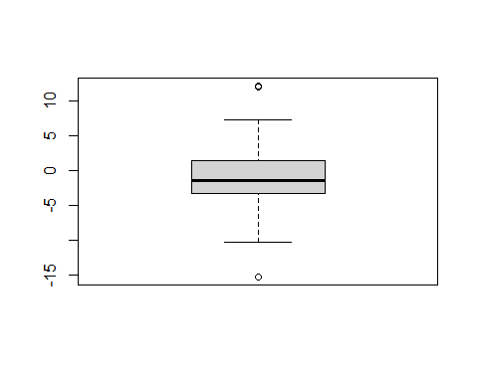

## There are a few outliers shown within the boxplot.

# Check the qq plots for normality  
qqnorm(Stockreturns)

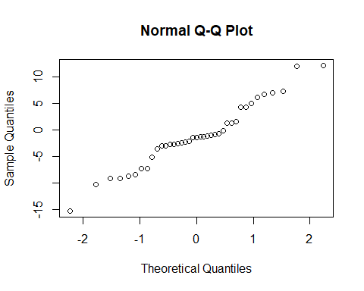

## In checking normality, this shows a normal plot with a positive correlation.

## 7

## The average of the S&P 500 stock index for the same period was 0.95%. Does the broker perform worse than average?   
  
## Null- H0 = .95  
## Alternative- Ha < .95

## 8

t.test(Stockreturns, mu = .95, alternative = "less")

##   
## One Sample t-test  
##   
## data: Stockreturns  
## t = -2.1674, df = 38, p-value = 0.01827  
## alternative hypothesis: true mean is less than 0.95  
## 95 percent confidence interval:  
## -Inf 0.4891698  
## sample estimates:  
## mean of x   
## -1.124615

## p-value = 0.1237  
## confidence interval is between -Inf 0.4891698

## 9

## Now answer the question originally stated. Does the broker perform worse than average? (Explain or justify in two or three sentences)  
  
  
## Since the p-value of 0.01827 and is greater than .05 at 95% confidence, we reject the null hypothesis that the average is equal to .95. In addition, Since the number .95 is not in the confidence interval of -Inf 0.4891698, this supports the claim that we reject the null hypothesis.