**Assignment: Functional Test**

For this assignment, you will be completing functional tests using the written test plans from assignment 4.2.

**Instructions:**

1. Select two of your peers' test plans from the *Module 4.2 Assignment - Test Plan Discussion Board* and complete them. Upload the completed documents to the assignment link above.
2. Screenshots are used to provide proof that the steps were either a success or failure. Without screenshots, how does one substantiate the results or know what to research to resolve potential errors? Remember, it is not enough to say you “checked it and it passed.” You need to prove the results. Here's an example:

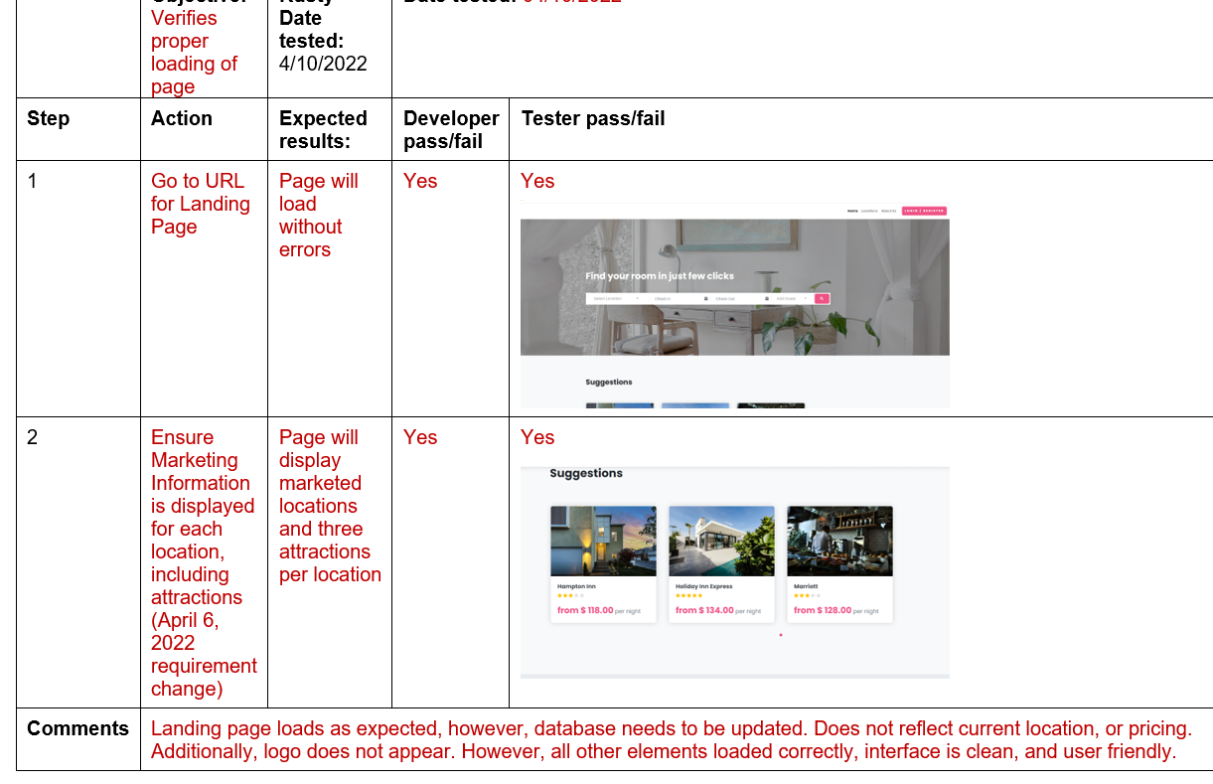 [Click for more options](https://cyberactive.bellevue.edu/webapps/blackboard/content/listContent.jsp?course_id=_537740_1&content_id=_16872073_1&mode=reset#contextMenu)

1. Remember, you are completing the “Tester pass/fail” section of the document and you **must** include screenshots of the results. **Include your name in the Peer Tester box.**

**Assignment Requirements and Grading:**

1. This assignment is due by **Sunday, 11:59 p.m., CST**.
2. Submit your paper by uploading it to the assignment link above. Add the URL to your GitHub repository in the comments area, then click on Submit.
3. Create (if you haven't already) a directory in your local CSD-380 directory named module-4.
4. Save your homework to your CSD/CSD-380/module-4 directory. Stage, commit and then push the file(s) to your GitHub repository.
   * Click on the following link for instructions: [GitHub Stage, Commit, and Push.pdf](https://cyberactive.bellevue.edu/bbcswebdav/xid-101703982_4) [Click for more options](https://cyberactive.bellevue.edu/webapps/blackboard/content/listContent.jsp?course_id=_537740_1&content_id=_16872073_1&mode=reset#contextMenu)
5. To view the rubric grading criteria, click on the following link: [General Assignment Grading Rubric](https://content.bellevue.edu/cst/csd/rubricgeneralassignmentv1.pdf)

**(45 points + 5 points for push to GitHub)**