CIVE 202
Spring 2026

Project 3

Graphing Transportation Data

Submitted by

Elizabeth Wiggins

Submitted to

Federal Highway Administration (FHWA)

March 27, 2026

Contents
Introduction 3
Project Background 3
Scope of Work 3
Method 4
Preliminary Measures 4
Bar Chart 4
Histogram 4
Boxplot 4
Time-Series Plots 4
Intelligent Driver Model (IDM) Simulation 5
Results 5
References 12

Introduction

Project Background
The Federal Highway Administration (FHWA) is looking for clean and simple graphs that showcase various trends and patterns in the dataset. Therefore, this project will be providing these graphs by using coding software to generate plots that are clear and purposeful. The traffic data featured in the following graphs is sourced from the National Household Travel Survey (NHTS) and the Next Generation Simulation (NGSIM) datasets.

Scope of Work
This project concentrates on comparing different variables in the previously listed datasets and graphing them in a clear and efficient manner. This will allow for patterns in traffic to be determined and inferences to be made that allow for a better understanding of transportation and daily life.
To accomplish this, a python coding file will be used with various graphing packages. A series of variables will be assigned to represent different aspects of interest within the dataset. To create these variables the data will have to be filtered for each different data column that is to be graphed. Then a series of plot functions will be used to create and print the graphs.
The program’s output will present 6 graphs that portray different patterns and trends in the traffic data. Graph types include a bar chart, histogram, boxplot, time-series, and more. One of the graphs output by the code is data generated from an intelligent driver model traffic simulation using NGSIM data. This graph will compare the acceleration vs time of one specified vehicle pair from the dataset to a simulated follower in the simulated traffic scenario.
Final deliverables include: a functioning Jupyter Notebook, an annotated code documentation, a GitHub repository with a user guide, a Gantt chart, the Scope of Work, time sheet, and a comprehensive technical report.

Method

Preliminary Measures
The process of producing the results of this project takes place entirely in python coding software. Begin by importing the necessary graphing and indexing packages: pandas, numpy, matplotlib, and seaborn. Set the desired visual style of your plots using sns.set_style() and sns.set_palette() functions. Import the NHTS and NGSIM datasets as well using pd.read_csv() function.

Bar Chart
To produce a bar chart that plots vehicle count by fuel type, filter the NHTS dataset by fuel type then count the number of vehicles using .valuecounts() and assign that to a new variable. Create plot using plt.figure(), select a figure size, and use .plot() after the count variable to plot those values to the graph. The kind of graph should be set to ‘bar’. Plt. functions can then be used to add axes labels, a title, and rotate the fuel type label to allow for better readability. Use “plt.show()” to print the graph.

Histogram
To produce a bar chart comparing rural vs urban vehicle ages, filter the NHTS dataset by urban household location vehicle ages and rural household location vehicle ages. Using plt.hist(), set the number of bins for the urban bars on the graph, I used 20, and add specifications for the colors, transparency, and labels. Repeat for the rural bars on the graph. Be sure to specify plot size and add axes labels, a title, and a legend. Finish by printing your histogram.

Boxplot
To produce a box plot demonstrating vehicle ages by make, begin by setting the figure size then use filtered vehicle age data and the .boxplot() function to create the graph. To make the different vehicles ‘Make’ labels along the x axis easily readable, rotate them 90 degrees. Add axes label and a title to the graph then it is ready for print.

Time-Series Plots
For the time series plots, pick a trajectory pair from the NGSIM data and assign it to a variable, then sort the dataset by that trajectory pair so only that data is saved to a specific data subset variable. Create a variable for the gap distance by subtracting the leader position values by the follower position, and a variable for the time. Then create a figure with 2x2 matrix so four graphs can be displayed, using “plt.subplots(2,2, figsize = ())”. Set the first graph to the top left position by using “axes[0,0].plot()” and set up a graph showing the position vs time for both the leader and follower vehicles with specifications for linewidth, labels, colors, transparency, a title, and a legend. The graph is to be set up by filtering the chosen vehicle pair data by leader and follower position, so each one has its own line on the graph. The same process can be used for the other three graphs in the plot, except the axes will change depending on position. For example, top right is [0,1], bottom left is [1,0], and bottom right is [1,1]. The other three time series plots should represent acceleration vs. time, speed vs. time, and gap width vs. time, which can be accomplished by adjusting the filter from position to speed, acceleration, or gap width. The process in its entirety can be repeated to create time-series plots for any vehicle pair in the dataset. My plots consisted of trajectory pairs 13 and 3.

Intelligent Driver Model (IDM) Simulation
Begin preparing for the IDM simulation by defining a function to calculate the acceleration. The function should contain an equation for the desired minimum gap, using variables for current speed of the follower vehicle (m/s), current gap distance between leader and follower (m), speed difference (m/s), desired velocity (m/s), minimum spacing (m), desired time headway (s), maximum acceleration (m/s^2), and acceleration exponent. Using a specified vehicle pair, I chose 13, filter the data to obtain that pair’s time data, leader acceleration, and leader speed. Identify the step in the data, set it equal to a variable, and set the rest of the IDM parameters. Desired velocity should be 30 m/s, minimum spacing is 2m, desired time headway is 1.5 s, maximum acceleration is 1 m/s^2, comfortable deceleration is 1.5 m/s^2, and the acceleration exponent is 4. The number of simulation steps should be set to equal the length of the time data and the simulated follower’s position should be equal to the real follower’s initial position. Next, a loop is made to calculate the gap and speed difference at each time step as well as updating the speed and position for the next steps. Finally, the acceleration vs time of the leader, follower, and simulated follower can be graphed using the same process as the previous acceleration vs. time graph. Include specifications for figure size, labels, colors, axes titles, graph title, legend, and grid. The plot is then ready for print.

Results
The bar chart, as seen in Figure 1, portrays the vehicle count by fuel type as recorded in the NHTS dataset. The chart clearly shows that the majority of vehicles are fueled by gas, as that category consists of the mean, median, and mode. Biodiesel was used by the smallest number of vehicles, making it the minimum in the dataset. This allows for a better understanding of the distribution of how frequently used various fuel types are.
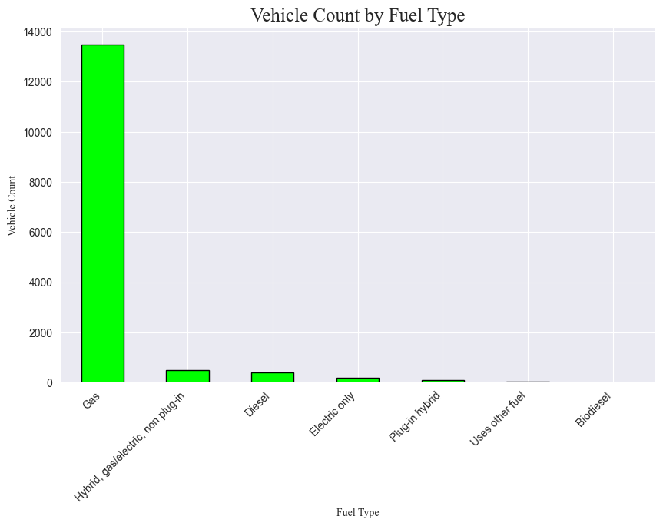
Figure 1 Vehicle Count by Fuel Type Bar Chart
The histogram, as seen in Figure 2, demonstrates the ages of vehicles in rural vs. urban areas using the NHTS data. The trend of the graph shows on average, vehicles in urban areas are comparatively newer than vehicles in rural areas. However, both urban and rural areas are skewed left, meaning that the majority of vehicles are on the younger side than the older side. This graph can allow for inferences to be made about the average vehicle age in traffic in either rural or urban areas.
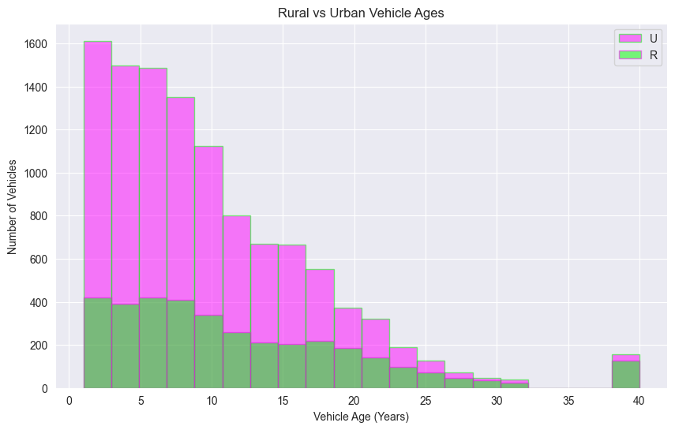
Figure 2 Histogram of Rural vs Urban Vehicle Ages
The box plot, as seen in Figure 3, demonstrates vehicle age by make using the NHTS data. It shows that some of the most consistently popular vehicle makes in the dataset over the last 40 years include Chevrolet, Harley Davidson, Ford, and Dodge. Meanwhile there are no recorded Pontiacs younger than about 12 years old, and no other domestic manufacturers older than 10 years of age. This provides insight into the most common age range of a given vehicle make in traffic.
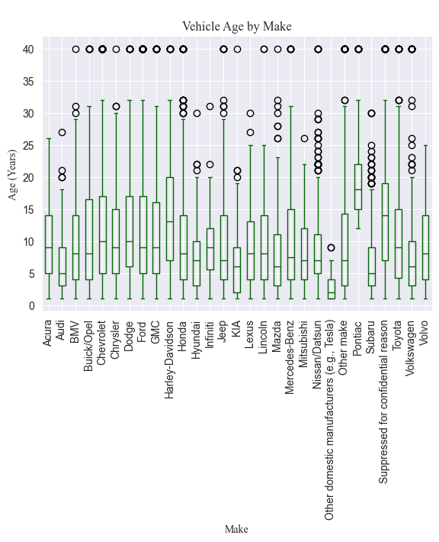
Figure 3 Vehicle Age by Make Boxplot

The time-series plots featured in Figure 4 provides a visualization of the position, acceleration, speed, and gap width vs time for trajectory pair 13 in the NGSIM dataset. Figure 5 demonstrates the same plots, but for trajectory pair 3. For both trajectory pairs, the acceleration vs time of both the leaders and followers indicates the same pattern, where while the leader accelerates or decelerates, the follower does as well at a similar rate. This is a good representation of how acceleration and deceleration typically relate between leading and following vehicles in actual traffic scenarios. The gap widths between the leader and follower in both vehicle pairs has a similar range of about 5-25m, but the gap by time varies significantly. The position vs. time graphs of each vehicle pair for both leader and follower share the same trend, which is increasing position by increased time. However, the rates at which the position changes are different between the two trajectory pairs, which is reasonable and representative of average vehicles in traffic as different vehicle pairs are not likely to travel at identical rates.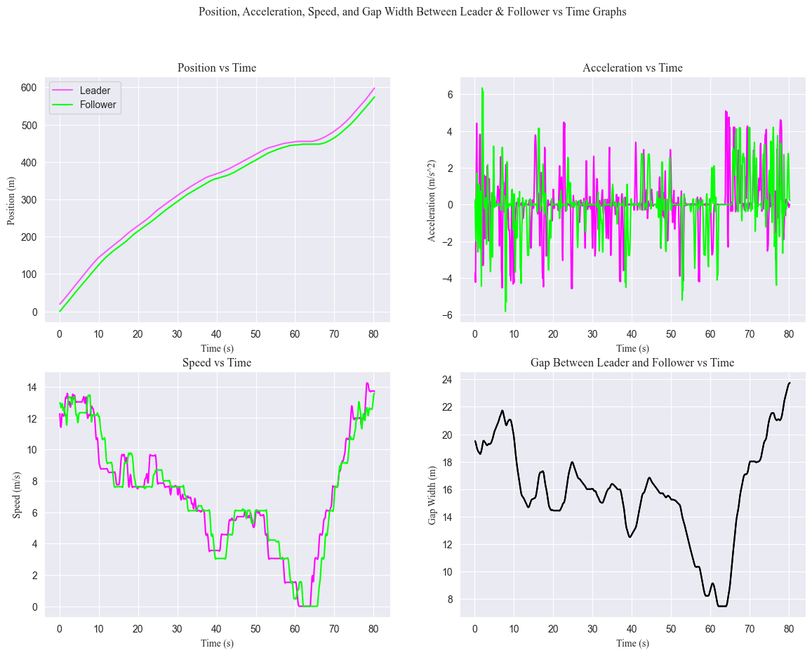
Figure 4 Time-Series Plot for Trajectory Pair 13
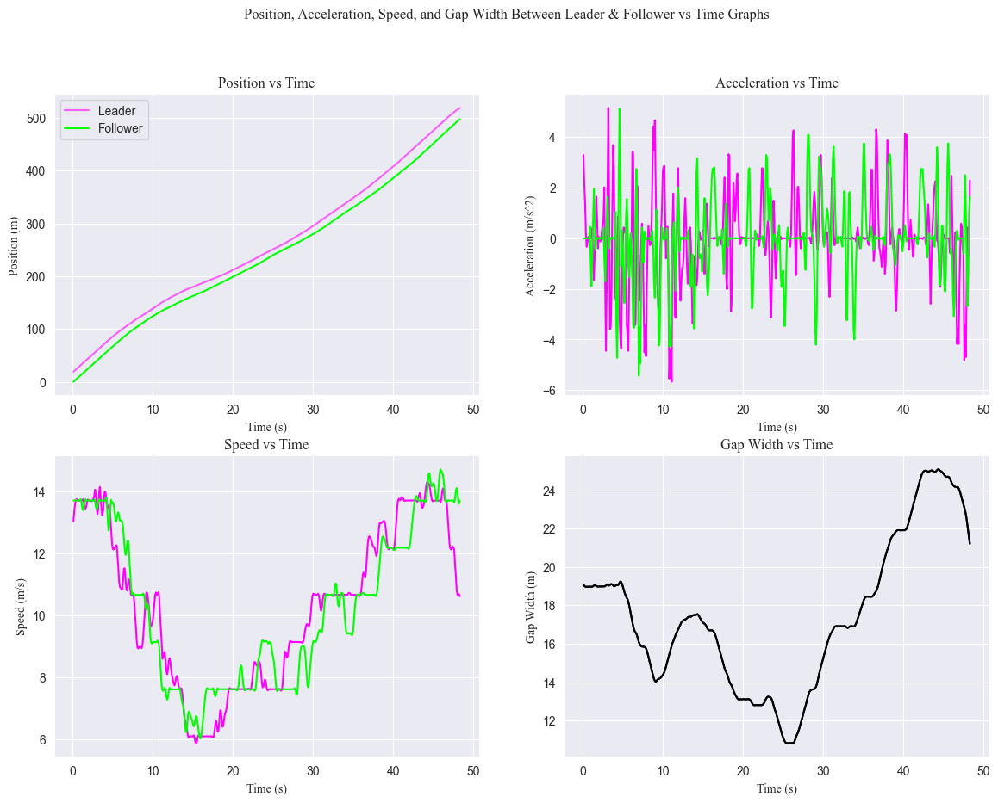
Figure 5 Time-Series Plot for Trajectory Pair 3
The final plot, Figure 6, shows the acceleration vs time of the leader and follower in vehicle pair 13 as well as a simulated follower calculated by the NGSIM data. The lines on the graph for the non-simulated follower and leader both show steep acceleration and deceleration patterns. The non simulated follower is responsible for reaching the maximum acceleration and deceleration, while the simulated follower consistently has the lowest average acceleration and deceleration compared to the other two vehicles. Although, the simulated follower does still follow the same pattern of quick increases and decreases in acceleration. The simulated follower’s less sharp trends of acceleration and deceleration compared to the other vehicles is likely explained by the simulation being more gradual with its stops and when speeding up. The code used to create the simulation set a maximum acceleration of 1m/s^2 and a comfortable deceleration of 1.5m/s^2, however these values are not likely representative of the average driver in traffic, as they probably will not drive as smoothly and as calculated as a simulated driver would. With that said, the non-simulated follower and driver trends are probably more representative of common real-life traffic patterns than the simulated follower.
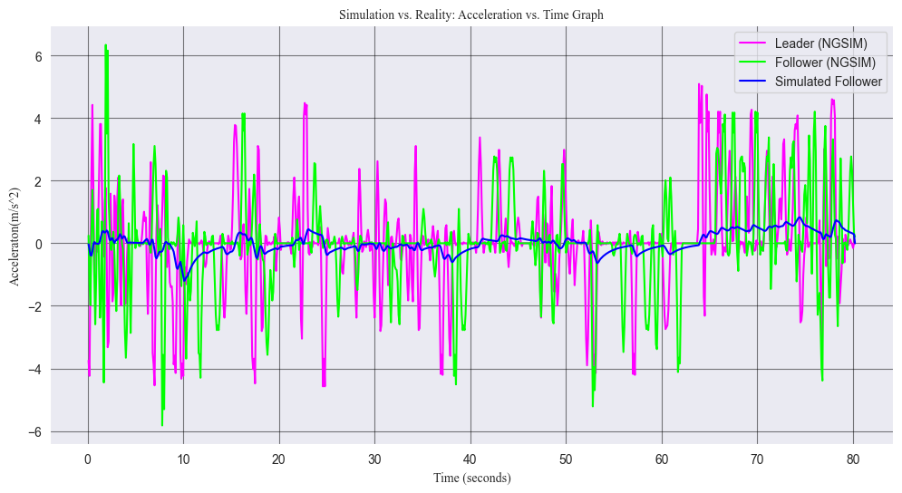
Figure 6 Simulation vs Reality: Acceleration vs Time Graph

References
- National Household Travel Survey Dataset. NHTS. https://excel.officeapps.live.com/x/_layouts/XlFileHandler.aspx?sheetName=Household&downloadAsCsvEnabled=1&WacUserType=WOPI&usid=ced34dde-cea0-8a1f-edbb-1ef6a478a58d&NoAuth=1&waccluster=GUK4
- Next Generation Simulation Dataset. NGSIM. https://excel.officeapps.live.com/x/_layouts/XlFileHandler.aspx?sheetName=in&downloadAsCsvEnabled=1&WacUserType=WOPI&usid=a20239c0-2f5d-2da5-cf70-e9854f8d7416&NoAuth=1&waccluster=PNL1

