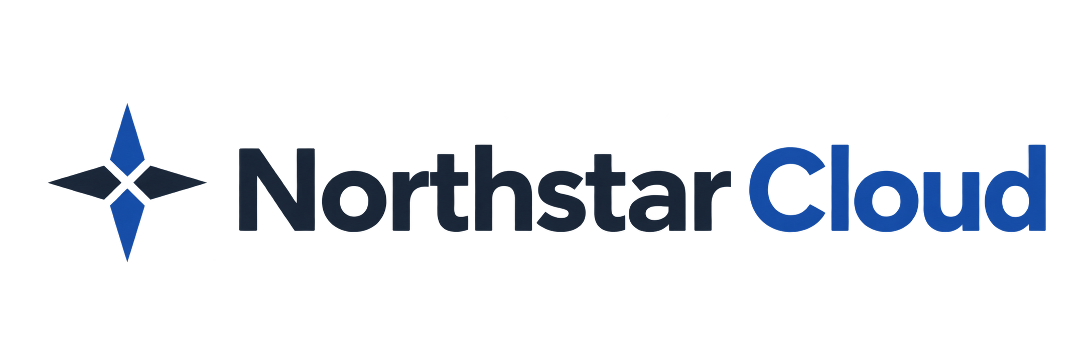

Roles and Permissions
Eliza Lenz | Fictional product documentation portfolio
Every user has one organization role. That role applies throughout Northstar Cloud. Team membership does not add permissions or restrict the role’s access.
Role | Scope
Owner | Manages users, teams, reports, organization settings, and authentication. Can assign or remove the Owner role.
Administrator | Manages other Administrators and Members, teams, and reports. Cannot administer Owners or organization authentication.
Member | Manages their own profile, security, and notifications and views their own team memberships.

Compare Permissions
Capability | Owner | Administrator | Member
View own profile and memberships | Yes | Yes | Yes
Change own name and notifications | Yes | Yes | Yes
View user directory and all teams | Yes | Yes | No
Invite as Administrator or Member | Yes | Yes | No
Resend or revoke invitations | Yes | Yes | No
Create and Manage Teams | Yes | Yes | No
View roles reference and reports; export CSV | Yes | Yes | No
Edit organization settings | Yes | No | No
Configure SSO and MFA policy | Yes | No | No

Permissions for Account Changes
The following actions apply to other users. You cannot change your own role, deactivate yourself, or administratively reset your own multi-factor authentication (MFA).
Action | Owner | Administrator
Change Member to Administrator or reverse | Yes, for Active users | Yes, for Active users
Assign or remove Owner | Yes, for Active users | No
Deactivate or reactivate an Administrator or Member | Yes | Yes
Deactivate or reactivate another Owner | Yes, with Owner safeguards | No
Reset local MFA | Other users | Other Members only

Ownership Safeguards
An organization must always have at least one active Owner. Northstar blocks changes that would remove the last active Owner. Invitations can assign only Administrator or Member; an Owner can promote a user after activation.
Roles cannot be changed for Invited or Deactivated accounts. Role and status changes end the affected user’s sessions. Unauthorized actions are hidden; temporarily unavailable actions are disabled with an explanation.

Personal MFA and Single Sign-On
Owners and Administrators must use local MFA for password sign-in and cannot disable it. Members may disable local MFA only when organization policy allows it. With single sign-on (SSO), MFA is managed by the identity provider.
Even when SSO is required, Owners retain password sign-in with local MFA as a recovery route.
Related guides: Manage Users; Configure SSO; Configure MFA.

