**The Relationships Between Genre Preference, Aural Skills,   
and Tonal Working Memory**

Elizabeth Monzingo,1 Emily M. Elliott,2 Daniel Shanahan,3 David John Baker,4 Juan Ventura,5 and Katherine Vukovics6

1,4,5,6 *School of Music, Louisiana State University, USA*

2 *Department of Psychology, Louisiana State University, USA*

3 *School of Music, Ohio State University, USA*

1emonzi1@lsu.edu, 2eelliott@lsu.edu, 3shanahan.37@osu.edu, 4dbake29@lsu.edu, 5kvukov1@lsu.edu

**Abstract**

Musical training and cognitive abilities appear to be related to one another, but why? Recent research has used measures of musical sophistication to predict measures of working memory capacity, especially tonal working memory capacity, and vice versa, but definitive mediators of the relationship have yet to be identified. Musicians may have an advantage over non-musicians due to their likely enrollment in aural skills courses, in which they learn strategies for melodic dictation, a complex tonal working memory task. They may also have an advantage due to an accruement of aural skills implicitly learned through more meaningful engagement with music, or due to engagement with specific types of music. The aim of this paper is to investigate the role of explicitly and implicitly learned aural skills as potential mediators of the relationship between musicianship and working memory capacity. Results suggest that musicians are more likely to engage strategies that encourage deeper levels of processing for tonal working memory tasks than non-musicians and that musicianship and aural skills achievement help predict tonal working memory capacity. Exploratory analysis of genre preference suggests listening to classical music, jazz, or heavy metal correlates to higher tonal WMC, which encourages further research into genre preference. Considering these findings, we suggest that the “musician advantage” in working memory tasks may be found in the acquisition of valuable strategies for decreasing working memory load gained through the pursuit of musical mastery.

**Introduction**

Students pursuing a degree in music will almost certainly be asked to learn to notate melodies by ear, a task known as melodic dictation. Though the specific strategies and assessment methods incorporated by the instructor will vary, this task generally asks the students to hear a short melody and write it down accurately, given a limited number of play-throughs and a limited amount of technical information (such as the time signature, the clef, etc.). A student’s ability to hold the melody accurately in their working memory, both in between and after play-throughs, is beneficial to the successful completion of the task. When viewed through the lens of cognitive science, the melodic dictation task begins to look like a complex assessment of tonal working memory capacity.

The relationship between musical sophistication and cognitive abilities has been the object of research for some time, and recent literature has focused on the particular cognitive abilities related to working memory tasks (see Müllensiefen et al., 2014 & Ollen, 2006). Meinz and Hambrick (2010) found that variance in sight-reading ability could be predicted by measures of working memory capacity (WMC) beyond sight-reading experience or musical training, and Colley et al. (2018) similarly found that an individual’s WMC helped account for differences in the ability to tap along to expressive timing in music. However, other researchers have found musical training to contribute significantly to performance on working memory tasks. Slevc et al. (2016) found musical ability to predict better performance on both auditory and visual updating tasks, or tasks that involve the ability to both monitor information continuously and quickly add and remove information from working memory. Swaminathan et al. (2017) similarly found evidence that supports musical aptitude as a contributing factor in predicting individual differences in general fluid intelligence between musicians and non-musicians. Talamini et al. (2017) conducted a meta-analysis to clarify whether musicians perform better than non-musicians in memory tasks, and their findings suggest that musicians do seem to have a large advantage with tonal stimuli in particular.

Whether musical ability provides an advantage in WMC or a highly functioning WMC provides an advantage in musical ability, research supports a relationship between the two mechanisms. The objective of this work is to explore potential mediators of this relationship, regardless of which presupposes which. One potential advantage that musicians have over non-musicians is that they are likely to explicitly learn and develop the skills to accomplish melodic dictation, or in other words, they explicitly practice strategies to hold tonal information in their working memory while they simultaneously apply themselves to the task of writing it down in a specific nomenclature. Another potential advantage is found in what musicians implicitly learn through the music they engage with on a regular basis. It is common for people to listen to music on a daily basis, but musicians also actively play, read, and create music. Perhaps the type of music we engage with, and the way in which we engage with the music, influences our ability to work with tonal information in our working memory.

In this paper, we first investigate the contribution of explicit aural skills learning on tonal WMC. We apply a stepwise hierarchical multiple linear regression to identify whether musical sophistication and, more specifically, aural skills achievement are significant factors in participant success in the tonal working memory task. We also examine the strategies that musicians and non-musicians used to complete the tonal working memory task, and we specifically hypothesize that musicians will employ more complex, and more explicitly musical, strategies than non-musicians.

As Wolf and Kopiez found, the prognostic validity of tests administered to incoming students to gauge their aural skills and music theory mastery are quite low (2014); perhaps there are other measures that can predict academic success better than explicit theory and skills knowledge. We investigate the contribution of implicit aural skills learning through an exploration of potential relationships between aural skills achievement, tonal WMC, and genre preference. We chose to explore genre preference due to its potential to serve as an indicator of what type of music the participants regularly enjoyed, and thus the type of music to which participants were regularly exposed.

**Methods**

**Participants**

Two hundred and fifty-four students enrolled at Louisiana State University completed the study. Students were recruited from the Department of Psychology and the School of Music and received course credit or $20. Participants were excluded in the analysis if they reported hearing loss or taking medication that would alter cognitive performance, or if their performance on any task was greater than 3 standard deviations from the mean score of that task. Thus, 15 participants were excluded (hearing loss: 8, age: 1, univariate outliers on one or more WMC tasks: 6). The remaining 239 eligible participants were between the ages of 17 and 43 (M = 19.72, SD = 2.74; 148 females).

**Procedure**

Participants completed a battery of tests and surveys measuring cognitive ability, musical sophistication, aural skills experience, and musical genre preferences. The tasks included the Goldsmiths Musical Sophistication Index (Gold-MSI) self-report inventory (Müllensiefen et al., 2014), the Short Test of Musical Preferences (STOMP; Rentfrow & Gosling 2003), a demographic questionnaire, two tests of general WMC (Symmetry Span and Operation Span, Unsworth et al., 2005), a novel test of tonal WMC (ToneSpan), perceptual tests from the Gold-MSI (Melodic Memory, Beat Perception, Sound Similarity), and two tests of general fluid intelligence (Number Series; Thurstone, 1938, Raven’s Advanced Progressive Matrices; Raven et al., 1998). Researchers later collected final grades for aural skills and music theory courses completed at Louisiana State University. Only the measures used for analysis are included below.

**Goldsmiths Musical Sophistication Index Self-Report (Gold-MSI).** Participants completed a 38-item self-report survey which included free response and Likert scale questions (the complete survey can be found at goo.gl/dqtSaB, Müllensiefen et al., 2014). We also added the Short Test of Musical Preferences (STOMP) to this survey, which asked participants to indicate their preference for 14 genres of music on a 7-point Likert scale.

**Operation Span (OSPAN).** Participants were tasked with completing a two-step math operation and then recalling a letter (F, H, J, K, L, N, P, Q, R, S, T, or Y) in an alternating sequence (Unsworth et al., 2005). The letter was presented visually for 1000ms after each math operation. During letter recall, participants were presented with a 4x3 matrix of all possible letters, each with its own check box. Participants checked the boxes for each letter in the serial order they recalled them being presented.

**Tone Span.** Participants were tasked with completing a two-step math operation and then recalling a tone (high, middle, low) in an alternating sequence (based on Unsworth et al., 2005). The three tones were modelled after Li, Cowan, & Saults (2005), using frequencies outside of the equal tempered system (200Hz, 375Hz, 702Hz). The tone was presented aurally for 1000ms after each math operation. During tone recall, participants were presented with the three possible tones: H, M, and L (High, Medium, and Low), each with its own check box. Participants checked the boxes for each letter in the serial order they recalled them being played.

**Aural Skills Achievement.** Aural skills achievement was operationalized as a composite score of final grades in aural skills courses taken at Louisiana State University. Students who passed into higher-level aural skills courses upon their arrival were given the equivalent of an A for each skipped lower-level aural skills course.

**Results**

**Regression Analysis**

We conducted a stepwise hierarchical multiple linear regression to investigate whether musical sophistication and aural skills achievement predict tonal working memory capacity. We operationalized musical sophistication as the General score from the Gold-MSI, and we operationalized tonal working memory capacity as the Tone Span score.

The results of our models can be seen in Table 1. Model 1 predicted Tone Span based on the self-report General score from the Gold-MSI. In the second step of the regression analysis, we added the composite aural skills achievement score to the model. There was a significant difference between model 1 and model 2, F(2, 211) = 5.99, *p* < .02 and the adjusted R2 value increased from .18 to .20.

**Table 1. Regression results using Tone Span score as the criterion.**

|  |  |  |  |  |  |  |  |  |  |
| --- | --- | --- | --- | --- | --- | --- | --- | --- | --- |
| Predictor | *b* | *b* 95% CI  [LL, UL] | *beta* | *beta* 95% CI  [LL, UL] | *sr2* | *sr2*  95% CI  [LL, UL] | *r* | Fit | Difference |
| (Intercept) | 29.51** | [22.38, 36.64] |  |  |  |  |  |  |  |
| GENERAL | 0.29** | [0.20, 0.37] | 0.43 | [0.30, 0.55] | .18 | [NA, NA] | .43** |  |  |
|  |  |  |  |  |  |  |  | *R2*  = .181** |  |
|  |  |  |  |  |  |  |  | 95% CI[NA,NA] |  |
|  |  |  |  |  |  |  |  |  |  |
| (Intercept) | 32.05** | [24.71, 39.38] |  |  |  |  |  |  |  |
| GENERAL | 0.24** | [0.15, 0.33] | 0.36 | [0.22, 0.49] | .10 | [.03, .18] | .43** |  |  |
| CompositeAural | 0.60* | [0.12, 1.09] | 0.17 | [0.03, 0.30] | .02 | [-.01, .06] | .31** |  |  |
|  |  |  |  |  |  |  |  | *R2*  = .203** | Δ*R2*  = .023* |
|  |  |  |  |  |  |  |  | 95% CI[NA,NA] | 95% CI[-.01, .06] |
| *Note.* A significant *b*-weight indicates the beta-weight and semi-partial correlation are also significant. *b* represents unstandardized regression weights. *beta* indicates the standardized regression weights. *sr2* represents the semi-partial correlation squared. *r* represents the zero-order correlation. *LL* and *UL* indicate the lower and upper limits of a confidence interval, respectively. * indicates *p* < .05. ** indicates *p* < .01. | | | | | | | | | |

**Tone Span Strategies**

Due to apparatus error, strategy responses could not be retrieved for 113 participants, leaving a total of N=126 participants in analyses involving Tone Span strategy data. To compare the strategies employed by musicians to those employed by non-musicians, we divided the participants by the way in which they were recruited; participants recruited through the School of Music were considered musicians, and those recruited through the Department of Psychology were considered non-musicians. We chose to operationalize in this manner for this comparison because we were particularly interested in the potential influence of aural skills courses on strategy use.

We asked participants to explain what strategies they employed in order to complete the Tone Span task in a free answer format. Five coders independently coded the responses as indicative of one or more of six different strategies we were interested in; if two or more coders agreed on a strategy type, the participant response was coded accordingly. As illustrated in Figure 1, a similar percentage of musicians and non-musicians indicated that they employed rehearsal and ordinal strategies. No musicians responded in a manner that indicated no strategy was used, while some non-musicians responded in a manner that indicated they did not use a strategy. A larger percentage of musicians than non-musicians indicated that they employed each of the remaining strategies. Table 2 shows the percentages of musician and non-musician responses indicating each type of strategy.

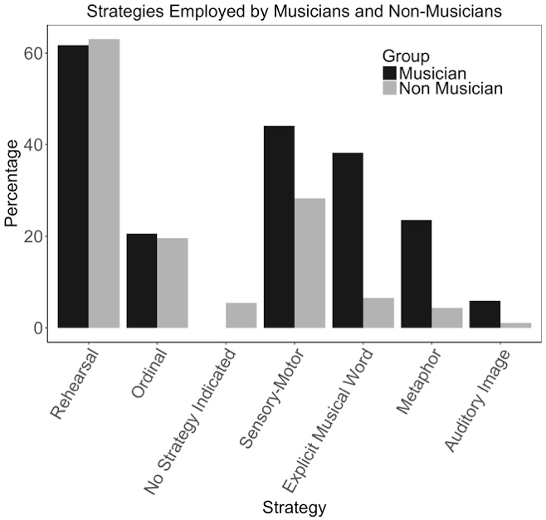

**Figure 1. Percentage of musicians and non-musicians who indicated employing each type of strategy in the Tone Span task.**

**Table 2. Percentage of musicians and non-musicians who indicated employing each type of strategy in the Tone Span task.**

|  |  |  |
| --- | --- | --- |
|  | **Percentage** | |
| **Strategy Employed** | **Musician** | **Non-Musician** |
| Rehearsal | 61 | 63 |
| Ordinal | 21 | 20 |
| No Strategy Indicated | 0 | 5 |
| Sensory-Motor | 44 | 28 |
| Explicit Musical Word | 38 | 7 |
| Metaphor | 23 | 4 |
| Auditory Image | 6 | 1 |

**Exploratory Relationships**

We found a significant and positive correlation between the composite aural skills score and the Tone Span score, as can be seen in Figure 2. However, when we focused on the musicians alone, the correlation disappears (see Figure 3). This finding may reflect the “musician advantage” in tonal working memory capacity, but may fail to illustrate an explicit link between tonal working memory capacity and aural skills achievement.

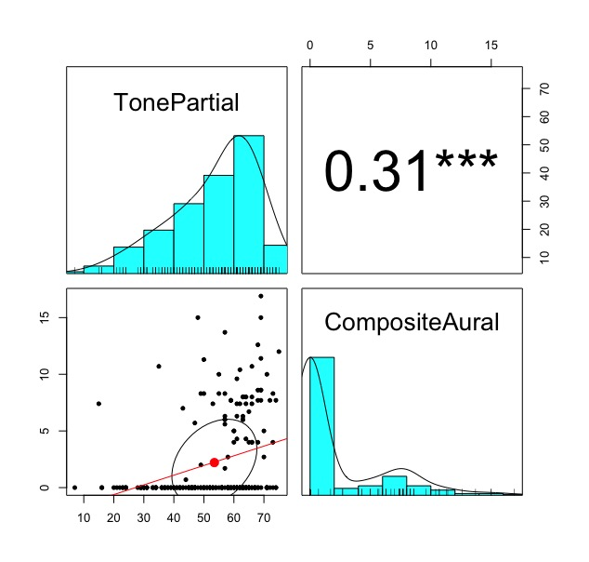

**Figure 2. Correlation between Tone Span score and composite aural skills achievement score, including entire subject pool (both musicians and non-musicians). *** indicates *p* < .001.**

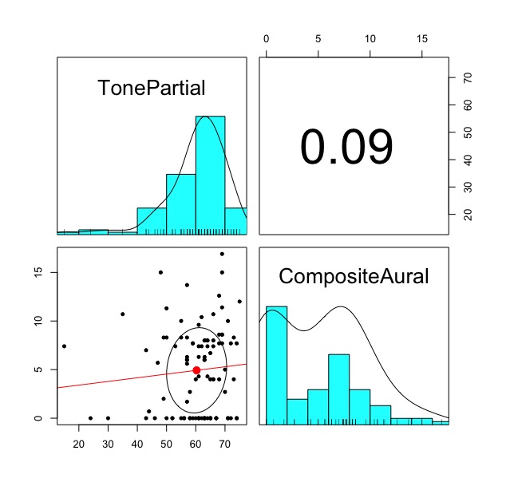

**Figure 3. Correlation between Tone Span score and composite aural skills achievement score, using only musicians from the subject pool.**

We next explored the correlations between genre preference and Tone Span score. We found indicated preference for three of the fourteen genres to correlate significantly and positively with Tone Span score after applying a Bonferroni correction for Type I error, as can be seen in Table 3.

**Table 3. Correlations between indicated preference for genre and Tone Span score. * indicates *p* < .05, ** indicates *p* < .01, and *** indicates *p* < .001. With a Bonferroni correction, only correlations marked with *** remain significant.**

|  |  |
| --- | --- |
| **Genre** | **Correlation with Tone Span Score** |
| Classical | 0.29*** |
| Blues | 0.20** |
| Country | -0.11 |
| Dance/Electronica | 0.01 |
| Folk | 0.20** |
| Rap/Hip-Hop | -0.13 |
| Soul/Funk | 0.12 |
| Religious | 0.01 |
| Alternative | 0.11 |
| Jazz | 0.31*** |
| Rock | 0.18* |
| Pop | -0.02 |
| Heavy Metal | 0.26*** |
| Soundtracks/Theme Songs | 0.10 |

**Discussion**

Musicians seem to have an advantage over non-musicians in tonal working memory tasks, which is what motivated our exploration of potential reasons for this advantage. One possibility is that musicians explicitly practice strategies for maintaining tonal information in their working memory, strategies they are likely to learn in an aural skills classroom. To investigate this possibility, we examined the ability of musicianship and aural skills achievement to predict our measure of tonal working memory capacity (WMC). We found that musicianship was able to account for approximately 18% of the variance in tonal WMC, and when we added aural skills achievement to the regression model, we were able to account for an extra 2% of variance. This finding serves to support the claim that musicians have an advantage in tonal working memory tasks, and it also suggests that success in aural skills courses may contribute to that advantage.

We then took a closer look at the strategies participants used to maintain tonal information in their working memory in our tonal working memory task, hypothesizing that musicians would be more likely to use strategies that encouraged deeper levels of processing, as well as strategies that were explicitly musical in nature. We found that a similar percentage of musicians and non-musicians indicated they employed rehearsal and ordinal strategies, while a higher percentage of musicians indicated they employed all the other strategies we were interested in. These findings support the theory that musicians are more likely to learn, and more likely to be aware enough to report using, strategies that encourage deeper levels of processing so as to potentially lessen working memory load.

Finally, we explored relationships between aural skills achievement, tonal working memory capacity, and genre performance. We first examined the entire participant pool and found a significant a positive correlation between aural skills achievement and tonal WMC. However, as roughly half of our sample had very low aural skills achievement scores (due to not having taken aural skills courses), we decided to further investigate this correlation within the pool of musician participants alone. This second correlation was non-existent. These findings likely serve to add support to the theory that musicianship is highly related to tonal working memory capacity, as musicians were more likely to have higher aural skills achievement scores than non-musicians. However, as the correlation disappears when focusing on musicians alone, it calls into question whether the skills musicians learn in aural skills courses are contributing in a meaningful way to tonal WMC. It may be that our population lacked in sufficient diversity to see the relationship clearly, or that, as Wolf and Kopiez state, grade inflation has served to diminish the predictive ability of grades (2014). Given the findings of the regression model, the types of strategies employed, and the significant correlation found between aural skills achievement and tonal WMC, we propose that aural skills courses are still worthy of future investigation into the question of the “musician advantage” in tonal working memory tasks.

We next considered the relationship between tonal WMC and genre preference, and we found that participants who indicated a higher preference for classical music, jazz, or heavy metal were also more likely to achieve a higher tonal WMC score. These correlations may serve to indicate that musicians are more likely to enjoy these genres than non-musicians, which makes intuitive sense given that undergraduate music students are likely to be studying either classical or jazz music, though the strong correlation between tonal WMC and preference for heavy metal music is somewhat surprising. The correlations may also serve to indicate that the music typical to these genres in some way facilitates the learning of tonal working memory strategies that allow for higher tonal WMC. Future research in a controlled setting would help illuminate the reasons behind the relationships we have explored in this study.

**Conclusion**

In this paper we examined the relationships between aural skills achievement, tonal working memory capacity, and genre preference in an effort to further explore the “musician advantage” in tonal working memory tasks. Our findings suggest that musicianship and aural skills achievement may contribute to higher tonal WMC, and that the strategies musicians develop to manipulate tonal information in their working memory may be a significant mediator of the relationship between musicianship and tonal WMC. Future research will continue exploring implicit learning of these strategies through engagement with particular genres.

**Acknowledgements.** The authors would like to thank Connor Davis, Hailey Holt, Hannah Keller, Brian Ritter, and Christopher Young for their help running participants for this study.

**References**

Colley, I. D., Keller, P. E., & Halpern, A. R. (2018). Working Memory and Auditory Imagery Predict Sensorimotor Synchronization with Expressively Timed Music. *Quarterly Journal of Experimental Psychology*, doi:10.1080/17470218.2017.1366531.

Harrison, Carole S., Edward P. Asmus, and Richard T. Serpe. (1994). “Effects of Musical Aptitude, Academic Ability, Music Experience, and Motivation on Aural Skills.” *Journal of Research in Music Education 42* (2). SAGE Publications Inc: 131–44.

Honing, Henkjan, and Olivia Ladinig. (2009). “Exposure Influences Expressive Timing Judgments in Music.” *Journal of Experimental Psychology: Human Perception and Performance* *35* (1): 281–88.

Meinz, E. J., & Hambrick, D. Z. (2010). Deliberate practice is necessary but not sufficient to explain individual differences in piano sight-reading skill: The role of working memory capacity. *Psychological Science*, *21*(7), 914-919.

Müllensiefen, D., Gingras, B., Musil, J., & Stewart, L. (2014). The musicality of non-musicians: an index for assessing musical sophistication in the general population. *PloS one, 9*(2), e89642.

Ollen, J. E. (2006). A criterion-related validity test of selected indicators of musical sophistication using expert ratings [electronic resource]. Available at http://www.ohiolink.edu/etd/view.cgi?osu1161705351.

Raven, J., Raven, J. C., & Court, J. H. (1998). Manual for Raven’s Progressive Matrices and Vocabulary Scales. Oxford, England: Oxford Psychologists Press.

Rentfrow, Peter J., and Samuel D. Gosling. (2003). “The Do Re Mi’s of Everyday Life: The Structure and Personality Correlates of Music Preferences.” *Journal of Personality and Social Psychology 84* (6): 1236–56.

Slevc, L. R., Davey, N. S., Buschkuehl, M., & Jaeggi, S. M. (2016). Tuning the mind: Exploring the connections between musical ability and executive functions. *Cognition, 152*: 199-211. doi:10.1016/j.cognition.2016.03.017.

Swaminathan, S., Schellenberg, E. G., & Khalil, S. (2017). Revisiting the association between music lessons and intelligence: Training effects or music aptitude? *Intelligence, 62*:119-124. doi:10.1016/j.intell.2017.03.005.

Talamini, Francesca, Gianmarco Altoè, Barbara Carretti, and Massimo Grassi. (2017). “Musicians Have Better Memory than Nonmusicians: A Meta-Analysis.” *PloS One 12* (10): e0186773.

Thurstone, L. L. (1938). Primary mental abilities. Chicago, IL: University of Chicago Press.

Unsworth, N., Heitz, R. P., Schrock, J. C., & Engle, R. W. (2005). An automated version of the operation span task.   
*Behavior Research Methods, 37* (3): 498-505. doi:10.3758/BF03192720.

Wolf, Anna, and Reinhard Kopiez. (2014). “Do Grades Reflect the Development of Excellence in Music Students? The Prognostic Validity of Entrance Exams at Universities of Music.” *Musicae Scientiae:* *The Journal of the European Society for the Cognitive Sciences of Music 18* (2): 232–48.