**The Effects of Melodic Contagions in the Oral Transmission of Melodies**

Elizabeth Monzingo,1 Daniel Shanahan,2 Anthony Marasco,3 Emily M. Elliott,4 David John Baker,5 Connor Davis,6 and Joshua Albrecht7

1,2,3,5,6 *School of Music, Louisiana State University, USA*2 *School of Music, Ohio State University, USA*

4 *Department of Psychology, Louisiana State University, USA*

7 *Music Department, University of Mary Hardin-Baylor, USA*

1emonzi1@lsu.edu, 2shanahan.37@osu.edu, 3amarasco@lsu.edu, 4eelliott@lsu.edu, 5dbake29@lsu.edu, 6cdav224@lsu.edu, 7jalbrecht@umhb.edu

**Abstract**

Previous research into the transmission and altering of musical signals has primarily examined recognition tasks, emphasizing the role of memory (e.g. Halpern & Bartlett, 2010). Recent studies suggest that the physical act of melodic production might also play a role. Shanahan and Albrecht (forthcoming) found that ascending stepwise motion at cadences tended to be replaced by descending stepwise motion over the course of oral transmission of melodies in a linear transmission train. The current study hypothesizes that this effect will be amplified over the course of oral transmission in a diffusion-based model, in which we examine the influence of a “contagion” cadence. We also examine the ability of measures of working memory capacity and musical sophistication to predict participant choice of cadence. Findings show that the contagion cadence serves to influence the type of cadence participants sing, and the descending contagion cadence exerts more influence than the ascending contagion cadence. Further, measures of working memory capacity and musical sophistication have no significant effect on the cadence chosen. We argue that chosen cadences align with physiological affordances, such that descending cadences are more likely to be sung than ascending cadences.

**Introduction**

There are a number of reasons why one melody might be more likely to be transmitted than another. Perhaps certain melodies contain features that are reminiscent of specific events; perhaps they are sung my more influential people, and connote status; perhaps melodies that are more prototypical are more likely to be transmitted, or perhaps it’s about simplicity. Recent work by Shanahan and Albrecht (forthcoming) has examined how melodies that are less physically affordant (i.e. those with cadences that ascend, rather than descend), are more likely to be transformed than a descending melody. Put more succinctly, “ti-do” melodies are far more likely to transform into “re-do” melodies than vice versa.

The field of Social Learning focuses on why certain ideas might be more easily lost in transmission than others, and is defined as “learning that is influenced by observation of, or interaction with, another animal…” (Hoppitt & Laland, 2013). The study of the transmission of ideas encompasses a broad scope, including evolutionary biology, animal behavior, and decision theory, among other fields. An example from the animal world includes a Payne and Payne study (1985), that found that male humpback whales in a certain population all sang a song that would gradually change through the season, as various changes were gradually introduced. Similarly, Garland et al. (2011) found that migration of humpback whales created a change in song types that followed the migratory patterns.

One of the earliest examples of a study focusing on information lost during transmission was Bartlett’s (1932) early work on memory and transmission, which involved participants being presented with either text or a picture, recalling it, and having the result of that recall passed to the next participant, who in turn produced their own version of their recollection to another participant. Bartlett concluded that there are always some features —“dominant features”— that are more easily maintained than others throughout transmission. This type of methodology is known as a “transmission chain.” The simplest form of transmission chain is a linear transmission chain, in which one person directly demonstrates to one observer (see Figure 1).

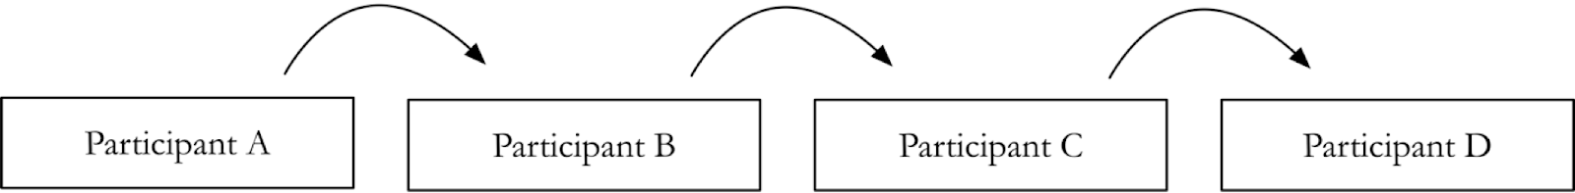

**Figure 1.  A linear transmission chain, demonstrating a melody from a single demonstrator to a single observer.**

The transmission chain methodology seems particularly appropriate for examining how a musical signal like a melody changes over time. One benefit of this approach is the ability to conduct an experiment in a controlled laboratory environment. On the other hand, it is unlikely that an idea is presented to an observer by only one demonstrator. For example, it is far more likely that a melody will have been sung to someone by multiple people before that person teaches it to someone else.

A more ecologically valid approach would be to enlist a diffusion-based model, in which each observer is presented with multiple versions of a melody (see Figure 2). In this paradigm, the observer not only tries to replicate a previously-encountered melody, but they are forced to make a choice regarding which melody they should replicate. In a more complex paradigm, this observer would then become one of four more demonstrators, and this would continue for a number of rounds.

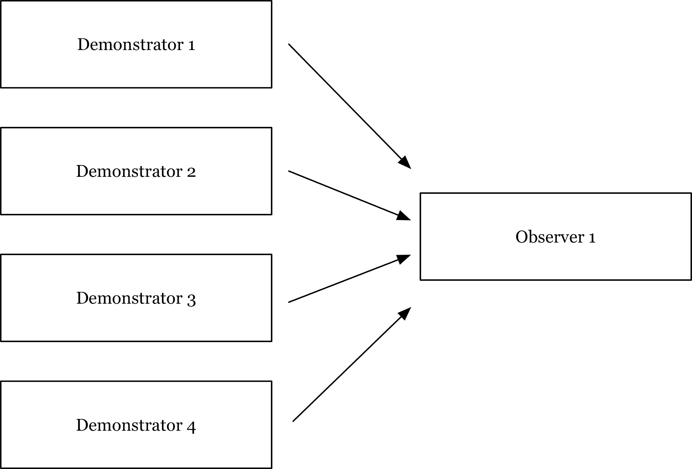

**Figure 2.  A diffusion-based model, in which one observer is presented with options from multiple demonstrators.**

For this study, we were interested in whether the melodies changed in the predicted fashion given multiple demonstrators and a “contagion” cadence. Specifically, we were interested in whether “re-do” (^2-^1) melodies would be more likely to be transmitted than “ti-do” (^7-^8) melodies when presented by multiple individuals, and we wondered whether this transformation would be amplified by presenting a single “re-do” cadence along with the “ti-do” cadences, or by presenting a single “ti-do” cadence along with the “re-do” cadences. We were also interested in how measures of working memory capacity and musical sophistication might be predictive of the choices observers made.

**Methods**

**Participants**

Seventy-two students enrolled at Louisiana State University participated in this study. Forty-two participants were recruited from the School of Music, and thirty participants were recruited from the Department of Psychology. Two participants were excluded due to attrition and four participants were excluded due to working memory capacity scores more than 3.5 SD from the mean (final N=66). Eligible participants were between the ages of 18 and 26 (M = 19.55, SD = 1.63; 31 females). Participants received course credit.

**Melodies**

Eight melodies were chosen as the tonal stimuli for this study. These melodies were chosen in a previous study (Shanahan and Albrecht, forthcoming), because they were meant to mirror the process of oral transmission as much as possible, but were not prevalent enough that participants would be aware of them. The previous study therefore employed an orally transmitted repertoire that would be unfamiliar to our participants. In order to mitigate the effects of lyrics, the original study by Shanahan and Albrecht set out to find stimuli in which the songs were sung on a neutral syllable. A suitable corpus that fulfills all of these criteria can be found in Weiss, et al. (2012). This study involved “unfamiliar folk melodies from the United Kingdom and Ireland [that]...conformed to Western tonality” sung by “an amateur female (alto) singer without lyrics (i.e. “la” for each note) in an everyday (non-operatic) manner” (p. 1075). Four of the chosen melodies included a re-do cadence, and four of the melodies included a ti-do cadence. Four vocalists (two men and two women) at Louisiana State University recorded two versions of each melody; one version included the original cadence, while the second version included the altered cadence.

**Goldsmiths Musical Sophistication Index (Gold-MSI)**

Participants completed the Gold-MSI Self Report, Beat Perception, Melodic Memory, and Sound Similarity Tasks. We used the General score from the Self Report, in which participants completed a 38-item self-report survey that included free response and Likert scale questions (the complete survey can be found at goo.gl/dqtSaB, Müllensiefen et al., 2014).

**Measures of Working Memory Capacity**

Participants completed one block each of three measures of working memory capacity (Foster et al., 2014). Each included a practice trial before the test trial.

**Operation Span (OSPAN).** Participants were tasked with completing a two-step math operation and then recalling a letter (F, H, J, K, L, N, P, Q, R, S, T, or Y) in an alternating sequence. The letter was presented visually for 1000ms after each math operation. During letter recall, participants were presented with a 4x3 matrix of all possible letters, each with its own check box. Participants clicked the check boxes for each letter in the serial order they recalled them being presented.

**Symmetry Span (SSPAN).** Participants were tasked with completing a two-step symmetry judgement and then recalling a visually presented red square on a 4x4 matrix in an alternating sequence. The square was presented in one of sixteen locations on a 4x4 matrix for 650ms after each symmetry judgement. In the symmetry judgement, participants were shown an 8x8 matrix with random squares filled in black, and they decided if the black squares were symmetrical about the matrix’s central vertical axis. During square recall, participants were presented with the 4x4 matrix and clicked the locations in the serial order they recalled the squares being presented.

**Rotation Span (RSPAN).** Participants were tasked with completing a two-step rotation match judgement and then recalling a visually presented arrow in an alternating sequence. The arrow was either of short or long length and pointed in one of eight different directions. In the rotation match judgement, participants were shown a rotated letter, and they decided whether the letter was presented correctly or as a mirrored image of the letter. During arrow recall, participants were presented with the sixteen possible arrows and clicked them in the serial order they recalled the arrows being presented.

**Procedure**

Participants in this study completed eight tasks in about 75 minutes. In the first task, participants were asked to listen to, and then record themselves singing, eight unique melodies.

Upon arrival, participants were assigned to one of two conditions (Condition A or Condition B). In each condition, each melody was demonstrated four times, as if by four different demonstrators. As Figure 3 illustrates, there were two possible presentation types: Descending Dominant Presentation or Ascending Dominant Presentation, labeled in accordance with the cadence that dominated the demonstrations in each presentation. In each set of four demonstrations, a single melody demonstration included a contagion cadence that opposed the other three demonstration cadences. More specifically, in Condition A, Melodies 1-4 were each presented in sets of 4 that included 3 re-do cadences and 1 ti-do cadence, while Melodies 5-8 were each presented in sets of 4 that included 3 ti-do cadences and 1 re-do cadence. In Condition B, Melodies 1-4 were each presented in sets of 4 that included 3 ti-do cadences and 1 re-do cadence, while Melodies 5-8 were each presented in sets of 4 that included 3 re-do cadences and 1 ti-do cadence. Table 1 illustrates how these melody and condition combinations ultimately sorted into the two presentation types.

Descending Dominant Presentation

Demonstrator 4: re-do cadence

Demonstrator 2: re-do cadence

Demonstrator 1: re-do cadence

Demonstrator 3: ti-do cadence

Observer

Ascending Dominant Presentation

Demonstrator 4: ti-do cadence

Demonstrator 2: re-do cadence

Demonstrator 1: ti-do cadence

Demonstrator 3: ti-do cadence

Observer

**Figure 3. The diffusion model includes a single “contagion” demonstration in each presentation type.**

To carry out the experiment, we designed software in Max/MSP. The interface played the four versions of each unique melody, as recorded by four vocalists (two men and two women), in a random order with two seconds of silence between them. Then, following a ten-second break after the final version of the melody played, the interface recorded the participant’s own sung version of the melody. Participants were instructed to match the melody presented as best they were able. When they were finished recording, participants were given the option to either erase their current recording and re-record their rendition, or to continue on to the next melody set. During their session, the software logged data to an embedded dictionary, keeping track of their subject number, the playback order of each melody set’s audio files, and the number of times they opted to re-record their rendition of the melody before moving on to the next melody. At the end of each participant session, the research assistant is exported and saved the embedded dictionary log as a JSON file. Participants were able to learn this process during a practice trial before continuing on to the experimental melodies.

**Table 1. Each melody was demonstrated in one of two presentation types.**

|  |  |  |
| --- | --- | --- |
| Presentation Type | Cadences Demonstrated | Melody + Condition |
| Descending Dominant Presentation | Demonstrators 1–3: “re-do”  Demonstrator 4: “ti-do” | Melody 1 + Condition A  Melody 2 + Condition A  Melody 3 + Condition A  Melody 4 + Condition A  Melody 5 + Condition B  Melody 6 + Condition B  Melody 7 + Condition B  Melody 8 + Condition B |
| Ascending Dominant Presentation | Demonstrators 1–3: “ti-do”  Demonstrator 4: “re-do” | Melody 1 + Condition B  Melody 2 + Condition B  Melody 3 + Condition B  Melody 4 + Condition B  Melody 5 + Condition A  Melody 6 + Condition A  Melody 7 + Condition A  Melody 8 + Condition A |

Participants then completed the Gold-MSI Self-Report, Beat Perception, Melodic Memory, and Sound Similarity Tests. Following that, they completed one block each of OSPAN, SSPAN, and RSPAN. Each task was administered on a desktop computer. Sounds were presented at a comfortable listening level for the tasks that required headphones. All participants provided informed consent.

**Results**

Our hypothesis stated that ti-do cadences would transform more often into re-do cadences than vice-versa through the act of oral transmission, despite the presentation of the opposite cadence alongside the original. Melodies recorded by participants sourced from the Department of Psychology were often difficult to label with solfege; as a result, we operationalized the re-do cadence as a descending cadence and the ti-do cadence as an ascending cadence. To test our hypothesis, 5 coders independently coded a subset of the melodies in the following way: assigned solfege to the final three pitches (if possible), discounting repeated pitches; provided a contour vector for the last three pitches; and labeled the movement from the penultimate pitch to the final pitch as “ascending” or “descending.”

A chi-square test was performed for each presentation type. Under the null hypothesis, participants would sing the dominantly presented cadence 75% of the time, and the weakly presented cadence 25% of the time. We expected to see the re-do contagion influence participants to sing the descending cadence more often than expected, and more often than the ti-do contagion influenced participants to sing the ascending cadence. Following the Ascending Dominant Presentation of a melody, participants were more likely to sing a descending cadence than expected, X2 (1, N=258) = 32.25, *p* = .0001. Following the Descending Dominant Presentation of a melody, participants were more likely to sing an ascending cadence than expected, X2 (1, N=260) = 5.25, *p* = .02. This suggests that the contagion demonstration asserted a significant influence on which cadence the participant sang, regardless of whether the contagion was a descending or ascending cadence.

**Figure 4. The percentage of ascending and descending cadences observed in each presentation type.**

In order to see if there was an effect of musicianship or working memory capacity, we examined measures of musical sophistication and working memory capacity as predictors in whether the penultimate note was changed. We operationalized musical sophistication as the General score from the Gold-MSI. We converted the working memory task recall scores to z-scores and made a composite measure of working memory capacity by averaging across all three z scores. A mixed-effects logistic regression was conducted, with working memory capacity and musical sophistication scores (log-transformed) as random effects, and the melody sung as a fixed effect. No effect was seen on penultimate note change (*p* = .65, n=432). This would suggest that the task was possibly less about memory or musicianship than about physiological affordances (see Figure 5).

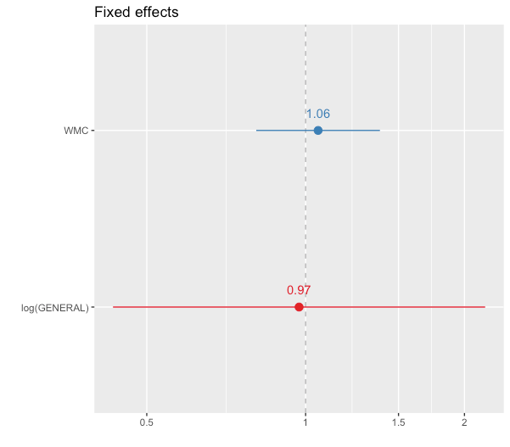

**Figure 5: A log-odds ratio of both working memory capacity and general musical sophistication, showing no significant effect.**

**Discussion**

In both cases, the contagion was influential on the participant’s choice of cadence. However, as Figure 4 and a comparison of the two chi-square values would indicate, the descending cadence contagion exerted a more powerful influence than the ascending cadence. This serves to support the theory that physiological affordances may be playing a significant role. As observed in Shanahan & Albrecht (forthcoming), physiological affordances can serve to minimize elements that deviate from the norm. In the same way that pitch tends to decline over the course of an utterance (see Collier, 1975; Vassiere, 1984; Hart, Collier, & Cohen, 2006), it may be the case that melodies also decline in pitch toward the end of a phrase. The near-ubiquitous effect found in speech is a convincing example of the “principle of least effort” (Bloomfield, 1933); perhaps the same principle also applies to melodies.

Physiological affordances may be a contributing factor in the transformation of melodies as they disseminate through oral transmission. In this study, we presented multiple demonstrations to a single observer, an improvement of ecological validity from the linear transmission chain previously used, in which each observer heard the melody from a single demonstrator. However, our study only included a single step - one transmission from multiple demonstrators to a single observer - instead of a transmission chain. We plan to expand upon this study in the future, such that each observer becomes one of multiple demonstrators to another observer. This future work will examine the transformation of cadences through the oral transmission of melodies over multiple transmission points to investigate the physical affordances theory further.

**Conclusion**

In this paper we examined the transformation of cadences through oral transmission. A “contagion” cadence demonstration significantly influenced whether the participant sang a descending or ascending cadence, and the descending cadence contagion was more influential than the ascending cadence contagion. We propose that this is due to physiological affordances, especially given that neither working memory capacity nor musical sophistication were predictive of cadence transformation. Future studies will extend the oral transmission chain to involve multiple points of dissemination.

**Acknowledgements**. The authors would like to thank Madison Casey, Hannah Keller, Andrew Owen, Brian Ritter, Adam Rosado, Katie Vukovics, and Christopher Young for their assistance in this study.

**References**

Bartlett, F. C. (1932). Remembering: An Experimental and Social Study. *Cambridge: Cambridge University*.

Bloomfield, L. (1933). *Language history: from Language (1933 ed.)*. Holt, Rinehart and Winston.

Collier, R. (1975). Physiological, correlates of intonation patterns. *The Journal of the Acoustical Society of America*, *58*(1), 249–256.

Foster, Jeffrey L., Zach Shipstead, Tyler L. Harrison, Kenny L. Hicks, Thomas S. Redick, and Randall W. Engle. (2015). “Shortened Complex Span Tasks Can Reliably Measure Working Memory Capacity.” Memory & Cognition, 43 (2), 226–36.

Garland, E. C., Goldizen, A. W., Rekdahl, M.s L., Constantine, R., Garrigue, C., Hauser, N. D., Noad, M. J. (2011). Dynamic horizontal cultural transmission of humpback whale song at the ocean basin scale. *Current Biology: CB*, *21*(8), 687–691.

Halpern, A. R., & Bartlett, J. C. (2010). Memory for Melodies. In Music Perception (pp. 233–258). Springer, New York, NY.

Hart, J. T., Collier, R., & Cohen, A. (2006). *A Perceptual Study of Intonation: An Experimental-Phonetic Approach to Speech Melody*. Cambridge University Press.Hoppitt, W., & Laland, K. N. (2013). Social Learning: An Introduction to Mechanisms, Methods, and Models. Princeton University Press.

Müllensiefen, D., & Halpern, A. R. (2014). The role of features and context in recognition of novel melodies. Music Perception: An Interdisciplinary Journal, 31 (5), 418–435.

Payne, K., & Payne, R. (1985). Large Scale Changes over 19 Years in Songs of Humpback Whales in Bermuda. *Zeitschrift Für Tierpsychologie*, *68*(2), 89–114.

Shanahan, D. and Albrecht, J. (forthcoming). Examining the Effect of Oral Transmission on Folksongs. Music Perception.

Smith, K., Brighton, H., & Kirby, S. (2003). Complex Systems in Language Evolution: The Cultural Emergence of Compositional Structure. Advances in Complex Systems, 06(04), 537–558.

Vaissière, J. (1984). PROSEIDON, Automatic Detection of Prosodic Cues in Continuous Speech. XIIIes JEP, 53–66.

Weiss, M. W., Trehub, S. E., & Schellenberg, E. G. (2012). Something in the way she sings: enhanced memory for vocal melodies. Psychological Science, 23(10), 1074–1078.