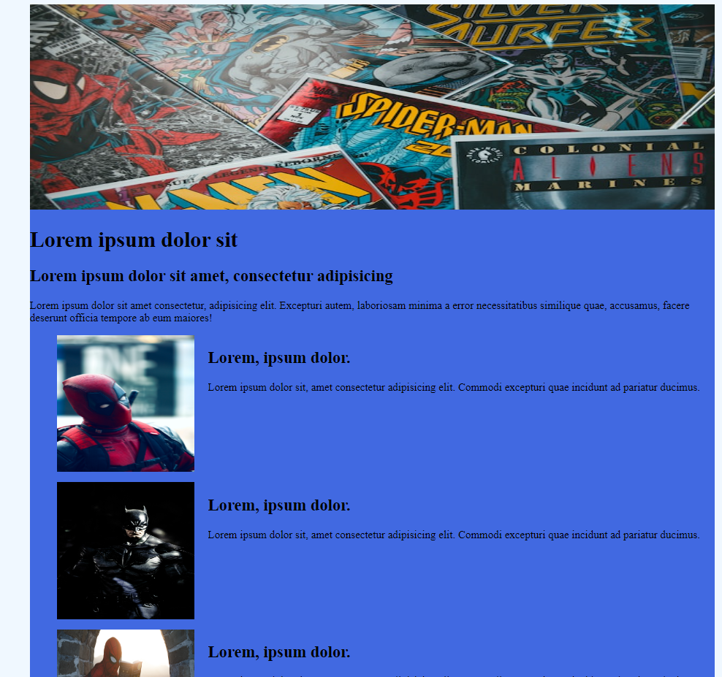

Convert the flowing html page with all the CSS included, to React Website.

1. Create a new React app. Using the command – ‘create-react-app app-name-whatever’
2. Header image and the subtitle 1 and 2 should be in component let call it HadderComponent.  
   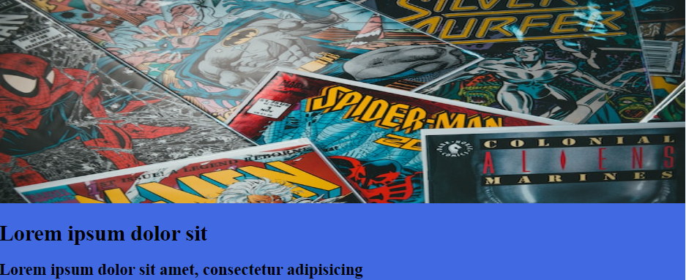
3. Each item in the list should be in a separate component. For that we need to create another component CardComponent.

HeaderComponent – should receive 3 arguments

1. imageUrl or path
2. title
3. description

CardComponent – should receive 3 arguments

1. imageUrl or path
2. title
3. description