**Family Tree**

**Input:** A family tree consists of members (nodes) and the interconnection (edges) shows the relationship between family members.

**Output:**

1. Displays the successors of a given member.
2. Displays the parent of a given member.
3. Displays the grandparent of a given member.

**Tree Structure:**

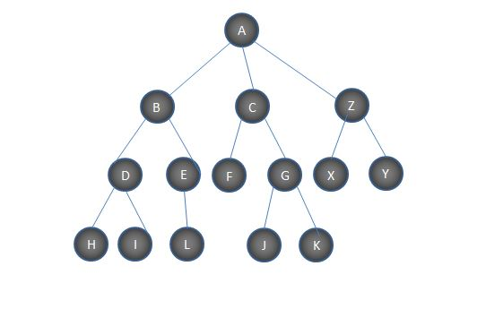

Tree structure used for the program is given above, family tree named as my_family.

This program has three functions:

**children(family, person)**

The function children(family,person) takes a Dictionary ie, family tree as its first parameter, and second is the name of a person. It return a list giving all the known successors of the input person.

**findparent(family,child)**

The function findparent(family,child) also takes a Dictionary as its first input, and second is the name of a member in the tree. It returns the parent (immediate ancestor) of the input member.

**grandparent(family, child)**

The function grandparent(family,child) also takes the family tree dictionary as its first input, and a member of the tree is provided as second input. It returns the grandparent of the input member.

**Run: python family_tree.py**

**Sample Output:**

**//Input member: C**

**\*\*\* All children \*\*\***

**['F', 'G', 'J', 'K']**

**//Input member: Y**

**\*\*\* Parent \*\*\***

**Z**

**//Input member: D**

**\*\*\* Grandparent \*\*\***

**Grand parent is: A**