CIS 415 Operating Systems

Assignment 1 Report Collection

Submitted to:

Prof. Allen Malony

Author:

*Xiangqian Zhang*

**Report**

**Introduction**

*In this project, I am building a shell in C which would have 8 fundamental commands. Also, this project asks to practice some LINUX system calls in the command.c file.*

**Background**

*Since this project asks to consider two modes, one is interactive and the other one is file mode. So in order to make the start simple, I first implement the interactive mode and simply test if each command can be tokenized and recognized. Then, I applied same logic to the file mode. When it comes to how store the tokenized commands, I used a 2-D array to store each token and then analyze each token according to the requirements of each command.*

**Implementation**

*So far, I am having trouble with cp and mv commands. I cannot correctly implement the cp command when the destination is just a directory with/without filename. I’ve tried to use the system call stat, but it turned out not work ideally. Then I rewrite it into couple situations which individually deal with file and path mode for source and destination sources.*

*Currently, my cp only works when source path is a file name or path name and destination path is only allowed to be a file name. I still couldn’t to figure out how to recognize the destinationPath type so that my cp can work ideally. Because the mv is very similar to cp, so I cannot make it work ideally until I solve the cp problems.*

*Here is my cp command:*

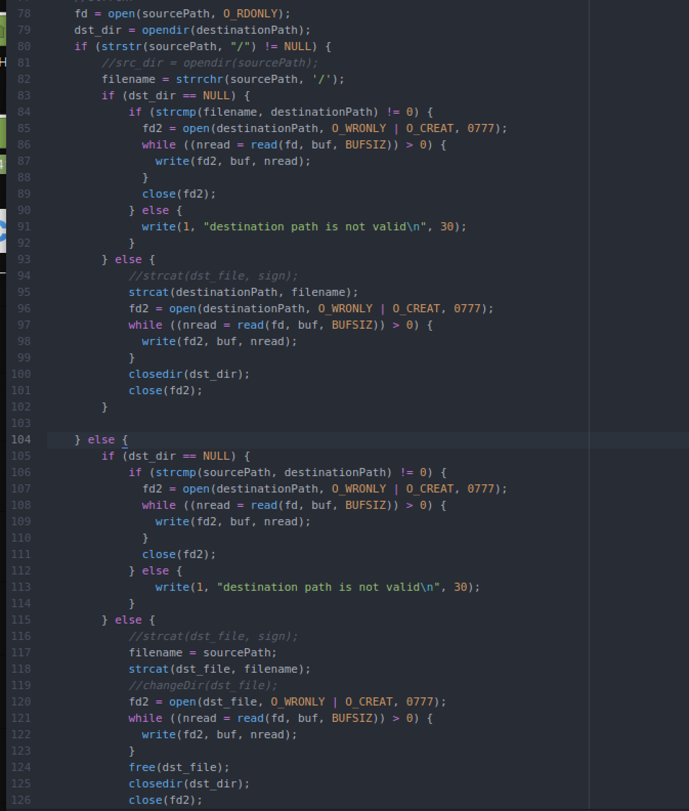

**Performance Results and Discussion**

*So far, in interactive mode, all commands except cp and mv are working correctly. The issue with cp and mv are mainly about how to detect the type of destinatinPath argument and then create a new file either has assigned filename or not to copy the content in sourcefile. If it’s a directory, I need to add the name of the file, either copy from source filename or create a new filename, based on the actual situation. If it is a filename, I also need to check if tis name has already exist. Since I have trouble with detect this, I haven’t completed the cp and mv commands.*

*For the file mode, my output is a little weird starting from the third line of commands. I assume the issue is related to my cp and mv commands.*

**Conclusion**

*In this project, I have learned some Linux system calls which I was not familiar with before. But through this project, I have known more about topics of pointer and memory address.*