CS 499 Milestone 4 Document 1

Database Creation/Manipulation Screenshots

E. Taylor

In creating a database from scratch, the first step was to download and install MySQL. Once that was complete and a local host connection established, I was able to create a new database title bookdb using the CREATE DATABASE command. I then used the SHOW DATABASES command to ensure the database was created and then once verified switched to that database using the USE command.

Next in the process was the creation of a table. Using the CREATE TABLE command and specifying the schema a table was created title book. The parameters were an id to act as an auto incrementing primary key, title, author and synopsis all of the data type VARCHAR, and review of the data type ENUM which could take values ‘Y’ or ‘N’ for yes or no. Each column was specified with either a NULL default or NOT NULL default.

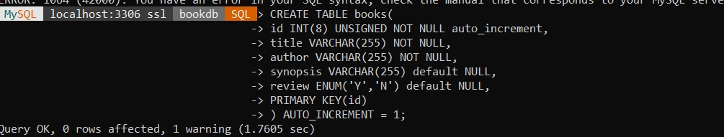

The command SHOW TABLES was used to verify creation of the book table and SHOW COLUMNS was used to verify the columns created.

The next step was to insert data into the table using the INSERT INTO command and using data specific to the data types, VARCHAR and ENUM.



After the data was insert, the SELECT \* FROM query was used to show all the data in the table.

A new column was needed to indicate whether the book had been completely read or not. Using the ALTER TABLE command a new column of finished was added specifying a data type of ENUM with accepted values of ‘Y’ or ‘N’ for yes or no.



Using query SELECT \* FROM books shows the column added, but the entire database is a bit off kilter. Using the UPDATE command to edit id 4’s particularly long synopsis fixes the problem and improves readability.

The finished column is added and all values are NULL currently. Luckily all the books currently in the database were books that had been finished so using the UPDATE command all finished with a value of NULL can be quickly changed to ‘Y’.

After adding more data into the table, a duplicate record is spotted. The same title, Caraval, has been added at id 20 and again at id 27.

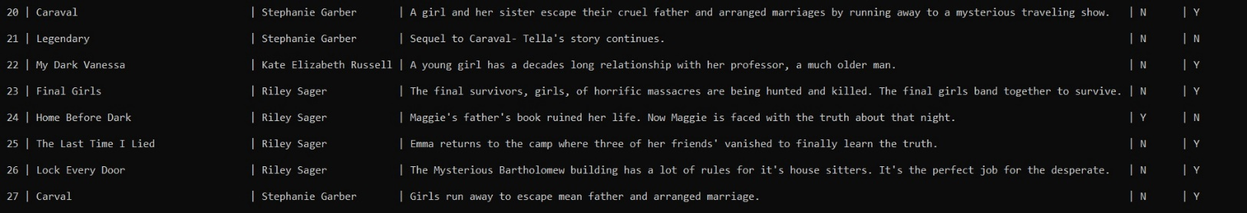

Using the DELETE command the duplicate record is deleted. Using SELECT \* FROM shows the duplicate record has been removed.

Using a SELECT COUNT query, the number of books in the database by a certain author can be found .

Another query that can be performed is to find how many books by each author are in the database.

