Design and Implementation of a UML-Based Via Online Store System

Problem Statement
Many small online stores still rely on manual tracking of orders, customer records, and expenses. This often results in errors, inefficient monitoring, and difficulty managing financial data. The Via Online Store system aims to digitize order processing, customer management, and expense tracking to improve accuracy, organization, and operational efficiency.

Project Objectives
- Develop a digital system for managing customer records and store items.
- Automate the order process from customers to the admin dashboard.
- Record and monitor expenses for financial tracking.
- Provide real-time visibility of customer orders to the admin.
- Implement a secure admin login and logout system.

Target Users
Admin / Store Owner
- Manages items and inventory.
- Views incoming customer orders.
- Records and monitors expenses.
- Logs in and logs out securely.
Customers
- Access the system using email.
- View available items only.
- Place orders using an order button.

System Scope
Included:
- Customer item viewing page.
- Order submission system from customer to admin.
- Customer records database.
- Expense records database.
- Admin dashboard for order monitoring.
- Admin login and logout functionality.
Excluded:
- Online payment gateway integration (future enhancement).
- Delivery tracking system.

System Features Overview
Customer Side:
- Email-based access.
- View items only.
- Submit orders using an order button.
Admin Side:
- View incoming orders.
- Manage customer records.
- Record and monitor expenses.
- Logout functionality.

UML Diagram – Class Structure
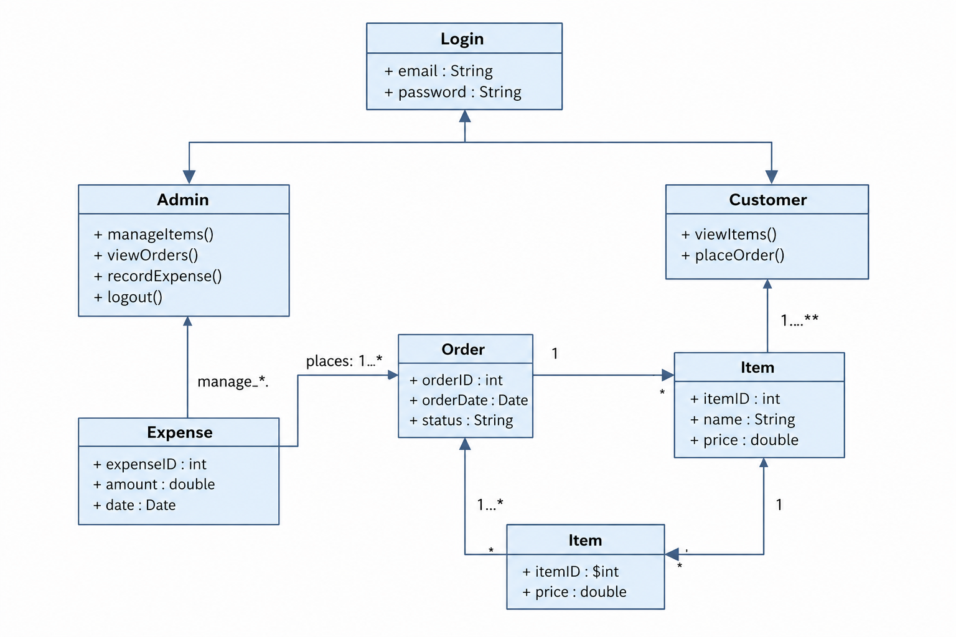

Relationships
- User inherits to Admin and Customer.
- Customer is associated with Order.
- Order is associated with Item.
- Admin manages Expense records.

