Software Application Name: **Find me a roommate**

Version: 1.4

Date: March 3-th 2024

Contents

Summary 1

Technology 1

Business Cases 1

Database 1

# Summary

Find me a roommate is an application which will facilitate a process between students who are aiming to share their living spaces. Students will be able to put up announcements online for sharing their living spaces. Other students will be able to look through the announcements and will be able to submit an application. Students who put up the announcement will check their respective applications and will approve the application that see fit.

# Technology

Chosen Application Architecture: Console Application

Technology: .NET 8.0, Microsoft SQL Server

Entities:

* Students (Users)

# Business Cases

* Users will be able to Register/ Log in.
* Users will be able to put up an announcement.
* Users will be able to submit an application.
* Users will be able to approve/reject.
* Users which will be admins will be able to add/update/remove users, dormitories etc.

## Database

**Dormitories** Id (int -> pk) – Place where user lives.

Code (string -> unique)

Name (string)

MaxCapacity (int)

**Students** Id (int -> pk)

Name (string)

Surname (string)

Address string

Gender(string)

Email string

Password string

**DormitoryStudent** Id (int -> pk)

DormitoryId (int -> fk)

StudentId (int -> fk -> unique)

Capacity (int)

**Announcements** Id (int -> pk)

Title (string)

StudentID int (Announcement Owner)

Description (string)

PublishedDate (DateTime)

IsActive (bool)

IsSameGender (bool)

**Applications** Id (int -> pk)

StudentId (int -> fk)

AnnouncementId (int -> fk)

ApplicationDate (DateTime)

IsActive (bool)

Status string (New/Approved)

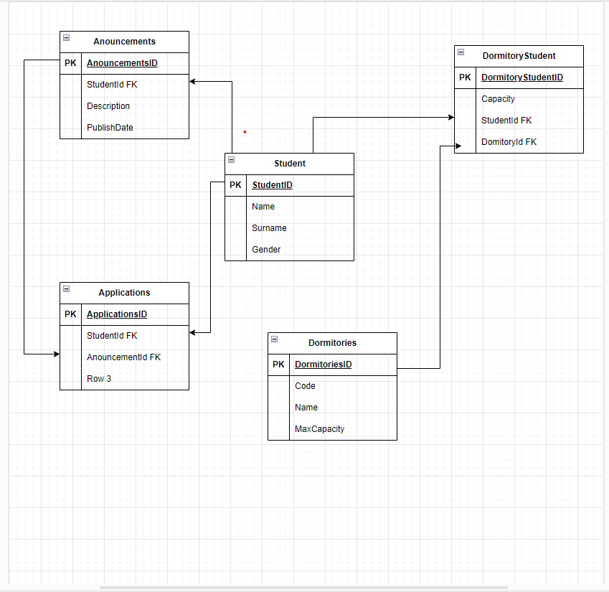

## Business Rules

* Users must be authenticated to make an announcement or submit an application.
* Users must not make an announcement more than once at a time.
* If dormitory has reached maximum capacity there should be prohibited to make an announcement.

# 

## Application Architecture

Console Application, Monolithic Architecture. Repository Pattern. Code First.

