

Visual Programming Languages

Eljon Zagradi

Project: Library Manager

for university

(Desktop Application,

Java, JavaFX, MySQL)

1. **Request**: Easy Management of a Library
2. **Funcionalities**: Manage Students (Register, Edit), Manage Books (Register, Edit), Register Book Borrowings, Import Students or Books using Exel, Manage Users(Edit,Regiter), Manage Study Programs and Faculties. Search Books, Search Students, Search Borrowings by Student or Book, Return Book.
3. **User Types**:

* Administrator: All Functionalities mentioned above.
* User: Search Students, Search Books, Search Borrowings, Register Borrowings, Return Book.
* Student: Search Books.

1. 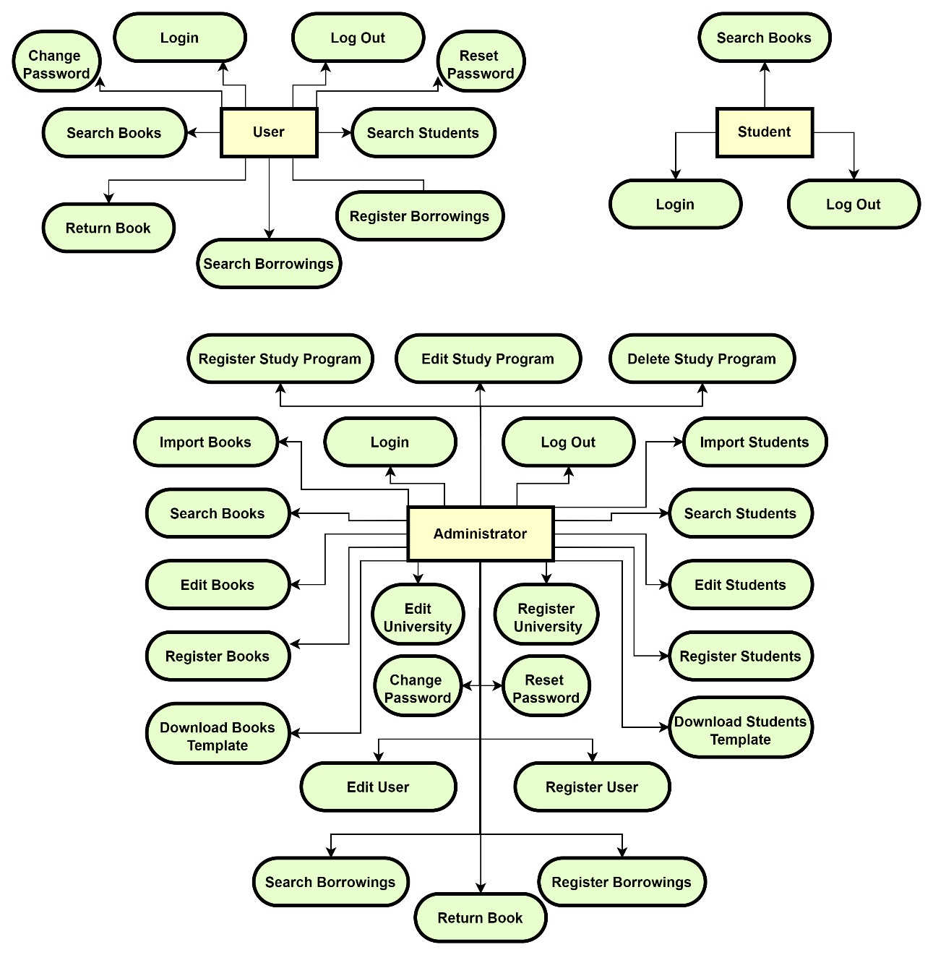**Information flow:**
2. Diagram

   Description automatically generated**Pages Flow:**
3. **Security issues:**