Proposal (Team 6)

Team composition:

David: Repos/database data handling

Elsana: Kotlin compose UI

Lucas: Kotlin compose UI

Joey: Image uploading

Application name/ Application Logo

-Name: EcoCap

-Logo:



Description of the application (1%)

EcoCap is an android application made with JetPack Compose with the goal of getting people outside for their physical well being. To motivate them, we chose to gamify the process. Once a day, EcoCap will send out a quest, you must go out and find the item or items listed, gaining points when you successfully take a picture of them. In doing so it tallies your total points by factoring in the accuracy and the length of your daily streak. This encourages competition between family and friends which gives the incentive to go outside.

Application scope (1%)

* **Camera** that implements Google MLKit’s object detection and tracking that will identify objects in your image.
* **Static Database table**, *QuestNames* topics that contains all the objects that the Machine Learning is trained with, Id and Name
* **Database Table**, *PointHistory* to save the points earned in the past, contains Id, StreakMultiplier, ScoreGained, Date, UserId, PictureUploaded
* **Database Table**, *User* contains Id, UserName, TotalPoints (email and password ect. can be implemented at a later date if needed)
* **Quest Collection** that holds a or multiple random objects which we got using Google MLKit
* **BottomAppBar** that contains navigation between screens
* **TopAppBar** that contains title and icon
* **HomeScreen** Contains today’s quests and total points
* **CameraScreen** Take a picture to complete quest
* **ImageSelector** implement a way of choosing images from your camera roll to upload.
* **PointHistoryScreen** Previously gained points and total points
* **QuestScreen** Additional weekly/monthly quests, gives more points
* **SettingsScreen** Change username (and theming?)
* **ResultsScreen** displays your image and points

Layout of the application (using a layout tool such as Figma) (3%)

Repository name and access to the teacher ([alex.fulleringer@johnabbott.qc.ca](mailto:alex.fulleringer@johnabbott.qc.ca)):

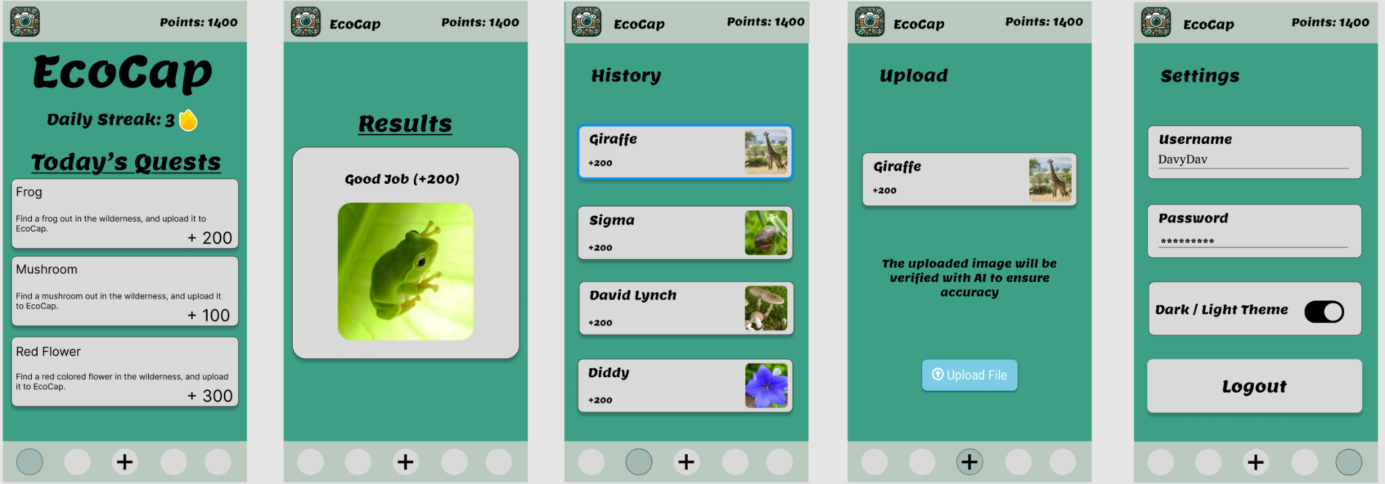

Figma link: <https://www.figma.com/design/xrRHvuCaNsosgO0AvXg6aq/Davydav's-team-library?node-id=0-1&t=3H2XJSv769DB3z06-1>

Github Repository Link: <https://github.com/elkanybek/EcoCap>

Themes:

