**Flappy Crocodile – iOS how to**

Project is located in folder: games\game_flappy_crocodile\proj.ios

Double click game_flappy.xcodeproj in order to load project in XCode (please make sure you are using latest XCode).

When project loads in XCode you’ll be able to see current target and device/simulator it’ll run on:

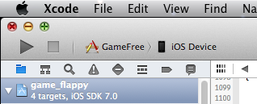

On this image you can see that GameFree is selected to run on iOS device (when you connect device you’ll see name of device displayed here).

Click on target and you’ll see following dropdown menu:

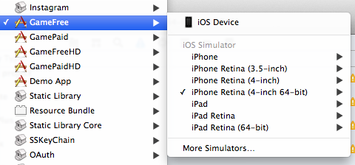

For Flappy Crocodile you can select:

* GameFree – free game (with ads)
* GamePaid – paid game (without ads)
* GameFreeHD – free HD game (with ads)
* GamePaidHD – paid HD game (without ads)

Select game you would like to run and select iOS device as your target (connect your device before you run game) or select one of the simulators. Press Run icon and after XCode builds project game will run on targeted device.

On following screenshot you can see game with ads (GameFree) running in simulator:

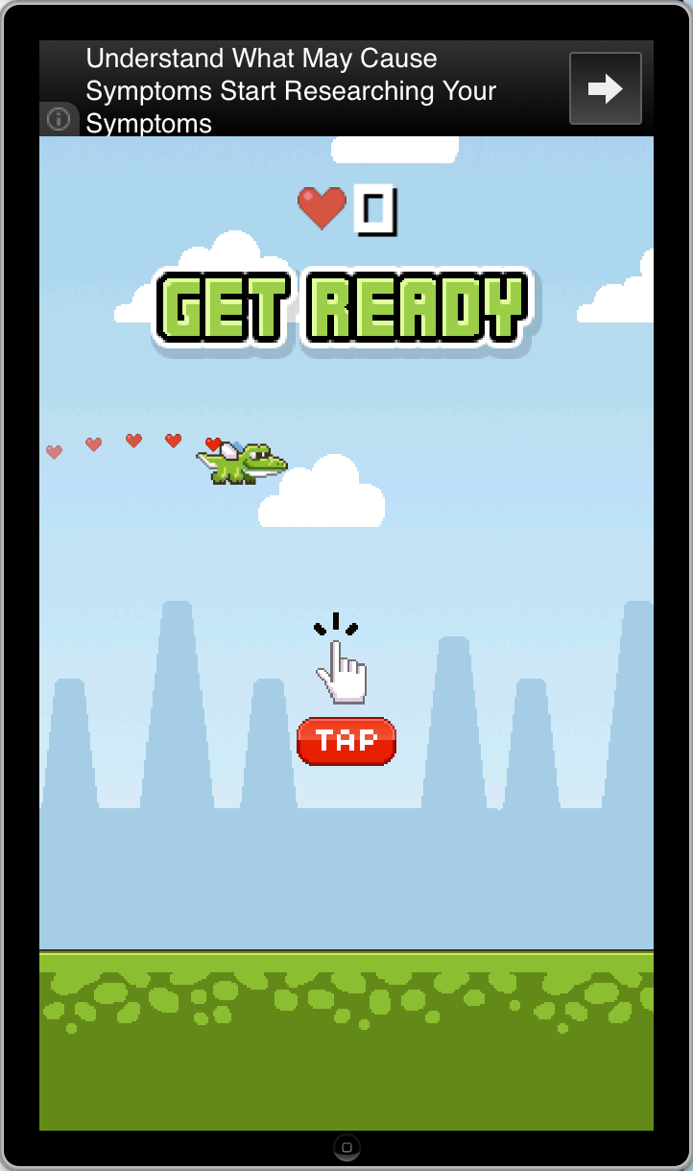

When building game for first time please make sure that you selected correct provisioning profiles and code signing identities, otherwise you’ll get code sign errors and game won’t start. You can select this in project Build Settings:

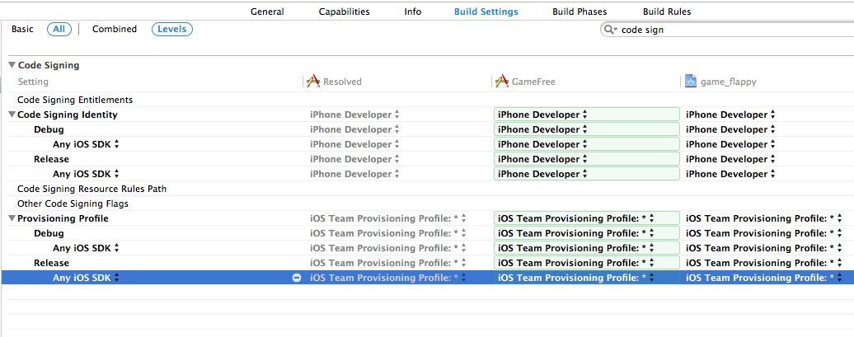

Artwork is located in games/game_flappy_crocodile/Resources

Splash screens and application icons are located in games/game_flappy_crocodile/proj.ios

In order to setup ad networks codes you should edit only one file - SKGameMetadata.h

File is located in games/game_flappy_crocodile/Classes.

You should setup the following codes (you will find samples in SKGameMetadata.h file):

APP_STORE_URL - your app url, used for RateMe button.

FLURRY_APP_KEY - your Flurry api key, for in-game analytics.

ADMOB_MEDIATION_ID - Admob mediation id. You must enable mediation from your Admob account, and ad iAd network from Admob website to show iAd ads in your game.