**TaibahCS**

* Mustafa Khaled

# **Project Description**

**Java application that mimic the assignment of academic courses to faculty members. The application has different types of users that are:**

* **Convener**
* **Lecturer**
* **TA (Teaching Assistant)**

## **Program structural**

Program have 5 Entity Class:

* **a Class called Course with Attribute:**
* **courseCode**
* **courseName**
* **creditHours**
* **a SuperClass called FacultyMember with Attribute:**
* **FacultyID**
* **firstName**
* **lastName**
* **academicRank**
* **academicSpecialization**
* **course *Convener* subclass inherits from the *FacultyMember* class with specific member variables representing:**
  + - ***courses***
    - **members (*Lecturers* and *TAs*)**
* ***Lecturers* and *TAs* are also SubClasses that inherit from *FacultyMember* class with some specific member variables:**
  + - ***maximumNumberOfCourses***
    - ***quotaOfCreditHours***
    - ***assignedCourses***

# UML class diagram that models Entites

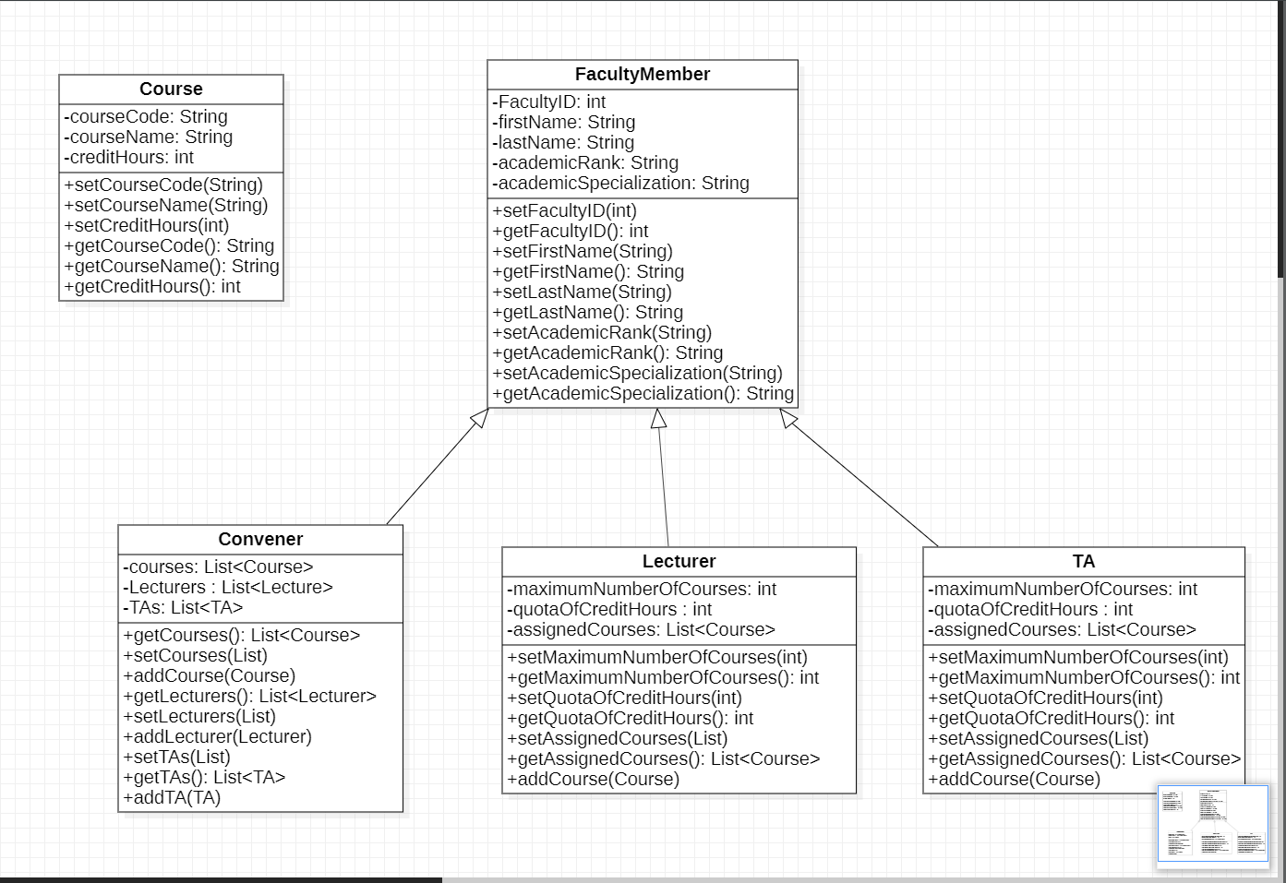

# Code of The Entities(Model)

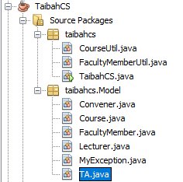

### Course

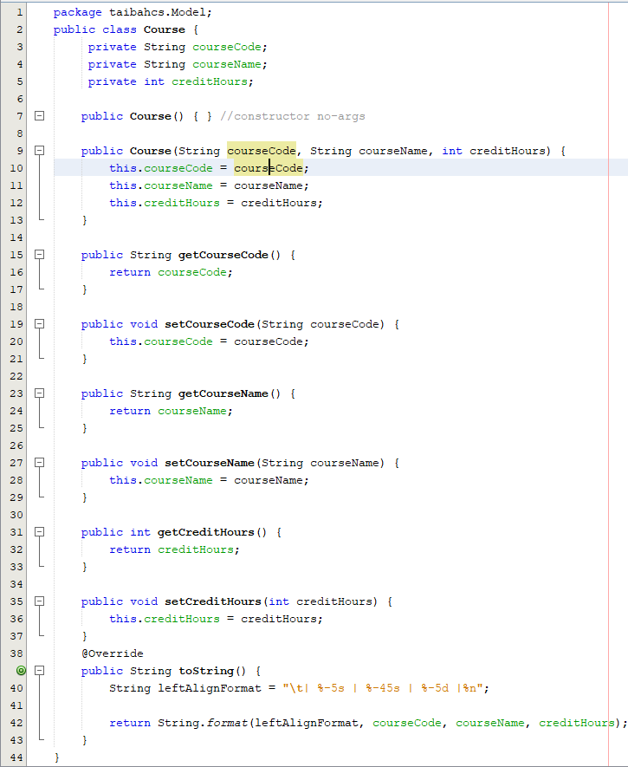

### FacultyMember

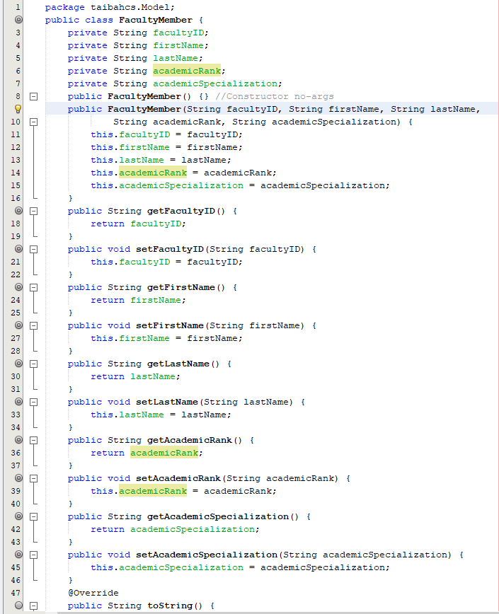

### Lecture

### TA

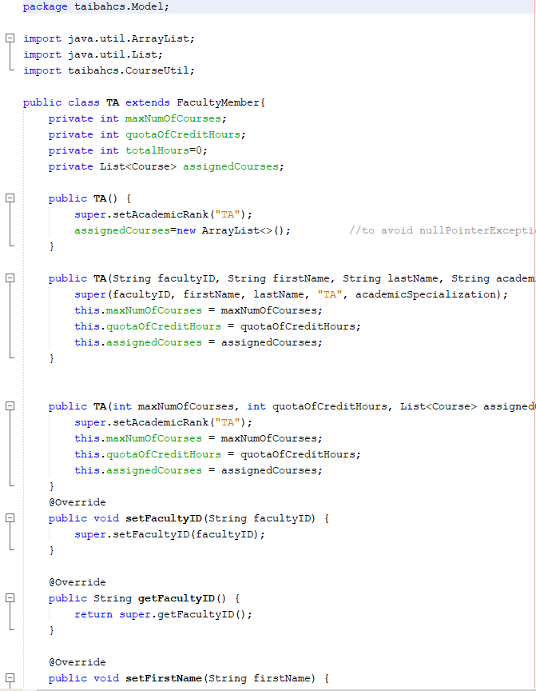

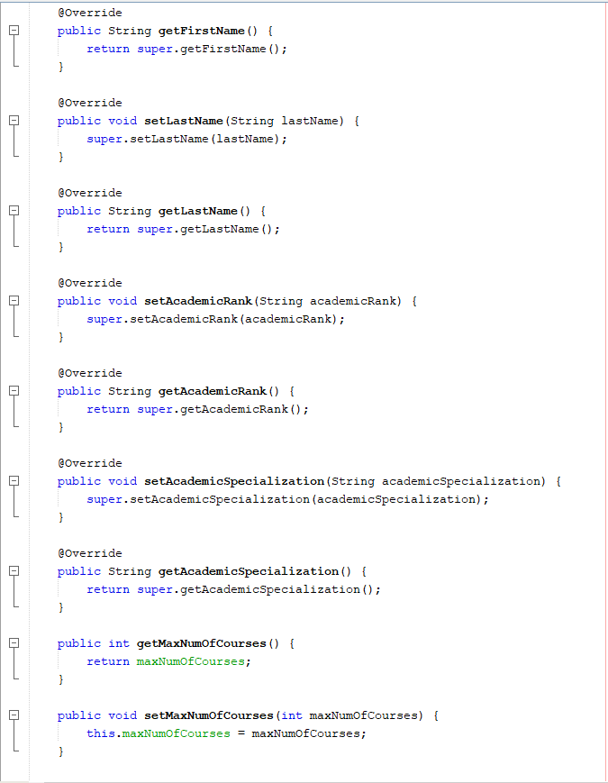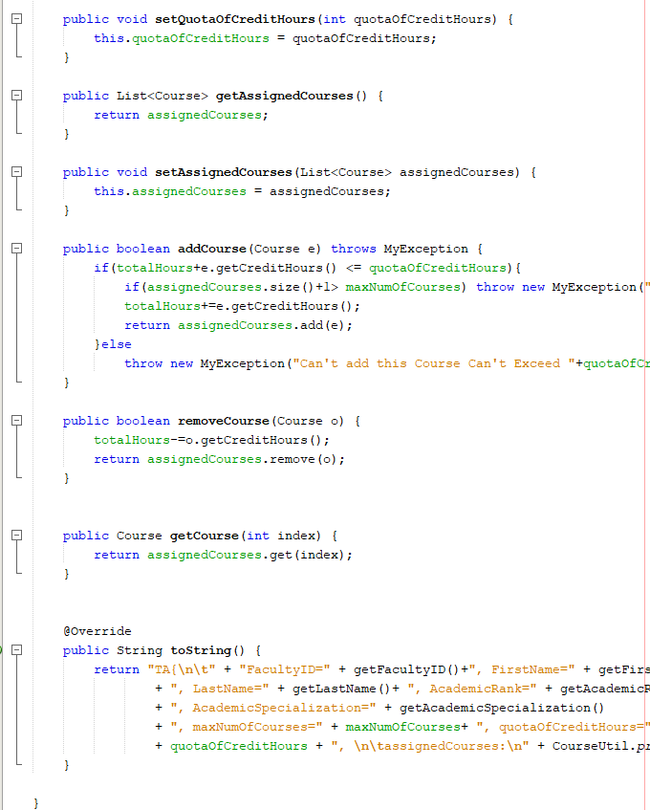

## Convener

# Executing and implementation

**Program display the three types of users:**

* **Convener**
* **Lecturer**
* **TA (Teaching Assistant)**

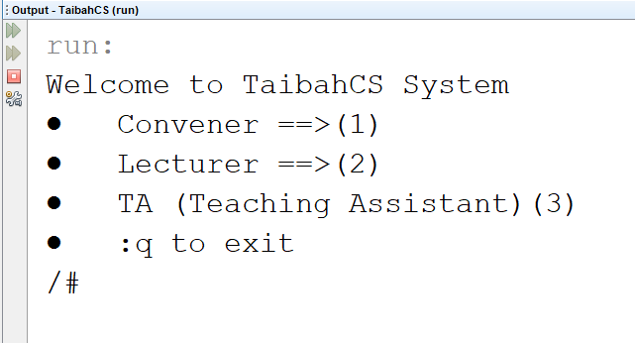

**If the user is Lecturer or TA they should enter the ID to display their information (*assignedCourses, maximumNumberOfCourses … etc).***

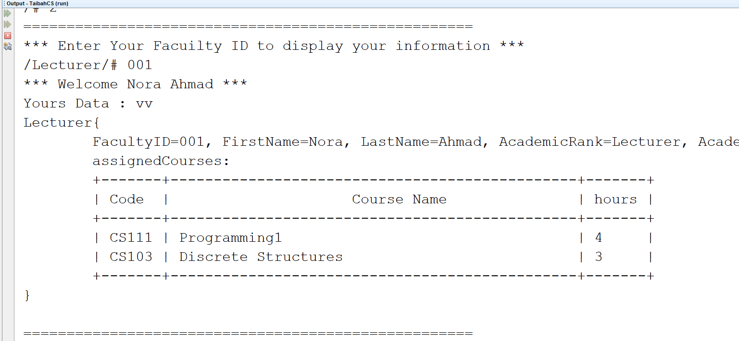

1. **If the user is Convener , he/she should enter the ID, based on that the following menu should display :**

* **Allocate course**
* **Drop course**
* **Print a report**

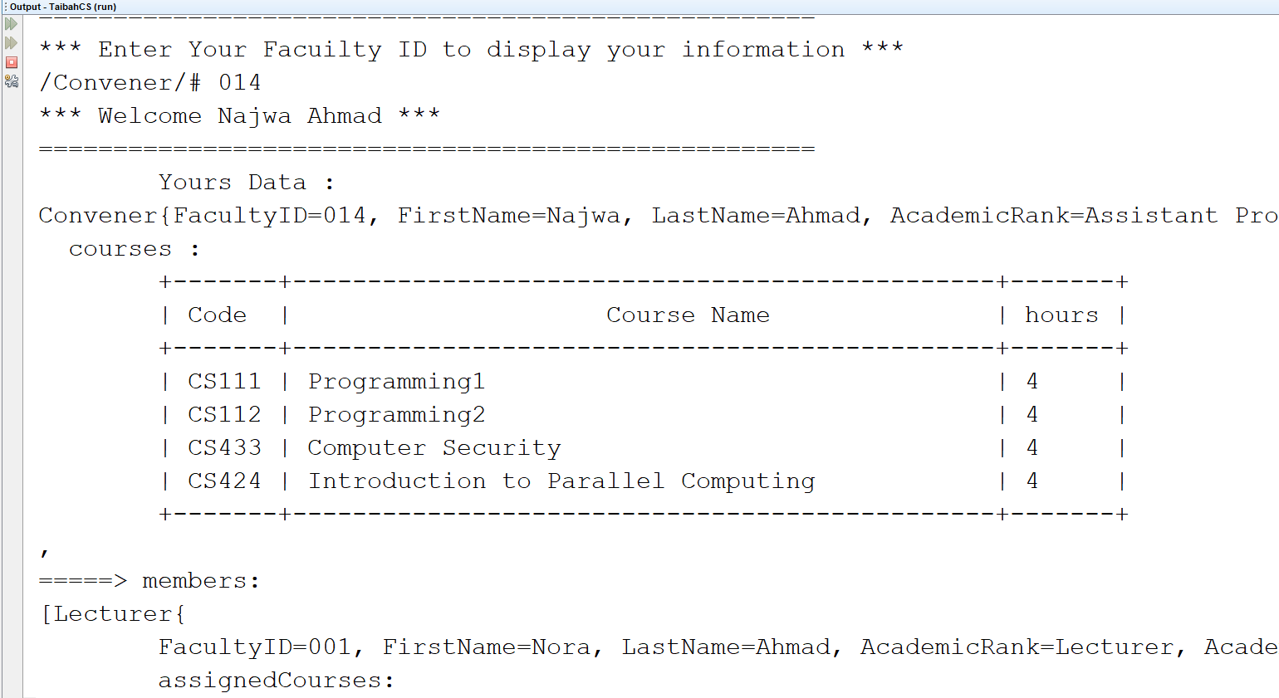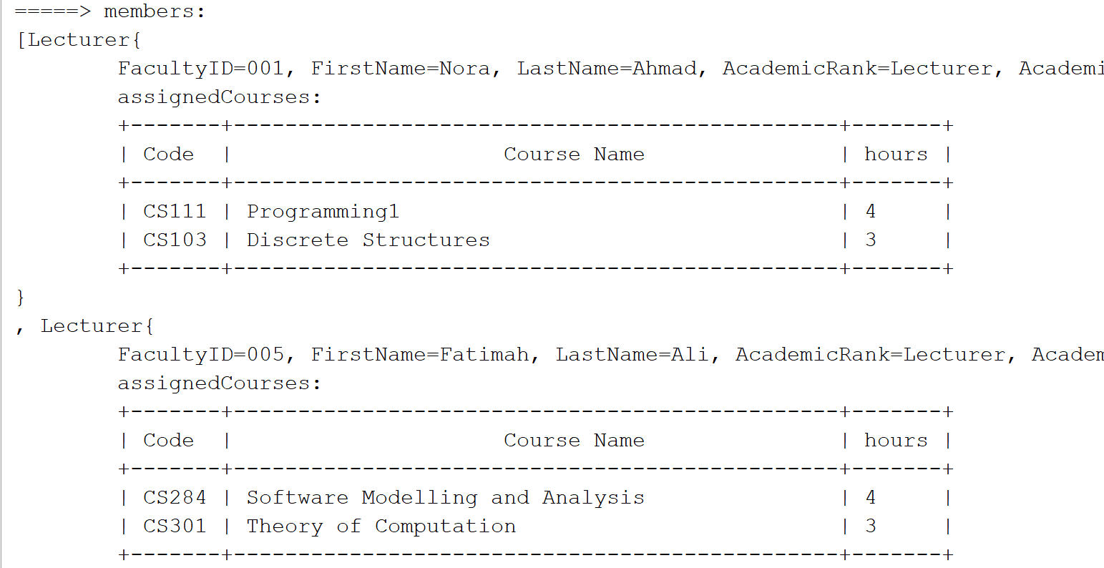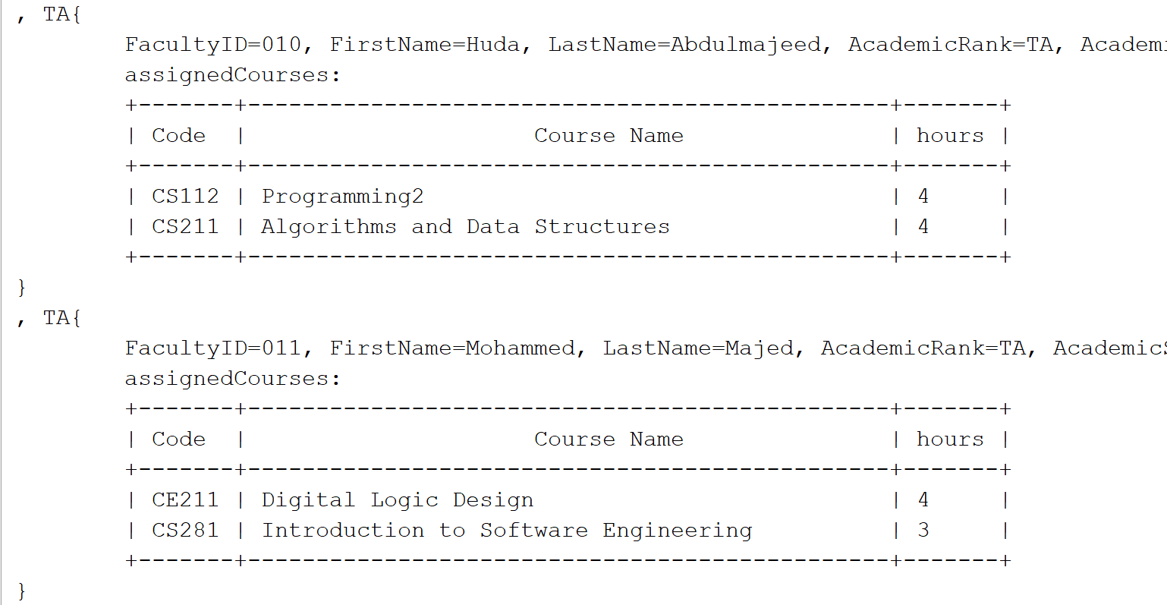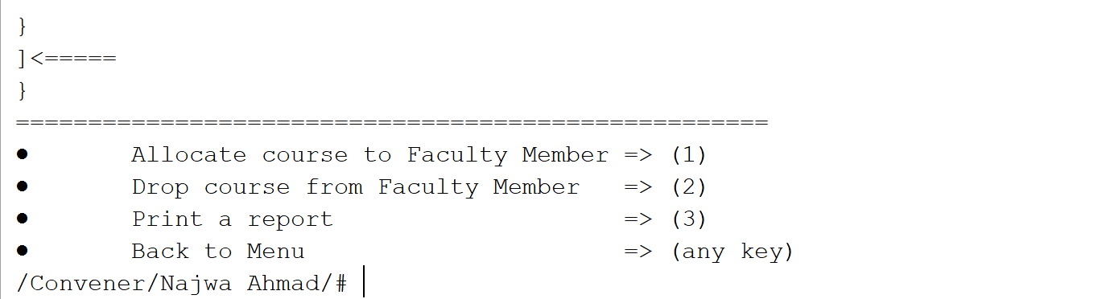

**If allocate course is chosen:**

**the list of all *Lecturer, TA and unallocated courses* that belong to this convener will be displayed to let the user choose the course id and the member id to complete the assigning**

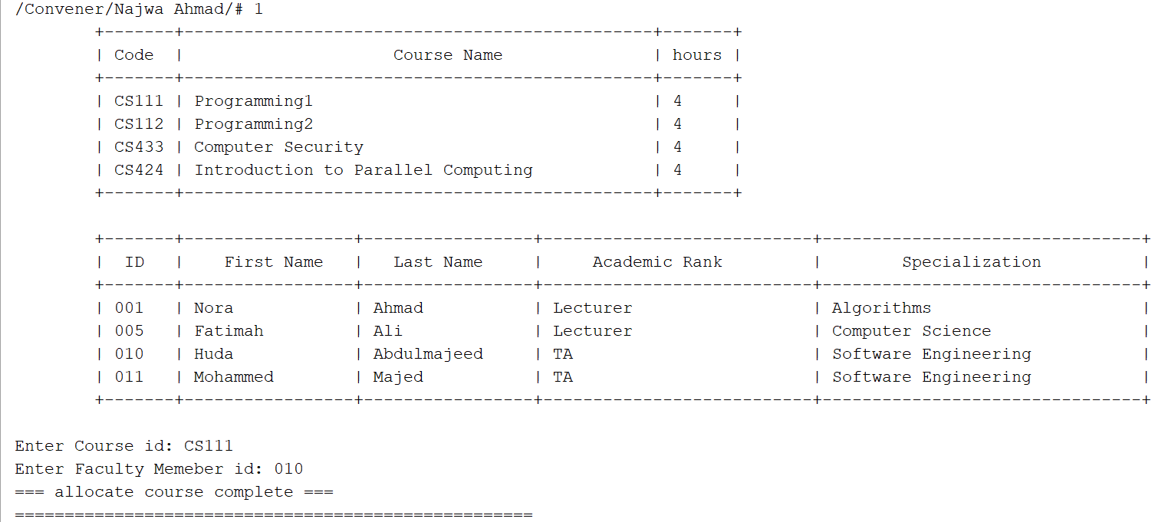**If Drop course is chosen, the list of all allocated courses that belong to this convener will be displayed to choose the course id to be dropped.**

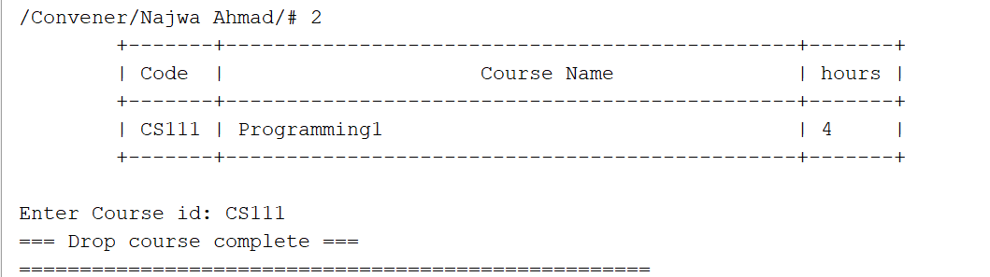

1. **Print a report should display lists of courses and members (based on their types) and the remaining unallocated courses.**

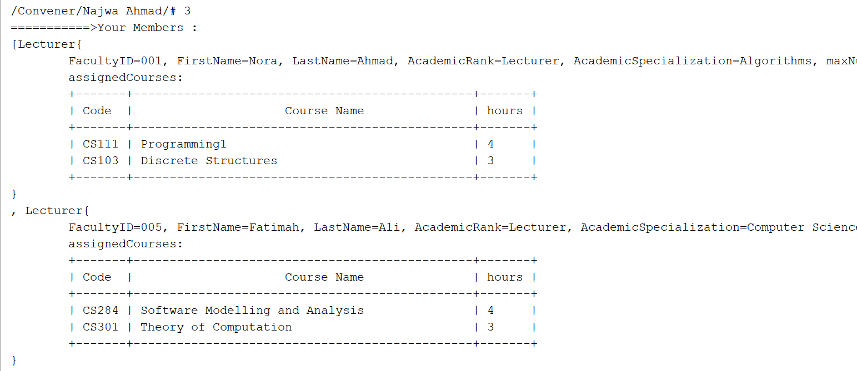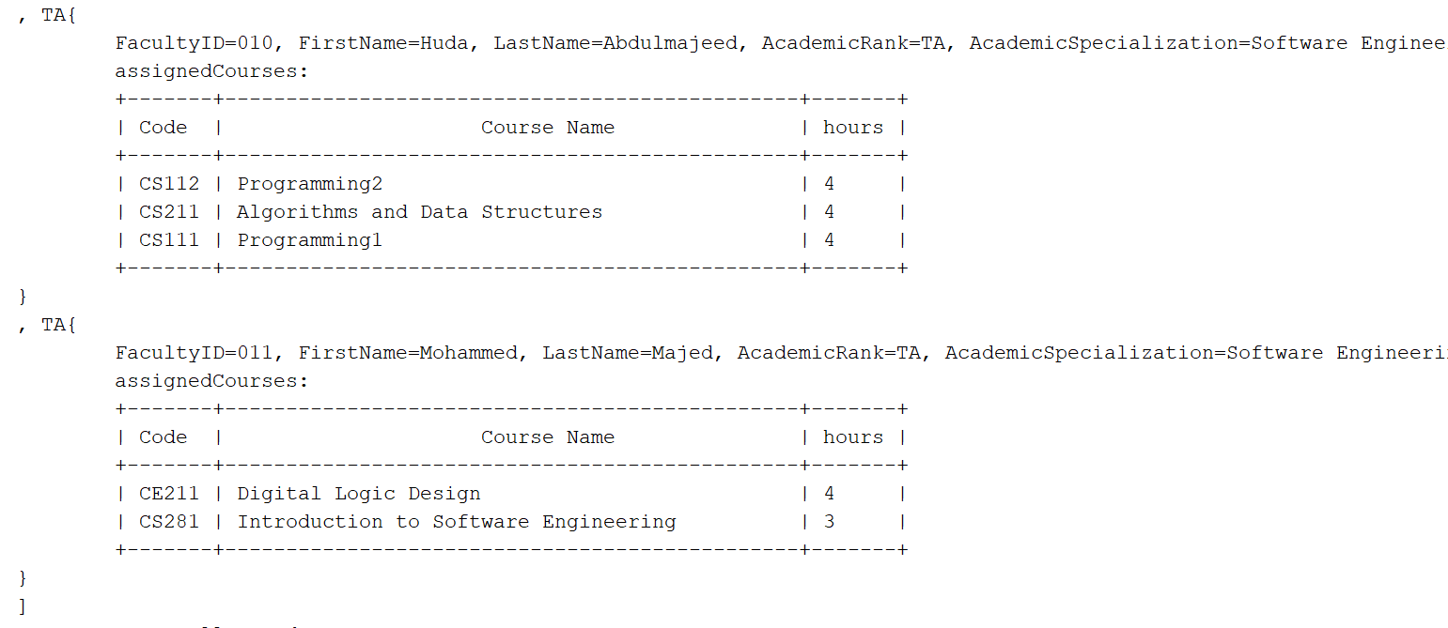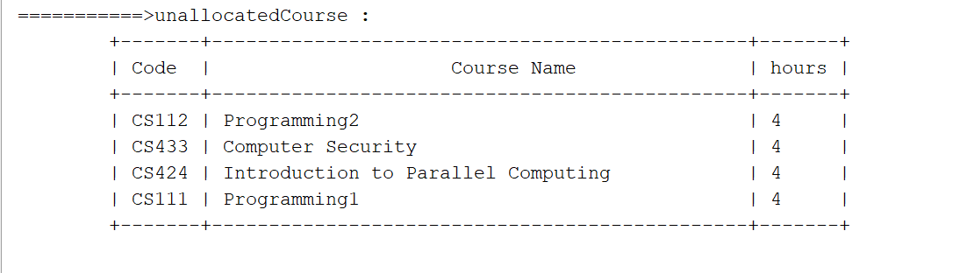

1. **Program use the array list to store those information instead of asking the user to enter them. In classes CourseUtil, FacultyMemberUtil**

