# **1000 Thread**

## **Problem Description**

Program lunches 1.000 threads, each thread add 1 to a variable sum that initially is 0.

## **The sequential solution:**

### Code

**Looping 1000 times to add one to var sum**

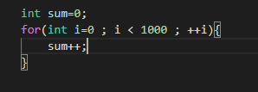

## **Parallel algorithm design:**

Program will start with sum that initially is 0, and Program lunches 1.000 threads each thread add 1 to a variable sum. Finally program end with sum equal 1000.

As shown blew: 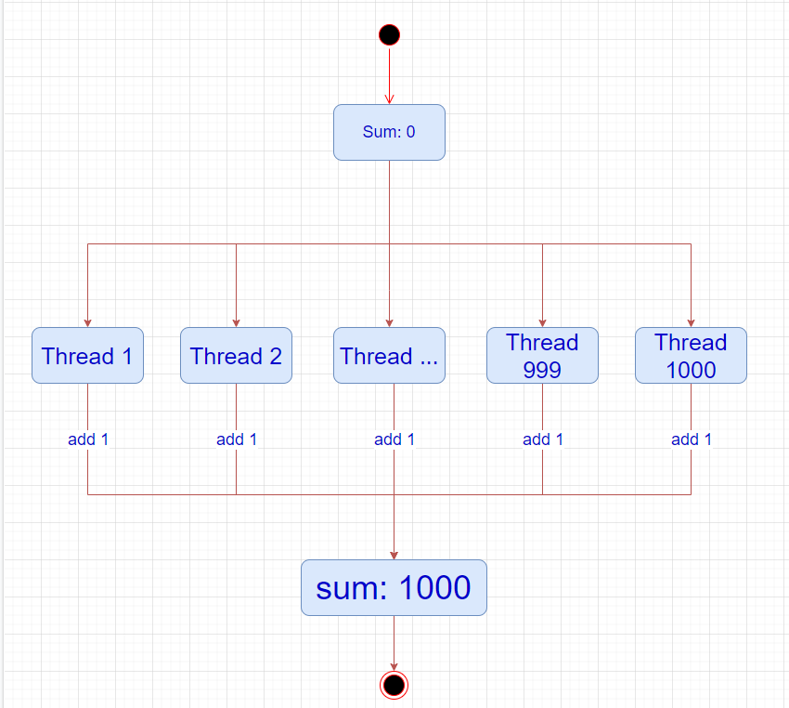

## **Parallel code:**

### **Without synchronization:**

### With synchronized:

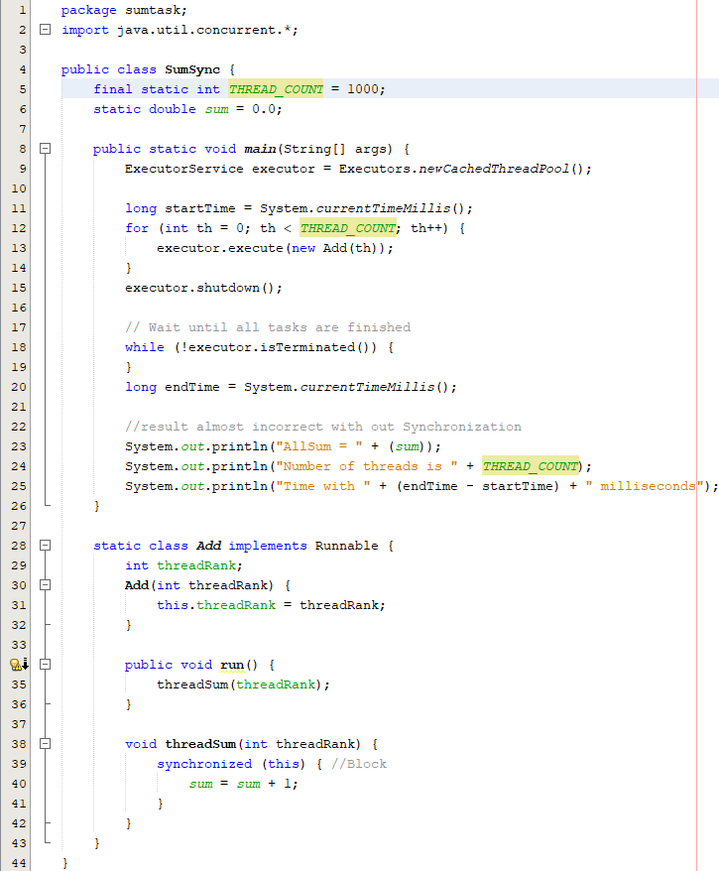

### With Lock

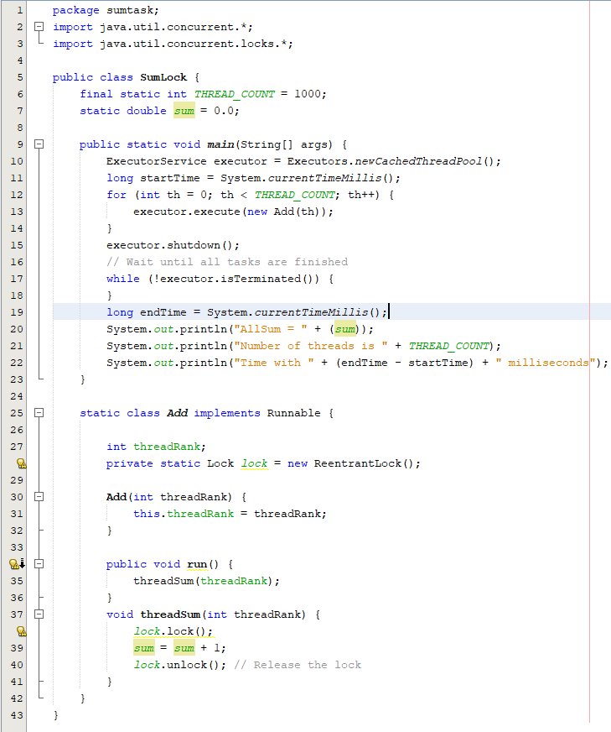

### **With Semaphore:**

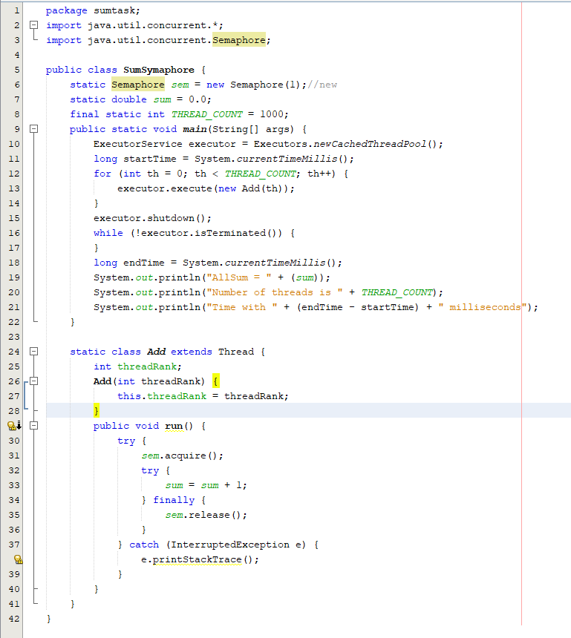

## **Sample output:**

### **Without synchronization:**

The output has random value less than or equal 1000 Because some threads add one at same time.

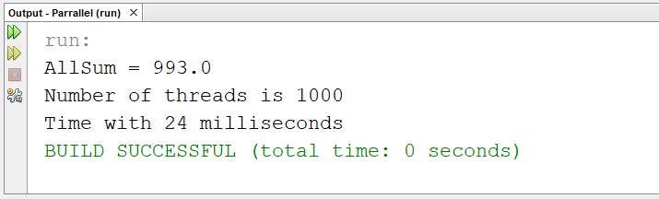

### **With synchronization:**

