# **Factorial Task**

## **Problem Description**

Program that compute factorial of a given number

F(n) = 1 × 2× … × n-1 × n

## **The sequential solution:**

### **Code**

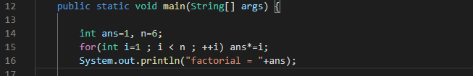

## **Parallel algorithm design:**

suppose program calculate fact(6) and run 3 threads , so program will fork tasks between them :

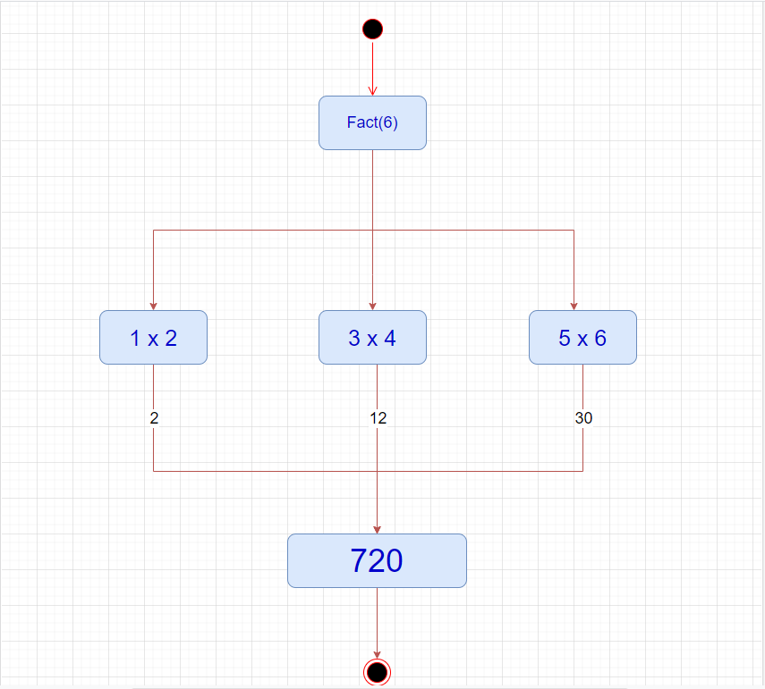

## **Parallel code**

## **Sample output:**

## 

## **Performance evaluation:**

|  |  |  |
| --- | --- | --- |
| N | Sequential time | Parrallel time |
| 10 | **0 ms** | **3 ms** |
| 100 | **1 ms** | **4 ms** |
| 1000 | **4 ms** | **7 ms** |
| 100000 | **69 ms** | **28 ms** |
| 100000 | **3324 ms** | **172 ms** |