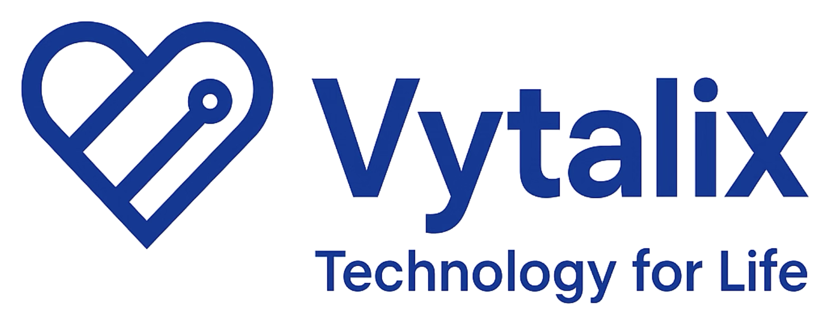

NON-DILUTIVE FUNDING ROUTES (kept outside the investor CRM)
These are grant or contract funders, not investors, so they are excluded from the 300-investor CRM, the Top 25 and the call lists in line with the investor-only rule. They remain high priority for the funding strategy (see /docs/09_FUNDING_STRATEGY.md).
Programme | What it funds | Stage / eligibility | Phone (public source) | Route | Source
Innovate UK (UKRI) | UK national innovation agency – NON-DILUTIVE grants (Smart, Biomedical Catalyst, Women in Innovation) and innovation loans | Any – pre-revenue eligible for grants | 0300 321 4357 | Innovation Funding Service https://apply-for-innovation-funding.service.gov.uk/ ; support 0300 321 4357 (9–12, 2–5 Mon–Fri) / support@iuk.ukri.org ; Innovate UK | https://apply-for-innovation-funding.service.gov.uk/info/contact
SBRI Healthcare (NHS England / Accelerated Access Collaborative, managed by LGC) | NHS-funded NON-DILUTIVE development contracts (100% funded, competition-based) for health innovations | Pre-revenue eligible; needs NHS partner and credible team | +44 20 8843 8125 | sbri@lgcgroup.com or +44 20 8843 8125 ; competitions via https://sbrihealthcare.co.uk/sbri-portal/ | https://sbrihealthcare.co.uk/contact-us
NIHR Invention for Innovation (i4i) Programme | NIHR NON-DILUTIVE translational funding (i4i Connect for SMEs, Product Development Awards, Challenge Awards) | Pre-revenue SMEs with a prototype and clinical partner | 020 8843 8080 | i4i@nihr.ac.uk (eligibility queries) or 020 8843 8080 ; applications via NIHR funding portal | https://www.nihr.ac.uk/contact-us?letter=H

