Persona for Puzzler App – Virtual Reality nanodegree

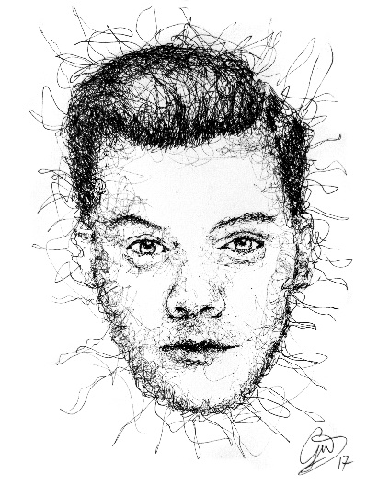 Russell, 28, Software Developer

Russell understands that a sharp mind is key to solving the most challenging problems in the IT industry. This is why he plays puzzle games such as Bubble Shooter at work, and has even been known to dabble into Sudoku. He currently works as a frontend developer, where he was asked to learn a technology he never used before for the job.  
  
“The art of simplicity is a puzzle of complexity.” – Douglas Horton