Sangha Coin



Joshua Elkington + David Peprah

**Problems with Money and Solutions**

In the developing world, there are many regions that lack access to banks and financial infrastructure that people in developed areas take for granted. This lack of financial services has an immense effect on the economic growth of the developing world because many transactions such as the trading of goods cannot take place easily without proper financial infrastructure.

People in developing nations are more likely to use mobile phones to access the Internet than with a traditional computer. Recently, mobile payments have been used to facilitate transactions in Third World countries. For example, M-Pesa is mobiles payments company that allows people to store money, make payments, and transmit money through their mobile devices. M-Pesa has found success in Kenya; however, there are limitations to this type of centralized payment system. However, M-Pesa is not a perfect solution because they still charge on average 10% per transaction.

Bitcoin is a decentralized currency that uses peer-to-peer cryptography system in order to determine who successfully “mined” or solved the hash in order to get the coins in the block to be added to the ledger. If the majority of miners accept this decision a new block is mined and more currency is made (Figure 1). However, there is a limit of 21.5 million Bitcoins that will be reached around the year 2140. The decentralized design of Bitcoin allows it to act as a global payment system because there is no central body that controls its supply. The decentralized nature of Bitcoins allows the removal of middle-men in any transaction. As a result, Bitcoin has the potential to develop as a tool to economically connect people around the world.

Many migrant workers in developed countries send money back home to support their families. In 2012, migrant workers send $372 billion to their home countries. But, the costs of transmitting this money back to their home can be as high as 20%. Moreover, Bitcoin has transactions fees of approximately 0.1%, although this may change overtime due to the need to incentivize “mining” as the number of mined coins reaches its upper limit. As a result, Bitcoin could be used to reduce the costs that migrant workers face when they send money back home. Even if Bitcoin doesn’t become widely accepted as a store of value, the technology Bitcoin is based on will allow it to be a useful tool to make international transactions. Money earned by a migrant worker in Germany could be exchanged for Bitcoin on an online exchange and sent to family in another country. Once the funds are received, the family members can exchange Bitcoin into their local currency. However, currency volatility is a major risk in these types of transactions. So the exchange would have to be done quickly, which is possible with Bitcoin or new mechanisms of risk management must be developed either by the Bitcoin protocol or companies looking to take on currency volatility to shield their customers from price swings of Bitcoin.

Bitcoin also offers the opportunity to connect entrepreneurs around the world. With the high cost barrier of making international transactions reduced, Bitcoin could act as a payment platform to promote international investment. Bitcoin or other crypto-currencies could act as a store of value in nations with high levels of inflation such as Argentina and Zimbabwe. In countries that have mismanaged central banks, a decentralized currency offers a way for people to be confident that the money they use will not be actively manipulated. Also, Bitcoin could facilitate the micro-loan industry by helping people in developed nations send funds to businesses in developing nations without a middleman. Contrary to expectations that people in developed nations would use Bitcoin more, developing countries such as Mongolia, Macedonia and Ukraine have some of the highest uses of Bitcoin. This trend validates the hypothesis that decentralized money can solve many of the economic problems of developing countries such as access to capital and trade. If people in the Ukraine are using Bitcoin very often, then the only thing preventing increased economic activity in countries like the Ukraine are tools that leverage the potential of Bitcoin and other decentralized currencies.

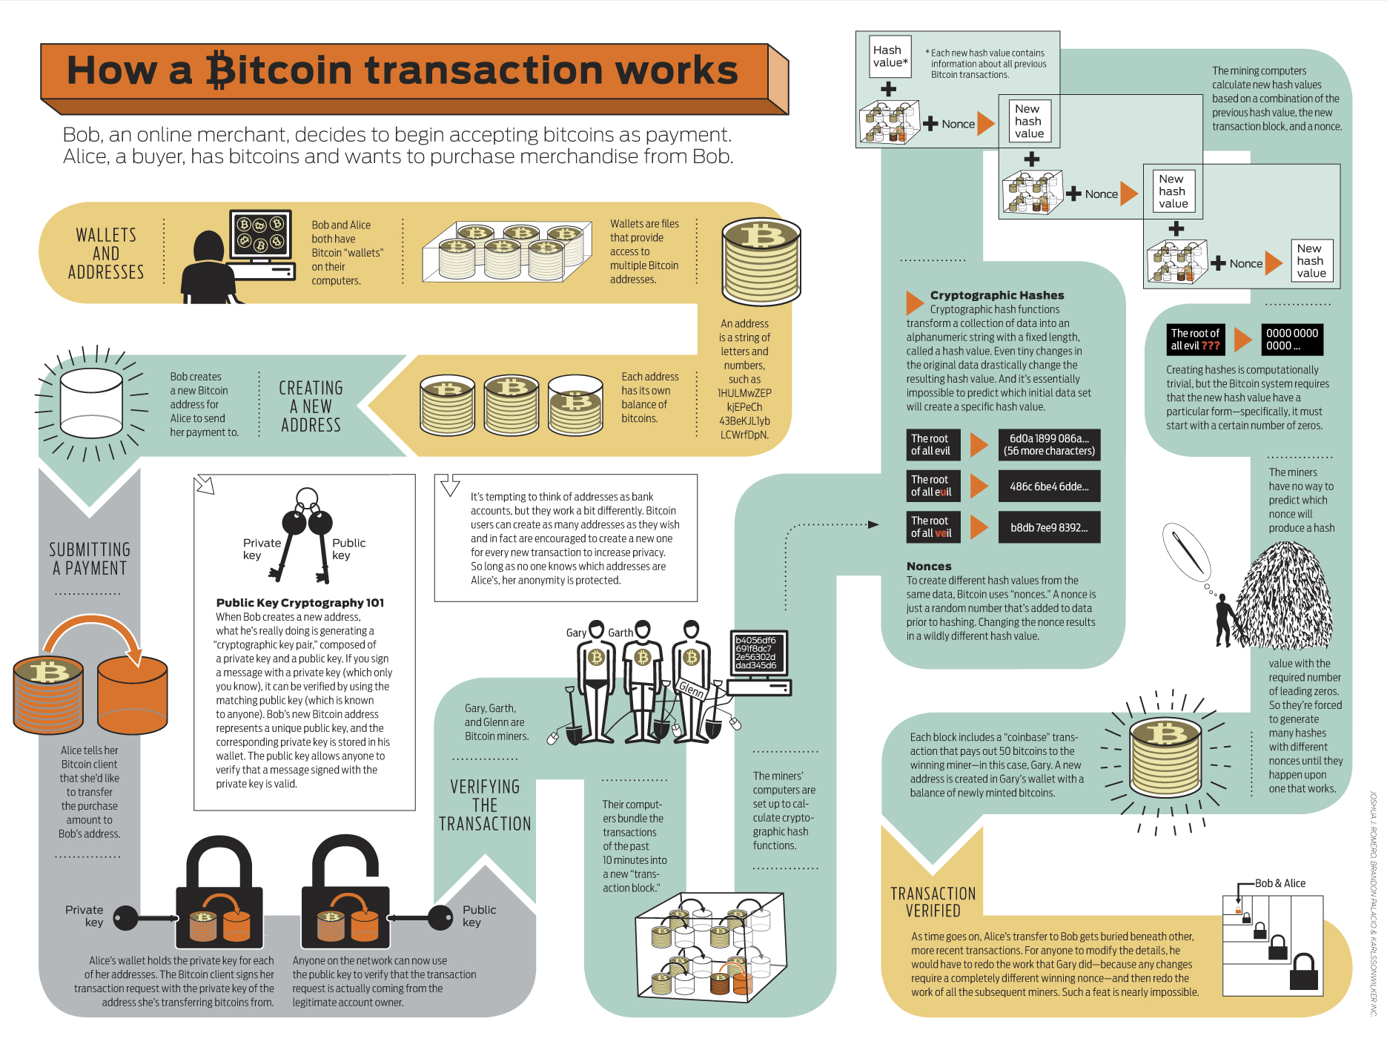

**Figure 1** Overview of Bitcoin transactions and “mining”

New tools for Bitcoin could be modifications on top of the protocol itself to create new types of transactions. For example, “coloring” Bitcoins allows people to use them as a means for other types of transactions such as contracts and financial derivatives. Also, a recent project called ZeroCoin is trying to anonymize Bitcoin by modifying the protocol itself. Furthermore, startups such as Coinbase and Coinpunk are trying to make Bitcoin easier to use by creating online wallets (Figure 2). Bitcoins are usually stored in wallets directly run on one’s computer. But, this can be memory intensive because the entire blockchain or history of Bitcoin transactions must be downloads before the user can begin to make their own transactions. These online Bitcoin wallets offer the ease of use of Bitcoin without the hassle of downloading the entire blockchain. However, there are security risks with storing Bitcoin on online servers because they are exposed to malicious hackers. Furthermore, several Android applications have been developed for Bitcoin, while Apple has not yet allowed Bitcoin wallets to be available on the App Store.

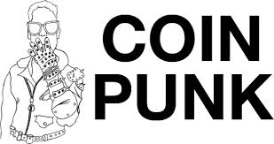

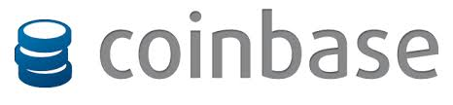

**Figure 2** Innovation in Bitcoin Space

In order to fully develop Bitcoin and decentralized currencies in developing nations, we plan to create our currency as well as an online wallet. We’ve already created the new currency by forking existing Bitcoin and Litecoin code. Some bugs still need to be worked out; however, we are confident that the currency itself can be launched in a short amount of time. The biggest challenges of launching any crypto-currency is a 51% attack where one miner controls a majority of the computational power of the mining pool and can awards themselves all the coins in each blockchain. Also, the new coin would need to develop a community in order to attract miners to uphold the currency. The wallet we are working on would be a simple wallet that can be accessed through a web browser. The online wallet will have a focus on simplicity and take into account that most people in developing countries have relatively simple phones that can only access basic web pages.

**Sangha Coin Team**

Joshua Elkington

Class of 2015

MCB

I was introduced to Bitcoin in 2011, and I was always interested in it’s ability to facilitate international transactions at high speeds and low costs. With the recent acceptance of some alternative crypto-currencies, I feel that Sangha Coin has the potential to make a substantial impact on the economic development of underdeveloped regions around the world.

David Peprah

Class of 2015

HDRB

I found out about Bitcoin in the news a couple of months ago. When Josh told me about “altcoins,” I started believing that other forms of money could be used for trade in places like Africa. New tools like altcoins have the ability to transform how trade is conducted between people.

**Plan of Action**

The first thing is creating the actual Sangha Coin. This is relatively simple because we only need to modify existing code. The hardest part of creating a new coin is convincing others to mine the coin. As result, intensive marketing must be undertaken to provide information on why this coin will be useful. Furthermore, new tools must be added to Sangha Coin to make it unique to other coins. However, we are still deliberating on what these new tools should be. We want there to be 100 billion to a trillion coins in circulation with lower mining difficulty in order to introduce more people in developing nations to decentralized money. While bitcoin is the most widely accepted cryptocurrency, Sangha Coin could be a good introduction to a decentralized payments system because of the lower cost Sangha Coin presumably would have.

The online wallet most likely will be a basic mobile html site with enhanced security. Again, marketing must be used in order to get people to use our wallet rather than existing ones such as Coinbase. As time goes on, we will get feedback from customers, and we will be able to create unique features for our wallet that make it best suited for developing nations. Ultimately, a minimal viable product (MVP) must be created in order to generate feedback from initial customers in order to create the best economic tools for economically developing regions.

**Impact of Sangha Coin**

The main problem for people in developing nations is the ability to trade with other people because of the lack of financial infrastructure available. Decentralized currency gets circumvents this problems by providing a payments platform that relies on a whole network of people rather than one central node. Our solution of creating our own decentralized currency with a secure online wallet is needed in developing nations in order to promote economic activity in these regions. As a result an MVP will be create for these products with a focus on marketing to customers in developing nations. If people begin to use our product, which we believe will happen because some developing nations are some of the highest users of Bitcoin and similar tools. By developing these tools in a lean way we can get feedback to create even better economic tools for underdeveloped areas around the world.

**Sustainability of Sangha Coin**

We will need money for servers, a computer to run the genesis block of Sangha coin, money for marketing in developing nations. If this project proceeds to the next level, we plan to recruit more friends to help develop the wallet and the coin.