
Yayasan Terang Bagi Sejahtera Bangsa

Nama: __________________
Kelas: ____________No: ____
Nilai
TT Orang Tua
Catatan Guru:
SEKOLAH DASAR KRISTEN TERANG BANGSA
Jl. Arteri Utara Kompleks Grand Marina Semarang
Telepon : (024) 7621552

LATIHAN ULANGAN HARIAN SEMESTER I
TAHUN PELAJARAN 2016/2017
Mata Pelajaran : Bahasa Jawa
Kelas : III (Tiga)
Hari/tanggal :
Materi : Pasinaon 3 lan 4

Pasangna Aksara Jawa ing ngisor iki karo huruf latine! (@1 poin)

1. an * kata
2. lw * ana
3. rw * lara
4. cl * lawa
5. kn * rawa
6. kl * kaca
7. fs * kana
8. kc * cala
9. lr * dasa
10. kt * kala
II. Wacanen wacan ngisor iki banjur isenana pitakone miturut isine wacan! (@2 poin)
Copet
Yen pinuju ana panggonan rame, kowe kabeh kudu luwih ngati-ati. Perlune kanggo jagan-jagan mbok menawa ana wong kang ora becik tumindake. Si Mbah kuwi wis nate kedrawasan.
Nalika kuwi, si Mbah ana ing Pasar Kliwon. Pinuju dina Minggu dadi ya rame jejel uyel-uyelan. Lagi nendheng-nedhenge si Mbah ngenyang klambi, ana wong bengok-bengok, “Copet! Copet! Copet!”
Si Mbah banjur noleh. Ing, kono, ana nom-noman dirangket karo hansip. Sing ngrubung akeh banget. Si Mbah uga kepengen melu nyedhak. Wusanane si Mbah melu ngrubung copet mau.

Ana ing wektu kuwi, kabeh uwong mung mandeng si copete sing mentas dikepruki wong-wong sing jengkel. Si Mbah ngematake copet kuwi. Nanging, dumadakan ana pawongan sing ndesel-ndesel si Mbah saka mburi. “Ana apa, Mbah? ….. Ana apa, Mbah?” pitakone wong kuwi karo sajak nyurung-nyurung si Mbah.
“Kuwi, lho, ana copet kecekel,” semaur si Mbah karo ora noleh.
“O, copet!” wangsulane wong kuwi.
Sawise wangsulan, pawongan ma uterus ilang, embuh menyang ngendi. Daktoleh wis ora ana. Banjur si Mbah krasa yen dhompet ana sak kathok mburi wis ora ana. Lha, edan tenan. Jebule, sing ndesel-ndesel kuwi mau, ya, copet! Apa tumon, lagi nonton copet kecekel malah kecopetan!

Gawea ukara pitakon manut isine crita mau!
11. __________________________________________________________
Simbah blanja klambi ing pasar.
12. __________________________________________________________
Ing pasar ana copet lagi dikepruki womg-womg sing jengkel.
13. __________________________________________________________
Sing ngrubung copete akeh banget.
14. __________________________________________________________
Yen pinuju ana panggonan rame, kowe kabeh kudu luwih ngati-ati.
15. __________________________________________________________
Simbah nate kecopetan ana pasar.
16. Yen pinuju ana panggonan rame, kowe kabeh kudu ...
17. Ing, kono, ana nom-noman dirangket karo ...
18. Banjur si Mbah krasa yen .... ana sak kathok mburi wis ora ana.
19. Apa tumon, lagi nonton copet kecekel malah ...
20. Si Mbah kuwi wis nate kedrawasan. Tembung kang dicethak kandel artine yaiku ....
Tulisen nganggo aksara Jawa! (@2 poin)
21. Ana nawala = _____________________________________________________________
22. Kaca rata = ___________________________________________________________
23. Narada ana kana = ___________________________________________________________
24. Dasa saka rawa = ___________________________________________________________
25. Ana lawa sadasa = ___________________________________________________________
III. Isenana manut prentahe! (@3 poin)
Gawenen ukara miturut gambare!
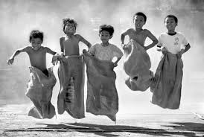
26. _______________________________________________________
_______________________________________________________
_______________________________________________________

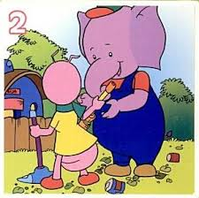
27. ________________________________________________________
________________________________________________________
________________________________________________________

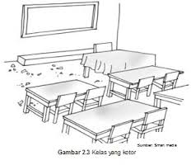
28. ________________________________________________________
________________________________________________________
________________________________________________________

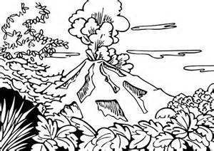
29. _______________________________________________________
_______________________________________________________
_______________________________________________________

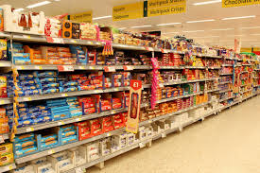
30. _______________________________________________________
_______________________________________________________
_______________________________________________________

