**CREATE API**

1. Make migration table and controller for project with the crud functions
2. Create route in api.php
3. Test it in postman
4. DONE

**CREATE THE PROJECT**

1. in folder root using npm run "npx create-nuxt-app <your-project-name>"

2. fill questions your project. for this project i use this:

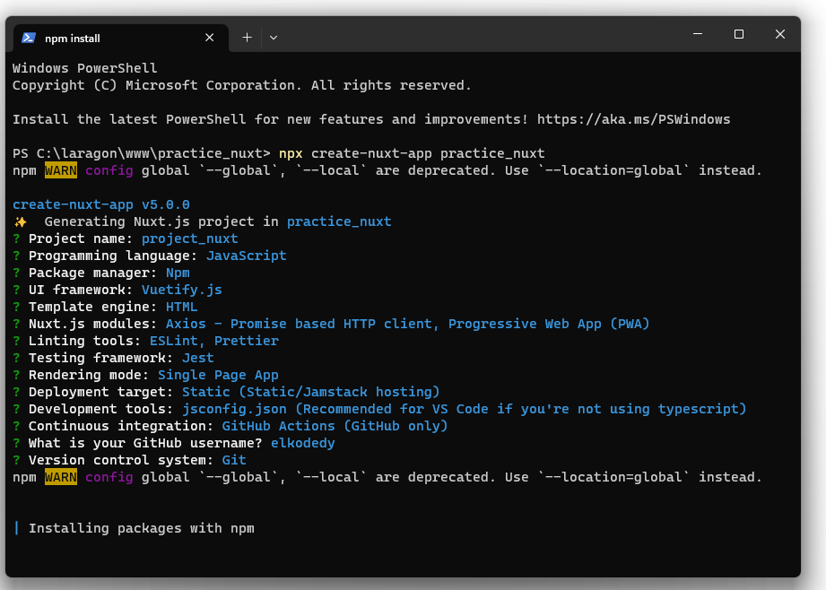

1. Project created! Done

**RUN PROJECT**

1. Open project folder in your cli
2. Run “npm run dev”
3. Open browser and go to <http://localhost:300>0 as a default url of nuxt

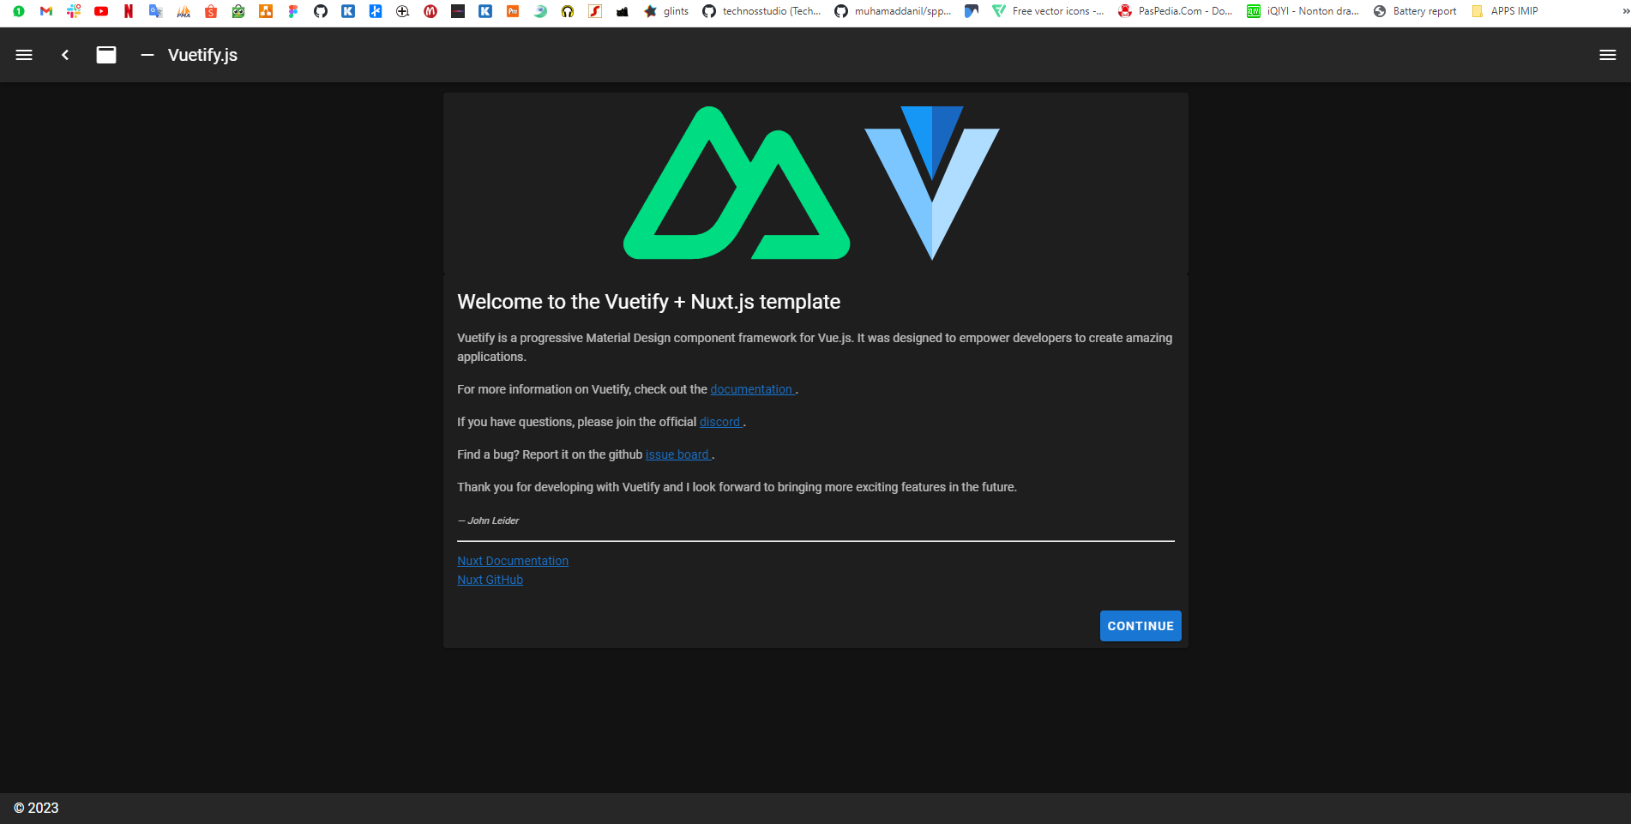

**SHOW DATA**