Estimation of Crop Water Requirement for Different Crops at Dambatta Thomas Dam Command Area, Kano State, Nigeria
¹I.A Adam and ²Abdulazeez Hudu Wudil
¹Department of Soil Science, Federal University Dutse, Jigawa State, Nigeria
²Department of Agricultural Economics and Agribusiness, Federal University Dutse, Jigawa State, Nigeria

ABSTRACT
Accurate estimation of crop water requirements (ETc) of any crop is essentially required for irrigation scheduling and water management. This work evaluated the water requirement of four irrigated crops (Groundnut, Maize, Onion and Tomato) using Hargreaves Equation and FAO-56 guidelines to compute the reference and potential evapotranspiration of the crops respectively. The crop water requirements estimated were compared with the water applied and the actual duration of crops in the field as per the practices followed by the farmers. The results showed that the crops water requirements for groundnut, maize, onion and tomato based on FAO-56 guideline are 602mm, 715mm, 1029mm, and 661mm, while the average water applied are 559mm, 577mm, 819mm, and 557mm respectively. The crops were also found to be harvested far earlier than recommended by FAO-56 guideline
Keywords: Different Crops, Water Requirement, Kano, Estimation
Corresponding Author: E-mail: azeezhud4real@gmail.com/ah.wudil@fud.edu.ng
INTRODUCTION
The adoption of exact or correct amount of water and correct timing of application is very essential for scheduling irrigations to meet the crop’s water demands and for optimum crop production (Mehta and Pandey, 2016). Water is an essential and indispensable input for agricultural activities, with a high level of importance and urgency. The shortage of water for agricultural crops is a consequence of the high demand for water across several sectors (Roja et al., 2020). Given the current climate change scenario, the optimal utilization of irrigation water in agricultural practices assumes heightened significance (Abdulhedi et al., 2000). In Nigeria, agriculture stands as the primary consumer of water among other sectors, necessitating significant attention towards optimizing its utilization. Accurate Crop Water Requirement (CWR), is among the major factor for the success of an irrigation project. The crop water requirement of the crops planted must be known so that the right amount of water should be diverted and delivered to the field. Crops need water in particular quantities for their optimum growth. Excessive or deficit amount of water could retard crop growth and ultimately lower the yield (Murty and Madan, 2011). Regarding air temperature, although there is general increase in the evaporation rate with increasing temperature, a high correlation between evaporation rate and air temperature does not exist. Thus, for the same mean monthly temperature, it is possible to have evaporation to different degrees in a lake in different months (Subramanya, 2013). The main source of energy turning water into vapour is solar radiation. Solar radiation absorbed by atmosphere and heat radiated by the earth increase air temperature. Physical heat of the air transmits energy to plants and controls evapotranspiration rate (Gad and El-Gayar, 2010). Evapotranspiration also called consumptive use of water or crop water requirement is defined as the total quantity of water used by the vegetative growth of a given area in transpiration and building of plant tissue, and that evaporated from the adjacent soil in the area in any specified time (Modi, 2012). The real evapotranspiration, occurring in specific situation in the field, however, is called actual evapotranspiration (AET). The amount of water a crop needs is determined by a number of factors, including climate, crop acreage and type, soil, growing season, and crop production frequency (Ewaid et al., 2019).
When compared to other African countries, Nigeria has a plentiful water supply. While there is plenty of water available for irrigation year round, only about a third of it really makes it to the crops (Pearce, 2018). In many cases, water does not reach farms in a timely manner or in sufficient quantities. Many large-scale irrigation projects in Nigeria are poorly managed, resulting to wide disparity between the water users at different location (Sangari, 2016; Wudil et al., 2020). Nigeria’s water resources are inefficiently managed especially when it comes to irrigation. Previously, this issue was not a real problem because of the abundance of rainfall water across the ecological zones of the country. However, with the recent economic and physical water scarcity crisis in the Sudan and Sahel savanna zones of the country, mainly due to erratic rainfall, decrease in the main rivers’ discharge, and high cost of fuel to power generators in case of ground water users. There has been a need to modernize irrigation systems. Agriculture is the main consumer of water in Nigeria, and the irrigation systems require modernization and good management by evaluating water system prerequisites precisely. It is therefore important to know the crop water requirements (CWRs) and irrigation scheduling to take care of the irrigation demand.
In the present study therefore, the irrigation water requirements of some selected crops (Groundnut, Maize, Onion and Tomato) in Dambatta Tomas irrigation project was studied using Hargreaves Equation and FAO-56 guidelines. The objectives of the study were to: 1. compute the reference and potential evapotranspiration of the selected crop 2. correlate between the standard crop water requirements as set out by FAO-56 based on Standard growing period (SGP), and crop water requirement for actual growing period (AGP) based on FAO-56.

METHODOLOGY

Study Area
The study area is located in Dambatta Local Government of Kano State in Nigeria along A2 highway, approximately falling between Latitude 12○19” N and Longitude 8○31”E. It is situated as a part of Tomas Dam command Area. Kano state has an arid to semi-arid climate, annual average high temperature of 33.2 ⁰C, annual average low temperature of 19.2 ⁰C and average temperature of 26.2 ⁰C with an average annual precipitation of 713 mm. The soil is generally sandy loam with a little silt deposit at the areas close to the delivery canals (DC). The major crops grown during irrigation farming are Tomato and Onion, with maize and groundnut in relatively smaller percentage.
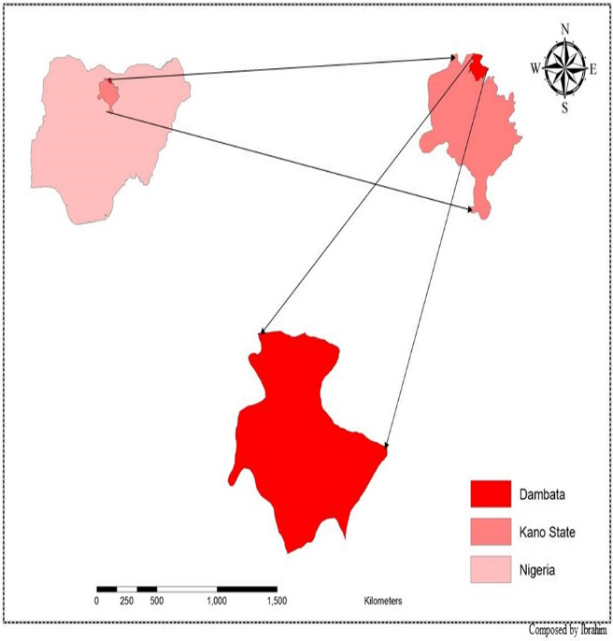
Figure 1: Map of the Study Area.

Metrological Data
Daily air temperature was also retrieved online from www.weather underground.com. The data was double checked to ensure quality. It was found out that some values were missing and, in some cases, the maximum and minimum temperatures were the same. The missing values were then generated using at least an average three years, and in some cases five (5) years average of that very date. For the case of some maximum and minimum values, the average value of previous day and the proceeding was used as correction. The data along with terrestrial radiation (R_{a}) will be used to compute reference evapotranspiration (ETo).

Air temperature
The air temperature comprising of both minimum and maximum values, were used to compute for average temperature (T.avg.) and mean temperature (T.D) using excel, these outputs are then used in Hargreaves equation as weather data.

Extra-terrestrial Radiation (R_{a})
The standard equation for determining extraterrestrial radiation (R_{a}) by FAO-56 (Richard et al., 2006) was used. Only one out of the five parameters for calculating Ra is constant given as the solar constant G_{sc}. The equation is given as;
………………………….. (1)
Where; R_{a} = extraterrestrial radiation [MJ m⁻²day⁻¹],
G_{sc} = solar constant = 0.0820 [MJ m⁻²min⁻¹],
d_{r} = inverse relative distance Earth-sun,
ω_{s} = sunset hour angle [rad],
= latitude [rad],
δ = solar declination [rad]
rad, d_{r}, δ and ω_{s} are given as;
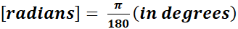 (2)
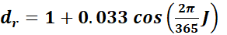 (3) 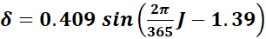 (4) (5)
Daily values of Ra are generated by Equation 1.

Hargreaves Equation
This equation is used to compute reference evapotranspiration (ETo) using only two required inputs, air temperature and terrestrial radiation, the other values are constant.
The Equation is given as;
(6)
(Droogers and Allen, 2002).
Where; ETo = reference evapotranspiration [mm day⁻¹]
R_{a} = extraterrestrial radiation [MJ m⁻²day⁻¹],
T_{avg} = average temperature [degrees],
T.D = mean temperature [degrees]

Reference Evapotranspiration (ETo)
This is the value obtained from Hargreaves Equation; it is proportional to rise in temperature. The daily ETo is then multiplied by crop coefficient to get potential evapotranspiration. (PET).

FAO-56 Crop Coefficient (Kc)
Standard crop coefficient was provided in FAO-56 manual, depending on the study area climatic region. Kano, as stated earlier has a semi-arid to arid climate. The crop coefficient for groundnut, maize, onion and tomato were obtained.

Potential Evapotranspiration (ETp)
This will give the amount of water to sufficiently fulfil crop need, which is the same as crop water requirement. Equation 7 is used to calculate daily crop water requirement for crops grown in the study area.
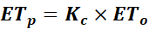 ……………………………………………………………… (7)

Where; Kc= crop coefficient
ETo= reference evapotranspiration (Richard et al 2006).
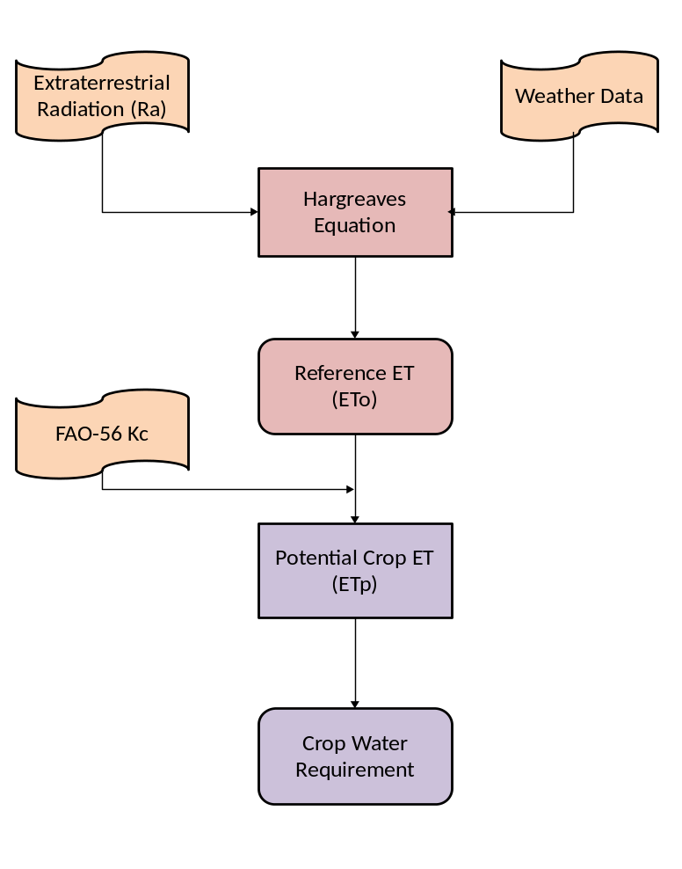

Figure 2: Conceptual model of analytical approach to crop water requirement

RESULTS AND DISCUSSION
The water requirements of the crops grown in the study area were estimated following the FAO-56 guidelines. Following the FAO-56 methodology, the Potential Evapotranspiration (ETp) was computed, the water requirement was estimated for the period when the crop was actually on the field i.e., actual planting/harvesting months widely adopted by farmers in the study area.

Reference Evapotranspiration of crops
Reference evapotranspiration is an important parameter in agricultural water management, irrigation scheduling and crop water requirement estimation. Result from Table 1 indicated that the reference evapotranspiration under FAO-56 standard growing period and FAO-56 applied growing period for groundnut was 667 mm and 645 mm respectively. Meanwhile, the difference between the two values was 22 mm equivalents to 3.35%. Similarly, for maize plant value of FAO-56 SGP and FAO-56 AGP were found to be 724mm and 556 mm respectively, the difference between the values was 168mm or 26.25% which was significantly high.
In a study conducted in three Nigerian agro ecological zone by Salako (2010), It was found out that apart from the differences in magnitude of ETo, trends of PM, HG and pan methods were similar, particularly for daily means and monthly totals.
Moreover, the result indicated that the reference evapotranspiration under FAO-56 SGP for Onion is 1055 mm as against 841mm under FAO-56 AGP. This result showcased a difference of 214 ETp equivalents to 22.57% differences. The difference seems to be very wide which could affect the productivity of the plant. The reference evapotranspiration of Tomato plant under FAO-56 SGP is 695 ETp, higher than 601 ETp under FAO-56 AGP. The margin between the two was found to be 14.51%.
Table 11: Reference Evapotranspiration of crops
Crops | FAO-56 SGP (ETp (mm) | FAO-56 AGP (ETp (mm) | Differences
Groundnut | 667 | 645 | 22 (3.35)
Maize | 724 | 556 | 168 (26.25)
Onion | 1055 | 841 | 214 (22.57)
Tomato | 695 | 601 | 94 (14.51)
** Figures in parenthesis are percentage differences
Source: Authors Computation

Crop Water Requirement
Crop water requirements (CWR) for an area are determined from the crop consumptive use of water or evapotranspiration includes evaporation of water from land and water surfaces and transpiration by vegetation. The excess estimation of crop consumptive use may ultimately create the problems of water logging whereas the under estimation leads to crop failure or low yield of crops. Thus the under estimation of CWR become major constraint to achieve the full economic benefits from agriculture produce (Rakhshanda et al 2002). To establish net water requirements of a crop in any environment, potential evapotranspiration (ETo) and crop coefficient (Kc) are required to calculate crop evapotranspiration (ETc). Crop water requirement is a given amount of water lost due to crop evapo-transpiration (ETc). In other word, the value of the crop water requirement is given equally to the amount of plant evapotranspiration (Roja et al., 2020).
The value of crop water requirements for Groundnut, maize, Onion, and Tomato is presented in Table 2.

Water Requirement for Maize
Maize is an efficient user of water in terms of total dry matter production whose crop factor (kc) relating to crop water requirements (Etc) with reference to evapo-transpiration (Eto) differs between growth stages (Wang et al., 2009). The water requirements for maize were obtained assuming January planting date under FAO-56 standard growing period (SGP), for which the crop should be in the field for almost 4.5 month before harvesting. This makes the water requirement to be relatively much higher than that of the actual growing period (AGP). Normally in the actual growing period, farmers planted the maize early to mid-February. Comparing FAO-56 standard growing period (SGP) and that of actual growing period (AGP), it can be seen that there is no late season which is due to the fact that irrigation farming ends by April, the farmers then begin preparing their lands for rainy season farming by the end of May. The crop should be left for five (5) months in the field under FAO-56 standard growing period (SGP) but was instead harvested less than four (4) months in actual field practice. Therefore, amount of water requirement under standard practice (715 mm) was not achieved under actual practice (577 mm).
A study conducted by Cid P et al. (2018) during 3 years of maize production in northeastern Colorado, USA, found out that the FAO-56 procedure had an acceptable performance in predicting maize ET, with an overestimation of 9% on average among treatments and growing seasons.

Water requirement for Onion
Among vegetable crops, onion (Allium cepa L.) is one of the major condiments widely used in every household round the year. In Nigeria, more than 70% all the onion is grown through irrigation. Mean per hectare yield of onion in the country is 12.3 tones which are low compared to other developing countries. Some studies have shown that the average water requirement of onion is 650 mm to produce mean yield of 48t/ha across different location, under different soil and agro climatic condition and with irrigation use efficiency. Result from Table 2, indicates the water requirement for onion under different water requirement scenarios (FAO-56 SGP and FAO-56 AGP). Under AGP, onion is planted towards ending of October, reaching maturity stage by January, a total of 819 mm water requirement falling short of the FAO-56 SGP of 1029 mm. under AFC the onion are harvested far earlier before they reach full maturity, that is why some plots used are reserved specifically for dry seed which is left to reach its full growth before it is harvested. The difference between the two scenarios was about 210 mm which is equivalent to 22.72%.

Water requirement for Tomato
The ETp computed under FAO-56 Actual Growing Period (AGP) is 557 mm; while that of FAO-56 standard Growing Period is 661mm. the difference is considerable which indicate crops are not getting sufficient amount of water which will inevitably affect yield. From these results, it can be inferred that planning a scientific water requirement is of great importance for the stated crops so as to achieve a higher productivity using the most optimum amount of water, once all the other agronomic practices are considered (Mehta et al., 2013).

Water requirement for Groundnut
Of the agronomic factors known to augment crop production, water management stand second, next to fertilizer contributing 27% in crop production. Among the various constraints for the low yield, the principal one is erratic, insufficient and unevenly distributed rainfall during rainy season. The result in Table 2 indicated that in actual growing period (AGP), farmers mostly plant the crop in December and harvest it around Mid-April. Comparatively there is a reduction in water requirement between FAO-SGP and FAO-56 AGP mm. Despite the fact that the FAO-56 AGP has 6 days more than the Standard growing period (SGP) in planting, the water requirement was less than FAO-56 SGP by 43mm equivalent to 7.4%. From the result it can be concluded that ground nut cultivars in the study area can obtained maximum yield without necessary adhering to the FAO-56 SGP.
Table 22: Potential Evapotranspiration of crops
Crops | FAO-56 SGP (ETp (mm) | FAO-56 AGP (ETp (mm) | Differences
Groundnut | 602 | 559 | 43 (7.4)
Maize | 715 | 577 | 138 (21.37)
Onion | 1029 | 819 | 210 (22.72)
Tomato | 661 | 557 | 104 (17.07)
** Figures in parenthesis are percentage differences
Source: Authors Computation

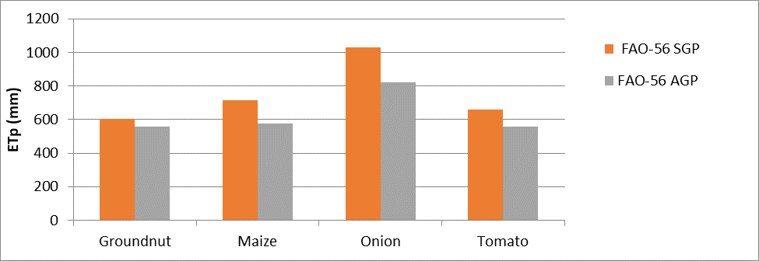
Figure 4: Potential evapotranspiration
Source: Author’s computation
CONCLUSION
If the water applied is less than the water required, the crops are set to be under irrigated. As water is needed for all pant activities, deficit in water applied affect the growth and health negatively; this will consequently affect the yield. For groundnut, the amount of water required based on FAO-56 SGP is 602 mm depth from planting to harvesting, and the amount needed based on the actual planting date (AGP) as practiced generally by the farmers is 559 mm, which may be due to the difference in planting month. In comparison. The same can be said to the rest of the planted crops signifying under irrigation, thereby compromising quality and yield of the planted crops. The water applied is always lower than the water required by the crops under both standard and actual conditions. In tomato and onion the difference is very wide, this may account for the farmers harvesting them early due to high demand or in the case of tomato, it is well known for its sensitive root and the farmers may opt to be too cautious and end of applying very less amount of water than required.
Daisuke et al. (2007) in a study conducted in Ethiopia under similar semi-arid condition, found out the measured Kc value was different from the estimated Kc value by FAO 56 due to specific
cultivator, soil type, the changes in local climatic conditions, and seasonal differences in crop growth patterns. Such differences obviously reflect the difficulty not only in extrapolating crop coefficients to other environments, but also in applying crop coefficients to determine crop water requirement.
REFERENCES
Abebe, N., & Kebede, E. (2020). Determination of crop coefficients and water requirement of tomato at Werer, Middle Awash Valley of Ethiopia.
Abdelhadi, A. W., Hata, T., Tanakamaru, H., Tada, A., & Tariq, M. A. (2000). Estimation of crop water requirements in arid region using Penman–Monteith equation with derived crop coefficients: a case study on Acala cotton in Sudan Gezira irrigated scheme. Agricultural Water Management, 45(2), 203-214.
Droogers, P., & Allen, R. G. (2002). Estimating Reference Evapotranspiration Under Inaccurate Data Conditions. Irrigation and Drainage Systems, vol.16, pp. 33-45.

Cid, P., Taghvaeian, S., & Hansen, N. C. (2018). Evaluation of the Fao‐56 methodology for estimating maize water requirements under deficit and full irrigation regimes in semiarid northeastern Colorado. Irrigation and drainage, 67(4), 605-614.
Ewaid, S. H., Abed, S. A., & Al-Ansari, N. (2019). Crop water requirements and irrigation schedules for some major crops in Southern Iraq. Water, 11(4), 756.
Gad, H. E., & El-Gayar, S. M. (2010). Effect Of Solar Radiation On The Crops Evapotranspiration In Egypt. Fourteenth International Water Technology Conference (pp. 769-783). Cairo: IWTC.
Mehta, R., & Pandey, V. (2016). Crop water requirement (ETc) of different crops of middle Gujarat. Journal of Agrometeorology, 18(1), 83-87.
Modi, P. (2012). Irrigation Water Resources and Water Power Engineering (Sixth ed.). New Delhi, India: RAJINDER KUMAR JAIN.
Murty, V. N., & Madan, K. J. (2011). Land and Water Management Engineering. New Delhi: KALYANI
Pearce, F. (2018). When the rivers run dry, fully revised and updated edition: water-the defining crisis of the twenty-first century. Beacon Press.
Rakhshanda, R., S. Ahmad and A. Ashraf. 2002. Characterization and Classification of Agro-Climates of Pakistan. Pak. J. Agric. Res., (17)3: 245-254.
Richard, G. A., Luis, S. P., Dirk, R., & Martin, S. (2006, February). FAO Irriagation andDrainage Paper. N0. 56, pp. pp 41-52.
Roja, M., Navatha, N., Devender Reddy, M., & Deepthi, C. (2020). Estimation of crop water requirement of groundnut crop using FAO CROPWAT 8.0 model. Agro Econ. Int. J, 7, 35-40.
Salako, F. K. (2010). Estimation of Evapotranspiration with FAO-56 Penman-Monteith equation for three Agroecological zones of Nigeria. ASSET: An International Journal (Series A)}, 8(2), 134-149.
Sangari D.U. (2006). An Evaluation of Water and Land Uses in the Kano River Project, Phase I, Kano State. Applied Science and Environmental Management, 105-111.
Subramanya, K. (2013). Engineering Hydrology. New Delhi: Mc Graw Hill Education (india) Private Limited.
Wang, Y. M., Traore, S., & Kerh, T. (2009). Applying evapotranspiration reference model and rainfall contribution index for agricultural water management plan in Burkina Faso. African Journal of Agricultural Research, 4(12), 1493-1504.

