Requirements Analysis Document

Galactic Conquest Project

CS325 Database Group
Spring 2006
SIUE

Authors:
Anthony Keeley
Ethel Ireland
Brian Glass
Ella Blackledge

1. Introduction 3
1.1 Purpose of the system 3
1.2 Scope of the system 3
1.3 Objectives and success criteria of the project 4
1.4 Definitions, acronyms, and abbreviations 4
1.5 References 9
1.6 Overview 9
2. Current System 10
3. Proposed System 10
3.1 Overview 10
3.2 Functional requirements 10
3.3 Nonfunctional requirements 12
3.3.1 Usability 12
3.3.2 Reliability 12
3.3.3 Performance 12
3.3.4 Supportability 12
3.3.5 Implementation 12
3.4 System models 13
3.4.1 Scenarios 13
3.4.2 Use case model 14

3.4.3 Object model 15
3.4.5 Entity Documentation 16
Static Game Data 16

1. Introduction

Purpose of the system
The purpose of the Database Team is to manage static and dynamic data for the Galactic Conquest Game Project. The Database Team will assist the client, users, the Developer Team, the Artificial Intelligence Team, the Infrastructure Team, and the Human Computer Interaction Team with exchange of data.

Scope of the system
The scope of the system is to construct a Database System that will successfully allow, according to access control, the Game Development Team, the Artificial Intelligence Team, the Infrastructure Team, and the Human Computer Interaction Team to insert, delete, retrieve, and update data.

Objectives and success criteria of the project
The objectives of the Database Team are to:
- provide our users with software that defines a database, stores the data, allows for retrieval of data, produces reports, and creates data entry screens.
- provide a collection of data, and storing it in a standardized format.
The Database Management System is accepted if at least the following success criteria are satisfied:
- The Database Management System is available on May 5, 2006 and satisfies the functional requirements specified in section 3.2.
- The Database Management System runs on the server chosen by Infrastructure.
- The Database Management System nonfunctional requirements from section 3.3 are satisfied.

Definitions, acronyms, and abbreviations
Destroyer (DE)
A DE is the bargain basement/first shot effort at a hyperlight warship. It basically consists of a somewhat larger hull than a Scout, with primitive weaponry and armor fitted around an oversize hyperlight drive - this enables it to travel at speed 4. This is basically the Hyundai of warships: light armament, lighter armor, cheap to build, and you don't cry too much if it gets dented - you just build another one.
Control Requirements: DEs have a ConReq value of 1. This is the lowest ConReq value, and as such DEs cannot control any other ship.
Scout (SC)
This is one of the most important units in the game. Initially, you will use a Scout to seek out new planets for exploration, and to find enemy races. Later on in the game, when development begins in earnest, you will use a Scout for picket duty, to insure that enemy races do not sneak up on you when you are busy doing something else. Finally, Scouts will become indispensable when the time comes to finally build your "death fleets." Scouts are the fastest units in the game and are very difficult to destroy (fast, and with their special sensors can see you coming), but do not add to a fleet's Defense rating.
Control Requirements: SCs are exempt from ConReq rules - you may have as many as you wish in a single fleet.
Sensor Satellite (SS)
These are basically Scouts without the engines. They, like the PDs, are placed in LaGrangian orbits, or scattered throughout a ring system/asteroid belt. Great for spotting someone sneaking up on your precious planets... Sensor Satellites may be transported by Transports and Fast Transports, but only in "mothballed" form - you will not receive any Scouting abilities from transporting an SS.
Control Requirements: SSs are exempt from ConReq rules - you may not have any in a fleet, and there are limits to the number a planet may have - see the Satellite rules.
Transport (TR)
Transports are the tramp freighters and steamships of the universe. Very slow with no offensive or defensive capabilities, this "18-wheeler" of starships is used to transport RPs, Satellites, Fighters, and Mines to and from an empire's planets. They're very cheap to build, and blow up like popcorn in a battle. Escort them if you wish to keep them...
Control Requirements: TRs are exempt from ConReq rules - you may have as many as you wish in a single fleet. However, TRs have DUO restrictions - see that section for details.

Fast Transport (FT)
A Fast Transport is a much better, much more expensive Transport. They are capable of speed 4, carry more cargo faster than a regular Transport, and have half the offensive, all the defensive power of a Destroyer...while this doesn't exactly make them able to stand up to a Battleship, it does help in a skirmish. Still, escort them!
Control Requirements: FTs are exempt from ConReq rules - you may have as many as you wish in a single fleet. However, FTs, like TRs, have DUO restrictions - see that section for details.
Light Cruiser (LC)
Light Cruisers are one of the best warships in the game. Zipping around at speed 4 and having twice the defense of a Destroyer, groups of these make a nifty fast attack fleet, or a good Fast Transport escort.
Control Requirements: LCs have a ConReq value of 2. This means each LC can control up to 3 ships with ConReq values less than 2 (in this case, DEs are the only ships with ConReq lower than 2).
Mine (XX)
This is actually not a discrete unit - actually it is a number of small warp sensitive bomblets which, when laid in a hex, populate that hex with a Minefield. Any ships entering this hex have a chance of setting one of these mines off. Once laid, a Minefield stays in that hex forever, until a Minesweeper sweeps it. These "units" can be carried (and laid) by Minesweeper units, or carried (and not laid) by Transports and Fast Transports. You may wonder why they are only a Tech 2 item when the Minesweeper you need to lay them is Tech 3. The answer is that a Minesweeper has a special Minefield deployment device that insures an even spread throughout a hex.
Control Requirements: XXs are exempt from ConReq rules - see the Mine rules.
Planetary Defense Satellite (PD)
These are small satellite battlestations situated in the LaGrangian positions around a planet, or scattered throughout a ring system/asteroid belt. PDs are inexpensive to build, and pack a respectable punch - especially if they have a full contingent of 3 fighters each. PDs can be transported in Transports and Fast Transports, but only in "mothballed" form - you will not receive any Offense or Defense from transporting a PD. Additionally, Fighters cannot be transported "inside" the PD being transported.
Control Requirements: PDs are exempt from ConReq rules - you may not have any in a fleet, and there are limits to the number a planet may have - see the Satellite rules.
Cruise Mine (CM)
This "unit" is a missile with a payload of "Minelets". You target this missile on a given hex, and it travels there on its own at speed 4, then MIRVs and deploys the Minelets once it gets there. However, it's payload is smaller than an equivalent "Mine" unit on a Minesweeper, so each Minelet only packs half the punch of a regular mine. Great for harrassing shipping and annoying other players. CMs can be carried in Transports and Fast Transports only (not in MSs) in "mothballed" form, and can only be launched from planets (they need that large a platform to keep their inertial guidance computers on track).
Control Requirements: CMs are exempt from ConReq rules - see the Mine rules.
Fighter (FG)
Fighters are tiny, fast attack craft based on a fission engine design rather than the fusion-ion engine design used in capital ships. Unfortunately, fission engines require heavy, unstable elements as fuel, and these can't be had just by diving into a Gas Giant's atmosphere the way capital ships refuel and they also lose efficiency when upscaled, so you'll only find them in fighters. Fighters are very cheap individually, but pack a very powerful punch in groups -but the life of a fighter pilot is not a long one... Fighters are based off of Carriers, Strike Carriers, or Planetary Defense Satellites. In addition, Fighters may be carried by Transports and Fast Transports, but in mothballed form - they can not operate as fighters while being transported like that. The best defense against a Fighter is another Fighter, and they are devastating against unprotected TRs and FTs...
Control Requirements: FGs are exempt from ConReq rules - the number of fighters in a fleet depends on their carrier type. Fighters Attack and Defend in groups, but dogfight with other Fighters in squadrons - see the Fighter rules.
Heavy Cruiser (HC)
This is a poor man's Battleship, capable of licking its cost in LC's and DE's in any pitched battle. A worthy addition to any speed 3 battle fleet.
Control Requirements: HCs have a ConReq value of 3. This means each HC can control up to 3 ships with ConReq values less than 3 (CSs, LCs, or DEs).
Minesweeper (MS)
This ship sweeps and lays mines. MSs, along with Transports and Fast Transports, are the only ships in the game that can carry mines - and TRs and FTs can't lay them (they carry them in "mothballed" form). Additionally, these are the only units in the game which can carry Nova Bombs. You will not succeed in the game without having some Minesweepers, nor will you be laying any Nova Bombs either...
Control Requirements: MSs are exempt from ConReq rules - you may have as many as you wish in a single fleet.
Battleship (BS)
A rich man's Heavy Cruiser. This ship represents the maximum offensive and defensive capability that can be crammed into a spaceframe capable of warp 3. A good, if expensive, investment for the up and coming warmonger (the phrase "..a load of BS..." takes on a whole new meaning in this game).
Control Requirements: BSs have a ConReq value of 4. This means each BS can control up to 3 ships with ConReq values less than 4 (HCs, CSs, LCs, or DEs).
Light Control Ship (LX)
Eventually, you will become frustrated at the limited speed 4 punch at your command due to Control Requirements. When this happens, look to buying an LX - they increase your possible speed 4 fleet strength by 50%.
Control Requirements: LXs do not have a ConReq value because they cannot be controlled by any other ships. They can control up to 3 ships with ConReq values less than 3 (CSs, LCs, or DEs). They cannot be in a fleet which has any unit with a ConReq value of 3 or greater (HCs, BSs, CAs, or DNs), nor can they be in a fleet which contains an HX. There may not be more than one LX in any given fleet.
Planet Eater (PE)
Big goofy-looking spacegoing garbage disposal with a bad attitude. The entertainment value of seeing an opponent discover one of these in his backyard headed for the refrigerator is well worth the cost. Yes folks, it eats planets, as well as ships (friendly or not), small children, pets, etc that are in its path. Mines don't bother it, and it doesn't listen to reason. Sadly, it takes so many resources to build one that it knocks the building planet down a Tech Level.
Control Requirements: PEs do not have a ConReq value and cannot be in a fleet. See the Planet Eater rules.
Strike Carrier (CS)
Okay, you got some fighters for Christmas. Now, wouldn't you like to show them to your neighbors? A Strike Carrier is perfect to get them there. It holds two 4 fighter squadrons (as opposed to the single 3 fighter squadron on a PD). TRs and FTs can also carry fighters, but in "mothballed" form only.
Control Requirements: CSs have a ConReq value of 2. This means each CS can control up to 3 ships with ConReq values less than 2 (in this case, DEs are the only ships with ConReq lower than 2).
Carrier (CA)
Maybe you got a LOT of fighters for Christmas...Carriers hold three 5 fighter squadrons, but they only go speed 3. They too have limited Scout capabilities. Once again, TRs and FTs can carry fighters, but in "mothballed" form only.
Control Requirements: CAs have a ConReq value of 4. This means each CA can control up to 3 ships with ConReq values less than 4 (HCs, CSs, LCs, or DEs).
Dreadnought (DN)
It doesn't matter if you're paranoid if they really ARE out to get you...these hulking behemoths eat Heavy Cruisers for breakfast, and use mines as an excuse to repaint the hull. Good thing these puppies only go speed 2 or the entire galaxy would be a low rent district. Perfect for system defense, terrible at offense (for example, "Task Force 8 is in position for the attack and is waiting for the Dreadnought to show up to begin...should be here in about 5 years...").
Control Requirements: DNs have a ConReq value of 5. This means each DN can control up to 3 ships with ConReq values less than 5 (BSs, CAs, HCs, CSs, LCs, or DEs).
Heavy Control Ship (HX)
Not enough speed 3 punch in your death fleet? Or maybe you'd just like to add a Carrier group to it. Either way, the HX is for you. Like an LX, these add 50% to the possible strength of any speed 3 fleet.
Control Requirements: HXs do not have a ConReq value because they cannot be controlled by any other ships. They can control up to 3 ships with ConReq values less than 6 (DNs, BSs, CAs, HCs, CSs, LCs, or DEs). There may not be more than one HX in any given fleet, and an LX cannot be in a fleet with an HX.
Nova Bomb (NB)
Big, ugly antimatter bomb that turns a megahex of prime real estate into radiation zones. Sometimes even more than a megahex (planets blow up too!). Perfect for urban renewal.
Control Requirements: NBs are exempt from ConReq rules - see the Nova Bomb rules.
Control Requirements (ConReq)
There are limitations on the number and type of ships which may be in a single fleet. These limitations represent the degree of coordination possible between different ship types and the amount and quality of Command/Control/Communications equipment on board a fleet's flagship. This section will explain how these requirements function.

The following ships have "ConReq" values: DE, LC, HC, BS, CS, CA, and DN. These ConReq values determine how many and what kind of ships which may be controlled by the valued unit. Units that are "exempt" from ConReq rules have other restrictions put on their inclusion into a fleet, ranging from Designated Unit Ordering (DUO) restrictions, to squadron size and group size (Fighters), to restrictions on number allowed in a fleet (Control Ships), to simply not being able to be part of a fleet (Planet Eaters). For these exempt units refer to their rules for descriptions of the restrictions.

References
Galactic Conquest, Version 3.0, Tim Gray.

Overview
Sending Information:
Both A.I. and H.C.I. groups will send data to the Game Design group in a “Turn Sheet” (format located on page 24 of game booklet).This will list all the activities or commands that a user has done in his or hers turn. – Talk to Game Design for more details.
Processing:
Game Design will take the data from the A.I., H.C.I., and Database Teams, and calculate the results.
Receiving Results:
After the results are processed, Game Design will give the results to the Database, and they will send the results to the rest of the groups.

- Infrastructure Team will handle the way the data and results are transported between the teams.
- Game Design Team will process all the data and calculate the results.
- H.C.I. Team will handle the user interface and commands that the user gives the game.
- A.I. group will handle how the computer will play the game and will follow along the lines of the H.C.I. Team.
- Database group will store the data that the Game Design Team needs to store and send the results of the game/battle to all the groups when told by the Game Design Team.

2. Current System
Currently, the Galactic Conquest Game can be played on paper only.

3. Proposed System

3.1 Overview
The main database will reside on the Main Database server and consist of three logical parts: Player and Game data, Static Game data, and Instance Game data.

Player and Game data contain global game data, not required for real-time game play. It is not copied to the instance databases. For example, team/player ratings will be updated after game end by a Game Development service.

Static Game data contains static information, used in playing the game. The data itself along with definitions and stored procedures are copied to instance database. Static data can be changed only by database administrators/maintenance. There shouldn’t be any changes to static data until the subsequent release of the game.

Instance Game data contains data that will exist only for duration of a game, and will be erased after the game end. Only table definition and functions are stored on the main database and copied to the instance databases.

3.2 Functional requirements

The diagram below shows an overview of the database as part of the Galactic Conquest Game system. Multiple games can be played at the same time. New database instance is created for each game instance.
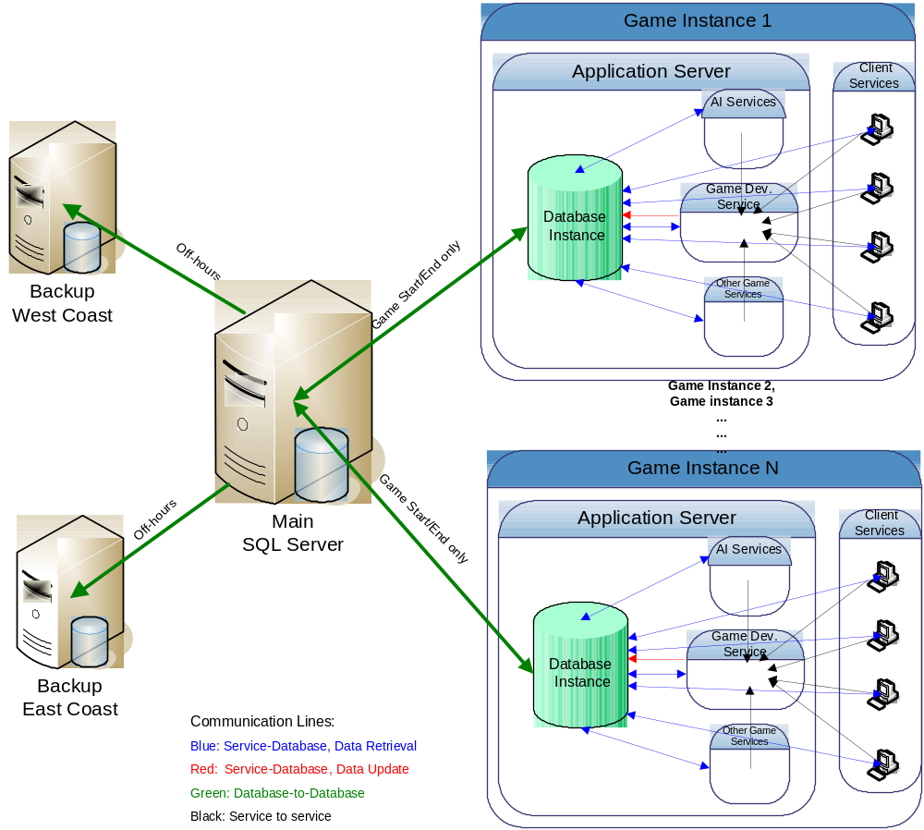

Communications occurs via network services. The Infrastructure team manages all details of the communications, including XML formatting. The database “sees” only network interface and performs two major tasks:
1) executes stored procedures to update/retrieve data;
2) for each database update, generates messages and notifies other services.

3.3 Nonfunctional requirements

3.3.1 Usability
The users of the database are: project management, software engineers and maintenance engineers. Database documentation must include the following: description of data entities along with data types and constraints, and description of stored procedures.

3.3.2 Reliability
The user has indicated importance of the reliability of the system. In case of service outage, special recovery procedures must be designed.

3.3.3 Performance
The game is played real time, so the data communication must occur very fast. Database software must be selected such that it includes multithreading and other capabilities used to achieve maximum processing speed.
Several games can be played at the same time. A separate database instance will be created for each game instance to accommodate multi-player feature.

3.3.4 Supportability
Stored procedures are used for communication with the database. This allows database changes without changes to underlying services.
The system should adhere to principles of multi-tier architecture. If possible, there should be a clear boundary between data layer and business layer. The purpose of the database should be data storage and data access only. All of the game logic should execute on the application server side.
The database must be well designed and normalized.

3.3.5 Implementation
SQL Server, Oracle, or any other relational database.

3.4 System models

3.4.1 Use Cases

The possible use cases are as follows:

1. User retrieves data
Participants: user message object, database message object, database
Flow of Events:
1. A message object is received from the user, requesting data from the database.
2. The database runs the correct stored procedure, given the parameters in the message object.
3. The database returns a message object containing the results of the stored procedure back to the user.

2. User updates data
Participants: user message object, database message object, database
Flow of Events:
- A message object is received from the user, requesting an update of data stored in the database.
- The database runs the correct stored procedure, given the parameters in the message object.
- The database returns a message object containing the results (succeed or fail) of the stored procedure back to the user.

3. User adds data
Participants: user message object, database message object, database
Flow of Events:
1. A message object is received from the user, requesting data be added to the database.
2. The database runs the correct stored procedure, given the parameters in the message object.
3. The database returns a message object containing the results (succeed or fail) of the stored procedure back to the user.

4. User deletes data
Participants: user message object, database message object, database
Flow of Events:
1. A message object is received from the user, requesting data be deleted from the database.
2. The database runs the correct stored procedure, given the parameters in the message object.
3. The database returns a message object containing the results (succeed or fail) of the stored procedure back to the user.

3.4.2 Use case model
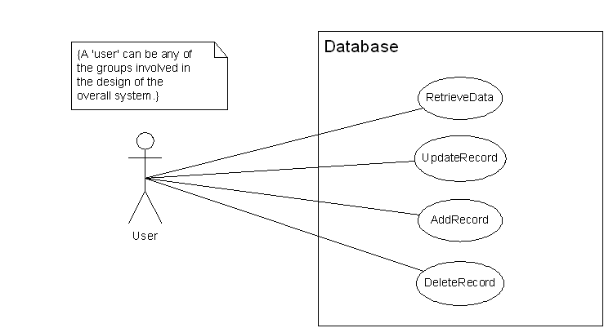

3.4.3 Object model
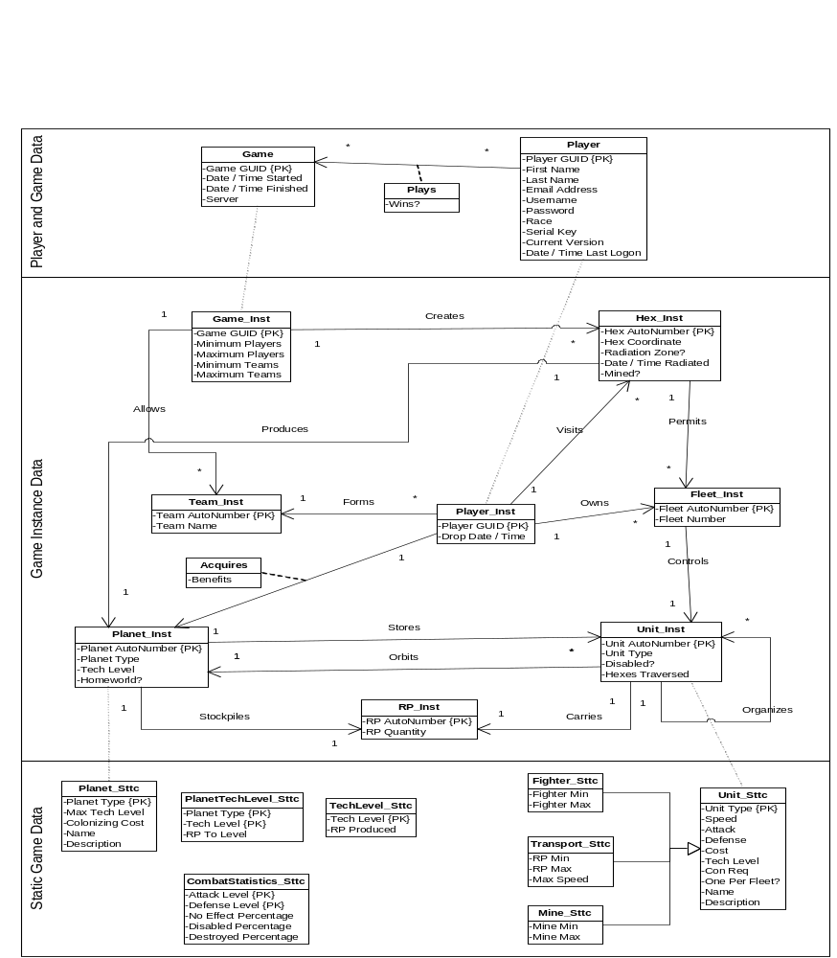>

3.4.5 Scenario
Use Case: User retrieves data.
Scenario: HCI service requests a row form Planet_Inst where PlanetAutoNumber= 123

1. Database Table – contains actual data in the following format:
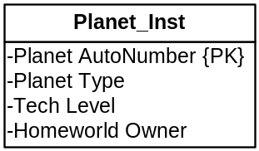

2. Schema definition file: Planet_Inst.xsd – contains “data about data” (data types, constraints, etc)
<xsd:schema xmlns:xsd="http://www.w3.org/2001/XMLSchema">

<xsd:element name="Planet_Inst" type=" PlanetInst Type"/>
<xsd:complexType name=" Planet_Inst ">
<xsd:sequence>
<xsd:element name="PlanetAutoNumber" type="xsd:positiveInteger"/>
<xsd:element name="PlanetType" type="xsd:string"/>
<xsd:element name="TechLevel" type=”xsd:integer"/>
<xsd:element name="HommeworldOwner" type=”xsd:integer"/>
</xsd:sequence>
</xsd:complexType>
</xsd:schema>

3. XML file : PlanetInst_GetRow.xml : contains actual table data in xml format used for communications (response to get row request)
(Pseudocode):
<soap:body>

<pre:Planet_Inst.PlanetInst_GetRows
<to> Planet_Inst.PlanetInst_GetRows
<from>HCI
soap:encodingStyle=”http://www.w3.org/2001/12/soap-encoding”>
<PlanetAutoNumber>123</PlanetAutoNumber>
</pre:Planet_Inst.PlanetInst_GetRows

<pre:Planet_Inst.PlanetInst_GetRows_Response>
< to >HCI
<from> Planet_Inst.PlanetInst_GetRows
soap:encodingStyle=”http://www.w3.org/2001/12/soap-encoding”>
<table_name>Planet_Inst</table_name>
<row>
<PlanetAutoNumber>123</ PlanetAutoNumber>
< PlanetType>abc</ PlanetType>
< TechLevel>2</ TechLevel>
< HommeworldOwner>3</ HommeworldOwner>
</row>
</ pre:Planet_Inst.PlanetInst_GetRows_Response>
</ soap:body>

4. Stored Procedure PlanetInst_GetRows.sql : contains code to execute GetRows request
Pseudocode:
Input Parameters are parsed from file PlanetInst_GetRow.xml located in the Post directory as specified by “Web Service – Use Contract” document
Output is written in file HCI.xml in the Get directory.
Execute select statement where PlanetAutoNumber = 123

In order to get the row from the database, HCI service will use DataLibrary, which will create all the needed xml and sends/receives message to/from the stored procedure.

Project-wide Data Library.

Clas Name:PlanetInst
struct Planet
Int PlanetAutoNumber
String PlanetType
Int TechLevel
Int HomeworldOwner

Method: PlanetInst:void GetRows().
Pseudocode:
Create xml message in format expected by the stored procedure “PlanetInst_GetRows”
Write xml file to web directory.
Read response from web directory.
Parse xml-formatted response and bind to the data object Planet.

To use PlanetInst method, the HCI service must complete the following steps:
Include and compile PlanetInst class from the library.
Create an instance of PlanetInst class p (can be anything instead of p)
Set p.PlanetAutoNumber = 123
Call p.GetRows

3.4.5 Entity Documentation

Player and Game Data

Data for this section is very crucial to the existence of the game. The data should never need to be deleted but may be occasionally updated. For the most part, this data will only increase in size. Many different forms of statistics can be queried from the data.

Game

Each Game will have a Globally Unique Identifier (GUID) to distinguish between different instances of games. Data that will needed to be retained indefinitely for each Game are the data and time the game started and finished along with what server the Game was played on.

Player

A Player will also have a GUID. Every time a new Player is introduced into the game, a GUID will be assigned to that Player. This GUID will bind the Player’s first and last name, email address, username (screen name), password, race, serial key used to obtain their unique GUID, the current version of the game installed, and the last time they logged onto the game. A Player can play many Games and a record of which Games were won by Player will be maintained as well for game statistics and player rank.

Static Game Data

The Static Game Data are rules and boundaries that define the game and much of its characteristics. Data for each of these entities should not ever change unless flaws in the game are discovered. This data is used everywhere in the game and must be readily accessible at all times for every game instance.

Planet_Sttc

There are many different Planets in the game, each having their own unique set of attributes. Each Planet is identified by a single letter known as its planet type. Each Planet can advance to a certain technological level in the game as well as have an initial colonizing cost to acquire. A name and description of the Planet are stored as well for the “storyline” of the game.

TechLevel_Sttc

A Technological Level (Tech Level for short) is a way to express how advanced a certain Planet in the game can evolve. Each Tech Level (undeveloped through 5) on any Planet produces different amounts of RPs.

PlanetTechLevel_Sttc
If a Player wishes to advance the Tech Level of a certain Planet, a certain amount of RPs must be used to get to this new Tech Level. Based on each type of Planet and its current Tech Level, a RP amount to Tech Level up must be stored for the combination.

CombatStatistics_Sttc

When combat occurs between two players, statistics are used to determine the winner of the battle. The Attack Level and Defense Level for each combat combined form a unique pair. For each pair, there is a percentage chance that No Effect will occur, a ship will become Disabled, or a ship will be Destroyed.

Unit_Sttc

There are many units in the game ranging from satellites to ships to mines. Every unit is identified by a two letter character code known as Unit Type. Each Unit Type has a certain Speed, Attack, and Defense value. Different units can be built at different Tech Levels and certain amount of RPs is required as the Cost to build each unit. A Con Req value and a flag of whether or not only one is acceptable per fleet are also important per unit when developing fleets. A more in depth Name and Description are also maintained for “storyline” purposes. Depending on a unit type, more information is needed to be stored such as for Strike Carriers, the number of minimum and maximum fighters is needed. Transports incur speed penalties depending on the number of RPs, or equivalent ships, is in the cargo bay. Minesweepers can carry different types of mines and depending on the type of mine, there is a minimum and maximum value that can be stowed.

Game Instance Data

For every game to exist, an instance of a game must exist. Each instance of the game has a lot of data that will be needed to be retrieved, inserted, updated, and deleted. The stored procedures of the database will use this information the most to provide useful information to the player requesting the data.

Game_Inst

Every game that is created is given a Game GUID to determine one game from another. For a particular game to start, a minimum number of players are required, and each game will have a maximum number of players too. This is also true for teams, a minimum and maximum number of teams is specified.

Team_Inst

Multiple teams are formed for each game. A team is assigned a unique number by the database and a team name is developed from the player’s in the team.

Player_Inst

Each player in the game belongs to one team per game. All necessary data already exists in the Player and Game Data database. The only thing that needs to be kept track of is the Date / Time the player disconnected from the server unexpectedly.

Hex_Inst

The universe is described as a hex-map. Each hex is assigned a number unique to each game by the database. Every hex is given a coordinate as well to determine where the hex is in relation to other hexes in the game. The hex can be full of mines and/or radiation. If a hex has become radiated, it is necessary to know when the hex became radiated for purposes of planetary creation.

Planet_Inst

Only one planet can exist per hex. Each planet is assigned a unique number by the database. Static data for each planet can be found in the static database. Each planet, however, is of a certain type and at a particular Tech Level. The planet may be a Homeworld for a certain player in the game. If it is, that player gains some sort of benefits for that player.

Fleet_Inst

Hexes in the game can have planets as well as fleets. Every player can own many fleets with each fleet designating a single unit as its lead ship. Each fleet is given a unique number by the database. Every fleet is assigned a Fleet Number by either the GM or by a player.

Unit_Inst

The units in the game are all assigned a unique number by the database. Most of the data for a particular unit is stored in the Static Game Data database. The unit type is needed to be known and whether the unit is disabled or not. A counter is needed to be kept to keep track of how many squares a certain unit has traversed. Units organize together to form fleets much similar to a tree. Different units can orbit a particular planet as well as being stockpiled on the planet itself.

RP_Inst

RPs exist only in two places in the universe. They exist either in a planet’s stockpile or in a cargo bay of a transport. They also exist in different quantities in each of the locations.

