class4.r
user
2026-01-16
x <- 1:50
plot(x)
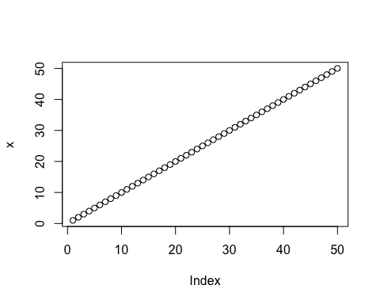
plot(x,sin(x), typ="l", col="blue", lwd=3, xlab= "Is it lunch time yet?")
