**Student Name: _____________________________ Observing Partner(s): __________________________________________**

**Techniques of Astronomy – Allegheny Observatory Lab**

**Observing Project 1: Astrometric (Plate Scale) Calibration of the 24” Telescope**

**Tentative Due Date: Sunday 25 Sep 2020**

**Short Description:** Take CCD imaging observations of a populated star field (e.g., the open clusters NGC 6633 and M11 would be good candidates) with the 24” telescope and determine its astrometric (plate scale) calibration in the telescope’s focal plane. The CCD detector lies in the telescope’s focal plane. In broad terms, you should follow the steps outlined below. You will need to measure the fractional pixel positions (x,y) of stars with known coordinates in the field of view (FOV) of the CCD. This can be done using the “MIRA” CCD imaging software installed on the computers in Allegheny Observatory’s student lab. You can then obtain the needed initial results (i.e., see the table at the end of this writeup) by hand calculator, which is a reasonable approach since this allows you to avoid using a black-box routine to learn about this topic. However, if you don’t want to use the MIRA software and you’re familiar with procedures to make measurements with the SIA Python software used by the STEPUP group, or you want to write your own Python code using Astropy routines, that’s also acceptable. In the end, this project will also require you to use MIRA’s black-box routine to obtain an astrometric calibration.

**Your Report:** You must write up the results of this exercise in lab notebook style and submit it through *Canvas* as a pdf. The name of the pdf file should include your last name and the exercise name (e.g., StudentName_PlateScale.pdf). In your writeup be as concise as possible. Only include required information (see below), but always remember that the information should allow another astronomer to repeat what you have done to confirm (or falsify) your results. You could make the writeup in Microsoft Word (with appropriate text, tables, images, and figures) and then convert it to a pdf before submitting it, but using Word is not required. Instructions will be posted explaining how to submit your pdf.

Details of your observations, including intermediate and final results, should be included in your submitted pdf Lab Report. NOTE: You won’t receive credit if you simply include the long headers of your FITS data files. The max grade is 10 points (1 point per step below). This is 10% of your course grade.

**Steps:**

1. **PART1.** Name your Lab Report file appropriately (e.g., StudentName_PlateScale.docx), save it as a pdf (StudentName_PlateScale.pdf), and submit it when finished.
2. Obtain 3 separate and consecutive observations of a populated star field with the r’ filter on the 24” telescope. Make sure the stars don’t saturate the image. Make sure you record an “observing log” in a table which matches the style specified in the posted AO_ObsLog.docx file. Don’t bother to record test observations in your table. Consider copying the table from the posted file, remove example entries, and paste it into your writeup with your own entries (Object, approx. J2000 RA + Dec, UT date of observation, UT time of observation, LST of observation, Elevation of object, Telescope used, Instrument + Detector used, Filter used, Exposure Time, Raw Data file name and location, Weather comment). If the table has missing entries, you’ll receive no credit for Step 2. In your table, make sure you include details of the calibration frames you’ll use to process raw data (especially bias and flatfield frames), even if someone else took the calibration frames. It’s fine to use some short-hand notation to record a sequence of observations (e.g., this might be appropriate for a long sequence of observations where nothing changes except for time and object elevation); however, make sure you specify start and end times and the object elevations at those times. Note that the airmass you’re observing through is “1/cos(z) = sec(z),” where sec is the secant function and z is the object’s zenith angle = 90o – elevation angle.
3. In your report/table make sure you comment on the weather conditions during your observations.
4. After your observing log is complete, you must indicate how you processed your raw data files. This is sometimes referred to as “reducing data.” Basic processing includes: “bias subtraction,” “dark subtraction,” and “flat fielding.” Write the names and locations of the 3 measured processed files in your Lab Report. Note that with short exposure times (e.g., 1 min or less), “dark subtraction” is generally unnecessary for modern CCD detectors.
5. An intermediate result for this exercise involves understanding how accurately you can measure the (x,y) pixel values of a star in an image. You can do this using the MIRA software in the computer lab. It’s important to measure fractional pixel values, not integer or half-integer values. Initially, use only two well-separated stars in your 3 separate images (call them Star A and Star B) and measure their (x,y) positions in the 3 images (you’ll have 12 numbers). Take a screen shot of one of your images, paste it into your Lab Report, and mark the two stars you used (A and B). For each of the 3 images, record the measured (x,y) positions of the two stars (12 numbers) in a new free-form table in your Report. For Star A you’ll have 3 (xA,yA) values (6 numbers) and for Star B you’ll have 3 (xB,yB) values (6 numbers). Calculate and record the x and y fractional pixel separations of Star A and Star B for each of the 3 images, e.g., xAB = xA – xB and yAB = yA – yB, and the total separations of Star A and Star B, sAB, where sAB2 = xAB2 + yAB2. Enter these 9 numbers in the new free-form table.
6. Assuming all 3 imaging observations are of equal quality (not always true) and that x and y are independent, separately calculate the mean x and y values (<xA>, <yA>, <xB>, <yB>) from the 3 observations. Also calculate the corresponding variance and standard deviation of <x> and <y> (x2 and x, y2 and y) for both Star A and Star B. Indicate whether the distribution of residuals (e.g., <x> – xi and <y> – yi, where i denotes the 3 observation numbers) are roughly consistent with each other. Note that evaluating this with only 3 observations is not ideal, but it’s often good enough to identify outlier data points, which would indicate a discrepant or problem measurement. Derive the same results for <xAB>, <yAB> and <sAB>. Some of this should be used to fill in the top 7 lines of the Summary Table (format shown on last page). Don’t enter residuals in the PART 1 Summary Table, but note whether or not the residuals are roughly consistent.
7. Include the PART 1 Summary Table (format shown on last page) in your Lab Report. Use known information on the RA + Dec of Stars A and B (from Step 8 below) and the dimensions of the CCD pixels (see info in the first set of lecture slides) to determine the information on the last two lines.
8. **PART 2.** Now identify at least 6 stars in the field (not just Star A and Star B) and look up their RA and Dec coordinates. This can be done using databases accessible using the online tool “AladinLite” (“Vizier” also works). For example, go to <http://aladin.u-strasbg.fr/AladinLite/>. Search for the target, e.g., NGC 6633 in AladinLite. Make the field of view (FOV) about 1o by 1o and select something like SIMBAD or Gaia to find the J2000 RA and Dec values for the 6 stars you identified. As an example, an image with 6 stars circled is shown on the next page for reference. Include one such an image in your Report. Next, you’ll match (RA,Dec) with (x,y) positions in your images.
9. You should now have (x,y) and (RA,Dec) pairs for at least 6 stars measured in 3 separate images (72 numbers). Tabulate this information in your Report and enter it into the MIRA software. MIRA will perform a “black-box” astrometric calibration of your image. The calibration will improve with more stars. This calibration will allow you to read (RA,Dec) values in an image instead of (x,y) values. Record the MIRA results in your Lab Report. Note that something similar is incorporated into PlaneWave’s mount software.
10. Answer this question: Given what you know from the lecture slides about the 24” telescope and its CCD, briefly explain why the above results are consistent or inconsistent with your expectations? If needed, use the appropriate equations to evaluate this.

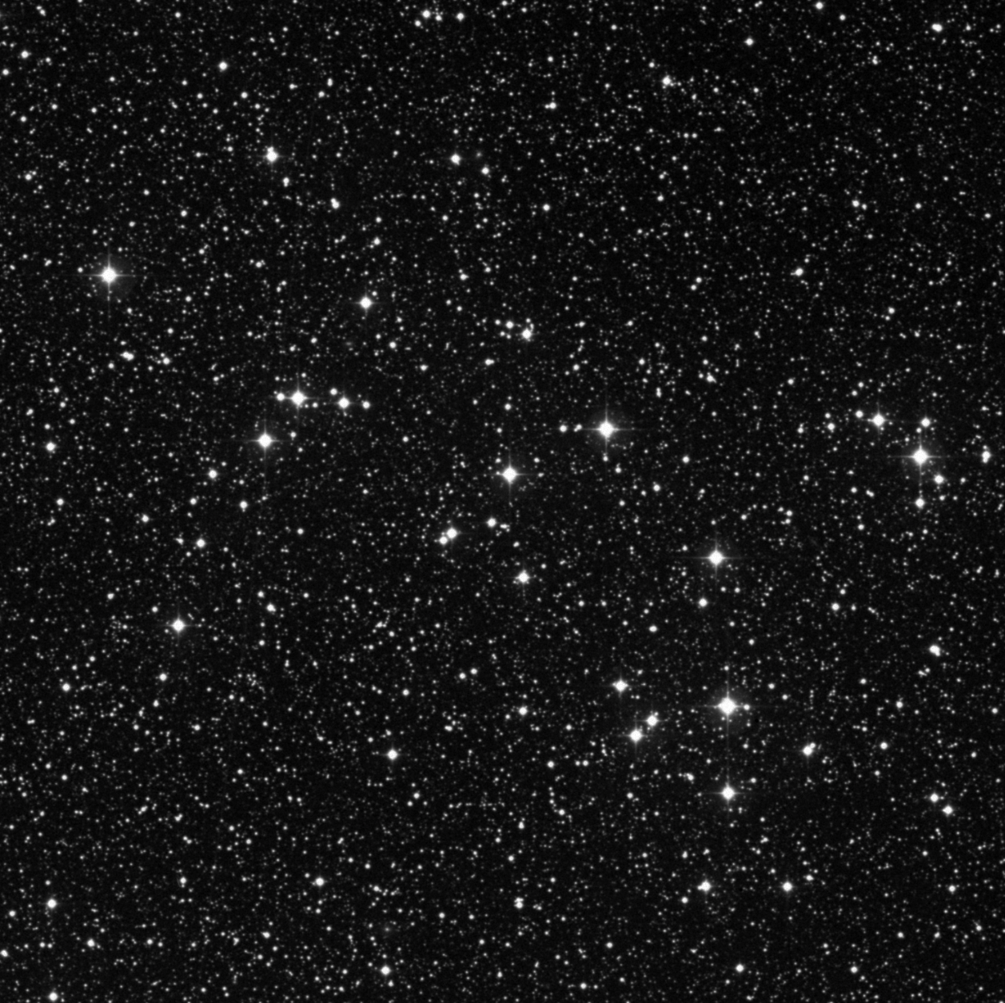

**PART 1 Summary Table (Plate Scale Results for the 24” Telescope from 3 Images):**

|  |  |  |  |  |
| --- | --- | --- | --- | --- |
| **Parameter** | **Mean** | **Variance** | **Standard Deviation** | **Comment (e.g. about distribution of residuals)** |
| XA (pixel units) |  |  |  |  |
| YA (pixel units) |  |  |  |  |
| XB (pixel units) |  |  |  |  |
| YB (pixel units) |  |  |  |  |
| XAB (pixel units) |  |  |  |  |
| YAB (pixel units) |  |  |  |  |
| SAB (pixel units) |  |  |  |  |
| Plate Scale (“/pixel) |  |  |  | Use RA + Dec of Stars A and B (Step 8) to determine. |
| Plate Scale (“/mm) |  |  |  | Use CCD pixel size in mm to determine. |

Notes:

1. Universal Time (UT, or “coordinated UT” UTC) is the mean solar time on the Prime Meridian at Greenwich, London.
2. UT = EST + 5h (EST = Eastern Standard Time)
3. UT = EDT + 4h (EDT = Eastern Daylight Time)
4. LST = RA of a star exactly on the north-south celestial meridian (LST = Local Sidereal Time; RA = Right Ascension)