Informational network characteristics drive consistent individual and group behavioural differences in the wild
Henry, E. G.^{1*}, Pearlman, N.¹, Gil, M. A.¹
¹ Department of Ecology and Evolutionary Biology, University of Colorado, Boulder CO, 80309, USA

*Corresponding author: Ella.Henry-1@colorado.edu

ABSTRACT
Social information transfer between conspecifics can improve the speed and accuracy of decisions when avoiding shared predators or locating food, but indiscriminate copying in the face of noise leaves individuals vulnerable to costly misinformation. Theory and laboratory experiments find the efficiency of information transfer to be determined by the structure of the underlying visual sensory network, including its size, connectivity and stability. However, whether these properties lead to consistent differences in fitness-determining behaviors at the individual and group-level in complex, dynamic natural environments remains unknown. Here, we leverage the unique life-history of the Brown garden eel, who form discrete, spatially fixed colonies where individuals partially emerge from permanent burrows to forage in close visual contact with their neighbours, to investigate behavioural consistency in response to a threat presentation experiment and long-term observational footage. First, a threat presentation experiment revealed that flights spread out from both the stimulus and the first responder and that eels may receive social cues from a fixed topological range. To explore whether a social rule is necessary to generate the experimental cascades, an SIR behavioural contagion model with and without social cueing was fitted via maximum likelihood. Finally, the chosen model was used to simulate long-term behavioural dynamics of different structured colonies, and explained the differences in foraging found between real eel colonies.

INTRODUCTION
To test whether consistent differences in foraging arise from differences in social network structure, here we present results from a predator threat experiment and natural observational data on Brown garden eel colonies. In our experiment, we repeatedly presented colonies with a threat stimulus in the form of a lead sinker weight dropped vertically onto the seafloor and tracked individual response timing. We used Bayesian model selection to infer whether responses spread out from the stimulus or the first eel to respond, and whether the identity of the second responder is best predicted by their metric, topological, or Voronoi distance to the first responder. Then, we use the selected rule
- Whether consistent behavioural differences arise from network characteristics and position
- Experimental stimulus to see if responses spread from first responder
- Bayesian model selection to see which rule determines who responds second
- SIR model to see if this rule generalizes to the whole cascade
- Fitted social threshold to observational data to see if
METHODS
Experimental data
Data collection
In April - June 2024, twelve colonies of different sizes (N = 22 – 196) were repeatedly
presented with a simulated predatory threat, and the flight responses were filmed. All
colonies chosen were located at one site (Playa Santa Cruz) to control for site-level
differences and were spaced at least 5m apart to ensure independence. Each colony received 45 predatory threat presentations over seven days. The
predatory threat consisted of a spherical fishing weight (hereafter ‘ball’) attached to a line.The ball was suspended approximately two metres above the colony by a researcher floating on the surface and then dropped onto the seafloor between individuals, ensuring free fall and a standard velocity. To vary which eel was closest to the ball, drop location was varied using a randomized block design, rotating among five regions of the colony (relative to the camera: North, South, West, East, Central). After the flight response, the ball was drawn back to the surface before eels re-emerged.
While threat presentations were occurring, each colony was filmed laterally using two
GoPro cameras mounted on a metal conduit tripod enabling stereo reconstruction of
distances between individuals and the stimulus. Experimental periods lasted approximately one hour, defined by the duration of camera battery life. Between four and six colonies were manipulated simultaneously in each period depending on the number of researchers available. The tripod was positioned approximately two metres from the edge of the colony and oriented to get the whole colony in the camera frame. For the two largest colonies, only a subset could be filmed, though total colony size was recorded. To facilitate the linking of individual identities between days, the tripod was placed in the same position each experimental period using a permanent marker on the substrate. On some days, batteries were replaced, and both morning and afternoon experimental periods were conducted. Researchers were responsible for dropping the ball on two colonies during an experimental period and aimed to drop on each at 2.5 minute intervals. Actual intervals varied due to boat traffic, line tangling, or eels being hidden during fish interactions, but precise timings have been extracted from the videos and will be included in the analysis,along with drop order.

Data extraction
Individuals within colonies were assigned identities that were consistent across all
videos. All videos have now undergone coarse-scale screening. An observer watched the videos to exclude bad drops and record the timings of good drops. Drops were excluded if the ball did not hit the ground (too little slack let out) or the ball was not seen in both cameras. Left and right videos were synchronised using audio cross-correlation and segmented to generate 15 second clips of each drop using a custom made automated ffmpeg code. Annotations of responses are currently being completed by a team of five EBIO undergraduate students, one of whom is pursuing an honors thesis on the dataset. All videos will have undergone annotation by the end of Fall semester (2025). Like in 2.1, the cameras were calibrated with a checkerboard enabling triangulation of positions of individuals and the ball into 3D. Clips are loaded into a custom-made python GUI. First, the frame at which the ball begins to drop and the frame at which the ball hits the sand are annotated in the left and right camera. These coordinates are triangulated to obtain the z-values and then the resulting sequence of 3D positions of the ball during its drop is interpolated. The distance between the ball and each individual is calculated for each frame. The frame of flight initiation to either partial or full hide is recorded for each individual. The head and base of all
individuals are annotated in the frame immediately before the first response in both the left and right cameras. These coordinates are triangulated to obtain the z-values, and a vector representing the posture is fitted between them (Figure 3). Ray-casting will be used to approximate the pathways of light onto the retina. Through estimating each individual’s eye position to be on the side of its head, and taking vector direction as the direction they are facing, a blind spot directly behind each individual will be calculated. This determines whether the individual can see the ball.

Data manipulation
- Those within 4 frames of first responder first responder
- Calculated social network neighbourhoods for each individual

Data analysis
- Spatial temporal spread of resposnes through using only >2 responder drops, Bayesian model selection between models with and without distance from ball/first responder
- Bayesian model selection between 42 candidate models with and without combinations of different social rules and private rules predicting the second responder given a first responder
- Fit SIR model inspired by Sosna et al., to data

Observational data
Data collection
In May-July 2025, six colonies were repeatedly filmed for ten hours across three sites
on the island of Curaçao. The three sites (Daaibooi, Lagun and Playa Forti) had been
identified as having garden eel colonies of varying sizes in previous years. A large (>70
individuals) and small (<30 individuals) colony at each site were selected for observation.Each colony was filmed using two GoPro cameras attached to a single metal conduit tripod to enable stereo reconstruction of individual positions. The GoPro’s were powered by a custom-built battery system using commercial power banks to extend recording time. On each recording day, two sites (four colonies) were filmed from 8am to 6pm. There were 12 recording days, which meant each site was filmed with each of the other two sites four times in total and each colony was recorded eight days in total.

Data extraction
Individuals within colonies were assigned identities that were consistent across all
videos. To extract the times at which individuals are foraging, I developed an automated
image-processing pipeline in MatLab (Figure 2). The 10 hour video is first converted into a series of stills at 1 frame per second. In the first frame, the user annotates the burrows of the eels in the image assigning an identity to each coordinate (Figure 2c). Since the cameras were placed in the same position each day, identities can be carried over between trials to test for consistent variation in individual behaviour over time. For each frame, pixels are assigned one or zero values through converting grayscale, increasing the contrast and binarizing. Since eels are dark-bodied against a white sandy background, this isolates the eel bodies as masks (Figure 2a). For each individual, the proportion of black pixels in a bounding box defined by the burrow coordinates is calculated (Figure 2b). If the proportion of black pixels exceeds a threshold, the individual is recorded as being emerged for that second. This generates a dataset of 1s (emerged) and 0s (hidden) for each individual in each second of each video (Figure 2d). The size of the bounding box and threshold proportion of black pixels is defined for each video depending on the distance of the camera and the lighting (using adaptive thresholding). The results of the pipeline are ground truthed to a subset of manually annotated data. To enable reconstruction of individual positions, two cameras filmed the scene in stereo. A checkerboard with 3cm squares was shown to the cameras at different angles and distances to calibrate the stereo camera setup. The package
‘python_stereo_camera_calibrate’ was used to process the videos. First, each camera the left and right videos are synced using their cross-correlation in audio. Then checkerboard patterns are detected using opencv and the position of the checkerboard pattern is used to calibrate each camera separately, and then the stereo camera setup. Annotations of the coordinates of each individual are made in the left and right camera. The package uses direct linear transformation to triangulate coordinates from the two cameras into 3D coordinates.

Data analysis
The model selected from the fitting to the experimental data was transformed to simulate the long-term foraging dynamics of real eel colonies. The residuals between the simulations and observational footage were computed.
RESULTS
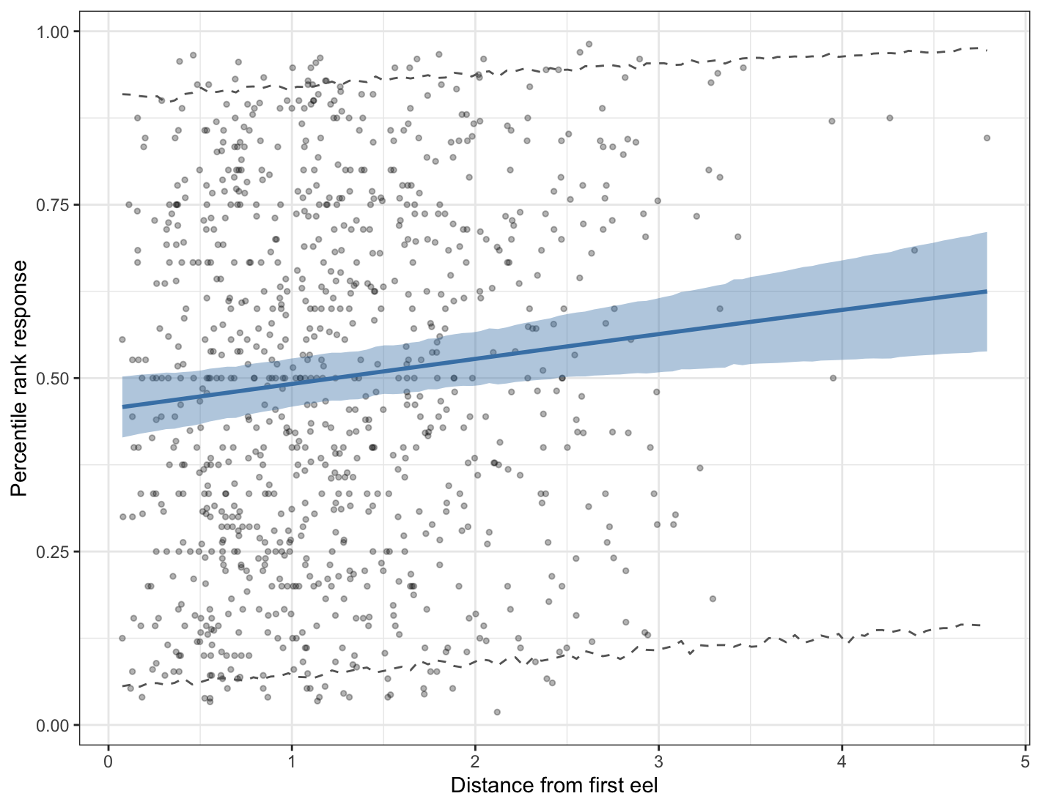
Figure 1.

DISCUSSION

