Bowtie Product Proposition Intern Assignment Question 2i and 2ii

# Proposal for Page Optimization (Question 2i)

## Digital Strategy

**1. Backlinking**

* Identify target websites: Start by identifying and listing popular parenting-related websites and forums that have high traffic and are influential among your target audience. Websites like *BabyKingdom, TOPick, HK01, Sundaykiss*, and others relevant to local or regional audiences will be ideal.

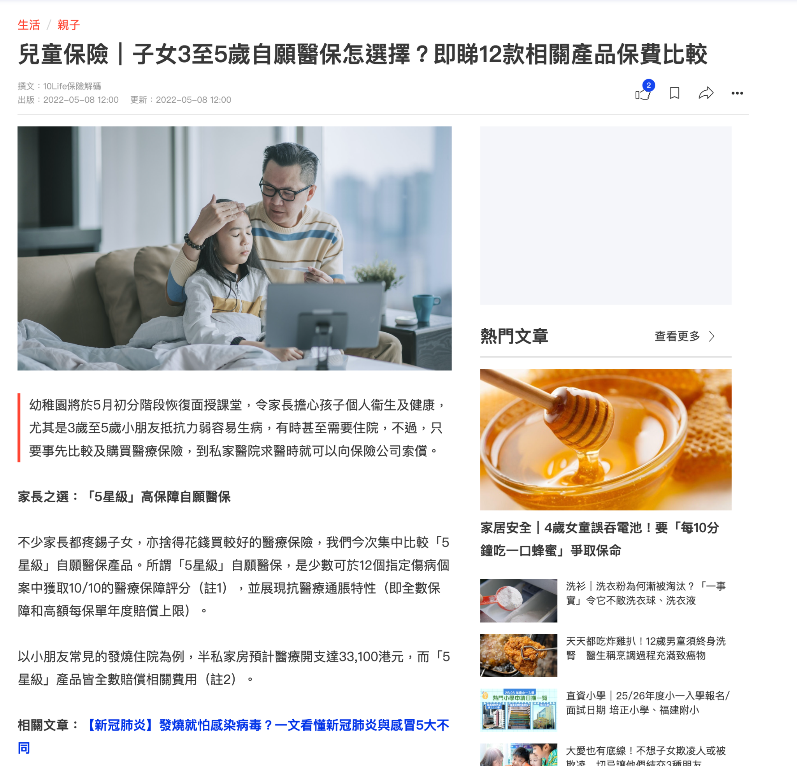

* Collaborate with websites: Reach out to these identified websites to explore opportunities for content collaboration. Propose guest posts that provide valuable insights on topics such as "The Importance of Medical Insurance for Young Children" or "How to Choose the Best Medical Insurance for Your Child," including a call-to-action (CTA) that links back to your campaign page.
* Monitor and analyse consistently: Use tools like Google Analytics and Ahrefs to monitor the traffic and quality of backlinks. Adjust your strategy based on which partnerships and types of content bring the most valuable leads.

**2. Search Engine Optimization (SEO)**

* Keyword Optimization with local-specific keywords: Conduct detailed keyword research using tools like SEMrush or Google Keyword Planner to find relevant keywords that new parents might use when searching for child medical insurance. Integrate these keywords naturally into your page content, meta tags, and URLs.

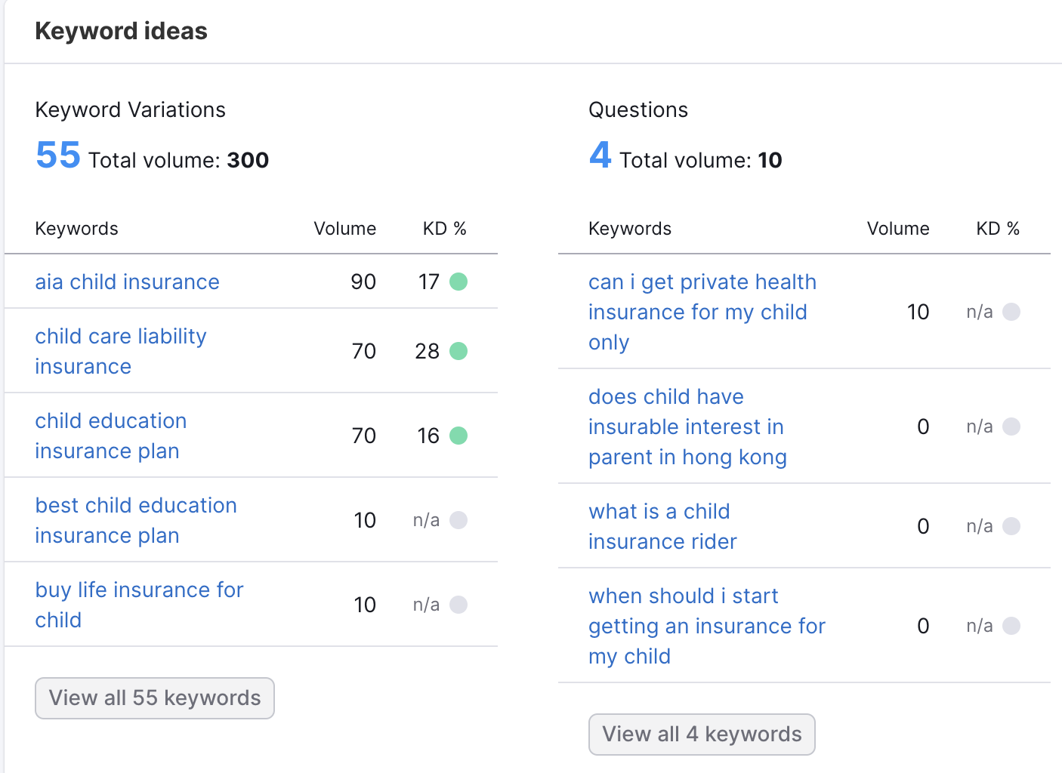

* Mobile Optimization: Ensure the campaign page is fully optimized for mobile users, considering a significant amount of parents might access the site via smartphones. This includes fast loading times, responsive design, and easily accessible contact forms.

## Content Strategy

**1. Create a Content Library with Specific Keywords**

* Educational Content: Develop a series of educational articles, infographics, and videos that cover topics important to new parents, such as child healthcare tips, the importance of insurance, and how to claim insurance. This content not only helps in SEO but also establishes your brand as a trustworthy authority in child healthcare.
* Include an FAQ Section: Compile and answer frequently asked questions about child medical insurance. This section will help in addressing common concerns and barriers that prevent conversion, thus enhancing user trust and engagement.
* Interactive Tools: Create interactive tools such as cost calculators for medical treatments without insurance versus with insurance, or a quiz to help parents understand the best type of insurance plan for their child based on their needs.

**2. New parents Blogging and Regular Updates**

* Regular Posting Schedule: Maintain a regular posting schedule for the blog to keep content fresh and engaging. This will also aid in maintaining a strong SEO presence.
* Guest Bloggers and Influencers: Invite guest bloggers or influencers who are experts in child healthcare or parenting to write for your blog or collaborate on videos. This can increase reach and credibility.
* Content Promotion: Promote new content through newsletters, social media, and other digital marketing channels to drive traffic back to the site.

**3. User Engagement and Feedback**

* Comment Sections and Forums: Enable comment sections in blogs and create forums where parents can discuss and ask questions about child care and insurance. This can increase page engagement and provide valuable insights into customer concerns.
* Feedback and Surveys: Regularly conduct feedback surveys through the website or via email about the content and usability of the site. Use this feedback to refine and improve content and layout.

# Proposal for Page Optimization (Question 2ii)

Post #1

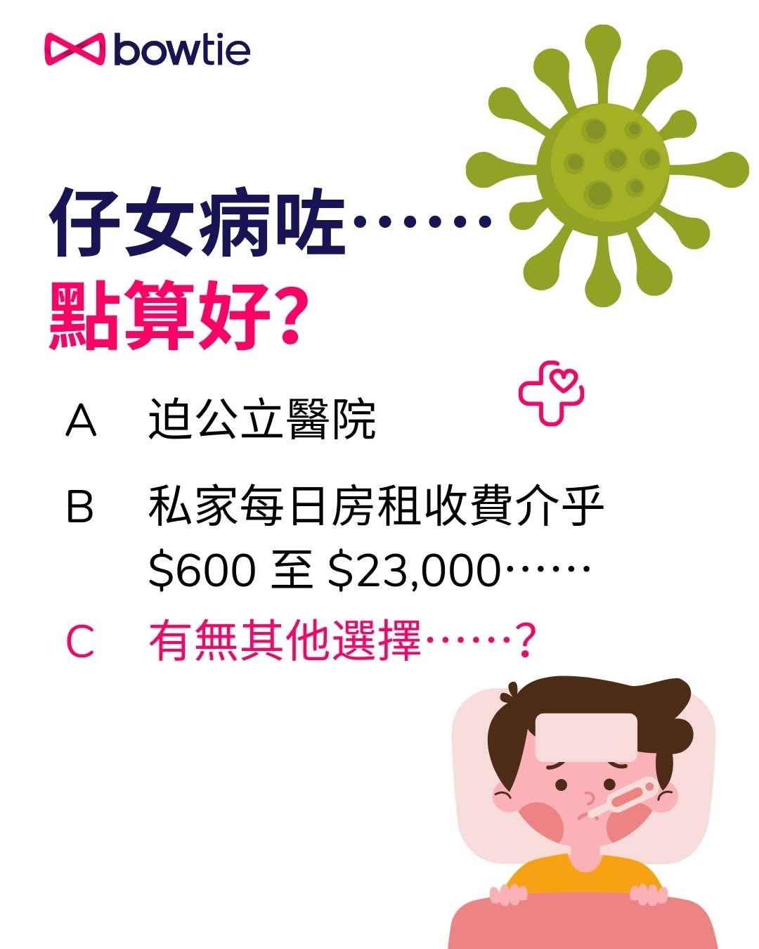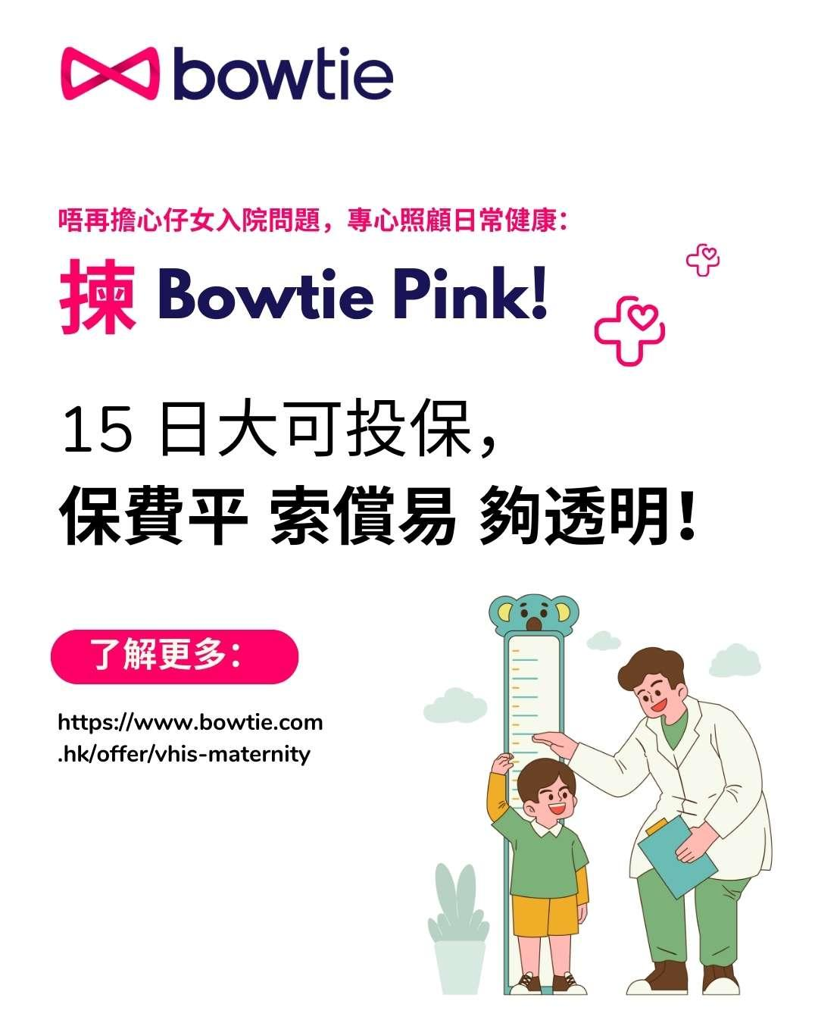

Post Copy:

👶🏻🏥 仔女病咗⋯⋯點算好？迫爆嘅公立醫院，私家醫院每日房租收費介乎 $600 至 $23,000⋯⋯有無其他選擇⋯⋯？

🌟 了解更多保障仔女嘅選擇，唔使再擔心醫療費用！Bowtie Pink 提供全面嘅醫療保險計劃，幫到您輕鬆應對高昂嘅醫療開支。👉 了解更多：https://www.bowtie.com.hk/offer/vhis-maternity！

🛡️ 小朋友健康係我哋嘅優先考慮！立即行動，為佢哋嘅未來作出最佳安排！✨

#兒童醫療保險 #家庭必備 #健康保障

Post #2

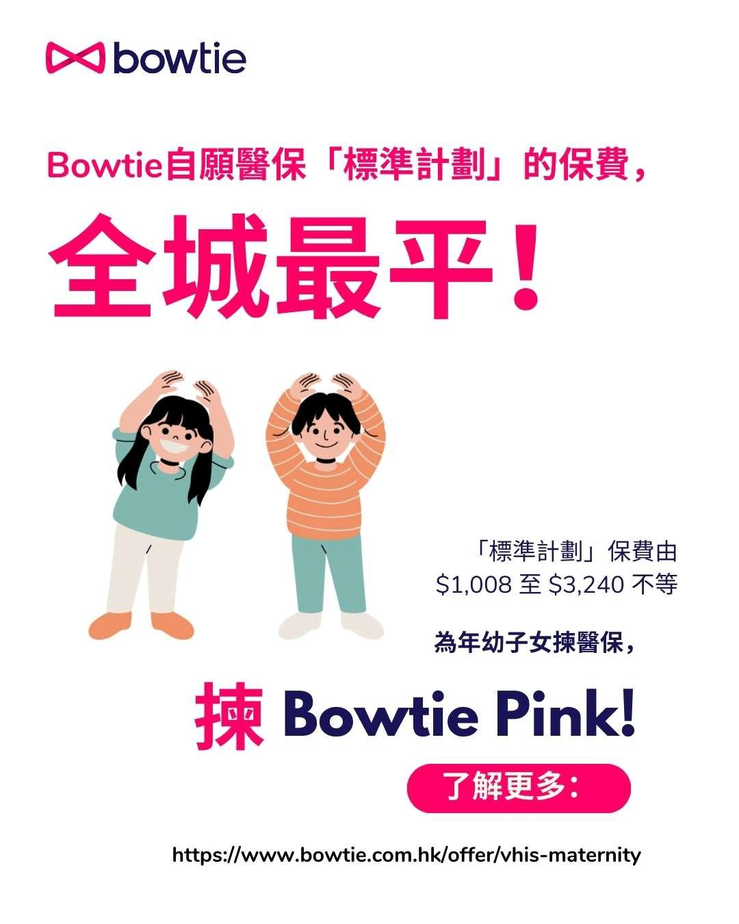

Post Copy:

🎀 要搵平價而可靠嘅醫保？👶🏻 Bowtie自願醫保「標準計劃」保費全城最平！

💰「標準計劃」嘅保費只需 $1,008 至 $3,240，讓您輕鬆為您嘅年幼子女提供全面保障！仲可以扣稅，即享門診會員價。

🌈 選擇 Bowtie Pink，為小朋友嘅健康投資！了解更多 👉 <https://www.bowtie.com.hk/offer/vhis-maternity>

🛡 為您嘅愛子女提供最佳醫療支援，無需擔心高昂醫療費，一齊守護小朋友嘅未來💖！

#BowtiePink #兒童醫療保險 #家庭健康保障