

South African National Biodiversity Institute

GIS METADATA : DETAILED REPORT

FILE NAME: NBA2010_benthic_and_coastal_protection_d_dd.shp
Full Path
Description (detailed) | Benthic and Coastal Ecosystem Protection Levels. As per NBA Benthic and coastal Habitats with an extra field "PALevel" and refer to tech doc for derivation.
Copyright Holder | N/A
Data Origin | ?
Capture Source | ?
Scale Digitised at | N/A
Date Captured | ?
Data Copyright | No
To be distributed | Yes

DATA INFORMATION AND METADATA INFORMATION
Owner Organisation | SANBI
Contact Person | Dr Kerry Sink
Position of Contact Person | Marine Program Manager, SANBI, Kirstenbosch Research Centre, Cape Town
Contact Address | Pvt Bag x7, Claremont 7735
Contact Number | 0217998855
Contact Email | K.Sink@sanbi.org.za

LEGEND PROPERTIES
Legend Title | Benthic and Coastal Ecosystem Protection Levels  Classification based on PA_level field.  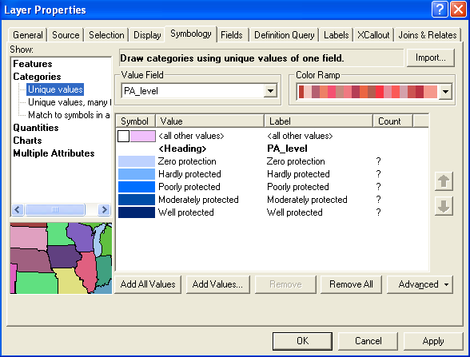
Feature Type | Polygons displaying Pelagic protection levels
Scale Parameters | N/A

PROJECTION
Projection Name | Geographic Coordinate System
Central Meridian
Upper Parallel
Lower Parallel

DATUM
Name | WGS84
Semi Major Axis | 6378137
Semi Minor Axis | 6356752.3142451793
Inverse Flattening | N/A

DETAILED NOTES: NBA2010_benthic_and_coastal_protection_dd.shp
Purpose:
The layer was prepared as part of the spatial assessment of the threat status and protection levels of South African marine and coastal ecosystems for the 2011 National Biodiversity Assessment. Prepared by Stephen Holness, Trevor Wolf, Kerry Sink, Linda Harris and Mandy Lombard with inputs from Ben Halpern and Hedley Grantham.

Methodology:
Data on Marine Protected Areas (including their Take or No-Take status) was obtained from the Offshore Marine Protected Area project (Sink et al. 2010), while data on terrestrial protected areas which have a coastal element was obtained from the National Protected Areas Expansion Strategy dataset (DEAT SANBI, 2009) . Terrestrial protected areas were assigned to the "Take" category unless their entire coastline was a "No-take" MPA. The Biodiversity Target of 20% was used in the evaluation, as is the standard practice for all NBA 2010 assessments. In addition a supplementary "No-take" target was derived from the marine offshore protected area targets contained in the National Protected Areas Expansion Strategy (DEAT SANBI, 2009), which includes targets for marine protection at 20% (i.e. the same as the biodiversity target) , and a "No-take" target of 15% of the habitat. The level of protection of each ecosystem was evaluated against the 20% biodiversity target, and then "No-take" areas were evaluated against the 15% target. The protection levels were defined according to the following categories. Ecosystems were classified as "Not protected" if there was no formal protection; as "Hardly protected" if under 5% of target was met in protected areas; as "Poorly protected" if from 5% to just under 50% of biodiversity target is met in protected areas; as "Moderately protected" if from 50% to just under 100% of the Biodiversity target is met in protected areas; and as "Well protected" if the biodiversity targets are fully met and the No-take target is met. Ecosystems where the biodiversity targets are fully met but where there is insufficient No-take area, were down-graded to a "Moderately protected" classification.

Input data:
NBA_benthic_and_coastal_habitat_map_wgs84.shp
Formal_Protected_Areas_and_Informal_Conservation_Area_System.shp (from BGIS)
Marine_protected_areas.shp (from Sink et al. 2010)

Available documentation and references:
DEAT, SANBI. 2009. National Protected Area Expansion Strategy for South Africa: Priorities for Expanding
the Protected Area Network for Ecological Sustainability and Climate Change Resilience. Government Gazette, South Africa.

Holness, S., Sink, K., Harris, L., Wolf, T. and Lombard, M.. 2011. Spatial assessment of the threat status and protection levels of South African marine and coastal ecosystems for the 2011 National Biodiversity Assessment: Methods and Outputs, SANBI unpublished report.

Sink K, Lombard M, Grantham H, Attwood C, Leslie R, Samaai T, Kerwath S, Fairweather T, van der Lingen C, Atkinson A, Wolf T & Majiedt P. 2010. Systematic Biodiversity Planning to identify a potential offshore Marine Protected Area network for South Africa, SANBI, 34.

ATTRIBUTE FIELDS
Field Name | Description | Alias
FID | Feature Identification
SHAPE | Polygon
Cat | Coastal or offshore
Zone | Area classification
Substrate | Substrate description/composition
Depthtopo | Depth classification
Broadtype | Broad area description
ExpoGeol | Area geology
Biogeogr | Biogeographic region
Habname | Biogeographic habitats
Position | Seaward or landward position
PA_Level | Protection status

