WORKFORCE ATTRITION AND RETENTION ANALYSIS DASHBOARD
NAME: AMALUCHUKWU EMMANUELLA CHIDIOGO
TOOLS USED: POWER BI /POWER QUERY /DAX
DATASET: HR EMPLOYEE ATTRITION DATASET
BUSINESS PROBLEM: Employee attrition affects organizational productivity, cost, and stability. This aims to identify key drivers of employee turnover and provide insights to improve retention strategies.
DATA CLEANING PROCESS: Removed unnecessary columns, checked data types and handled missing values.
KPI METRICS USED: Total workforce, Employees who left, Attrition rate, Average monthly salary.
DASHBOARD SCREENSHOT:
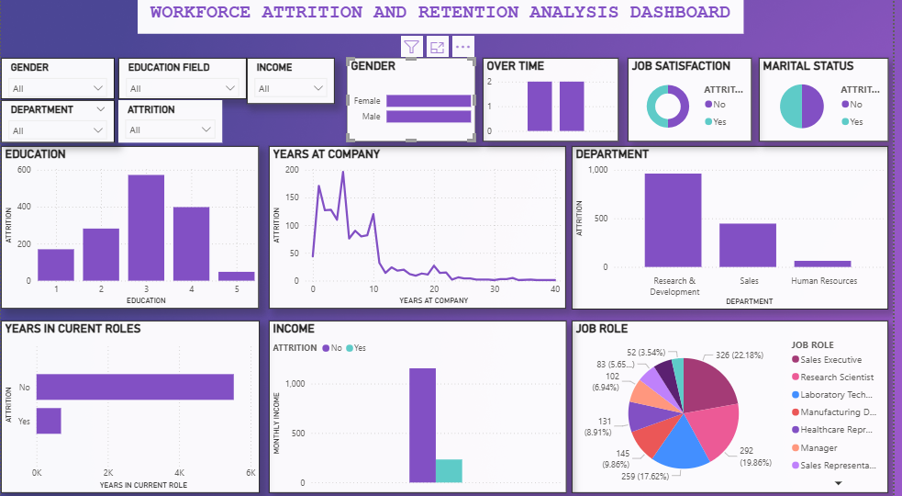

KEY INSIGHTS:
1.Overtime employees are more likely to leave.
2. Research departments have higher turnover.
3. Low salary band employees show higher exit rates.
RECOMMENDATION
- Improve compensation for lower salary bands.
- Reduce overtime workload.
- Implement early-career retention programs.

