Multi-Year Assessment of Recreational Water Quality at New Jersey Beaches (2021–2025)

Elle Duffy

Vassar College
Poughkeepsie, New York

Independent Biostatistics Research Project
Summer 2026

eduffy@vassar.edu
Abstract
Recreational water quality monitoring helps protect public health by identifying bacterial contamination that may increase the risk of waterborne illness. Enterococcus bacteria are commonly used as an indicator of fecal contamination in marine recreational waters, and routine monitoring provides valuable information about the safety of public beaches. This study evaluated recreational water quality at New Jersey beaches using Enterococcus monitoring data collected during the recreational swimming seasons from 2021 through 2025.
The dataset was obtained from the New Jersey Department of Environmental Protection and analyzed in R. After data cleaning, descriptive statistics were calculated, and annual, seasonal, and geographic trends were evaluated. Data visualizations were created to examine the distribution of Enterococcus concentrations, and logistic regression was used to assess factors associated with samples exceeding the U.S. Environmental Protection Agency (EPA) recreational water quality standard.
A total of 16,745 water samples were included in the analysis. Most Enterococcus measurements remained below the EPA recreational water quality threshold, although modest annual, seasonal, and geographic variation was observed. Overall, only 78 samples (0.47%) exceeded the EPA standard, indicating consistently good recreational water quality throughout the study period.
This study demonstrates how publicly available environmental monitoring data can be used to evaluate recreational water quality and highlights the value of reproducible statistical analyses for environmental health research.

- Introduction
Recreational beaches provide opportunities for swimming, surfing, fishing, and other outdoor activities that are important for both public health and local economies. However, exposure to contaminated recreational waters can increase the risk of gastrointestinal illness, skin infections, and other waterborne diseases. Because of these potential health risks, routine water quality monitoring plays an essential role in protecting the safety of beach visitors and informing public health decisions.
Enterococcus bacteria are widely used as an indicator of fecal contamination in marine recreational waters. Although Enterococcus itself is not always responsible for causing illness, elevated concentrations suggest that disease-causing microorganisms may also be present. For this reason, the U.S. Environmental Protection Agency (EPA) recommends water quality criteria based on Enterococcus concentrations to help determine whether recreational waters are safe for public use. Beaches that exceed these criteria may be subject to swimming advisories or temporary closures until water quality improves.
New Jersey has nearly 130 miles of Atlantic coastline and hundreds of public beaches that attract millions of visitors each year. To protect public health, the New Jersey Department of Environmental Protection (NJDEP) conducts routine monitoring of recreational beaches throughout each swimming season. These publicly available monitoring data provide an opportunity to evaluate long-term patterns in recreational water quality and identify differences among beaches and sampling periods.
The purpose of this study was to evaluate recreational water quality at New Jersey beaches using Enterococcus monitoring data collected during the 2021–2025 recreational swimming seasons. Specifically, this study examined annual, seasonal, and geographic patterns in Enterococcus concentrations using descriptive statistics, data visualization, and logistic regression. Using publicly available monitoring data, this study demonstrates how statistical methods can improve our understanding of recreational water quality and support environmental health research.

- Methods
  - Data Source
Water quality monitoring data were obtained from the New Jersey Department of Environmental Protection (NJDEP) through its publicly available recreational water quality monitoring program. The dataset included Enterococcus measurements collected from recreational beaches throughout New Jersey during the 2021–2025 swimming seasons. Each record contained information on sampling date, beach location, Enterococcus concentration (CFU/100 mL), and additional monitoring information reported by the NJDEP. The original dataset contained 16,816 observations collected from 295 recreational beaches.

  - Data Preparation
All data cleaning and analysis were performed in R (version 4.5.3) using RStudio. The dataset was imported as a comma-separated values (CSV) file and examined for missing or incomplete observations. Records containing missing values in variables required for analysis were removed, resulting in a final dataset of 16,745 observations.
Sampling dates were converted to a standard date format, and additional variables representing the sampling year and month were created to support temporal analyses. A binary outcome variable was also created to classify samples as safe or unsafe based on the U.S. Environmental Protection Agency (EPA) recreational water quality criterion of 104 colony-forming units (CFU) of Enterococcus per 100 mL. Samples with Enterococcus concentrations greater than 104 CFU/100 mL were classified as unsafe for statistical analyses.

  - Statistical Analysis
Descriptive statistics were calculated to summarize Enterococcus concentrations across all samples, including the mean, median, standard deviation, and the proportion of samples exceeding the EPA recreational water quality threshold. Annual, seasonal, and beach-level summaries were generated to evaluate changes in water quality over time, while beach-specific summaries were used to compare recreational water quality among monitoring locations.
Figures were created using the ggplot2 package to illustrate the distribution of Enterococcus concentrations, annual trends in unsafe samples, seasonal variation, beach-to-beach differences, and changes in Enterococcus concentrations over time.
Logistic regression models were used to evaluate associations between unsafe water quality measurements and explanatory variables including sampling year, season, and beach location. Odds ratios were calculated to estimate the relative likelihood of unsafe water quality across categories. All statistical analyses were conducted using R with the dplyr and ggplot2 packages.

- Results
  - Descriptive Statistics
A total of 16,745 water samples collected from 295 recreational beaches were included in the final analysis following data cleaning. The mean Enterococcus concentration was 8.08 CFU/100 mL, while the median concentration was 5.00 CFU/100 mL, indicating that most samples contained relatively low bacterial concentrations. The standard deviation was 16.27 CFU/100 mL, reflecting variability in Enterococcus measurements across samples.
Only 78 samples (0.47%) exceeded the U.S. Environmental Protection Agency recreational water quality threshold of 104 CFU/100 mL, indicating that the vast majority of water samples met recommended recreational water quality standards during the study period.

  - Distribution of Enterococcus Concentrations
The distribution of Enterococcus concentrations is shown in Figure 1. Most water samples contained relatively low bacterial concentrations, with the majority of observations occurring below 20 CFU/100 mL. As Enterococcus concentrations increased, the frequency of observations declined sharply, resulting in a strongly right-skewed distribution.
The EPA recreational water quality threshold (104 CFU/100 mL) is indicated by the dashed vertical line in Figure 1. Only a small number of samples approached or exceeded this threshold, demonstrating that most recreational water samples remained well within recommended water quality standards during the study period.
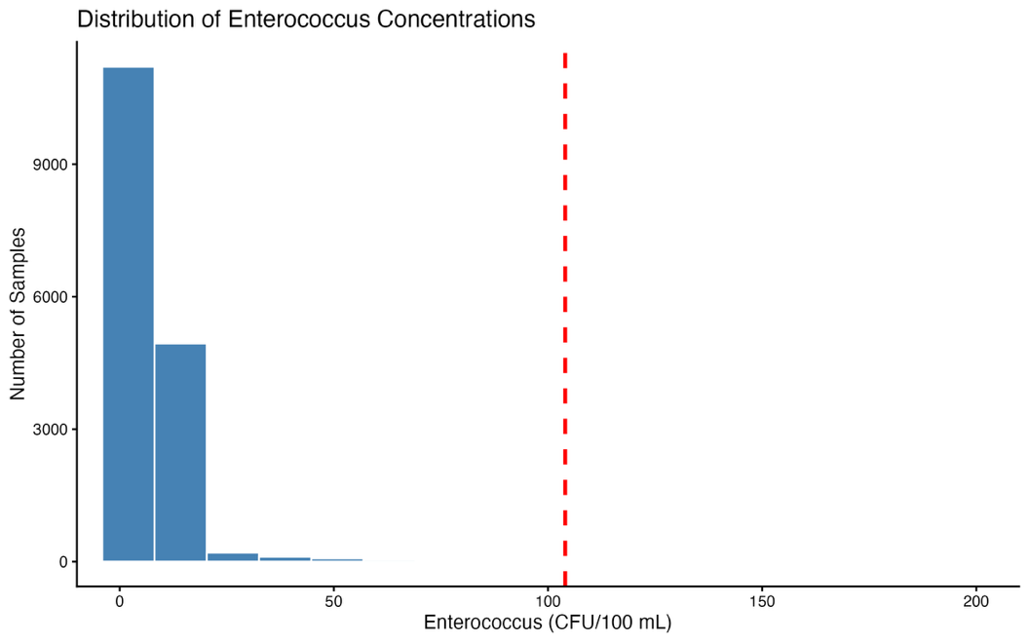
Figure 1. Distribution of Enterococcus concentrations measured at New Jersey recreational beaches during the 2021–2025 recreational swimming seasons. The dashed red line indicates the U.S. Environmental Protection Agency recreational water quality threshold of 104 CFU/100 mL.

  - Annual Trends
Annual trends in the percentage of water samples exceeding the U.S. Environmental Protection Agency (EPA) recreational water quality standard are presented in Figure 2. The proportion of samples classified as unsafe remained below 1% during each recreational swimming season, indicating consistently high recreational water quality throughout the study period.
The percentage of unsafe samples increased between 2021 and 2023, reaching its highest level in 2023, before declining in 2024 and remaining relatively stable in 2025. Although modest year-to-year variation was observed, the overall frequency of unsafe water quality measurements remained low across all five monitoring seasons.
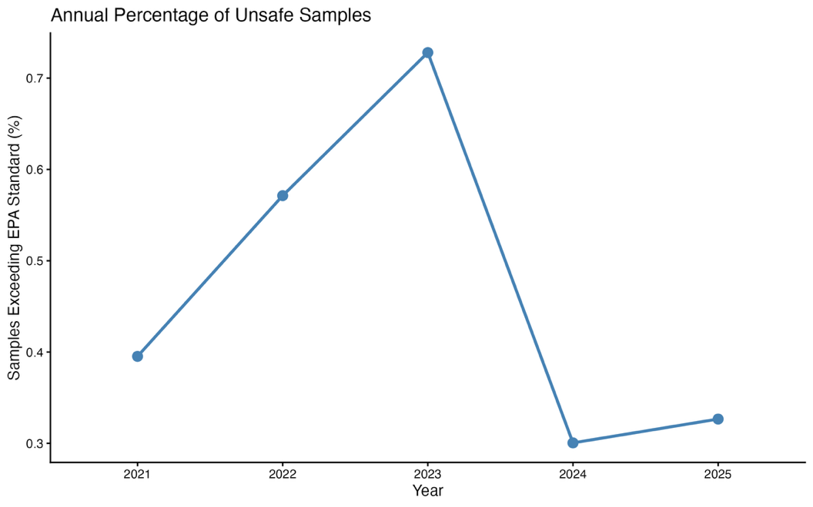
Figure 2. Annual percentage of water samples exceeding the U.S. Environmental Protection Agency (EPA) recreational water quality standard during the 2021–2025 recreational swimming seasons. Although modest year-to-year variation was observed, the overall percentage of samples exceeding the EPA standard remained below 1% throughout the study period.

  - Seasonal Trends
Seasonal patterns in the percentage of water samples exceeding the U.S. Environmental Protection Agency (EPA) recreational water quality standard are presented in Figure 3. The proportion of unsafe samples increased steadily throughout the recreational swimming season, rising from its lowest level in May to its highest level in September.
Although a gradual increase in unsafe samples was observed over the course of the swimming season, the percentage of samples exceeding the EPA standard remained below 1% in every month. Overall, the percentage of samples exceeding the EPA standard remained below 1% throughout the recreational swimming season.
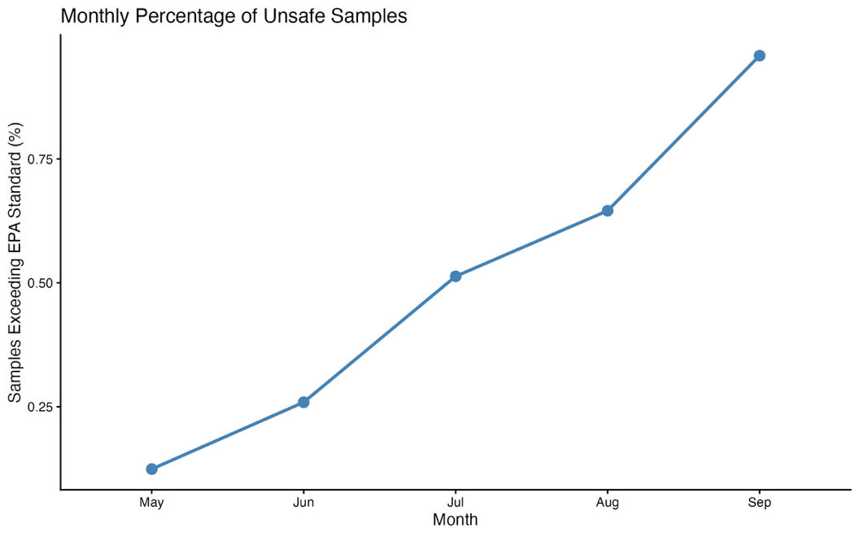
Figure 3. Monthly percentage of water samples exceeding the U.S. Environmental Protection Agency (EPA) recreational water quality standard during the 2021–2025 recreational swimming seasons. The percentage of samples exceeding the EPA standard increased progressively from May through September, although fewer than 1% of samples exceeded the threshold in every month.

  - Beach Comparisons
Differences in recreational water quality among monitoring locations are presented in Figure 4. While most beaches recorded very few samples exceeding the U.S. Environmental Protection Agency (EPA) recreational water quality standard, several locations exhibited higher percentages of exceedances than others.
The four beaches with the highest percentages of samples exceeding the EPA standard each had an unsafe sample rate of approximately 2%, while the remaining beaches in the top ten had rates of approximately 1%. Despite these differences among monitoring locations, the overall percentage of samples exceeding the EPA standard remained relatively low, indicating generally good recreational water quality across New Jersey beaches during the study period.
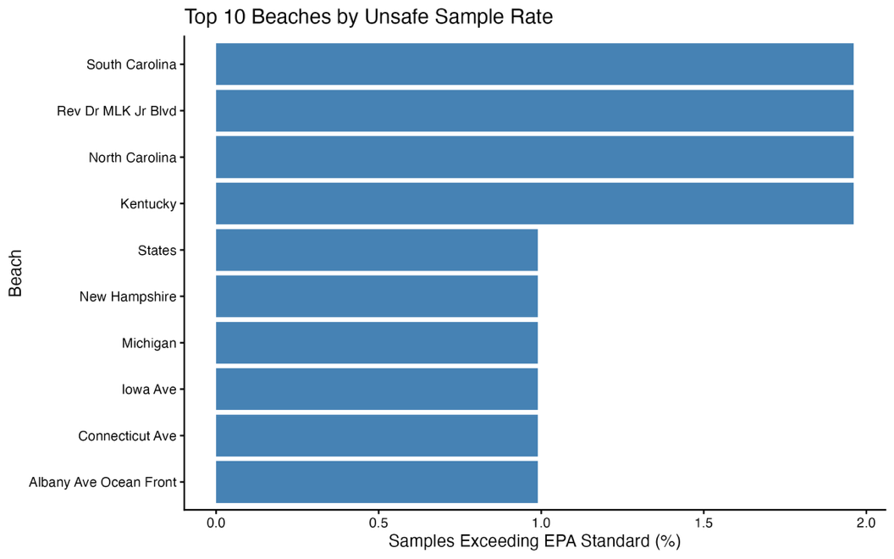
Figure 4. Ten recreational beaches with the highest percentage of water samples exceeding the U.S. Environmental Protection Agency (EPA) recreational water quality standard during the 2021–2025 recreational swimming seasons. Although these beaches exhibited the highest percentages of samples above the EPA standard, exceedances remained relatively uncommon across all monitored locations.

  - Logistic Regression
Logistic regression models were used to evaluate associations between unsafe water quality measurements and sampling year, season, and beach location. The analyses indicated that the likelihood of an unsafe water quality measurement varied across these factors, supporting the descriptive patterns observed in the annual, seasonal, and beach-level summaries. Odds ratios were calculated to quantify the relative likelihood of unsafe measurements among comparison groups.

- Discussion
This study evaluated recreational water quality at New Jersey beaches using publicly available Enterococcus monitoring data collected during the 2021–2025 recreational swimming seasons. Overall, recreational water quality remained high throughout the study period, with only 78 of 16,745 samples (0.47%) exceeding the U.S. Environmental Protection Agency (EPA) recreational water quality standard. These findings suggest that the vast majority of monitored beaches met recommended bacterial water quality criteria during routine sampling.
Although exceedances of the EPA standard were uncommon, the analyses identified modest annual, seasonal, and geographic variation in recreational water quality. The percentage of samples exceeding the EPA standard increased between 2021 and 2023 before declining in 2024 and remaining relatively stable in 2025. Seasonal analyses showed that exceedances became more common later in the recreational swimming season, while beach-level analyses demonstrated that some monitoring locations consistently exhibited higher percentages of samples exceeding the EPA standard than others. These findings suggest that local environmental conditions may influence recreational water quality and support continued monitoring throughout the swimming season.
The strongly right-skewed distribution of Enterococcus concentrations indicates that elevated bacterial measurements were relatively uncommon but occurred occasionally. Such patterns are frequently observed in environmental monitoring datasets, where most observations remain within acceptable limits while isolated events produce substantially higher bacterial concentrations. Although this study did not evaluate specific environmental factors contributing to these events, weather conditions, stormwater runoff, wildlife activity, tidal influences, and other local factors may contribute to short-term increases in bacterial concentrations.
This study also demonstrates the value of publicly available environmental monitoring data for investigating recreational water quality. By combining reproducible statistical analyses with data visualization, publicly available datasets can be used to identify long-term trends, compare monitoring locations, and communicate environmental health information in a clear and accessible manner.
Several limitations should be considered when interpreting these findings. First, the analysis relied on routinely collected monitoring data and therefore could not account for environmental variables such as rainfall, temperature, or tidal conditions that may influence bacterial concentrations. Second, only Enterococcus concentrations were evaluated, although recreational water quality may also be affected by additional biological, chemical, or environmental factors. Finally, the study was limited to publicly available monitoring data collected during the recreational swimming season and may not represent water quality outside the routine monitoring period.
Overall, the findings indicate that recreational water quality at monitored New Jersey beaches remained consistently good during the 2021–2025 recreational swimming seasons while demonstrating measurable annual, seasonal, and geographic variation. Continued monitoring and reproducible statistical analyses can help identify changing patterns in recreational water quality and support evidence-based public health decision-making.

- Conclusion
This study evaluated recreational water quality at New Jersey beaches using publicly available Enterococcus monitoring data collected during the 2021–2025 recreational swimming seasons. Overall, recreational water quality remained consistently good, with fewer than 1% of water samples exceeding the U.S. Environmental Protection Agency recreational water quality standard.
Although exceedances were uncommon, the analyses identified measurable annual, seasonal, and geographic variation in recreational water quality, demonstrating the value of continued monitoring throughout the recreational swimming season. The use of reproducible statistical analyses and publicly available environmental data provided an effective framework for evaluating long-term water quality patterns and communicating findings through clear visualizations.
This project demonstrates how accessible environmental monitoring data can be used to answer meaningful public health questions while illustrating the importance of reproducible data analysis in environmental health and biostatistics. Future studies incorporating environmental variables such as rainfall, temperature, and tidal conditions could provide additional insight into factors influencing short-term changes in recreational water quality.

References

