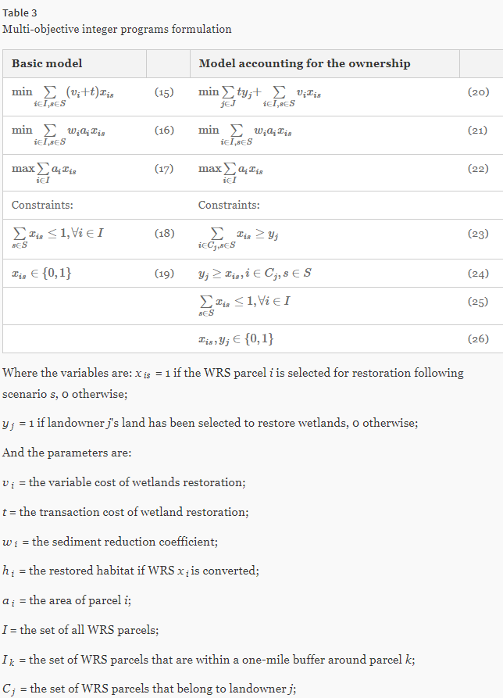

Min

OBJECTIV:

1 cost - 1 sed - 1 hab

Subject to:

Obj_Cost: 1549.34225x_0_0 + 1549.34225x_0_1 + 1549.34225x_0_2 + 1549.34225x_0_3 + 1549.34225x_0_4 + 1549.34225x_0_5 + 1549.34225x_0_6 + 1549.34225x_0_7 + 1549.34225x_0_8

+ 561.24337x_1_0 + 561.24337x_1_1 + 561.24337x_1_2 + 561.24337x_1_3 + 561.24337x_1_4 + 561.24337x_1_5 + 561.24337x_1_6 + 561.24337x_1_7 + 561.24337x_1_8

+ 61171.88173x_2_0 + 61171.88173x_2_1 + 61171.88173x_2_2 + 61171.88173x_2_3 + 61171.88173x_2_4 + 61171.88173x_2_5 + 61171.88173x_2_6 + 61171.88173x_2_7 + 61171.88173x_2_8 - hab = 0

clus1: x_5987_0 + x_5987_1 + x_5987_2 + x_5987_3 + x_5987_4 + x_5987_5 + x_5987_6 + x_5987_7 + x_5987_8 - y1>=0

clus2: x_1118_0 + x_1118_1 + x_1118_2 + x_1118_3 + x_1118_4 + x_1118_5 + x_1118_6 + x_1118_7 + x_1118_8

+ x_1119_0 + x_1119_1 + x_1119_2 + x_1119_3 + x_1119_4 + x_1119_5 + x_1119_6 + x_1119_7 + x_1119_8

+ x_1123_0 + x_1123_1 + x_1123_2 + x_1123_3 + x_1123_4 + x_1123_5 + x_1123_6 + x_1123_7 + x_1123_8 - y2>=0

clus3: x_564_0 + x_564_1 + x_564_2 + x_564_3 + x_564_4 + x_564_5 + x_564_6 + x_564_7 + x_564_8 - y3>=0

cluster1_5987: y1 - x_5987_0 - x_5987_1 - x_5987_2 - x_5987_3 - x_5987_4 - x_5987_5 - x_5987_6 - x_5987_7 - x_5987_8 >= 0

cluster2_1118: y2 - x_1118_0 - x_1118_1 - x_1118_2 - x_1118_3 - x_1118_4 - x_1118_5 - x_1118_6 - x_1118_7 - x_1118_8 >= 0

cluster2_1119: y2 - x_1119_0 - x_1119_1 - x_1119_2 - x_1119_3 - x_1119_4 - x_1119_5 - x_1119_6 - x_1119_7 - x_1119_8 >= 0

cluster2_1123: y2 - x_1123_0 - x_1123_1 - x_1123_2 - x_1123_3 - x_1123_4 - x_1123_5 - x_1123_6 - x_1123_7 - x_1123_8 >= 0

cluster3_564: y3 - x_564_0 - x_564_1 - x_564_2 - x_564_3 - x_564_4 - x_564_5 - x_564_6 - x_564_7 - x_564_8 >= 0

cluster4_4317: y4 - x_4317_0 - x_4317_1 - x_4317_2 - x_4317_3 - x_4317_4 - x_4317_5 - x_4317_6 - x_4317_7 - x_4317_8 >= 0

Scen0: x_0_0 + x_0_1 + x_0_2 + x_0_3 + x_0_4 + x_0_5 + x_0_6 + x_0_7 + x_0_8 <=1

Scen1: x_1_0 + x_1_1 + x_1_2 + x_1_3 + x_1_4 + x_1_5 + x_1_6 + x_1_7 + x_1_8 <=1

Scen2: x_2_0 + x_2_1 + x_2_2 + x_2_3 + x_2_4 + x_2_5 + x_2_6 + x_2_7 + x_2_8 <=1

Scen3: x_3_0 + x_3_1 + x_3_2 + x_3_3 + x_3_4 + x_3_5 + x_3_6 + x_3_7 + x_3_8 <=1

Scen4: x_4_0 + x_4_1 + x_4_2 + x_4_3 + x_4_4 + x_4_5 + x_4_6 + x_4_7 + x_4_8 <=1

Scen5: x_5_0 + x_5_1 + x_5_2 + x_5_3 + x_5_4 + x_5_5 + x_5_6 + x_5_7 + x_5_8 <=1

Scen7720: x_7720_0 + x_7720_1 + x_7720_2 + x_7720_3 + x_7720_4 + x_7720_5 + x_7720_6 + x_7720_7 + x_7720_8 <=1

Scen7721: x_7721_0 + x_7721_1 + x_7721_2 + x_7721_3 + x_7721_4 + x_7721_5 + x_7721_6 + x_7721_7 + x_7721_8 <=1

Bounds

sed > 0

cost > 0

Binary

x_0_0 x_0_1 x_0_2 x_0_3 x_0_4 x_0_5 x_0_6 x_0_7 x_0_8

x_1_0 x_1_1 x_1_2 x_1_3 x_1_4 x_1_5 x_1_6 x_1_7 x_1_8

x_2_0 x_2_1 x_2_2 x_2_3 x_2_4 x_2_5 x_2_6 x_2_7 x_2_8

y1 y2 y3 y4 y5 y6 y7 y8 y9 y10 y11 y12 y13 y14 y15 y16 y17 y18 y19 y20

y21 y22 y23 y24 y25 y26 y27 y28 y29 y30 y31 y32 y33 y34 y35 y36 y37 y38 y39 y40